**Buttons**

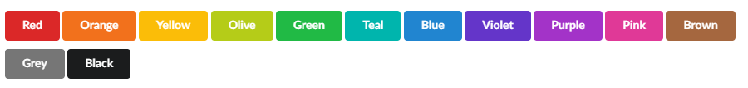

<button class="ui red button">Red</button>



<button class="ui active button">

<i class="[user icon](https://semantic-ui.com/elements/icon.html)"></i> Follow </button>



<button class="ui disabled button">

<i class="[user icon](https://semantic-ui.com/elements/icon.html)"></i> Followed </button>

**Navigation Bar**

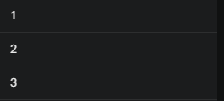

<body> <div class="ui sidebar inverted vertical menu"> <a class="item"> 1 </a> <a class="item"> 2 </a> <a class="item"> 3 </a> </div> <div class="pusher"> *<!-- Site content !-->* </div> </body>

$('.ui.sidebar') .sidebar('toggle') ;

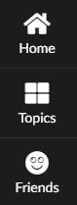

<div class="ui left demo vertical inverted sidebar labeled icon menu"> <a class="item"> <i class="[home icon](https://semantic-ui.com/elements/icon.html)"></i> Home </a> <a class="item"> <i class="[block layout icon](https://semantic-ui.com/elements/icon.html)"></i> Topics </a> <a class="item"> <i class="[smile icon](https://semantic-ui.com/elements/icon.html)"></i> Friends </a> </div>

$('.ui.labeled.icon.sidebar') .sidebar('toggle') ;

<div class="ui visible sidebar"></div>

<div class="ui top sidebar"></div>

<div class="ui right sidebar"></div>

<div class="ui bottom sidebar"></div>

<div class="ui left sidebar"></div>

**Sticking Content**

$('.ui.sticky') .sticky({ context: '#example1' }) ;

$('.ui.sticky') .sticky({ context: '#example2', pushing: true }) ;

$('.ui.sticky') .sticky({ context: '#example3' }) ;

**Uploading**

Active Progress Bar



<div class="ui active progress"> <div class="bar"> <div class="progress"></div> </div> <div class="label">Uploading Files</div> </div>

Success Progress Bar



<div class="ui progress success"> <div class="bar"> <div class="progress"></div> </div> <div class="label">Everything worked, your file is all ready.</div> </div>

**Modal**

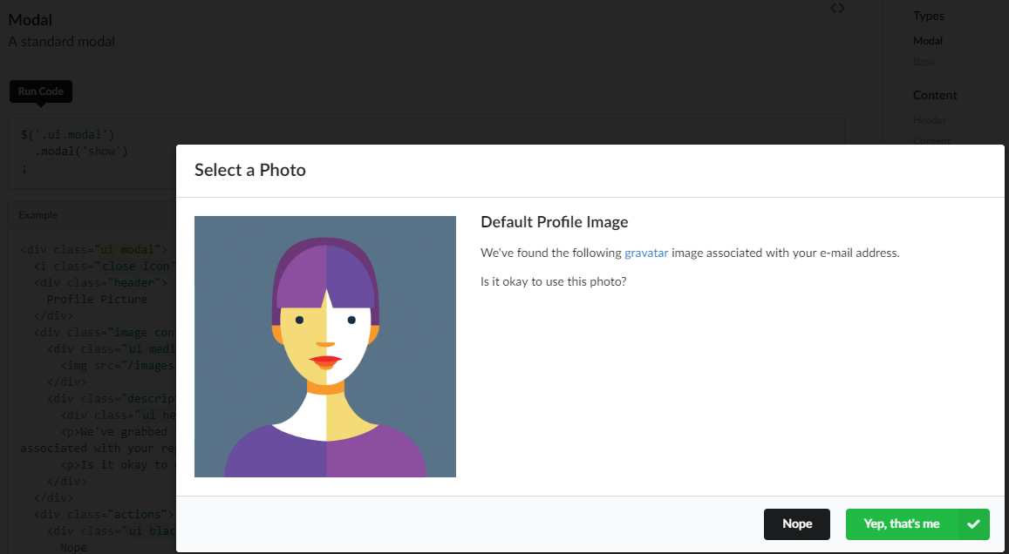

<div class="ui modal"> <i class="[close icon](https://semantic-ui.com/elements/icon.html)"></i> <div class="header"> Profile Picture </div> <div class="image content"> <div class="[ui medium image](https://semantic-ui.com/elements/image.html)"> <img src="/images/avatar/large/chris.jpg"> </div> <div class="description"> <div class="[ui header](https://semantic-ui.com/elements/header.html)">We've auto-chosen a profile image for you.</div> <p>We've grabbed the following image from the <a href="https://www.gravatar.com" target="_blank">gravatar</a> image associated with your registered e-mail address.</p> <p>Is it okay to use this photo?</p> </div> </div> <div class="actions"> <div class="[ui black deny button](https://semantic-ui.com/elements/button.html)"> Nope </div> <div class="[ui positive right labeled icon button](https://semantic-ui.com/elements/button.html)"> Yep, that's me <i class="[checkmark icon](https://semantic-ui.com/elements/icon.html)"></i> </div> </div> </div>

**Dropdown**

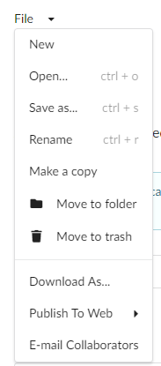

<div class="ui dropdown"> <div class="text">File</div> <i class="dropdown icon"></i> <div class="menu"> <div class="item">New</div> <div class="item"> <span class="description">ctrl + o</span> Open... </div> <div class="item"> <span class="description">ctrl + s</span> Save as... </div> <div class="item"> <span class="description">ctrl + r</span> Rename </div> <div class="item">Make a copy</div> <div class="item"> <i class="[folder icon](https://semantic-ui.com/elements/icon.html)"></i> Move to folder </div> <div class="item"> <i class="[trash icon](https://semantic-ui.com/elements/icon.html)"></i> Move to trash </div> <div class="divider"></div> <div class="item">Download As...</div> <div class="item"> <i class="dropdown icon"></i> Publish To Web <div class="menu"> <div class="item">Google Docs</div> <div class="item">Google Drive</div> <div class="item">Dropbox</div> <div class="item">Adobe Creative Cloud</div> <div class="item">Private FTP</div> <div class="item">Another Service...</div> </div> </div> <div class="item">E-mail Collaborators</div> </div> </div>

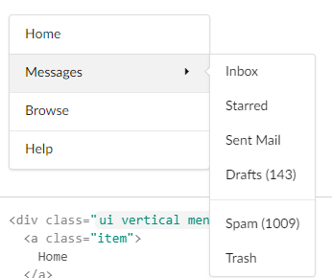

<div class="[ui vertical menu](https://semantic-ui.com/collections/menu.html)"> <a class="item"> Home </a> <div class="ui left pointing dropdown link item"> <i class="dropdown icon"></i> Messages <div class="menu"> <div class="item">Inbox</div> <div class="item">Starred</div> <div class="item">Sent Mail</div> <div class="item">Drafts (143)</div> <div class="divider"></div> <div class="item">Spam (1009)</div> <div class="item">Trash</div> </div> </div> <a class="item"> Browse </a> <a class="item"> Help </a> </div>

**Statistics**

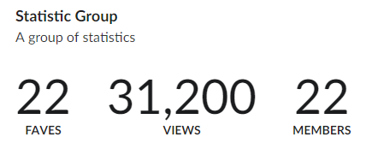

<div class="ui statistics"> <div class="statistic"> <div class="value"> 22 </div> <div class="label"> Faves </div> </div> <div class="statistic"> <div class="value"> 31,200 </div> <div class="label"> Views </div> </div> <div class="statistic"> <div class="value"> 22 </div> <div class="label"> Members </div> </div> </div>