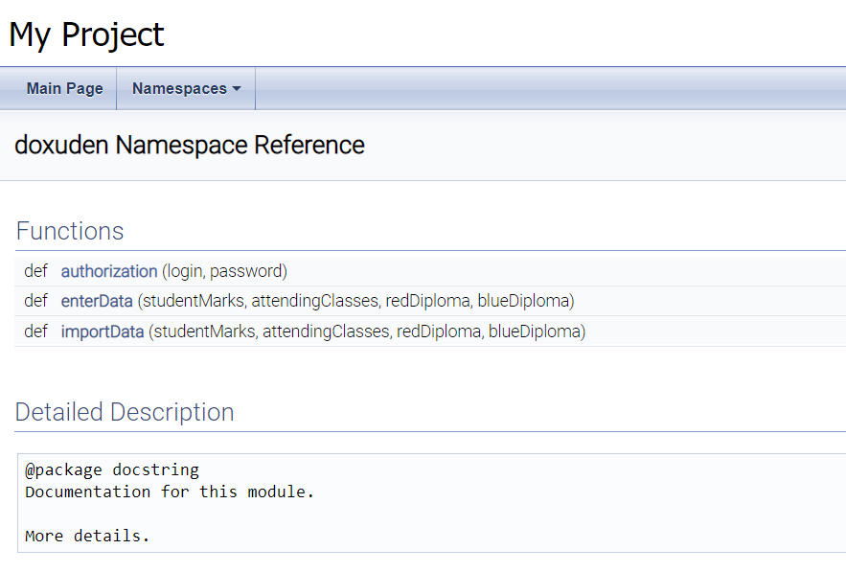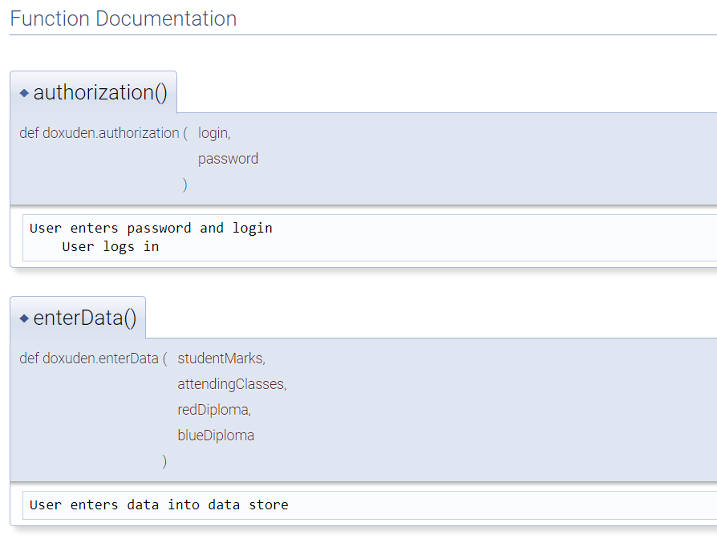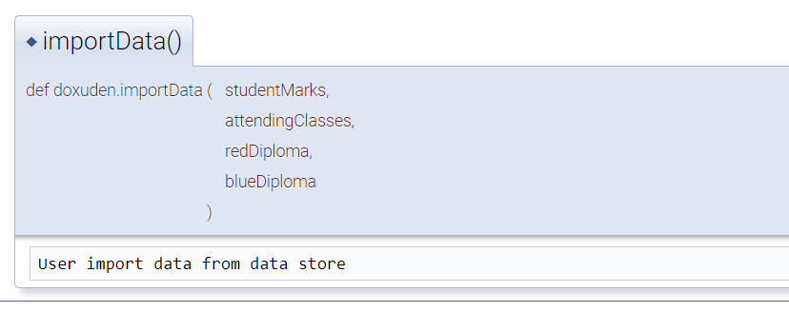

"""@package docstring

Documentation for this module.

More details.

"""

User enters password and login

User logs in

def authorization(login, password):

    """User enters password and login

        User logs in

    """

    pass

def enterData(studentMarks, attendingСlasses, redDiploma, blueDiploma):

    """User enters data into data store

    """

    pass

def importData(studentMarks, attendingСlasses, redDiploma, blueDiploma):

    """User import data from data store

    """

    pass