Вариант 13

Полином: $x^{35}+x^{2}+1$

**Тест 1**

Тестовая ситуация:

Шифрование и дешифрование короткого текстового файла.

Исходные данные:

* нач. состояние регистра: 11111111111111111111111111111111111;
* название исходного файла: Тест(текст).txt;
* содержимое исходного файла: hello.

Таблица генерации ключа:

|  |  |  |  |  |  |  |  |  |  |  |  |  |  |  |  |  |  |  |  |  |  |  |  |  |  |  |  |  |  |  |  |  |  |  |  |  |  |
| --- | --- | --- | --- | --- | --- | --- | --- | --- | --- | --- | --- | --- | --- | --- | --- | --- | --- | --- | --- | --- | --- | --- | --- | --- | --- | --- | --- | --- | --- | --- | --- | --- | --- | --- | --- | --- | --- |
|  |  | Разряды регистра | | | | | | | | | | | | | | | | | | | | | | | | | | | | | | | | | | | xor |
|  |  | 35 | 34 | 33 | 32 | 31 | 30 | 29 | 28 | 27 | 26 | 25 | 24 | 23 | 22 | 21 | 20 | 19 | 18 | 17 | 16 | 15 | 14 | 13 | 12 | 11 | 10 | 9 | 8 | 7 | 6 | 5 | 4 | 3 | 2 | 1 |  |
| Шаги / Состояние регистра | 1 | 1 | 1 | 1 | 1 | 1 | 1 | 1 | 1 | 1 | 1 | 1 | 1 | 1 | 1 | 1 | 1 | 1 | 1 | 1 | 1 | 1 | 1 | 1 | 1 | 1 | 1 | 1 | 1 | 1 | 1 | 1 | 1 | 1 | 1 | 1 | 0 |
| 2 | 1 | 1 | 1 | 1 | 1 | 1 | 1 | 1 | 1 | 1 | 1 | 1 | 1 | 1 | 1 | 1 | 1 | 1 | 1 | 1 | 1 | 1 | 1 | 1 | 1 | 1 | 1 | 1 | 1 | 1 | 1 | 1 | 1 | 1 | 0 | 0 |
| 3 | 1 | 1 | 1 | 1 | 1 | 1 | 1 | 1 | 1 | 1 | 1 | 1 | 1 | 1 | 1 | 1 | 1 | 1 | 1 | 1 | 1 | 1 | 1 | 1 | 1 | 1 | 1 | 1 | 1 | 1 | 1 | 1 | 1 | 0 | 0 | 1 |
| 4 | 1 | 1 | 1 | 1 | 1 | 1 | 1 | 1 | 1 | 1 | 1 | 1 | 1 | 1 | 1 | 1 | 1 | 1 | 1 | 1 | 1 | 1 | 1 | 1 | 1 | 1 | 1 | 1 | 1 | 1 | 1 | 1 | 0 | 0 | 1 | 1 |
| 5 | 1 | 1 | 1 | 1 | 1 | 1 | 1 | 1 | 1 | 1 | 1 | 1 | 1 | 1 | 1 | 1 | 1 | 1 | 1 | 1 | 1 | 1 | 1 | 1 | 1 | 1 | 1 | 1 | 1 | 1 | 1 | 0 | 0 | 1 | 1 | 0 |
| 6 | 1 | 1 | 1 | 1 | 1 | 1 | 1 | 1 | 1 | 1 | 1 | 1 | 1 | 1 | 1 | 1 | 1 | 1 | 1 | 1 | 1 | 1 | 1 | 1 | 1 | 1 | 1 | 1 | 1 | 1 | 0 | 0 | 1 | 1 | 0 | 0 |
| 7 | 1 | 1 | 1 | 1 | 1 | 1 | 1 | 1 | 1 | 1 | 1 | 1 | 1 | 1 | 1 | 1 | 1 | 1 | 1 | 1 | 1 | 1 | 1 | 1 | 1 | 1 | 1 | 1 | 1 | 0 | 0 | 1 | 1 | 0 | 0 | 1 |
| 8 | 1 | 1 | 1 | 1 | 1 | 1 | 1 | 1 | 1 | 1 | 1 | 1 | 1 | 1 | 1 | 1 | 1 | 1 | 1 | 1 | 1 | 1 | 1 | 1 | 1 | 1 | 1 | 1 | 0 | 0 | 1 | 1 | 0 | 0 | 1 | 1 |
| 9 | 1 | 1 | 1 | 1 | 1 | 1 | 1 | 1 | 1 | 1 | 1 | 1 | 1 | 1 | 1 | 1 | 1 | 1 | 1 | 1 | 1 | 1 | 1 | 1 | 1 | 1 | 1 | 0 | 0 | 1 | 1 | 0 | 0 | 1 | 1 | 0 |
| 10 | 1 | 1 | 1 | 1 | 1 | 1 | 1 | 1 | 1 | 1 | 1 | 1 | 1 | 1 | 1 | 1 | 1 | 1 | 1 | 1 | 1 | 1 | 1 | 1 | 1 | 1 | 0 | 0 | 1 | 1 | 0 | 0 | 1 | 1 | 0 | 0 |
| 11 | 1 | 1 | 1 | 1 | 1 | 1 | 1 | 1 | 1 | 1 | 1 | 1 | 1 | 1 | 1 | 1 | 1 | 1 | 1 | 1 | 1 | 1 | 1 | 1 | 1 | 0 | 0 | 1 | 1 | 0 | 0 | 1 | 1 | 0 | 0 | 1 |
| 12 | 1 | 1 | 1 | 1 | 1 | 1 | 1 | 1 | 1 | 1 | 1 | 1 | 1 | 1 | 1 | 1 | 1 | 1 | 1 | 1 | 1 | 1 | 1 | 1 | 0 | 0 | 1 | 1 | 0 | 0 | 1 | 1 | 0 | 0 | 1 | 1 |
| 13 | 1 | 1 | 1 | 1 | 1 | 1 | 1 | 1 | 1 | 1 | 1 | 1 | 1 | 1 | 1 | 1 | 1 | 1 | 1 | 1 | 1 | 1 | 1 | 0 | 0 | 1 | 1 | 0 | 0 | 1 | 1 | 0 | 0 | 1 | 1 | 0 |
| 14 | 1 | 1 | 1 | 1 | 1 | 1 | 1 | 1 | 1 | 1 | 1 | 1 | 1 | 1 | 1 | 1 | 1 | 1 | 1 | 1 | 1 | 1 | 0 | 0 | 1 | 1 | 0 | 0 | 1 | 1 | 0 | 0 | 1 | 1 | 0 | 0 |
| 15 | 1 | 1 | 1 | 1 | 1 | 1 | 1 | 1 | 1 | 1 | 1 | 1 | 1 | 1 | 1 | 1 | 1 | 1 | 1 | 1 | 1 | 0 | 0 | 1 | 1 | 0 | 0 | 1 | 1 | 0 | 0 | 1 | 1 | 0 | 0 | 1 |
| 16 | 1 | 1 | 1 | 1 | 1 | 1 | 1 | 1 | 1 | 1 | 1 | 1 | 1 | 1 | 1 | 1 | 1 | 1 | 1 | 1 | 0 | 0 | 1 | 1 | 0 | 0 | 1 | 1 | 0 | 0 | 1 | 1 | 0 | 0 | 1 | 1 |
| 17 | 1 | 1 | 1 | 1 | 1 | 1 | 1 | 1 | 1 | 1 | 1 | 1 | 1 | 1 | 1 | 1 | 1 | 1 | 1 | 0 | 0 | 1 | 1 | 0 | 0 | 1 | 1 | 0 | 0 | 1 | 1 | 0 | 0 | 1 | 1 | 0 |
| 18 | 1 | 1 | 1 | 1 | 1 | 1 | 1 | 1 | 1 | 1 | 1 | 1 | 1 | 1 | 1 | 1 | 1 | 1 | 0 | 0 | 1 | 1 | 0 | 0 | 1 | 1 | 0 | 0 | 1 | 1 | 0 | 0 | 1 | 1 | 0 | 0 |
| 19 | 1 | 1 | 1 | 1 | 1 | 1 | 1 | 1 | 1 | 1 | 1 | 1 | 1 | 1 | 1 | 1 | 1 | 0 | 0 | 1 | 1 | 0 | 0 | 1 | 1 | 0 | 0 | 1 | 1 | 0 | 0 | 1 | 1 | 0 | 0 | 1 |
| 20 | 1 | 1 | 1 | 1 | 1 | 1 | 1 | 1 | 1 | 1 | 1 | 1 | 1 | 1 | 1 | 1 | 0 | 0 | 1 | 1 | 0 | 0 | 1 | 1 | 0 | 0 | 1 | 1 | 0 | 0 | 1 | 1 | 0 | 0 | 1 | 1 |
| 21 | 1 | 1 | 1 | 1 | 1 | 1 | 1 | 1 | 1 | 1 | 1 | 1 | 1 | 1 | 1 | 0 | 0 | 1 | 1 | 0 | 0 | 1 | 1 | 0 | 0 | 1 | 1 | 0 | 0 | 1 | 1 | 0 | 0 | 1 | 1 | 0 |
| 22 | 1 | 1 | 1 | 1 | 1 | 1 | 1 | 1 | 1 | 1 | 1 | 1 | 1 | 1 | 0 | 0 | 1 | 1 | 0 | 0 | 1 | 1 | 0 | 0 | 1 | 1 | 0 | 0 | 1 | 1 | 0 | 0 | 1 | 1 | 0 | 0 |
| 23 | 1 | 1 | 1 | 1 | 1 | 1 | 1 | 1 | 1 | 1 | 1 | 1 | 1 | 0 | 0 | 1 | 1 | 0 | 0 | 1 | 1 | 0 | 0 | 1 | 1 | 0 | 0 | 1 | 1 | 0 | 0 | 1 | 1 | 0 | 0 | 1 |
| 24 | 1 | 1 | 1 | 1 | 1 | 1 | 1 | 1 | 1 | 1 | 1 | 1 | 0 | 0 | 1 | 1 | 0 | 0 | 1 | 1 | 0 | 0 | 1 | 1 | 0 | 0 | 1 | 1 | 0 | 0 | 1 | 1 | 0 | 0 | 1 | 1 |
| 25 | 1 | 1 | 1 | 1 | 1 | 1 | 1 | 1 | 1 | 1 | 1 | 0 | 0 | 1 | 1 | 0 | 0 | 1 | 1 | 0 | 0 | 1 | 1 | 0 | 0 | 1 | 1 | 0 | 0 | 1 | 1 | 0 | 0 | 1 | 1 | 0 |
| 26 | 1 | 1 | 1 | 1 | 1 | 1 | 1 | 1 | 1 | 1 | 0 | 0 | 1 | 1 | 0 | 0 | 1 | 1 | 0 | 0 | 1 | 1 | 0 | 0 | 1 | 1 | 0 | 0 | 1 | 1 | 0 | 0 | 1 | 1 | 0 | 0 |
| 27 | 1 | 1 | 1 | 1 | 1 | 1 | 1 | 1 | 1 | 0 | 0 | 1 | 1 | 0 | 0 | 1 | 1 | 0 | 0 | 1 | 1 | 0 | 0 | 1 | 1 | 0 | 0 | 1 | 1 | 0 | 0 | 1 | 1 | 0 | 0 | 1 |
| 28 | 1 | 1 | 1 | 1 | 1 | 1 | 1 | 1 | 0 | 0 | 1 | 1 | 0 | 0 | 1 | 1 | 0 | 0 | 1 | 1 | 0 | 0 | 1 | 1 | 0 | 0 | 1 | 1 | 0 | 0 | 1 | 1 | 0 | 0 | 1 | 1 |
| 29 | 1 | 1 | 1 | 1 | 1 | 1 | 1 | 0 | 0 | 1 | 1 | 0 | 0 | 1 | 1 | 0 | 0 | 1 | 1 | 0 | 0 | 1 | 1 | 0 | 0 | 1 | 1 | 0 | 0 | 1 | 1 | 0 | 0 | 1 | 1 | 0 |
| 30 | 1 | 1 | 1 | 1 | 1 | 1 | 0 | 0 | 1 | 1 | 0 | 0 | 1 | 1 | 0 | 0 | 1 | 1 | 0 | 0 | 1 | 1 | 0 | 0 | 1 | 1 | 0 | 0 | 1 | 1 | 0 | 0 | 1 | 1 | 0 | 0 |
| 31 | 1 | 1 | 1 | 1 | 1 | 0 | 0 | 1 | 1 | 0 | 0 | 1 | 1 | 0 | 0 | 1 | 1 | 0 | 0 | 1 | 1 | 0 | 0 | 1 | 1 | 0 | 0 | 1 | 1 | 0 | 0 | 1 | 1 | 0 | 0 | 1 |
| 32 | 1 | 1 | 1 | 1 | 0 | 0 | 1 | 1 | 0 | 0 | 1 | 1 | 0 | 0 | 1 | 1 | 0 | 0 | 1 | 1 | 0 | 0 | 1 | 1 | 0 | 0 | 1 | 1 | 0 | 0 | 1 | 1 | 0 | 0 | 1 | 1 |
| 33 | 1 | 1 | 1 | 0 | 0 | 1 | 1 | 0 | 0 | 1 | 1 | 0 | 0 | 1 | 1 | 0 | 0 | 1 | 1 | 0 | 0 | 1 | 1 | 0 | 0 | 1 | 1 | 0 | 0 | 1 | 1 | 0 | 0 | 1 | 1 | 0 |
| 34 | 1 | 1 | 0 | 0 | 1 | 1 | 0 | 0 | 1 | 1 | 0 | 0 | 1 | 1 | 0 | 0 | 1 | 1 | 0 | 0 | 1 | 1 | 0 | 0 | 1 | 1 | 0 | 0 | 1 | 1 | 0 | 0 | 1 | 1 | 0 | 0 |
| 35 | 1 | 0 | 0 | 1 | 1 | 0 | 0 | 1 | 1 | 0 | 0 | 1 | 1 | 0 | 0 | 1 | 1 | 0 | 0 | 1 | 1 | 0 | 0 | 1 | 1 | 0 | 0 | 1 | 1 | 0 | 0 | 1 | 1 | 0 | 0 | 1 |
| 36 | 0 | 0 | 1 | 1 | 0 | 0 | 1 | 1 | 0 | 0 | 1 | 1 | 0 | 0 | 1 | 1 | 0 | 0 | 1 | 1 | 0 | 0 | 1 | 1 | 0 | 0 | 1 | 1 | 0 | 0 | 1 | 1 | 0 | 0 | 1 | 0 |
| 37 | 0 | 1 | 1 | 0 | 0 | 1 | 1 | 0 | 0 | 1 | 1 | 0 | 0 | 1 | 1 | 0 | 0 | 1 | 1 | 0 | 0 | 1 | 1 | 0 | 0 | 1 | 1 | 0 | 0 | 1 | 1 | 0 | 0 | 1 | 0 | 1 |
| 38 | 1 | 1 | 0 | 0 | 1 | 1 | 0 | 0 | 1 | 1 | 0 | 0 | 1 | 1 | 0 | 0 | 1 | 1 | 0 | 0 | 1 | 1 | 0 | 0 | 1 | 1 | 0 | 0 | 1 | 1 | 0 | 0 | 1 | 0 | 1 | 1 |
| 39 | 1 | 0 | 0 | 1 | 1 | 0 | 0 | 1 | 1 | 0 | 0 | 1 | 1 | 0 | 0 | 1 | 1 | 0 | 0 | 1 | 1 | 0 | 0 | 1 | 1 | 0 | 0 | 1 | 1 | 0 | 0 | 1 | 0 | 1 | 1 | 0 |
| 40 | 0 | 0 | 1 | 1 | 0 | 0 | 1 | 1 | 0 | 0 | 1 | 1 | 0 | 0 | 1 | 1 | 0 | 0 | 1 | 1 | 0 | 0 | 1 | 1 | 0 | 0 | 1 | 1 | 0 | 0 | 1 | 0 | 1 | 1 | 0 | 1 |

Ожидаемый результат:

* ключ: 1111111111111111111111111111111111100110;
* исходный текст: 0001011010100110001101100011011011110110;
* шифро текст: 1110100101011001110010011100100100010000.

Полученный результат:

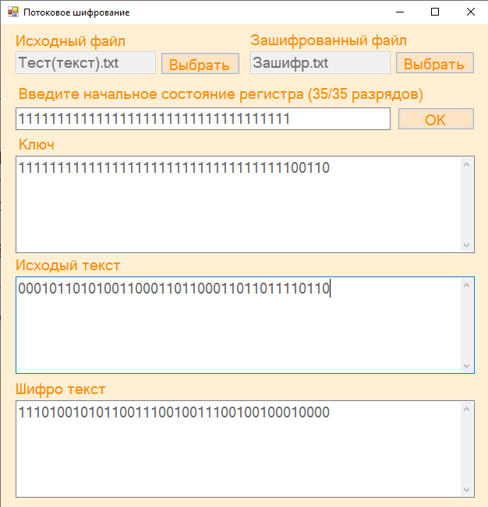 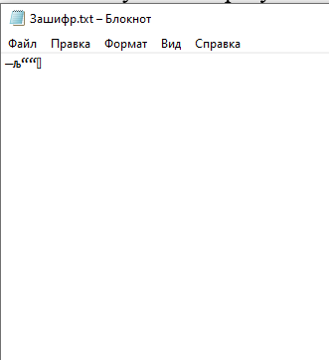

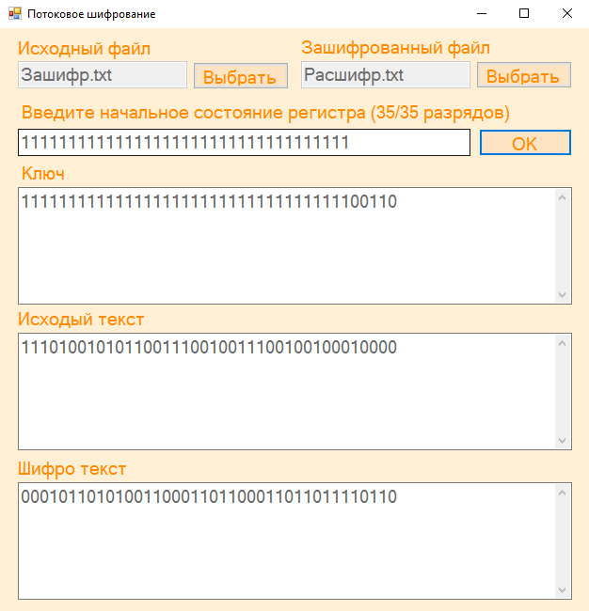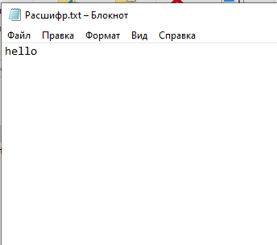

**Тест 2**

Тестовая ситуация:

Шифрование и дешифрование текстового документа.

Исходные данные:

* нач. состояние регистра: 10101010101010101010101010101010101;
* название исходного файла: Тест(текст).docx.

Ожидаемый результат:

* ключ: 101010101010101010101010101010101011101110111011101110111011101110111001001110010011100100111001001110010111100101111001…;
* исходный текст:

000010101101001011000000001000000010100000000000011000000000000000010000000000000000000000000000100001000000000010101111…;

* шифро текст:

101000000111100001101010100010101001001110111011110110111011101110101001001110010011100100111001101111010111100111010110…

Полученный результат:

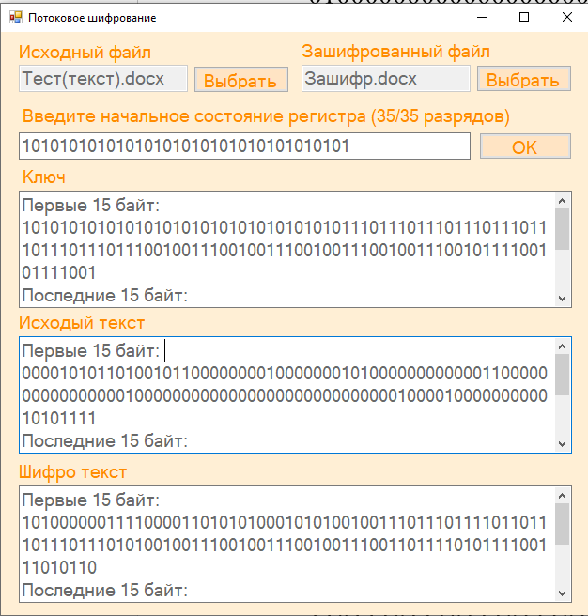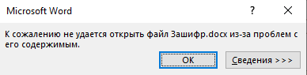

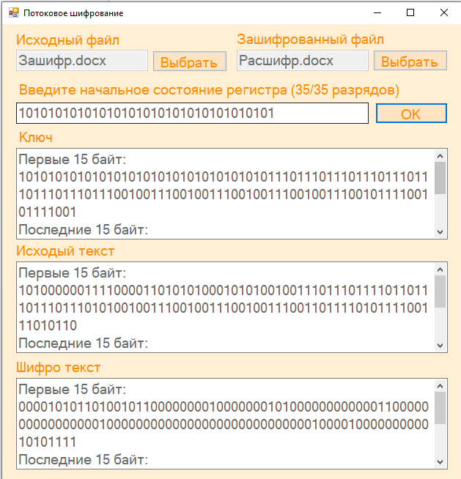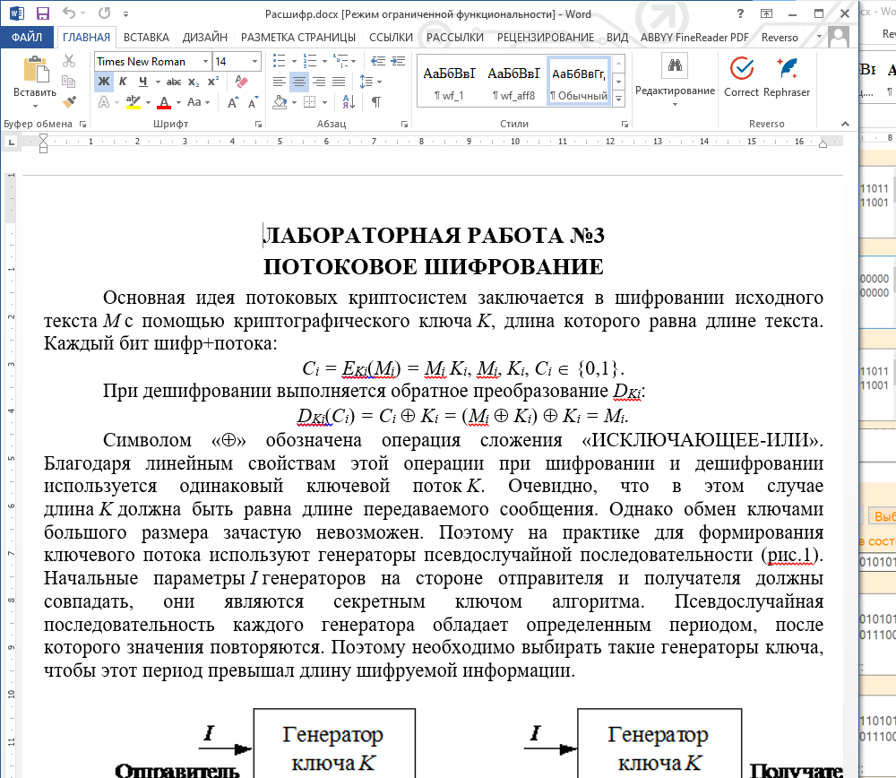

Тест 3

Тестовая ситуация:

Шифрование и дешифрование аудио файла.

Исходные данные:

* нач. состояние регистра: 10101010101010101010101010101010101;
* название исходного файла: Тест(аудио).wav.

Ожидаемый результат:

* ключ: 101010101010101010101010101010101011101110111011101110111011101110111001001110010011100100111001001110010111100101111001…;
* исходный текст:

010010101001001001100010011000100110011011000110100000000000000011101010100000100110101010100010011001101011011000101110…;

* шифро текст:

111000000011100011001000110010001101110101111101001110111011101101010011101110110101001110011011010111111100111101010111…

Полученный результат:

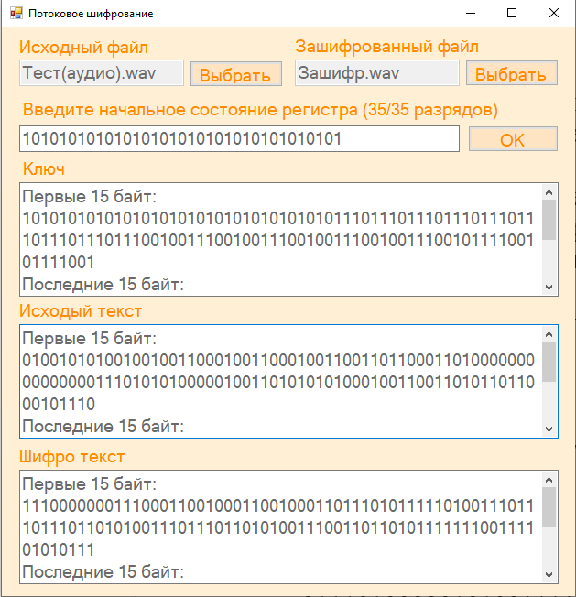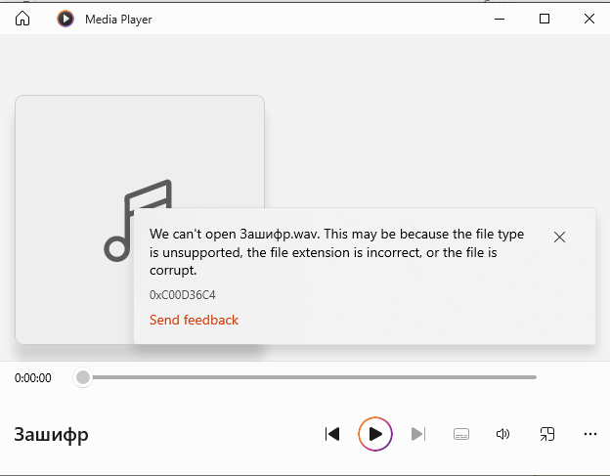

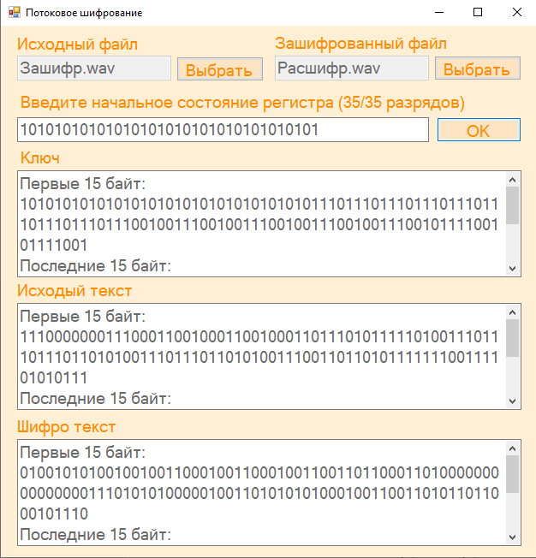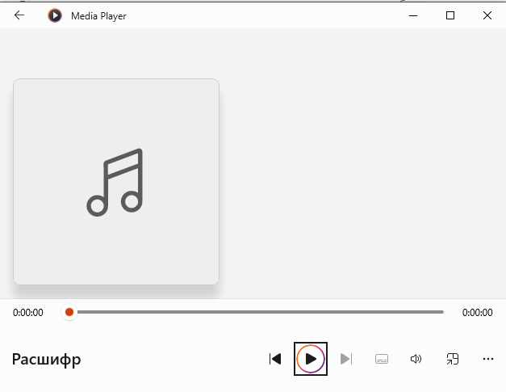

**Тест 4**

Тестовая ситуация:

Шифрование и дешифрование видео файла.

Исходные данные:

* нач. состояние регистра: 10101010101010101010101010101010101;
* название исходного файла: Тест(видео).mp4.

Ожидаемый результат:

* ключ: 101010101010101010101010101010101011101110111011101110111011101110111001001110010011100100111001001110010111100101111001…;
* исходный текст:

000000000000000000000000000001000110011000101110100111100000111010010110110011101111011010110110000000000000000001000000…;

* шифро текст:

101010101010101010101010101011101101110110010101001001011011010100101111111101111100111110001111001110010111100100111001…

Полученный результат:

