Lab 8

Time Spent: 10hours

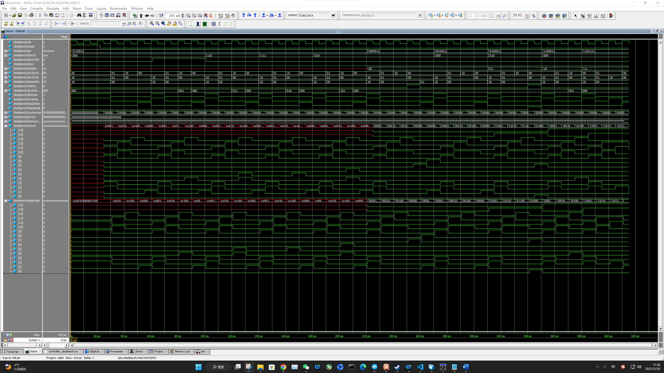

The results match exactly what I want. The testbench file passed with no errors.

RTL:

Code:

图形用户界面

Test Bench

Test Vector:

//op[6:0]_funct3[2:0]_funct7b5_Zero_ImmSrc[1:0]_ALUSrcA[1:0]_ALUSrcB[1:0]_ResultSrc[1:0]_AdrSrc_ALUControl[2:0]_IRWrite_PCWrite_RegWrite_MemWrite

// add

0110011_000_0_0__XX_00_10_10_0_000_1_1_0_0 // Fetch

0110011_000_0_0__XX_01_01_00_0_000_0_0_0_0 // Decode

0110011_000_0_0__XX_10_00_00_0_000_0_0_0_0 // ExecuteR

0110011_000_0_0__XX_00_00_00_0_000_0_0_1_0 // ALUWB

// sub (only differs in ALUControl during ExecuteR)

0110011_000_1_0__XX_00_10_10_0_000_1_1_0_0 // Fetch

0110011_000_1_0__XX_01_01_00_0_000_0_0_0_0 // Decode

0110011_000_1_0__XX_10_00_00_0_001_0_0_0_0 // ExecuteR

0110011_000_1_0__XX_00_00_00_0_000_0_0_1_0 // ALUWB

// or (only differs in ALUControl during ExecuteR)

0110011_110_0_0__XX_00_10_10_0_000_1_1_0_0 // Fetch

0110011_110_0_0__XX_01_01_00_0_000_0_0_0_0 // Decode

0110011_110_0_0__XX_10_00_00_0_011_0_0_0_0 // ExecuteR

0110011_110_0_0__XX_00_00_00_0_000_0_0_1_0 // ALUWB

// and (only differs in ALUControl during ExecuteR)

0110011_111_0_0__XX_00_10_10_0_000_1_1_0_0 // Fetch

0110011_111_0_0__XX_01_01_00_0_000_0_0_0_0 // Decode

0110011_111_0_0__XX_10_00_00_0_010_0_0_0_0 // ExecuteR

0110011_111_0_0__XX_00_00_00_0_000_0_0_1_0 // ALUWB

// slt (only differs in ALUControl during ExecuteR)

0110011_010_0_0__XX_00_10_10_0_000_1_1_0_0 // Fetch

0110011_010_0_0__XX_01_01_00_0_000_0_0_0_0 // Decode

0110011_010_0_0__XX_10_00_00_0_101_0_0_0_0 // ExecuteR

0110011_010_0_0__XX_00_00_00_0_000_0_0_1_0 // ALUWB

// Test I-type instructions (lw, addi)

// lw takes five cycles to execute, addi takes four cycles

// ImmSrc = 00

// Other outputs based on Fig Multi-cycle controller FSM

//{Op[6:0]}_{Funct3[2:0]}_{Funct7b5}_{Zero}__{ImmSrc[1:0]}_{ALUSrcA[1:0]}_{ALUSrcB[1:0]}_{ResultSrc[1:0]}_{AdrSrc}_{ALUControl[2:0]}_{IRWrite}_{PCWrite}_{RegWrite}_{MemWrite}

// lw

0000011_010_0_0__00_00_10_10_0_000_1_1_0_0 // Fetch

0000011_010_0_0__00_01_01_00_0_000_0_0_0_0 // Decode

0000011_010_0_0__00_10_01_00_0_000_0_0_0_0 // MemAdr

0000011_010_0_0__00_00_00_00_1_000_0_0_0_0 // MemRead

0000011_010_0_0__00_00_00_01_0_000_0_0_1_0 // MemWB

// addi

0010011_000_0_0__00_00_10_10_0_000_1_1_0_0 // Fetch

0010011_000_0_0__00_01_01_00_0_000_0_0_0_0 // Decode

0010011_000_0_0__00_10_01_00_0_000_0_0_0_0 // ExecuteI

0010011_000_0_0__00_00_00_00_0_000_0_0_1_0 // ALUWB

// Test S-type instructions (sw)

// sw takes four cycles to execute

// ImmSrc = 01

// Other outputs based on Fig Multi-cycle controller FSM

//{Op[6:0]}_{Funct3[2:0]}_{Funct7b5}_{Zero}__{ImmSrc[1:0]}_{ALUSrcA[1:0]}_{ALUSrcB[1:0]}_{ResultSrc[1:0]}_{AdrSrc}_{ALUControl[2:0]}_{IRWrite}_{PCWrite}_{RegWrite}_{MemWrite}

// sw

0100011_010_0_0__01_00_10_10_0_000_1_1_0_0 // Fetch

0100011_010_0_0__01_01_01_00_0_000_0_0_0_0 // Decode

0100011_010_0_0__01_10_01_00_0_000_0_0_0_0 // MemAdr

0100011_010_0_0__01_00_00_00_1_000_0_0_0_1 // MemWrite

// Test B-type instructions (beq)

// beq takes three cycles to execute

// ImmSrc = 10

// Other outputs based on Fig Multi-cycle controller FSM

//{Op[6:0]}_{Funct3[2:0]}_{Funct7b5}_{Zero}__{ImmSrc[1:0]}_{ALUSrcA[1:0]}_{ALUSrcB[1:0]}_{ResultSrc[1:0]}_{AdrSrc}_{ALUControl[2:0]}_{IRWrite}_{PCWrite}_{RegWrite}_{MemWrite}

// beq

1100011_000_0_0__10_00_10_10_0_000_1_1_0_0 // Fetch

1100011_000_0_0__10_01_01_00_0_000_0_0_0_0 // Decode

1100011_000_0_0__10_10_00_00_0_001_0_0_0_0 // BEQ

// Test J-type instructions (jal)

// beq takes four cycles to execute

// ImmSrc = 11

// Other outputs based on Fig Multi-cycle controller FSM

//{Op[6:0]}_{Funct3[2:0]}_{Funct7b5}_{Zero}__{ImmSrc[1:0]}_{ALUSrcA[1:0]}_{ALUSrcB[1:0]}_{ResultSrc[1:0]}_{AdrSrc}_{ALUControl[2:0]}_{IRWrite}_{PCWrite}_{RegWrite}_{MemWrite}

1101111_000_0_0__11_00_10_10_0_000_1_1_0_0 // Fetch

1101111_000_0_0__11_01_01_00_0_000_0_0_0_0 // Decode

1101111_000_0_0__11_01_10_00_0_000_0_1_0_0 // JAL

1101111_000_0_0__11_00_00_00_0_000_0_0_1_0 // ALUWB