

**Placement Empowerment Program**

***Cloud Computing and DevOps Centre***

Host a Static Website Locally: Set Up a Local

Server Apache and Host a Simple HTML page

with your name

Department : IT

**Name:Dashetha**

Apache HTTP Server is one of the most widely used

web

servers

for

hosting

websites.

It

allows

you

to

serve

static

web

pages

HTML,

(

CSS,

JavaScript)

efficiently on your local machine or a network.

This guide provides a step-by-step process to install,

configure, and run Apache on Windows 11 for hosting

a static website. By following these instructions...

**Introduction to Hosting a Static**

**Website Using Apache on Windows**

**Introduction**

**Objectives**

Install and set up Apache on Windows.

Configure Apache to serve your website from a

custom directory.

Start and test the Apache server.

Troubleshoot common issues.

Whether you are a beginner learning web

hosting or need a local development

environment, this guide will help you get

started with Apache easily.

**Steps to Host a Static Website Using Apache on Windows**

# Install Apache

Download Apache from Apache Lounge.

Extract the ZIP file to C:\Apache24.

Open Command Prompt as Administrator and run:

# Configure Apache (httpd.conf)



Save and close the file.

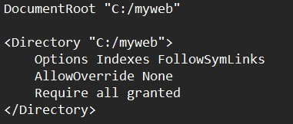

Open C:\Apache24\conf\httpd.conf in Notepad.

Update DocumentRoot to your website folder:

Set the ServerNameto avoid warnings

# Start Apache

Open Command Prompt as Administrator and run:



Open your browser and visit:

http://localhost/ and after that a default apache page would appear

# Add Your Website Files

Place your index.html inside C:\mywebsite.

Refresh http://localhost to see your page.

