

**Placement Empowerment Program**

***Cloud Computing and DevOps Centre***

Automate File Copying with a Script

Create a script to copy files from one folder to

another automatically

Department : IT

**Name:Dashetha**

# Create a Batch Script

Open Notepad and add the following batch :

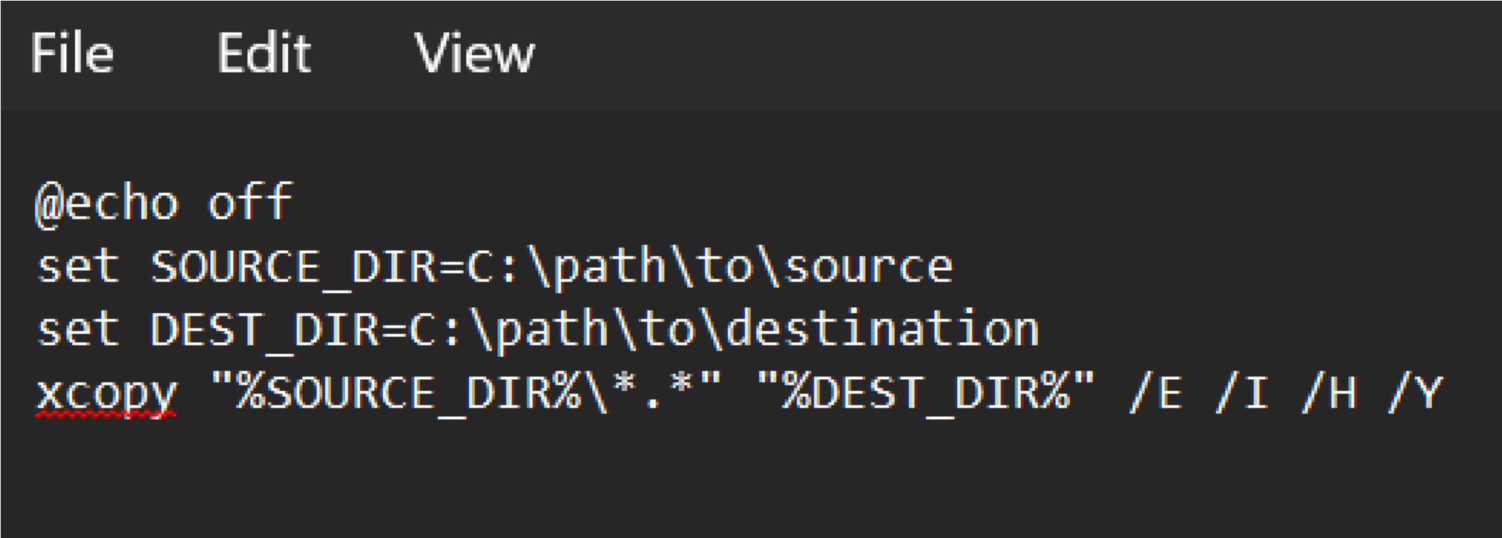

Save as copy_files.bat (Select "All Files" in Save As type).

# Execute the Script Manually

Double-click copy_files.bat to run it.

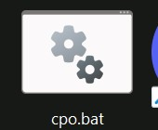

# Automate Using Task Scheduler

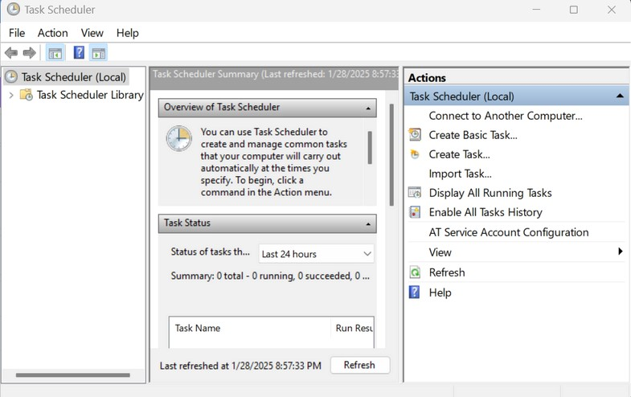

Open Task Scheduler → Click Create Basic Task.

Name: "Copy Files Task" → Click Next. Trigger: Select schedule (e.g., Daily) → ClickNext.

Action: Choose Start a Program → Click Next. Program/script: Browse and select copy_files.bat → Click Finish.

To test, right-click the task → Run.

