

**Placement Empowerment Program**

# Cloud Computing and DevOps Centre

Host a Static Website Locally: Set Up a Local Server Apache and Host a Simple HTML page with your name



**Name:Dashetha.N**

Department : IT



**Introduction to Hosting a Static Website Using Git and Apache**

Version control and web hosting are essential for managing and deploying websites efficiently. By

combining Git for version control and Apache for local hosting, you can create a structured workflow for developing and testing your static website.

**Why Use Git?**

Track changes and maintain a history of your website files.

Restore previous versions if needed.

Collaborate with others efficiently.

**Why Use Apache?**

Host and preview your website locally before deploying.

Serve static files (HTML, CSS, JavaScript) with high performance.

Simulate a real web server environment.

**Workflow Overview**

Set up Apache to serve your static website.

Initialize Git in your website folder to enable version control.

Track changes and commit updates regularly.

Push to a remote repository (like GitHub) if needed.

**Step 1: Install Git (If Not Installed)**

Download Git from [git-scm.com](https://git-scm.com/downloads).

Run the installer and select "Git Bash" and "Git GUI" during installation.

Open Command Prompt (cmd) or Git Bash

and check if Git is installed:bash

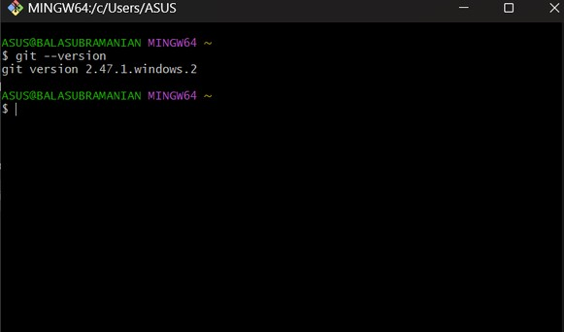

**Step 2: Navigate to Your Website Directory**

Open Command Prompt (cmd) or Git Bash.

Change directory to your website folder:

# Step 3: Initialize the Git Repository

Run the following command to create a Git repository in your website folder:

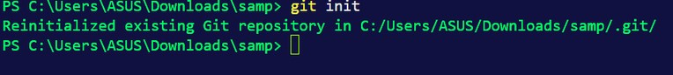

## Step 4: Add Files to the Repository

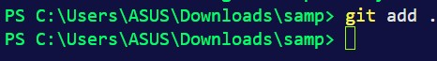

**Step 5 :Commit the Files**

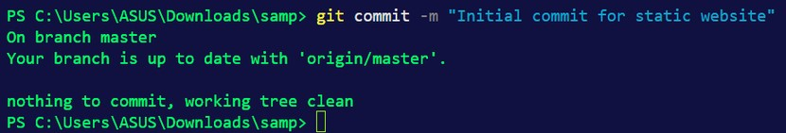

**Step 6: Check the status**

You can check the status of your repository anytime:

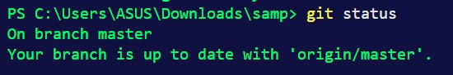

**Step 7: Check Logs:**

