Prog7312 Read me

19013369 Dishani Odayar G1

Varsity College

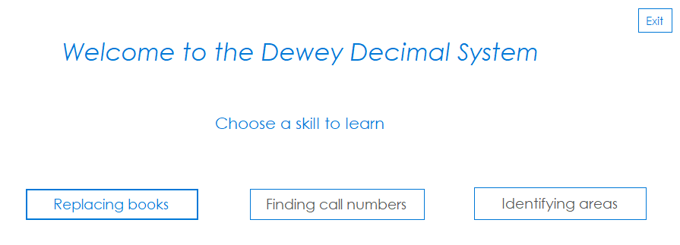

This is the first screen the user sees when running the application. The buttons “Finding call numbers” and “Identifying areas” are disabled thus allowing the users to see the buttons but have no function yet. The user may then click on the “Replacing books” button and be taken to the “Replacing call numbers” form.

The “Exit” button can be clicked at any point in running the application to stop the execution of the program.

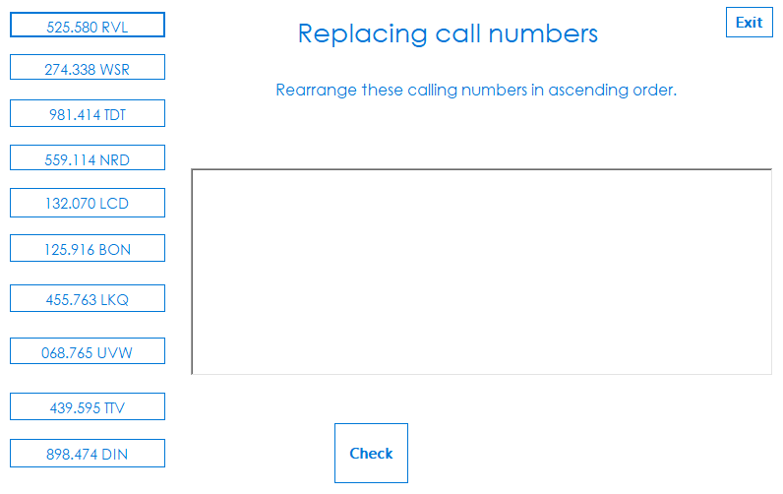Here the user will see the numbers random displayed on buttons on the side, a “Check” button at the bottom and a rich edit box in the middle. The instructions are at the top of the screen below the title of the task. The user needs to tap on the button to select the number and the numbers must be selected in ascending order. All ten numbers must be selected for the task to be completed properly.

The “Exit” button can be clicked at any point in running the application to stop the execution of the program.

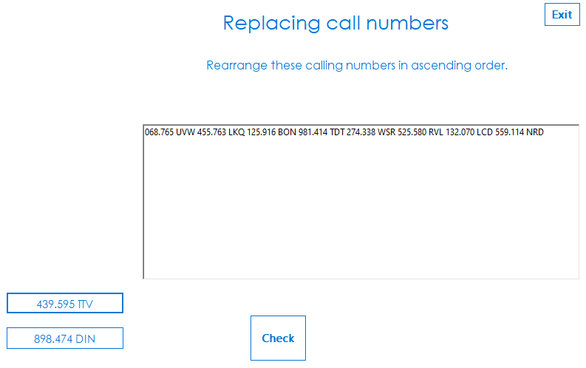

The user will tap on the button with the number and the number that has been tap will be displayed in the rich edit box in the order that user has clicked. Once the button has been tapped, it will no longer be visible to the user, this signifies that the number can only be selected once, and the number selected will be added to a list. The user can at any point click the “Check” button and the list of numbers selected by the user will be check against a list of ascending sorted numbers.

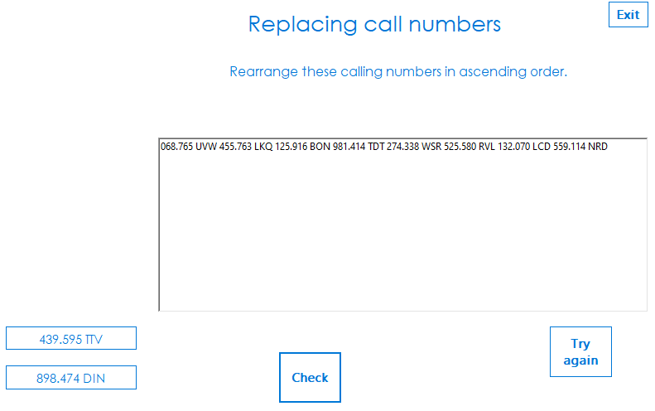

If the user selects the number in the wrong order or does not select all 10 numbers, the user will then be prompted to try again until the user clicks the “Exit” button or until the user is able to select all the numbers in ascending order. The user will be prompted to try again by the appearance of a “Try again” button that will disappear again once the user has correctly sorted the list. Once the user has clicked the “Try again” button a new list of number will be shown, and the rich edit box will be cleared.

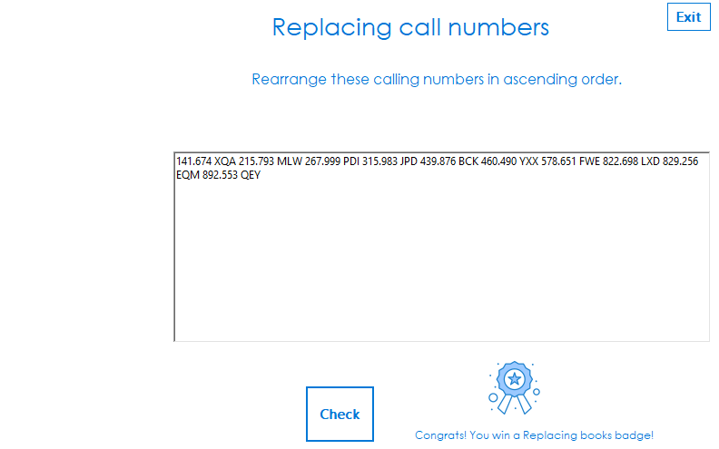

Once the user has selected all 10 numbers and in ascending order, the user will then be awarded a badge to commemorate the task completed and to prove that the skill was learnt. This is made possible by means of the Gamification feature. The user can then click the “Exit” button to stop the application running.