### High-Level Solution Architecture

A very simple diagram showing how the solution will be hosted may be helpful and will be included only if it helps. This isn’t meant to be a plan, only a suggestion of how to proceed or confirmation of what was learned or inferred from the workshop meeting.

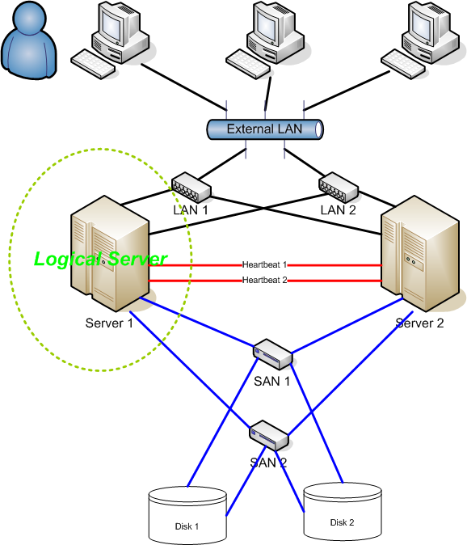

### Mockups

After the workshop meeting, the development team will consider the solution and may make some very preliminary mockups based on what they learned.

