**Project Title: Customized animation of satellite images over the internet**

**Team: X-GEN**

The source code is available in a public repository link: <https://bitbucket.org/ShreedaS/sih2018>

This project aims to develop an efficient mechanism to view an animation of time series of satellite photos as per user's requirement. User can choose the start and end time / date and the required interval and is able to visualize its animation over the internet with different speeds. The project is an user-end application of the gathered images from a satellite in a user friendly way for further analysis.

To enhance the user experience as well as to cater different user requirements, we have provided key features namely,

**a) Speed of animation: As per user’s requirements,** we provide 4 speeds of animation of 1 fps, 2 fps, 4 fps, 8 fps. This option has to be provided by the user before viewing the animation.

**b) Video quality:** As per internet speed availability, we provide 4 video resolutions of 360p, 720p, 1080p, 1440p. This option has to be provided by the user before viewing the animation.

**c) Seamless transition between two images:** It uses morphing techniques if the images are more than 30 minutes apart resulting in a seamless transition between the images. The morphing technique can easily be changed as per the image contents to cater different purposes.

Use-case: In case of the unexpected circumstances, it may happen that some images may not be received at all. In that case, the software creates new images using image blending, thus predicting the nature of the missing images and using them to produce smooth animation.

**d) Animation using selective images:** This is useful for viewing the images at the specific time of the day to study the change in pattern.

e.g. If the interval is set to 24 hours, the effects of sunlight or temperature can be studied at a particular time of the day(say 12 pm)

Note: The minimum and default interval is selected is 30 minutes as the satellites selected for demonstration (as per the dataset received) sent images every 30 minutes.

**GrazerFeed settings:**

For this example, the following settings have been configured as per the Readme.

Readme link: <https://bitbucket.org/ShreedaS/sih2018/src/default/README.md>

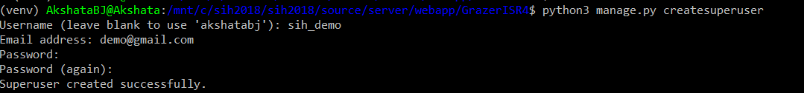

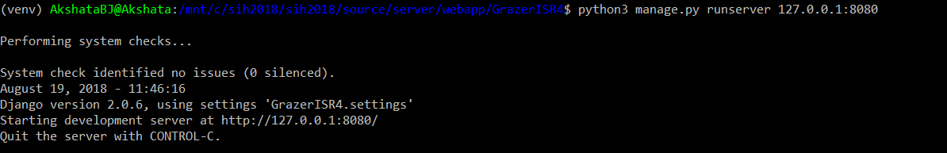

GrazerFeed User Interface:

1) LoginPage:

url: 127.0.0.1:8080/GrazerFeed/Login

These are the credentials of the super user created as per the Readme of the repository.

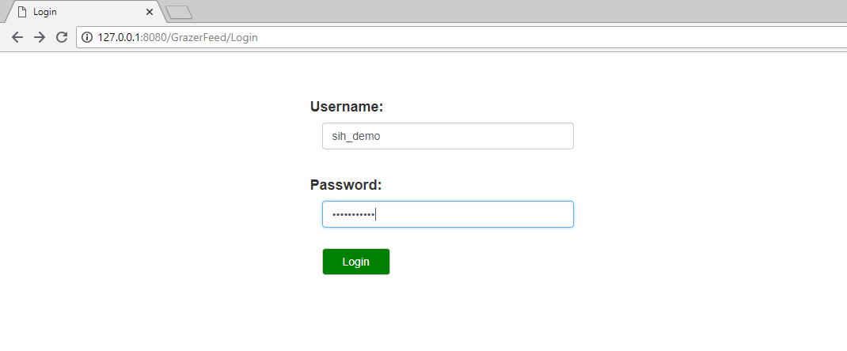

2) OptionsPage:

url: 127.0.0.1:8080/GrazerFeed/Options

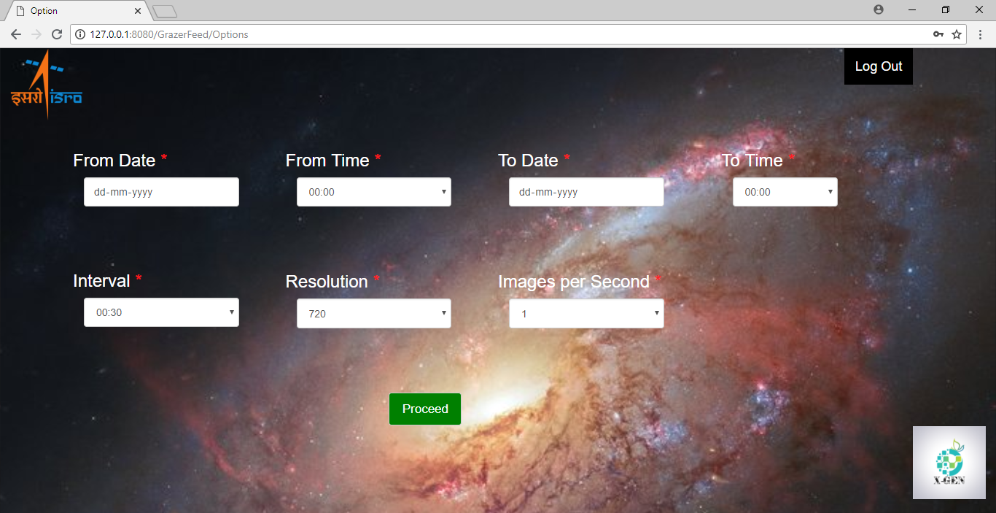

**From Date and From Time fields:** This represents the start date and time.

**To Date and To Time fields:** This represents the end date and time.

**Interval:** The interval field is used to select the time-gap between two images. This is explained above in the key feature “Animation using selective images”.

**Resolution and Images per second:** This represents the required resolution and speed to be selected from the options for the animation.

Note: From Date and To Date values cannot be in future.

3) Animation:

This displays the animation based on previous selected options. It has all basic video player options.

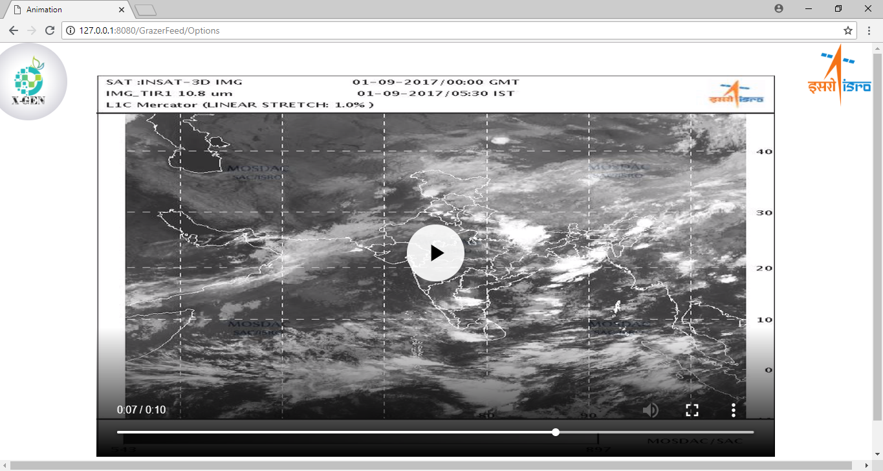

**Technology stack:**

Linux( Ubuntu)

postgresql database server

Python 3.5

Django 2.10

FFmpeg

pillow

psycopg2-binary

numpy

requests

moviepy

watchdog

whitenoise