**Project 2**

**Airport Stimulation**

班级： 2015级教务三班

姓名： 罗剑杰 学号：15331229

姓名： 卢健彬 学号：15331225

姓名： 刘俊君 学号：15331214

姓名： 卢童杰 学号：15331226

**【题目要求】**

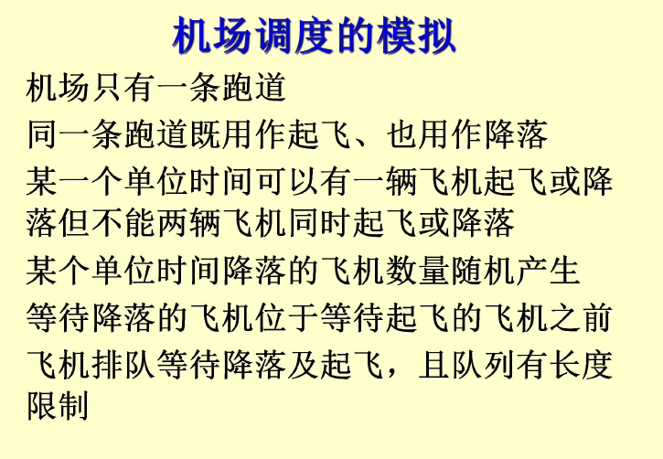

[图1]

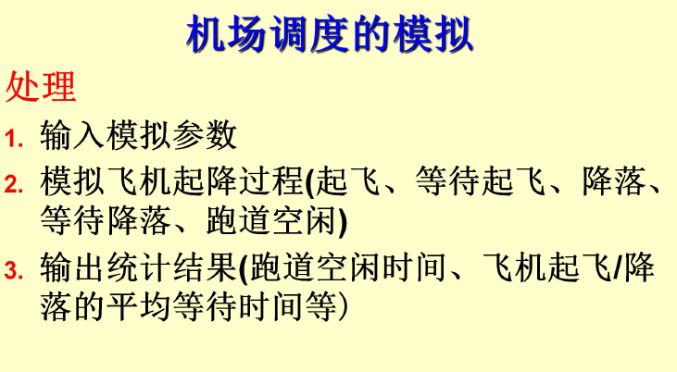

[图2]

P1.将所有用于飞机场模拟的函数与方法组合成一个完整的程序。用飞机场模拟程序做若干次试运行实验，调整准备着陆和起飞的飞机数的期望值，并找出在飞机不会被拒绝服务的条件下这些数字的尽可能大的近似值。如果队列的长度增加或减少，那么这些值将会有什么变化？

P2.修改模拟程序，使飞机场有两条飞机跑道，其中一条总是用于着陆，另一条总是用于起飞。比较双跑道机场能服务的总飞机数和单条飞机跑道的飞机场的相应数字，前者是否是后者的两倍？

P3.修改模拟程序，使飞机场有两条飞机跑道，其中一条总是用于着陆，；另一条总是用于起飞。如果某个队列是空的，那么两条跑道都能用于其他的队列。如果着陆队列总是满足的并且另一架飞机要到达着陆，那么将停止起飞，并将两条跑道都用于清理搁置的着陆飞机。

P4.修改模拟程序，使飞机场有3条飞机跑道，其中各保留一条总用于着陆和起飞，第三条用于着陆，但在着陆队列为空的情况下，第三条亦可用于起飞。

P5.修改最初的模拟程序（单条跑道），使得当每架飞机到达着陆时，它将有（作为它的数据成员的）一个（随机产生的）油位，以剩余的时间单元度量。如果飞机没有足够的油位在队列中等待，则允许它立即着陆。因此着陆队列里的飞机可能需要再等待附加的单元，因此可能用完自身燃料。作为着陆函数的一部分检查这一点，并且查明在飞机由于燃料用尽而开始坠毁前机场有多忙。

P6.写一个占位程序来代替随机数函数，这个占位函数既能用于调试程序又允许用户正确地控制每一个时间单元内每个队列到达的飞机数。

**【数据结构与算法】**

1.Extended_Queue: 采用循环数组加上模板template来实现队列，缺点是队列长度定长为500，然后一开始就分配好了内存导致可能数据量少的时候内存开销比较大。

2.Plane，主要按照书本上的数据结构

3.Random，采用泊淞分布，具体的结构如下:

**#include <cmath>**

**class Random {**

**public:**

**Random() {}**

**Random(bool pseudo = true);**

**double random_real();**

**int poisson(double mean);**

**~Random() {}**

**private:**

**int reseed();**

**int seed, multiplier, add_on;**

**};**

4. Runway类

P1,2,3,4,6都使用的是书本上的数据结构，

P5使用的是改造后的Runway 的类，结构上多加了一个方法before_crash(）

1. **各个题目的算法流程图：**

P1: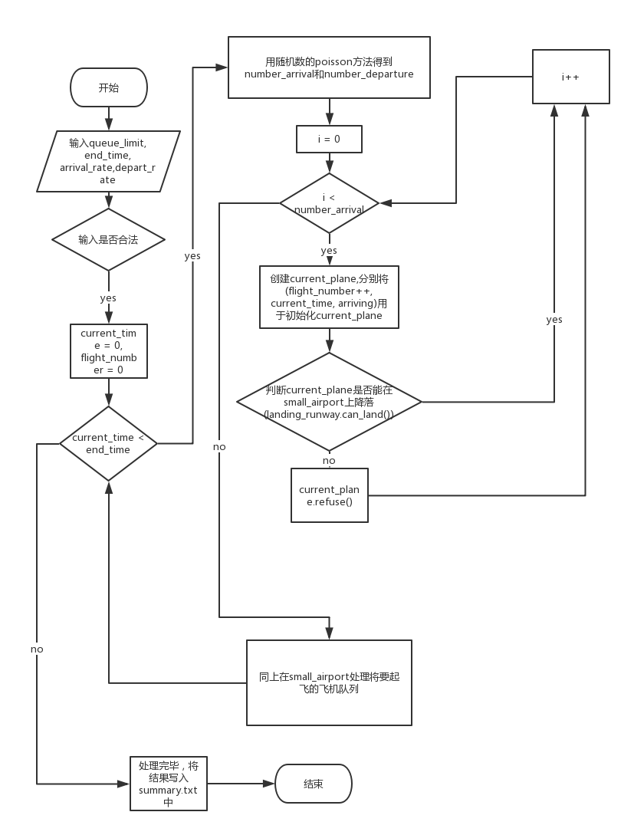

[图3]

P2:

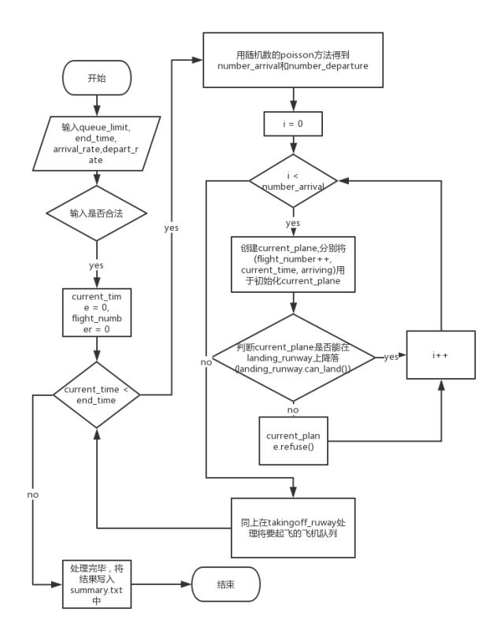

[图4]

P3:

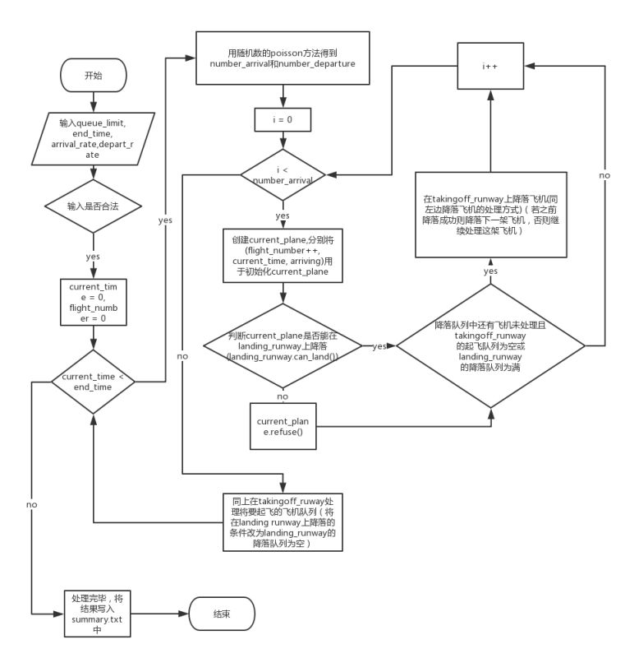

[图5]

P4:

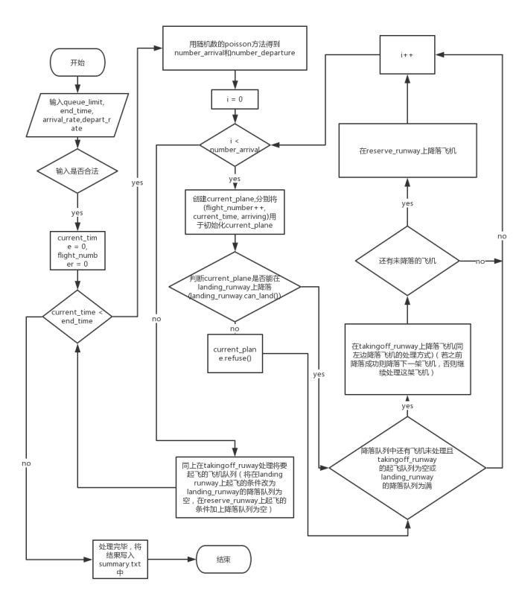

[图6]

P5:

开始

运行initialize函数，输入queue_limit,end_time等参数

current_time = 0

current_time > end_time?

打印机场运行信息，输出到文件流

结束程序

enmergency = false，用于判断飞机是否处于危机情况

飞机处于紧急情况？

moving_plane = current_plane

等待降落的飞机进入等待队列，队列已满则拒绝

等待起飞的飞机进入起飞队列，队列已满则拒绝

飞机是否紧急降落

调用activity

返回结果是否为land

飞机降落

返回结果是否为takeoff

飞机起飞

机场空闲

让飞机紧急降落

current_time++

判断输入参数是否合法

否

是

是

否

是

否

否

是

是

否

是

否

[图7]

开始

运行initialize函数，输入queue_limit,end_time等参数

current_time = 0

current_time > end_time?

打印机场运行信息，输出到文件流

结束程序

用户输入要求进入降落队列的飞机数，队满则拒绝

用户输入要求进入起飞队列的飞机数，队满则拒绝

调用activity

返回结果是否为land

飞机降落

返回结果是否为takeoff

飞机起飞

机场空闲

current_time++

判断输入参数是否合法

否

是

是

否

是

否

是

否

用版水印

P6:

[图8]

**【测试数据，结果及分析】**

测试数据及分析：（具体调度过程在控制台中输出，当使用大量数据的时候控制台输出的具体调度数目会很大，在此处p1-p5调度截图作部分，截图的是输出至summary.txt文件中的统计信息）

**P1:**

**开始运行：**

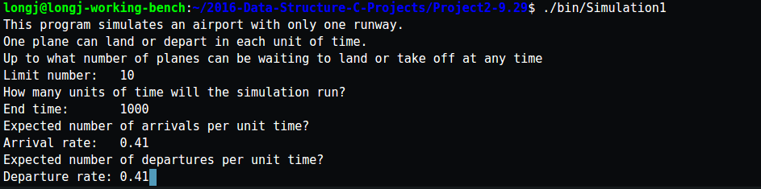

[图9]

**部分调度输出：**

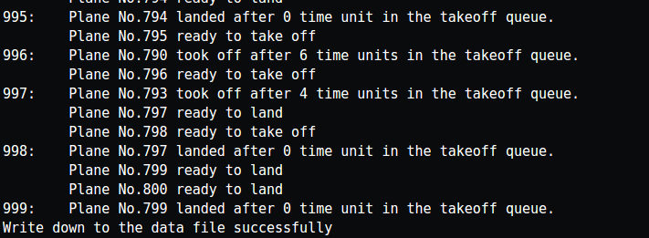

[图10]

**统计结果输出：**

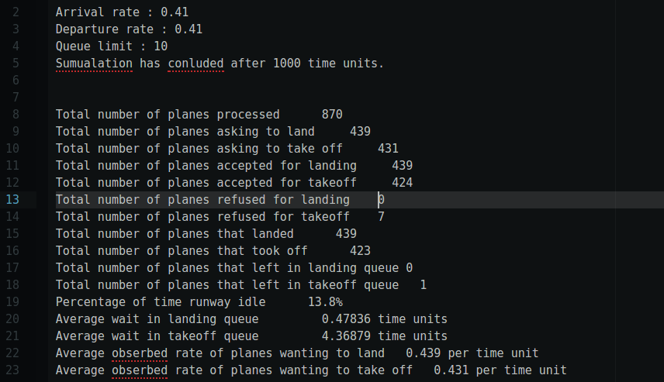

[图11]

多组数据测试直接复制输出通知结果summary.txt的内容：

Arrival rate : 0.4

Departure rate : 0.4

Queue limit : 10

Sumualation has conluded after 1000 time units.

Total number of planes processed 806

Total number of planes asking to land 379

Total number of planes asking to take off 427

Total number of planes accepted for landing 379

Total number of planes accepted for takeoff 427

Total number of planes refused for landing 0

Total number of planes refused for takeoff 0

Total number of planes that landed 379

Total number of planes that took off 427

Total number of planes that left in landing queue 0

Total number of planes that left in takeoff queue 0

Percentage of time runway idle 19.4%

Average wait in landing queue 0.23219 time units

Average wait in takeoff queue 3.73536 time units

Average obserbed rate of planes wanting to land 0.379 per time unit

Average obserbed rate of planes wanting to take off 0.427 per time unit

Arrival rate : 0.4

Departure rate : 0.4

Queue limit : 5

Sumualation has conluded after 1000 time units.

Total number of planes processed 777

Total number of planes asking to land 391

Total number of planes asking to take off 386

Total number of planes accepted for landing 391

Total number of planes accepted for takeoff 375

Total number of planes refused for landing 0

Total number of planes refused for takeoff 11

Total number of planes that landed 391

Total number of planes that took off 375

Total number of planes that left in landing queue 0

Total number of planes that left in takeoff queue 0

Percentage of time runway idle 23.4%

Average wait in landing queue 0.286445 time units

Average wait in takeoff queue 2.26133 time units

Average obserbed rate of planes wanting to land 0.391 per time unit

Average obserbed rate of planes wanting to take off 0.386 per time unit

Arrival rate : 0.35

Departure rate : 0.35

Queue limit : 5

Sumualation has conluded after 1000 time units.

Total number of planes processed 665

Total number of planes asking to land 330

Total number of planes asking to take off 335

Total number of planes accepted for landing 330

Total number of planes accepted for takeoff 324

Total number of planes refused for landing 0

Total number of planes refused for takeoff 11

Total number of planes that landed 329

Total number of planes that took off 324

Total number of planes that left in landing queue 1

Total number of planes that left in takeoff queue 0

Percentage of time runway idle 34.7%

Average wait in landing queue 0.24924 time units

Average wait in takeoff queue 1.73765 time units

Average obserbed rate of planes wanting to land 0.33 per time unit

Average obserbed rate of planes wanting to take off 0.335 per time unit

Arrival rate : 0.32

Departure rate : 0.32

Queue limit : 5

Sumualation has conluded after 1000 time units.

Total number of planes processed 606

Total number of planes asking to land 311

Total number of planes asking to take off 295

Total number of planes accepted for landing 311

Total number of planes accepted for takeoff 295

Total number of planes refused for landing 0

Total number of planes refused for takeoff 0

Total number of planes that landed 311

Total number of planes that took off 295

Total number of planes that left in landing queue 0

Total number of planes that left in takeoff queue 0

Percentage of time runway idle 39.4%

Average wait in landing queue 0.199357 time units

Average wait in takeoff queue 0.857627 time units

Average obserbed rate of planes wanting to land 0.311 per time unit

Average obserbed rate of planes wanting to take off 0.295 per time unit

Arrival rate : 0.4

Departure rate : 0.4

Queue limit : 20

Sumualation has conluded after 1000 time units.

Total number of planes processed 780

Total number of planes asking to land 397

Total number of planes asking to take off 383

Total number of planes accepted for landing 397

Total number of planes accepted for takeoff 383

Total number of planes refused for landing 0

Total number of planes refused for takeoff 0

Total number of planes that landed 397

Total number of planes that took off 383

Total number of planes that left in landing queue 0

Total number of planes that left in takeoff queue 0

Percentage of time runway idle 22%

Average wait in landing queue 0.392947 time units

Average wait in takeoff queue 4.93734 time units

Average obserbed rate of planes wanting to land 0.397 per time unit

Average obserbed rate of planes wanting to take off 0.383 per time unit

Arrival rate : 0.45

Departure rate : 0.45

Queue limit : 20

Sumualation has conluded after 1000 time units.

Total number of planes processed 940

Total number of planes asking to land 452

Total number of planes asking to take off 488

Total number of planes accepted for landing 452

Total number of planes accepted for takeoff 487

Total number of planes refused for landing 0

Total number of planes refused for takeoff 1

Total number of planes that landed 452

Total number of planes that took off 471

Total number of planes that left in landing queue 0

Total number of planes that left in takeoff queue 16

Percentage of time runway idle 7.7%

Average wait in landing queue 0.49115 time units

Average wait in takeoff queue 11.3673 time units

Average obserbed rate of planes wanting to land 0.452 per time unit

Average obserbed rate of planes wanting to take off 0.488 per time unit

Arrival rate : 0.44

Departure rate : 0.44

Queue limit : 20

Sumualation has conluded after 1000 time units.

Total number of planes processed 901

Total number of planes asking to land 415

Total number of planes asking to take off 486

Total number of planes accepted for landing 415

Total number of planes accepted for takeoff 486

Total number of planes refused for landing 0

Total number of planes refused for takeoff 0

Total number of planes that landed 415

Total number of planes that took off 486

Total number of planes that left in landing queue 0

Total number of planes that left in takeoff queue 0

Percentage of time runway idle 9.9%

Average wait in landing queue 0.322892 time units

Average wait in takeoff queue 5.97737 time units

Average obserbed rate of planes wanting to land 0.415 per time unit

Average obserbed rate of planes wanting to take off 0.486 per time unit

Arrival rate : 0.44

Departure rate : 0.44

Queue limit : 20

Sumualation has conluded after 1000 time units.

Total number of planes processed 908

Total number of planes asking to land 419

Total number of planes asking to take off 489

Total number of planes accepted for landing 419

Total number of planes accepted for takeoff 489

Total number of planes refused for landing 0

Total number of planes refused for takeoff 0

Total number of planes that landed 419

Total number of planes that took off 488

Total number of planes that left in landing queue 0

Total number of planes that left in takeoff queue 1

Percentage of time runway idle 9.3%

Average wait in landing queue 0.288783 time units

Average wait in takeoff queue 5.97951 time units

Average obserbed rate of planes wanting to land 0.419 per time unit

Average obserbed rate of planes wanting to take off 0.489 per time unit

Arrival rate : 0.44

Departure rate : 0.44

Queue limit : 20

Sumualation has conluded after 1000 time units.

Total number of planes processed 811

Total number of planes asking to land 412

Total number of planes asking to take off 399

Total number of planes accepted for landing 412

Total number of planes accepted for takeoff 399

Total number of planes refused for landing 0

Total number of planes refused for takeoff 0

Total number of planes that landed 411

Total number of planes that took off 399

Total number of planes that left in landing queue 1

Total number of planes that left in takeoff queue 0

Percentage of time runway idle 19%

Average wait in landing queue 0.270073 time units

Average wait in takeoff queue 3.64662 time units

Average obserbed rate of planes wanting to land 0.412 per time unit

Average obserbed rate of planes wanting to take off 0.399 per time unit

Arrival rate : 0.45

Departure rate : 0.45

Queue limit : 40

Sumualation has conluded after 1000 time units.

Total number of planes processed 887

Total number of planes asking to land 442

Total number of planes asking to take off 445

Total number of planes accepted for landing 442

Total number of planes accepted for takeoff 445

Total number of planes refused for landing 0

Total number of planes refused for takeoff 0

Total number of planes that landed 442

Total number of planes that took off 445

Total number of planes that left in landing queue 0

Total number of planes that left in takeoff queue 0

Percentage of time runway idle 11.3%

Average wait in landing queue 0.373303 time units

Average wait in takeoff queue 7.46966 time units

Average obserbed rate of planes wanting to land 0.442 per time unit

Average obserbed rate of planes wanting to take off 0.445 per time unit

Arrival rate : 0.48

Departure rate : 0.48

Queue limit : 40

Sumualation has conluded after 1000 time units.

Total number of planes processed 943

Total number of planes asking to land 466

Total number of planes asking to take off 477

Total number of planes accepted for landing 466

Total number of planes accepted for takeoff 477

Total number of planes refused for landing 0

Total number of planes refused for takeoff 0

Total number of planes that landed 465

Total number of planes that took off 473

Total number of planes that left in landing queue 1

Total number of planes that left in takeoff queue 4

Percentage of time runway idle 6.2%

Average wait in landing queue 0.447312 time units

Average wait in takeoff queue 11.0909 time units

Average obserbed rate of planes wanting to land 0.466 per time unit

Average obserbed rate of planes wanting to take off 0.477 per time unit

Arrival rate : 0.49

Departure rate : 0.49

Queue limit : 40

Sumualation has conluded after 1000 time units.

Total number of planes processed 938

Total number of planes asking to land 446

Total number of planes asking to take off 492

Total number of planes accepted for landing 446

Total number of planes accepted for takeoff 492

Total number of planes refused for landing 0

Total number of planes refused for takeoff 0

Total number of planes that landed 446

Total number of planes that took off 477

Total number of planes that left in landing queue 0

Total number of planes that left in takeoff queue 15

Percentage of time runway idle 7.7%

Average wait in landing queue 0.38565 time units

Average wait in takeoff queue 17.6834 time units

Average obserbed rate of planes wanting to land 0.446 per time unit

Average obserbed rate of planes wanting to take off 0.492 per time unit

Arrival rate : 0.495

Departure rate : 0.495

Queue limit : 40

Sumualation has conluded after 1000 time units.

Total number of planes processed 984

Total number of planes asking to land 483

Total number of planes asking to take off 501

Total number of planes accepted for landing 483

Total number of planes accepted for takeoff 501

Total number of planes refused for landing 0

Total number of planes refused for takeoff 0

Total number of planes that landed 483

Total number of planes that took off 497

Total number of planes that left in landing queue 0

Total number of planes that left in takeoff queue 4

Percentage of time runway idle 2%

Average wait in landing queue 0.507246 time units

Average wait in takeoff queue 13.8793 time units

Average obserbed rate of planes wanting to land 0.483 per time unit

Average obserbed rate of planes wanting to take off 0.501 per time unit

Arrival rate : 0.497

Departure rate : 0.497

Queue limit : 40

Sumualation has conluded after 1000 time units.

Total number of planes processed 997

Total number of planes asking to land 498

Total number of planes asking to take off 499

Total number of planes accepted for landing 498

Total number of planes accepted for takeoff 499

Total number of planes refused for landing 0

Total number of planes refused for takeoff 0

Total number of planes that landed 498

Total number of planes that took off 484

Total number of planes that left in landing queue 0

Total number of planes that left in takeoff queue 15

Percentage of time runway idle 1.8%

Average wait in landing queue 0.439759 time units

Average wait in takeoff queue 21.905 time units

Average obserbed rate of planes wanting to land 0.498 per time unit

Average obserbed rate of planes wanting to take off 0.499 per time unit

Arrival rate : 0.499

Departure rate : 0.499

Queue limit : 40

Sumualation has conluded after 1000 time units.

Total number of planes processed 967

Total number of planes asking to land 515

Total number of planes asking to take off 452

Total number of planes accepted for landing 515

Total number of planes accepted for takeoff 452

Total number of planes refused for landing 0

Total number of planes refused for takeoff 0

Total number of planes that landed 514

Total number of planes that took off 449

Total number of planes that left in landing queue 1

Total number of planes that left in takeoff queue 3

Percentage of time runway idle 3.7%

Average wait in landing queue 0.468872 time units

Average wait in takeoff queue 22.5657 time units

Average obserbed rate of planes wanting to land 0.515 per time unit

Average obserbed rate of planes wanting to take off 0.452 per time unit

**分析和结论：结论：“在调度时间相同的情况下，当队列长度越长，准备着陆和起飞的飞机数的期望值相应增加，但两者不成线性关系”**

**P2:**

**运行截图：**

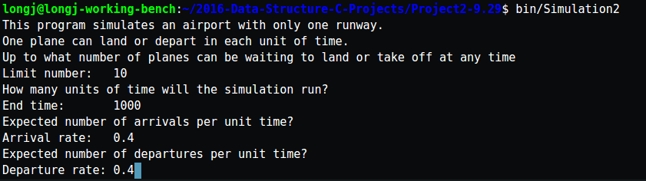

[图12]

**部分调度信息输出结果**：

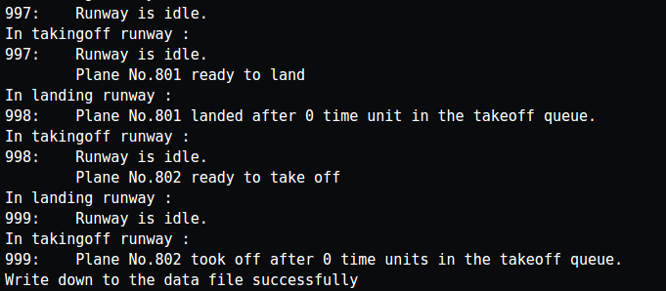

[图13]

**summery.txt数据收集：**

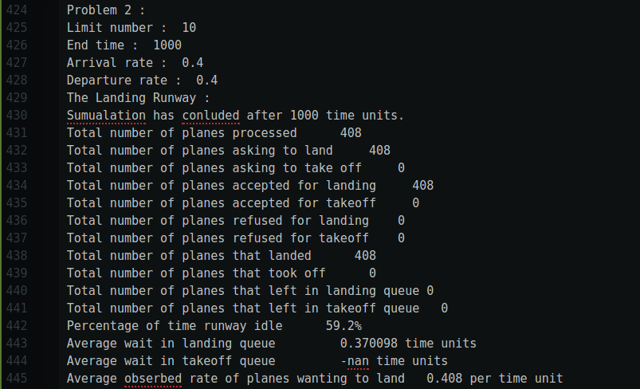

[图14]

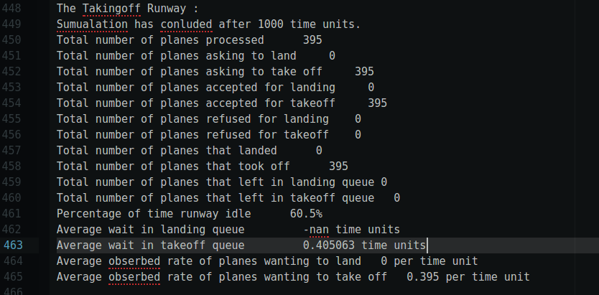

[图15]

**结果分析：通过比较发现，前者并不是后者的简单的两倍关系**

P3:

运行输入：

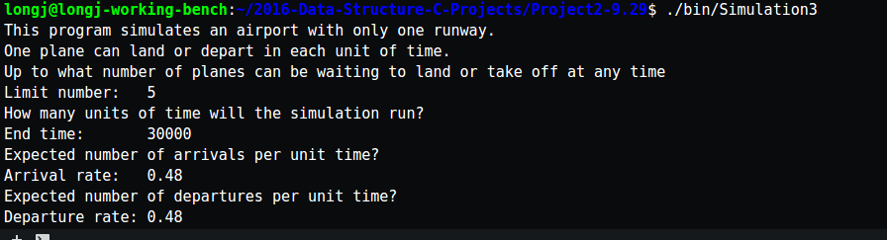

[图16]

部分调度输出：

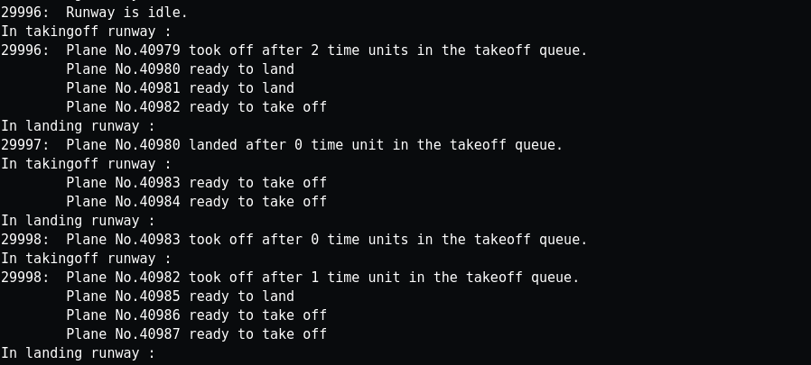

[图17]

Summery.txt 统计结果：

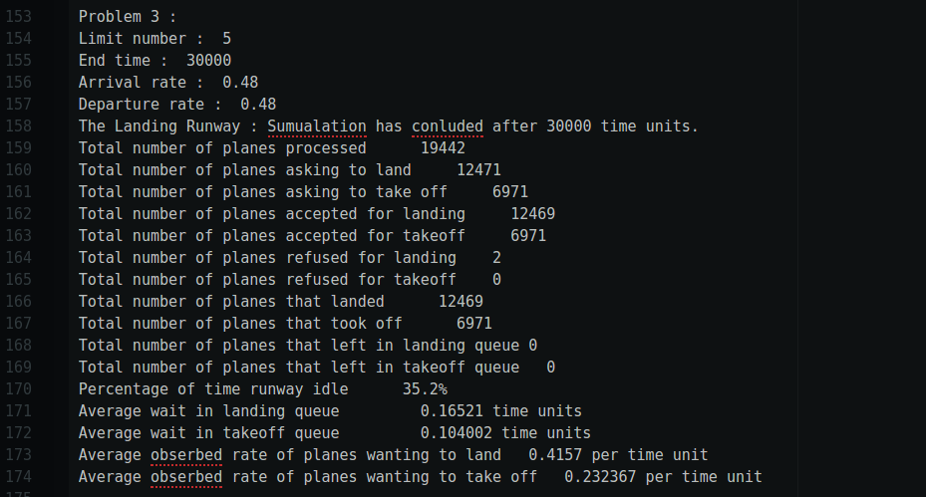

[图18]

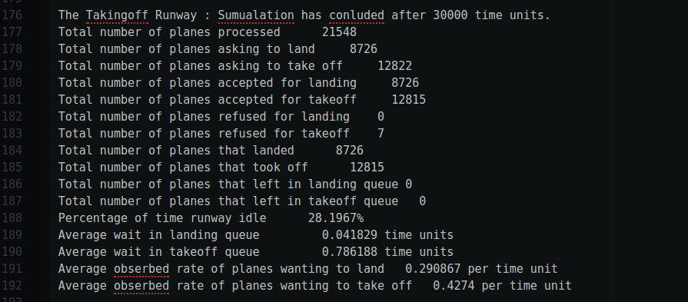

[图19]

P4:

运行输入：

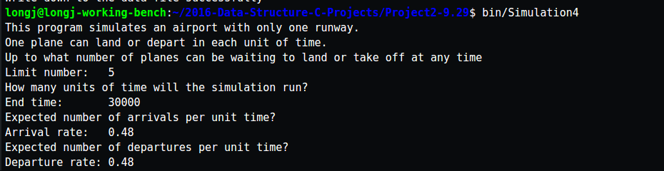

[图20]

部分调度输出：

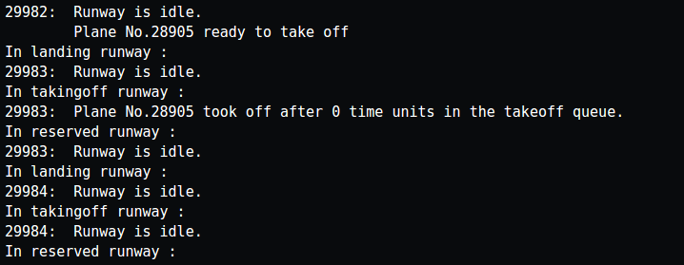

[图21]

Summery.txt统计结果

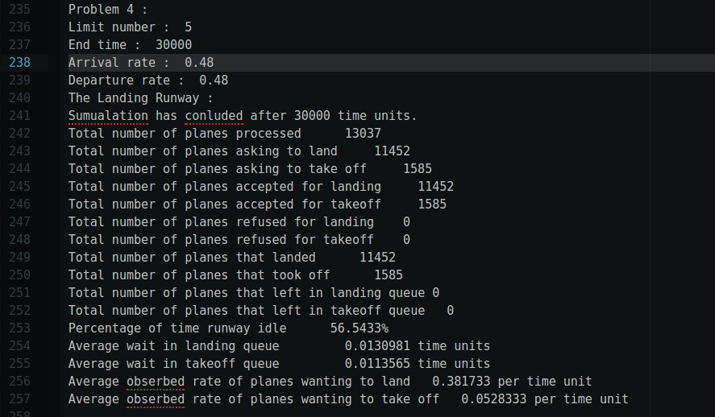

[图22]

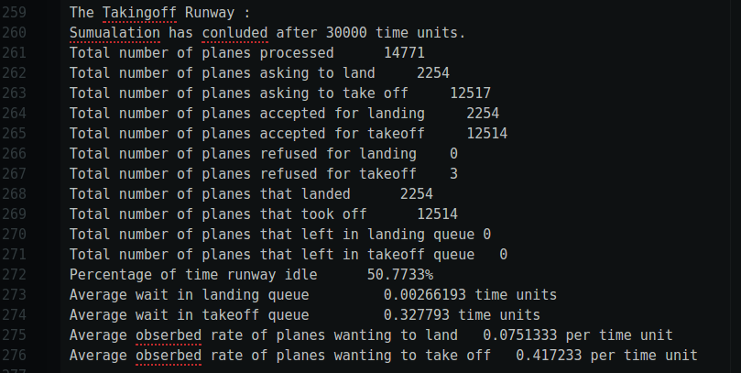

[图23]

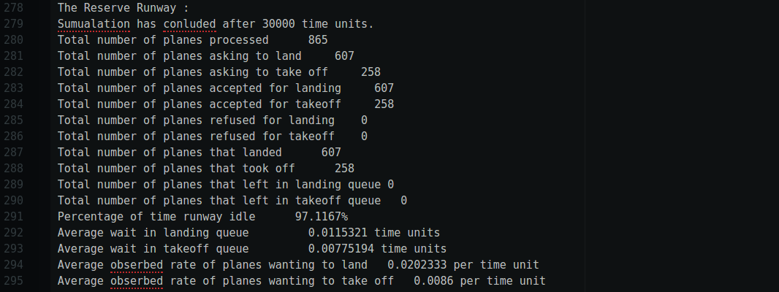

[图24]

P5:

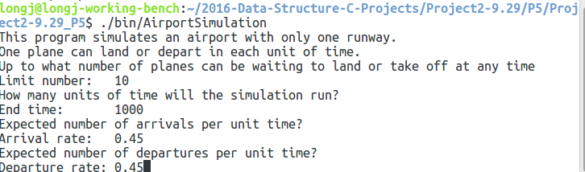

[图25]

输出的数据：

This is the situation before the plane crash

Total number of planes processed 15

Percentage of time runway idle 33.3333%

0.277778 per time unit

This is the situation before the plane crash

Total number of planes processed 93

Percentage of time runway idle 17.6471%

0.441176 per time unit

This is the situation before the plane crash

Total number of planes processed 116

Percentage of time runway idle 14.876%

0.471074 per time unit

This is the situation before the plane crash

Total number of planes processed 233

Percentage of time runway idle 14.1762%

0.467433 per time unit

This is the situation before the plane crash

Total number of planes processed 246

Percentage of time runway idle 13.6029%

0.474265 per time unit

This is the situation before the plane crash

Total number of planes processed 275

Percentage of time runway idle 12.7036%

0.465798 per time unit

This is the situation before the plane crash

Total number of planes processed 294

Percentage of time runway idle 12.5382%

0.458716 per time unit

This is the situation before the plane crash

Total number of planes processed 296

Percentage of time runway idle 12.462%

0.458967 per time unit

This is the situation before the plane crash

Total number of planes processed 403

Percentage of time runway idle 16.0338%

0.424051 per time unit

This is the situation before the plane crash

Total number of planes processed 412

Percentage of time runway idle 15.8004%

0.428274 per time unit

This is the situation before the plane crash

Total number of planes processed 464

Percentage of time runway idle 15.0838%

0.43203 per time unit

This is the situation before the plane crash

Total number of planes processed 467

Percentage of time runway idle 15%

0.42963 per time unit

This is the situation before the plane crash

Total number of planes processed 592

Percentage of time runway idle 13.6228%

0.435629 per time unit

This is the situation before the plane crash

Total number of planes processed 627

Percentage of time runway idle 13.1837%

0.436185 per time unit

This is the situation before the plane crash

Total number of planes processed 630

Percentage of time runway idle 13.1653%

0.438375 per time unit

This is the situation before the plane crash

Total number of planes processed 672

Percentage of time runway idle 13.8961%

0.432468 per time unit

This is the situation before the plane crash

Total number of planes processed 753

Percentage of time runway idle 12.6478%

0.449173 per time unit

This is the situation before the plane crash

Total number of planes processed 769

Percentage of time runway idle 12.3843%

0.451389 per time unit

This is the situation before the plane crash

Total number of planes processed 884

Percentage of time runway idle 11.1452%

0.4591 per time unit

This is the situation before the plane crash

Total number of planes processed 886

Percentage of time runway idle 11.1338%

0.459653 per time unit

This is the total situation :

Sumualation has conluded after 1000 time units.

Queue limit : 10

Arrival rate & departure rate : 0.45

Total number of planes processed 898

Total number of planes asking to land 441

Total number of planes asking to take off 457

Total number of planes accepted for landing 441

Total number of planes accepted for takeoff 450

Total number of planes refused for landing 0

Total number of planes refused for takeoff 7

Total number of planes that landed 441

Total number of planes that took off 450

Total number of planes that left in landing queue 0

Total number of planes that left in takeoff queue 0

Percentage of time runway idle 10.9%

Average wait in landing queue 0.419501 time units

Average wait in takeoff queue 6.70667 time units

Average obserbed rate of planes wanting to land 0.441 per time unit

Average obserbed rate of planes wanting to take off 0.457 per time unit

The plane that crashed : 20

**分析和结论：从第一辆坠毁的飞机到最后一辆坠毁的飞机，飞机场的忙碌程度越来约接近飞机场的总体忙碌情况。**

P6:

运行的整体过程：

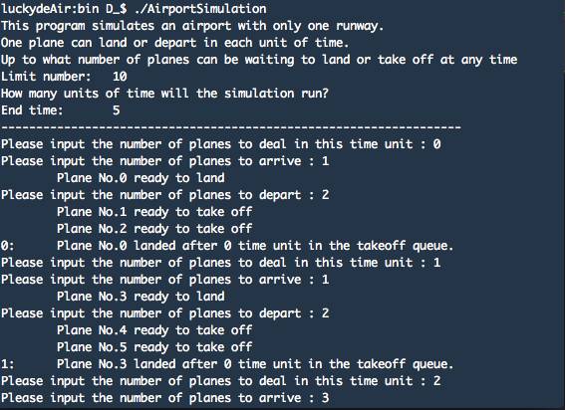

[图26]

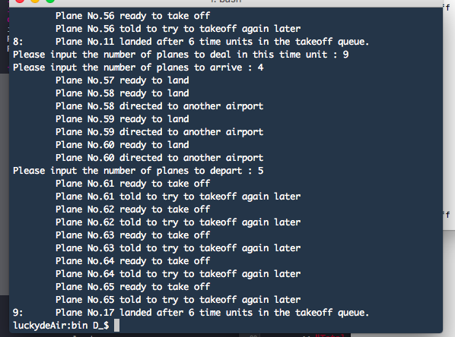

[图27]

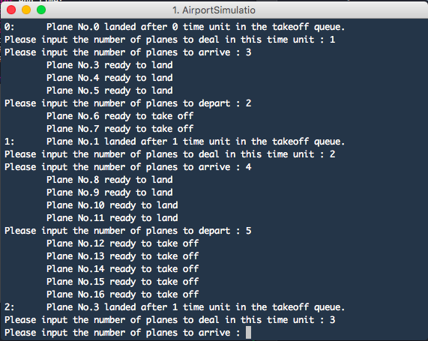

[图28]

**可以看到，实现了占位程序的控制**

**【分工、贡献%、自我评分】**

刘俊君：负责书本初始代码的录入，负责p1的数据模拟, p5,p6的实现和数据 的拟，负责Randon随机数生成器的实现

卢健彬：负责p2, p3, p4 的代码修改，负责实现输出结果转文件流的方法

罗剑杰：负责实现底层基础的queue的代码，负责管理项目文件结构处理，负责 makefile的书写，全局修改初始文件使得整个项目可以跑起来，负责项 目程序输出的需求与改进，负责实验报告

卢童杰：参与开始的project讨论，完成实验报告的部分文字录入

**贡献%： 刘俊君35%，卢健彬30%，罗剑杰：30%，卢童杰：5%**

自我评分：87

**【项目总结】**

**完成情况：**可以成功实现所有的题目要求，可以达到成功模拟的效果。

**开发过程中的优点及收获：**

1. 有进一步优化代码规范，在开发之前开发者之间统一了代码文件的风格，给协同开发带来了阅读的方便性
2. 重新学习了random产生随机数的方法实现
3. 学会Makefile统筹6个有耦合的文件
4. Makefile编译templat动态模板的语法问题得到解决
5. 使用文件输出流完成了统计结果的永久化叠加储存，为以后的数据分析提供了方便

**开发过程中的不足及以后要改进的：**

1. 思考了很多关于实现上的逻辑细节，发现在原有的数据结构的基础上有一些现实上的逻辑很难实现，限于时间关系没有办法能够赶上重构书本上的代码使其变得更加容易扩展
2. Git的使用还是非常不熟练，开发者之间使用github协同开发的时候没有养成良好的开发习惯，导致在版本合并的过程中浪费了很多时间
3. 鉴于小组人员的知识有限，还是没有办法优化project的输出界面，比如说没有实现图形界面，也没有实现具体调度的动画实现，只是实现了调度记录的输出和调度统计记录的永久化存储，争取下一次再实现。
4. 没有找到方法测试在极大数据的情况下调度情况的正确性，在小数据的测试中可以通过
5. 时间和知识水平的局限导致没有办法实现对每一个类使用独立的gtest测试，争取下次做到。
6. 在初始实现的版本下，为了巩固自己不熟悉的循环队列，在底层使用了循环队列，这样的数据结构其实是不太好的，一开始就分配好了空间，而且队列数组里面的元素是class，非常耗费内存，而且可扩展性并不强。最好的实现应该是轧成使用链式的队列。
7. 在实际写实验报告的过程中发现，我们现在的输出是非常不利于读者去看到数据之间的联系关系的，我们一开始的关注点在每一次输出的信息完备，而没有考虑到叠加多次模拟后的数据统计的方便性，意识到这一点的时候时间已经不够用了，而且负责这个部分的同学也是从不太友好的输出中总结出了规律，这个我们下次一定要改正。

**【程序清单】**

├── data

│   └── summary.txt

├── include

│   ├── enum.hpp

│   ├── Extended_queue.hpp

│   ├── Plane.hpp

│   ├── Random.hpp

│   └── Runway.hpp

├── Makefile

├── P5_only

│   └── Project2-9.29_P5

│   ├── data

│   │   └── summary_p5.txt

│   ├── include

│   │   ├── enum.hpp

│   │   ├── Extended_queue.hpp

│   │   ├── Plane.hpp

│   │   ├── Random.hpp

│   │   └── Runway.hpp

│   ├── Makefile

│   ├── p1_p5_p6.md

│   ├── src

│   │   ├── Extended_queue.cpp

│   │   ├── main.cpp

│   │   ├── Plane.cpp

│   │   ├── Random.cpp

│   │   └── Runway.cpp

│   └── Todo.md

├── Project 2.docx

├── src

│   ├── Extended_queue.cpp

│   ├── main1.cpp

│   ├── main2.cpp

│   ├── main3.cpp

│   ├── main4.cpp

│   ├── main6.cpp

│   ├── Plane.cpp

│   ├── Random.cpp

│   └── Runway.cpp

└── Todo.md

8 directories, 34 files