CS 255 Business Requirements Document Template

Complete this template by replacing the bracketed text with the relevant information.

This template lays out all the different sections that you need to complete for Project One. Each section has guiding questions to prompt your thinking. These questions are meant to guide your initial responses to each area. You are encouraged to go beyond these questions using what you have learned in your readings. You will need to continually reference the interview transcript as you work to make sure that you are addressing your client’s needs. There is no required length for the final document. Instead, the goal is to complete each section based on your client’s needs.

Tip: You should respond in a bulleted list for each section. This will make your thoughts easier to reference when you move into the design phase for Project Two. One starter bullet has been provided for you in each section, but you will need to add more.

System Components and Design

Purpose
What is the purpose of this project? Who is the client and what do they want their system to be able to do?
- The purpose of the DriverPass project is to design a system that gives customers better preparation for DMV driving tests through online classes, practice tests, and on-the-road training.
- DriverPass is the client. The system should support customers, the owner, the IT officer, the secretary, and drivers while allowing the business to manage training packages, appointments, test progress, and customer information.
- The system should be accessible online from computers and mobile devices so DriverPass can serve customers and manage business information from different locations.

System Background
What does DriverPass want the system to do? What is the problem they want to fix? What are the different components needed for this system?
- DriverPass was created to address the problem of students being underprepared for DMV driving tests. The company wants to provide more complete preparation than studying previous tests alone.
- Customers need access to online classes and practice tests and must be able to schedule two-hour driving lessons. Customers may schedule online, while the secretary must also be able to schedule lessons for customers who call or visit.
- The system must track customers, training packages, reservations, drivers, vehicles, test results, lesson notes, and user activity.
- The system must connect with the DMV so DriverPass can receive updated rules, policies, and sample questions and notify appropriate users when updates are available.
- The system should be web-based and preferably cloud-hosted so backup and security can be handled with minimal technical burden on DriverPass.

Objectives and Goals
What should this system be able to do when it is completed? What measurable tasks need to be included in the system design to achieve this?
- Allow customers to register and maintain account information, including contact, pickup, and drop-off information.
- Allow customers and the secretary to create driving lesson reservations and allow customers to modify or cancel their own appointments online.
- Match each scheduled lesson with the correct customer, driver, time, and vehicle.
- Provide three training packages and allow DriverPass to disable a package when it is no longer offered.
- Provide online class and practice-test access for customers whose package includes those services, and track test name, time taken, score, and status.
- Maintain driver notes and lesson start and end times.
- Provide role-based access for the owner, IT officer, secretary, drivers, and customers.
- Provide downloadable reports and activity tracking that identifies who created, canceled, or last modified reservations.
- Receive DMV updates so training content can remain current.

Requirements

Nonfunctional Requirements
In this section, you will detail the different nonfunctional requirements for the DriverPass system. You will need to think about the different things that the system needs to function properly.

Performance Requirements
What environments (web-based, application, etc.) does this system need to run in? How fast should the system run? How often should the system be updated?
- The system should be web-based and available through common browsers on computers and mobile devices.
- The system should respond quickly enough for normal tasks such as login, scheduling, practice testing, and report viewing without unnecessary delays.
- Reservation and account changes should update the central system while the user is online so duplicate or conflicting data is avoided.
- DMV content should be updated when new rules, policies, or sample questions are received.

Platform Constraints
What platforms (Windows, Unix, etc.) should the system run on? Does the back end require any tools, such as a database, to support this application?
- The application should run through a web browser rather than require a specific desktop operating system.
- The preferred hosting environment is cloud-based so DriverPass does not have to maintain its own backup and security infrastructure.
- A centralized database is required to store user accounts, reservations, package information, vehicle and driver assignments, practice-test results, and activity records.
- Users may download reports or information for offline work, but system data should only be modified while connected online.

Accuracy and Precision
How will you distinguish between different users? Is the input case-sensitive? When should the system inform the admin of a problem?
- Each user should have a unique account so actions can be associated with the correct person.
- The system should accurately record who creates, cancels, or modifies a reservation and preserve this information for activity reports.
- Appointment records should accurately match the customer with the assigned driver, vehicle, date, and time.
- Practice-test records should accurately store the test name, time taken, score, and status such as not taken, in progress, failed, or passed.
- The system should validate required information and alert the appropriate user when data is missing, invalid, or creates a scheduling conflict.

Adaptability
Can you make changes to the user (add/remove/modify) without changing code? How will the system adapt to platform updates? What type of access does the IT admin need?
- Authorized administrators should be able to add, remove, modify, reset, or block user access without changing application code.
- DriverPass should be able to disable an existing training package when it is no longer available.
- The design should allow future package or module changes to be implemented by a developer or systems analyst.
- The web-based design should be maintained so it can continue to work as supported browsers and devices are updated.
- The IT officer should have full administrative access needed to maintain accounts and the system.

Security
What is required for the user to log in? How can you secure the connection or the data exchange between the client and the server? What should happen to the account if there is a “brute force” hacking attempt? What happens if the user forgets their password?
- Users should authenticate with individual credentials and receive access based on their assigned role and permissions.
- The IT officer should be able to reset passwords and block accounts when access must be removed.
- Customers who forget a password should be able to use an automatic password-reset process.
- Sensitive customer information, including credit card data, should be protected during transmission and storage.
- The system should use secure connections between users and the server and should temporarily restrict or lock access after repeated failed login attempts.
- Cloud hosting should provide appropriate backup and security protections for DriverPass data.

Functional Requirements
Using the information from the scenario, think about the different functions the system needs to provide. Each of your bullets should start with “The system shall . . .” For example, one functional requirement might be, “The system shall validate user credentials when logging in.”
- The system shall allow customers to create and access an account.
- The system shall store customer contact information, pickup location, drop-off location, and required payment information.
- The system shall allow customers to schedule two-hour driving lessons online.
- The system shall allow the secretary to schedule appointments for customers who call or visit the office.
- The system shall allow customers to modify or cancel their appointments online.
- The system shall associate each driving appointment with a customer, driver, vehicle, date, and time.
- The system shall support the three DriverPass training packages described by the client.
- The system shall allow an authorized user to disable a training package.
- The system shall provide online class and practice-test access when included in the customer's package.
- The system shall record practice-test name, time taken, score, and status.
- The system shall store driver comments and lesson start and end times.
- The system shall allow the IT administrator to manage accounts, reset passwords, and block user access.
- The system shall allow customers to automatically reset a forgotten password.
- The system shall record who creates, cancels, and last modifies reservations.
- The system shall generate activity reports and allow authorized users to download reports.
- The system shall receive updated DMV rules, policies, and sample questions and notify DriverPass when an update is available.
- The system shall provide a contact page and a method for DriverPass to contact students.

User Interface
What are the needs of the interface? Who are the different users for this interface? What will each user need to be able to do through the interface? How will the user interact with the interface (mobile, browser, etc.)?
- Customers should use a browser-based interface on computers or mobile devices to register, log in, manage account information, schedule or change appointments, access eligible online content, take practice tests, and view progress.
- The secretary should have an interface for entering student information and creating appointments for customers.
- The IT officer should have an administrative interface for account maintenance, password resets, access blocking, and system management.
- The owner should have access to business information, reports, activity records, reservations, and training information.
- Drivers should be able to access the lesson information needed for their assigned customers and enter driver notes and lesson times.
- The interface should include customer information, online test progress, driver notes, special-needs information where applicable, and driver/student photos as shown in the client's sketch.

Assumptions
What things were not specifically addressed in your design above? What assumptions are you making in your design about the users or the technology they have?
- Users will have access to an internet-connected computer or mobile device when making changes to system data.
- DriverPass will maintain its current set of 10 cars and assigned drivers unless the business later changes that information.
- The DMV will provide a method for DriverPass to receive updated rules, policies, or sample questions.
- Cloud services selected for the project will provide suitable backup, availability, and security features.
- Major package or module changes will require a developer or systems analyst, while authorized staff will be able to disable existing packages.

Limitations
Any system you build will naturally have limitations. What limitations do you see in your system design? What limitations do you have as far as resources, time, budget, or technology?
- Users will not be able to safely modify central system data while offline because doing so could create duplicate or conflicting data.
- The initial release will not allow nontechnical staff to freely add or remove system modules or redesign training packages.
- System availability will depend on internet access and the availability of the selected cloud services.
- The project must follow the schedule agreed upon in the interview, so significant client-requested changes after approval could affect later tasks and delivery dates.
- The accuracy of DMV training content depends on DriverPass receiving timely and usable updates from the DMV.

Gantt Chart
Please include a screenshot of the GANTT chart that you created with Lucidchart. Be sure to check that it meets the plan described by the characters in the interview.

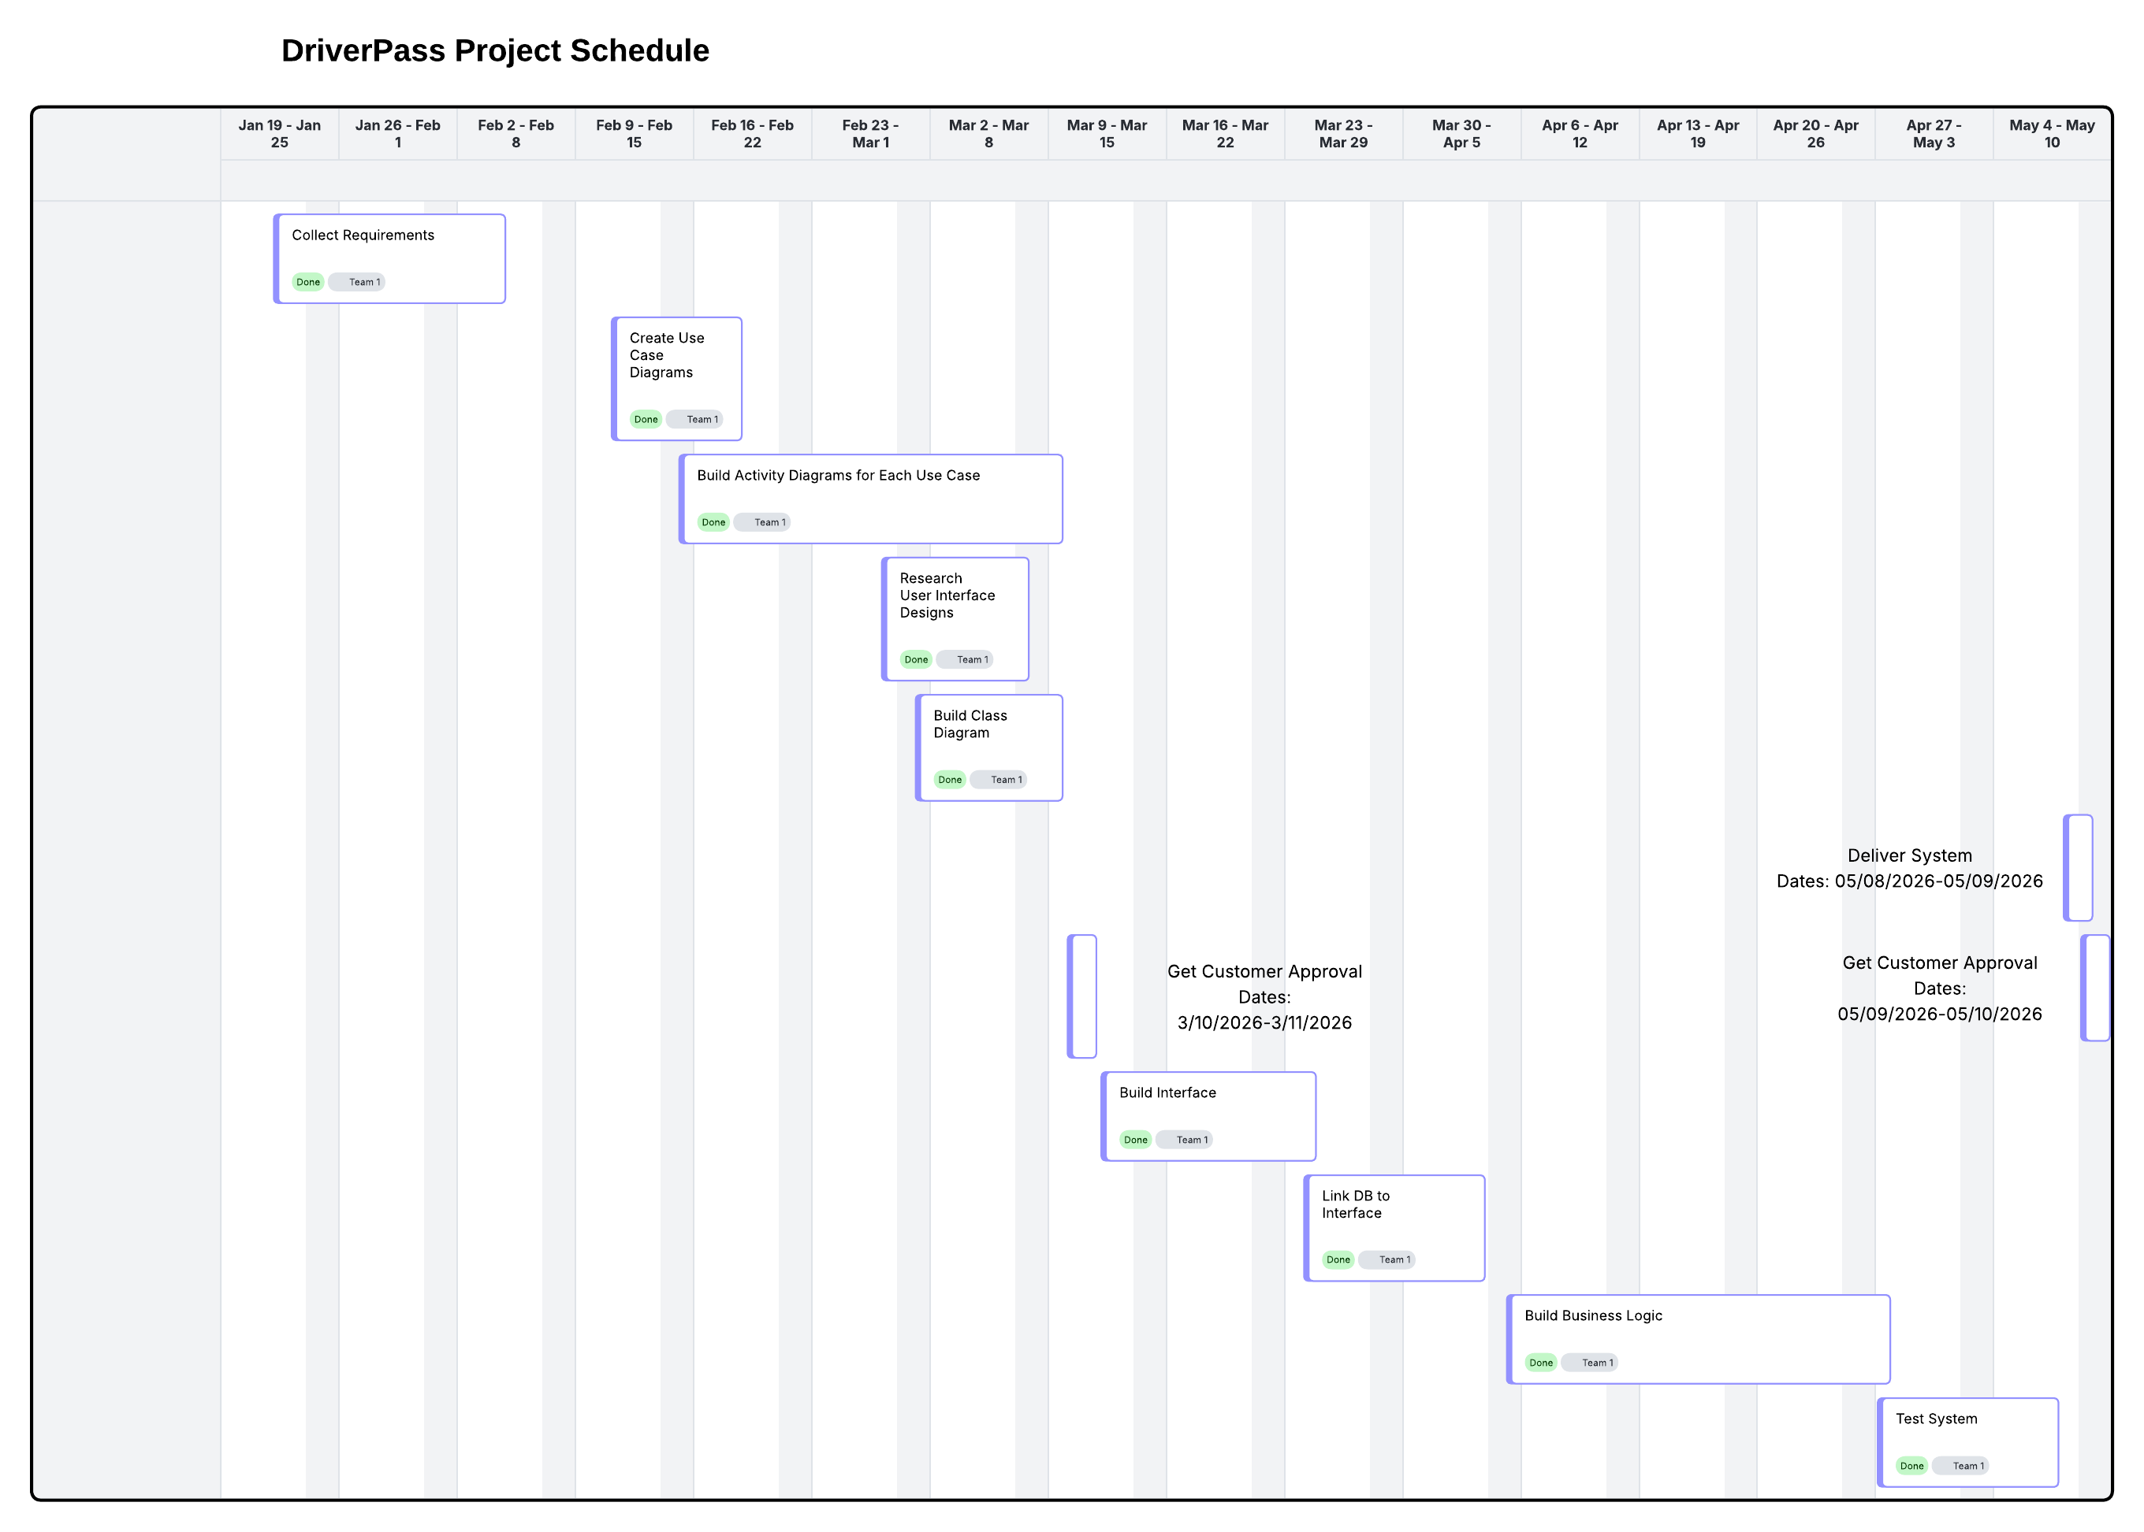
DriverPass Project Schedule (Lucidchart)

AI Use Acknowledgment
Generative AI was used to assist with organizing and drafting content for this assignment. The final content was reviewed for accuracy and alignment with the provided DriverPass interview transcript and project requirements.

