TESTCASE DOC

DIRECT CASE

Path :
/branches/dev_lilian/DassFlow_varchg/cases/sw_mono/bin_channel_straight/rundirect/

Simulation and numerical params

Readable directly in /branches/dev_lilian/DassFlow_varchg/cases/sw_mono/bin_channel_straight/rundirect/input.txt

Mesh description
Rectangular mesh :
- Length = 1000m
- width = 100m
- nb node = 1000
- nb cells = 891 (9 *99)

- irregular splope →
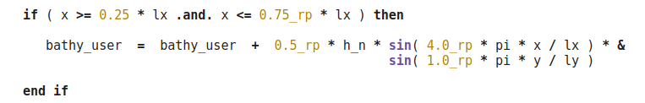

- no variation along the width (y axis)

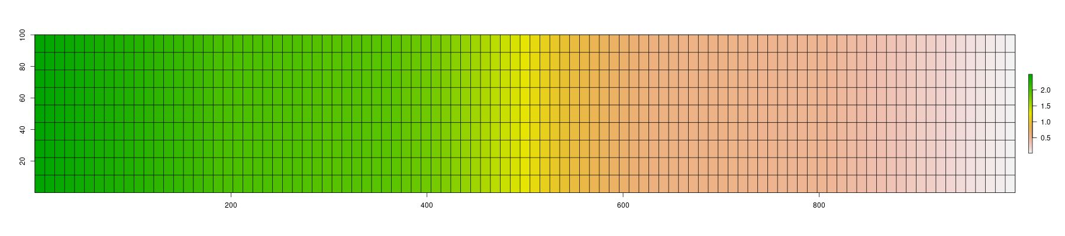
y
x

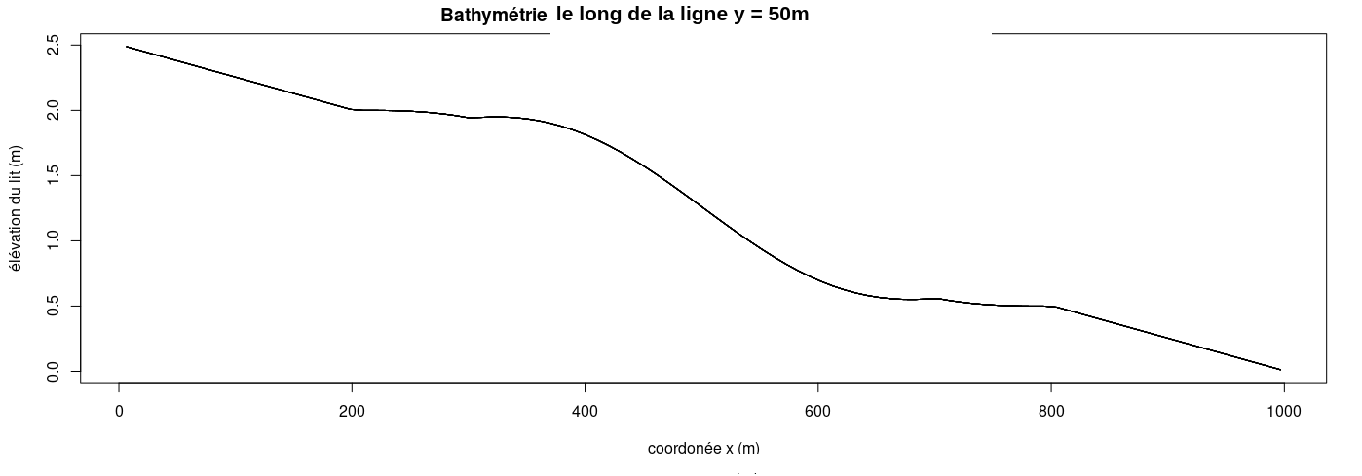

Boundary conditions
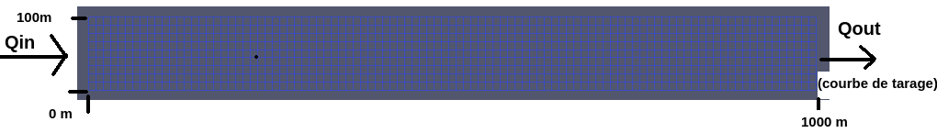

Qin

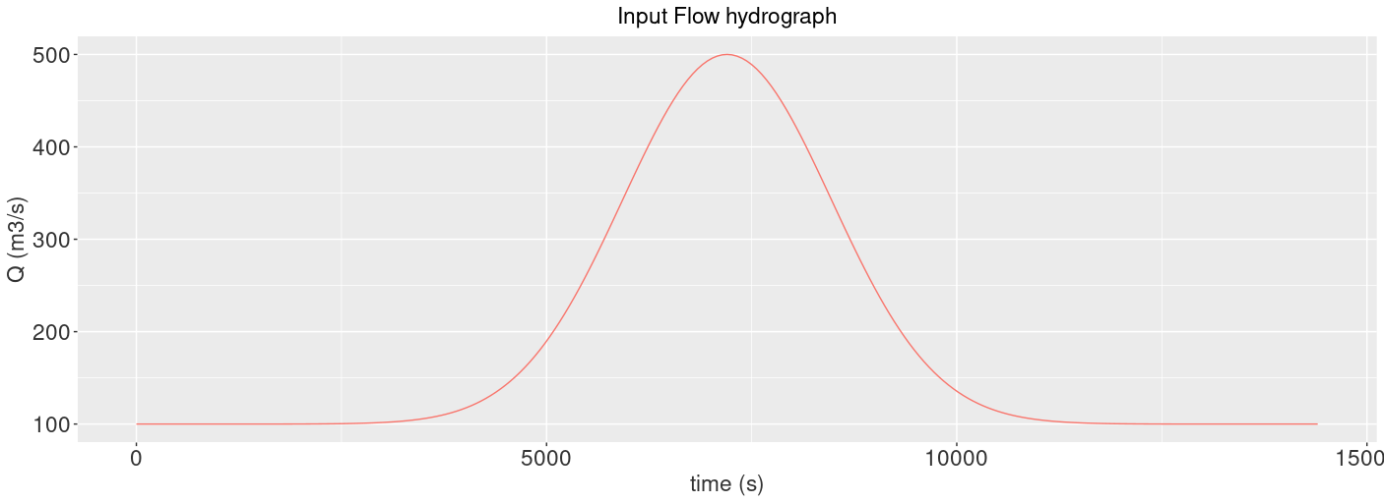

Rating curve
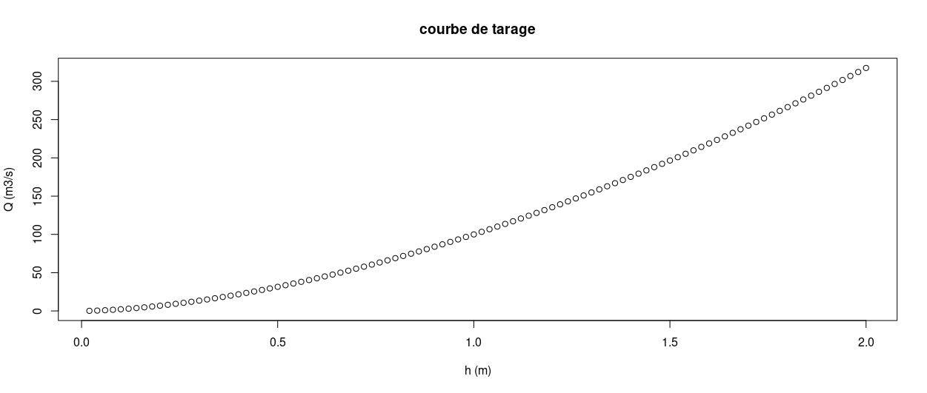

Complementary info for the test case

- Manning is uniform : n= 0,05

Observed stations



4 observed points
- points 1 and 2 take a single measure
- Points 3 and 4 are defined in stations_grp_xxxx.txt → it gives one observed value (ie the mean of the 9 points considered ? → Need to be confirmed)

PRIOR data for minimisation
Path :
/branches/dev_lilian/DassFlow_varchg/cases/sw_mono/bin_channel_straight/prior_data/

Qin :

Qin = constant = 100m³/s

Bathy :
Straight slope here
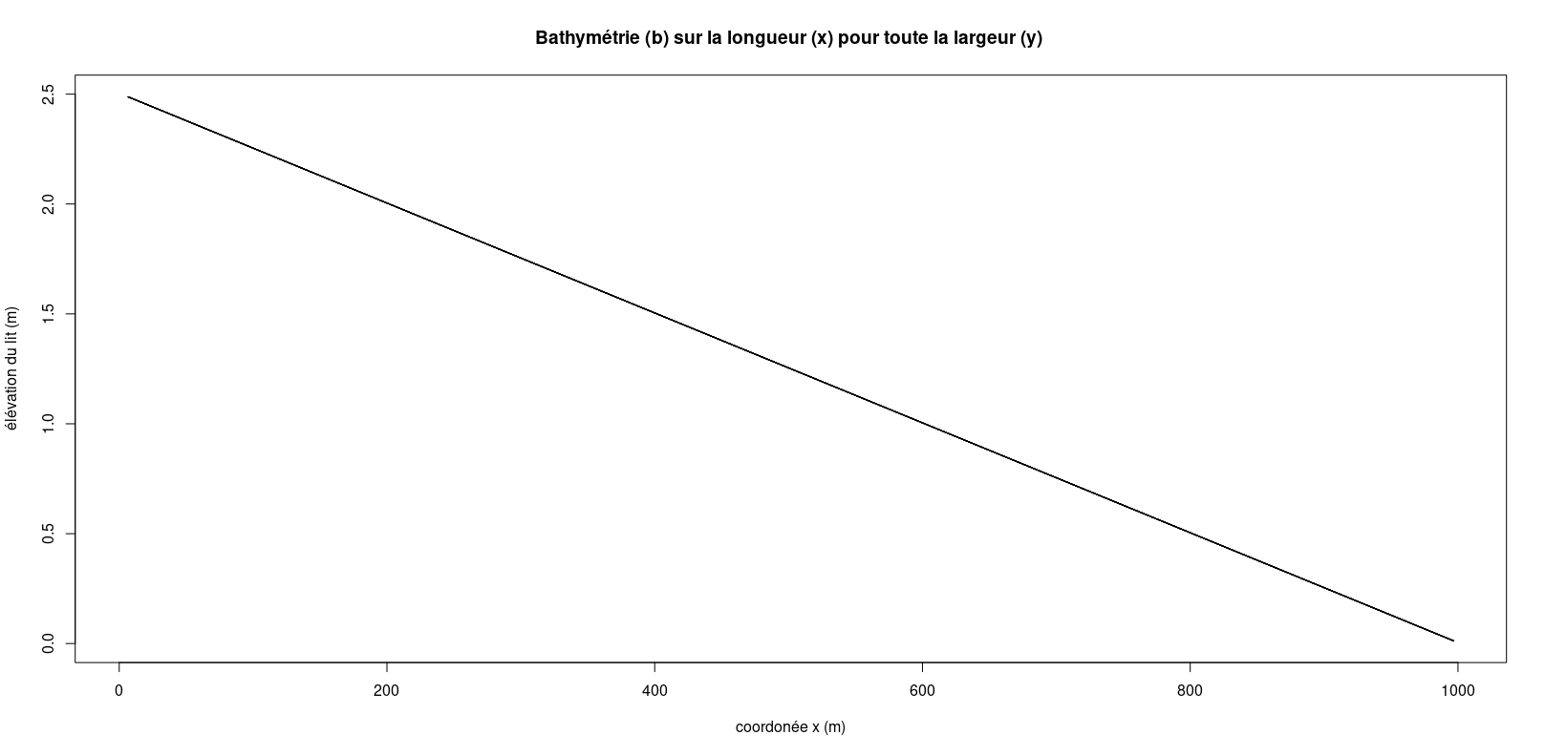
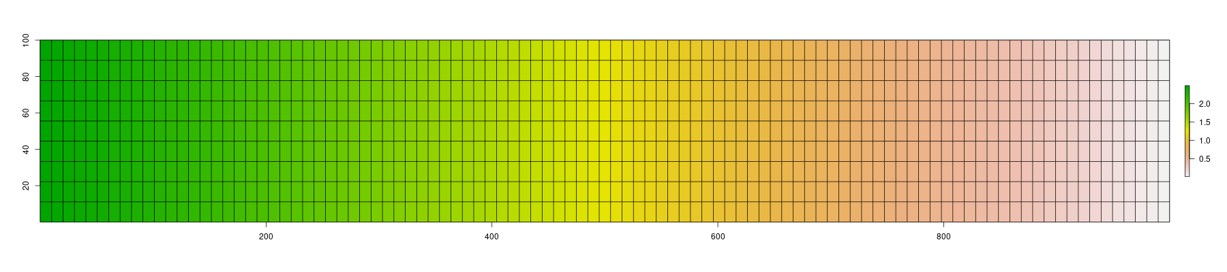

Manning :

n=0.5

