PCSim² User’s Guide
DRAFT

Notice
This document is the result of a cooperative effort undertaken at the direction of Cable Television Laboratories, Inc. for the benefit of the cable industry and its customers. This document may contain references to other documents not owned or controlled by CableLabs. Use and understanding of this document may require access to such other documents. Designing, manufacturing, distributing, using, selling, or servicing products, or providing services, based on this document may require intellectual property licenses from third parties for technology referenced in the document.

Neither CableLabs nor any member company is responsible to any party for any liability of any nature whatsoever resulting from or arising out of use or reliance upon this document, or any document referenced herein. This document is furnished on an "AS IS" basis and neither CableLabs nor its members provides any representation or warranty, express or implied, regarding the accuracy, completeness, or fitness for a particular purpose of this document, or any document referenced herein.
Table of Contents

1 Overview 4
1.1 Revision History 4
1.2 Abbreviations 4
1.3 Definitions and Terms 4
2 Getting Started 6
2.1 Configuration Area 6
2.1.1 Platform Settings Subsection 8
2.1.2 DUT Configuration Subsection 8
2.1.3 Test Script Subsection 9
2.1.4 Test Run 10
2.2 Test Execution Area 10
2.2.1 Console Tab 12
2.2.2 Registrar Tab 13
2.2.3 View Results Tab 14
2.2.4 View Log 15
2.3 Menu Bar 16
2.3.1 File Menu Button 16
2.3.2 Edit Menu Button 17
2.3.3 Help Menu Button 18
3 Configuration Files 20
3.1 Platform Configuration File 20
3.2 Update Button 20
3.3 Network Element Drop-Down List 20
3.4 Contents 21
3.4.1 Element 21
3.4.2 Description 21
3.4.3 Platform Value 21
3.4.4 Setting 21
3.4.5 Description 21
3.5 DUT Configuration File 21
3.6 Log Configuration File 23

Table of Figures

Figure 1 Initial User Interface Window 6
Figure 2 Configuration Area 8
Figure 3 Test Execution Area Expanded 11
Figure 4 Test Pair Highlight 12
Figure 5 Console 13
Figure 6 Registrar 14
Figure 7 View Results 15
Figure 8 View Log 16
Figure 9 File Menu Items 17
Figure 10 Find 18
Figure 11 Help Menu Button 19
Figure 12 Example Platform Configuration File 20
Figure 13 Using the Network Element Drop-down List 21
Figure 14 DUT Type Drop-down list 22
Figure 15 DUT Configuration Settings 23
Figure 16 Example Log Configuration File 24

Overview
This document provides a description on the various components of the PacketCable Simulator 2.0 (PCSim²). Section 2 describes the methodology of the platform and how to begin using it. Section 3 provides details on what is contained in the configuration files used by the PCSim² platform.

Revision History
The following revision chart describes the changes made for each version of this document.

Revision | Date | Change Description
0.1 | 07/31/2007 | Initial draft
0.2 | 09/30/2009 | Add appendix for configuring use of the Voicetronix OpenLine4 card.

Abbreviations
Below is a list of abbreviations used throughout this document

AS – Application Server
CSCF – Call Session Control Function
DCF – DUT Configuration File
DUT –Device Under Test
LCF – Log Configuration File
PCF – Platform Configuration File
PCSim² – PacketCable Simulator 2.0
TS – PC2 XML Test Script
UI – User Interface

Definitions and Terms
Batch File – This is a PCSim² text file contains the absolute or relative path to zero or one Platform Configuration File, zero or more DUT Configuration Files, and/or zero or more PC2 Test Scripts.

DUT Configuration File – This is a properly formatted Excel file defining all the feature support of a device under test as well as the network configuration about the device (e.g. its’ IP address and MAC address).

Global Registrar – This is an externally controlled persistent Registrar for simulating one or more SIP dialogs without the need to manage the registration processing. When this feature is enabled in the Platform Configuration File, the system will accept and process SIP registration messages before, during and after any test runs for any devices defined by any DCFs in the DUT Configuration list and by any device indicated as not being simulated in the PCF.

Log Configuration File – Defines the information that will be displayed in the Console tab, the PCSim² Application log file and/or the Test log file. Each of these can be independently managed from within this single file.

Network Element Label – This is a string abbreviation that allows the platform to refer to a specific network element during a test. A network element label must take the following form: Device Type followed by a Number Identifier. An example of this would be UE3 which defines a UE with identifier number 3. The Number Identifier 0 is reserved for use as a label for the DUT. To illustrate this, a DUT that is a UE can be referred to by its network label of DUT or UE0.

PC2 Test Script – It is a document that defines the test operations to be performed by the PCSim² platform. The script’s syntax is defined by the PCSim² XML Syntax document. It consists of one or more FSMs operating collectively with the PCF and DCF providing the pertinent network architectural details.

Platform Configuration File – This is a properly formatted Excel file defining each of the network elements (simulated or real) that may be used during the execution of one or more tests.

Relative Path – The term “relative path” is always based upon the perspective of the directory that the PCSim² simulator was installed unless otherwise indicated.

Test Pair – The term means the actual execution of a specific DUT Configuration File with a specific PC2 XML Test Script.

Test Run – The execution of all of the Test Pairs defined in the Configuration Area.

Getting Started
To start the PCSim² application, double-click on the PCSim² icon added to the desktop during installation. This should result in the following window to be displayed.

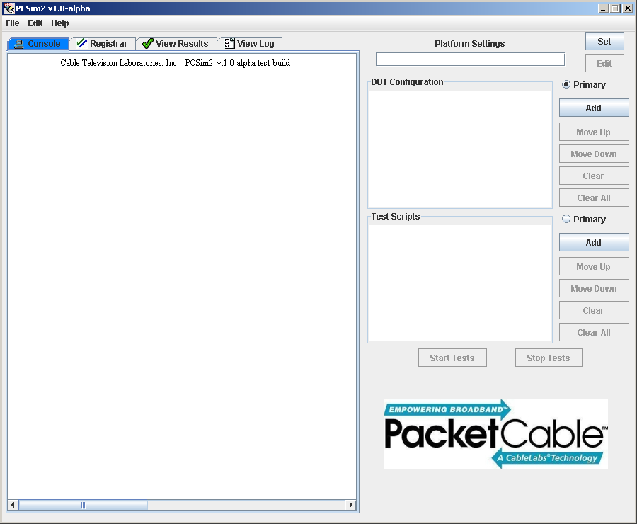
Figure 1 Initial User Interface Window

The PCSim² User Interface (UI) is divided into two operational areas; the test execution area and the configuration area. The left-side of the UI comprises a set of tabs. This is the test execution area. While the area with the Platform Settings, DUT Configuration list and the Test Scripts list is called the configuration area and is located on the right half of the UI. The configuration area is covered in more details first. The test execution area will be discussed later.

Configuration Area
In order to run a test, the PCSim² platform must have at least one of each of the following file types: a Platform Configuration File (PCF), a DUT Configuration File (DCF), and a PC2 XML Test Script (TS). The configuration area is subdivided to reflect the setting of each of these three file types; the Platform Setting, DUT Configuration, and Test Scripts which correspond respectively to the PCF, the DCF, and the TS file types. Lastly this area contains the two buttons used to start or stop a test run.

During the execution of a single test run, the PCSim² uses one and only one PCF along with one DCF and TS. The DCF and TS currently being executed is referred to as the Test Pair. The platform can have one or more DCF in the list of DUT Configuration files as well as one or more TS in the list of Test Script files. All of the current files defined in the configuration area define a “batch” of Test Pairs to be executed. When the simulator is notified to start a test run, it will attempt to run all of the Test Pair combinations defined in the configuration area. The batch execution is conducted by consecutively executing one Test Pair at a time.

The pairing process uses the primary file type (indicated by the Primary radio button in either the DUT Configuration or Test Scripts subsection) with each file in the secondary list. The test is executed with the file from the secondary list being replaced with the next file in that list. Once all of the Test Pair combinations from the secondary list have been executed with the first entry in the primary list, the primary list moves to the next file in its’ list were this new file will again be sequentially tested with each file from the secondary list. When all of the Test Pairs have completed, the PCSim² will stop and wait for instruction to begin the next test run.

In preparation of executing a test run, the user must indicate at least one of each of the file types to use. Any or all of these can be loaded from a previously saved PCSim² Batch File. Alternatively, the user can indicate the PCF to use during the test(s) by clicking the Set button. DCF(s) can be added to the list of DUT Configuration Files through the Add button. Test Scripts can be added to the list of scripts by the accompanying Add button. Once there is at least one of each of the three types of files defined, the Start Tests button will become active and the test(s) can be executed (see Figure 2).

It is important to note some operational aspects that occur as the user includes file types to the configuration area. When a user sets the Platform Configuration File, the PCSim² will automatically activate all of the protocol stacks that it defines. Any listening sockets will also be come active. If the platform is performing any global operations, e.g. Global Registrar, these will be initiated as well.

As DCF are added to the DUT Configuration list, the platform will notify any global operations that they may receive requests from this device. As an example if the Global Registrar is enabled in the PCF, when the DCF is added to the list, the Global Registrar is notified to accept SIP registration messages from the device defined by the DCF.

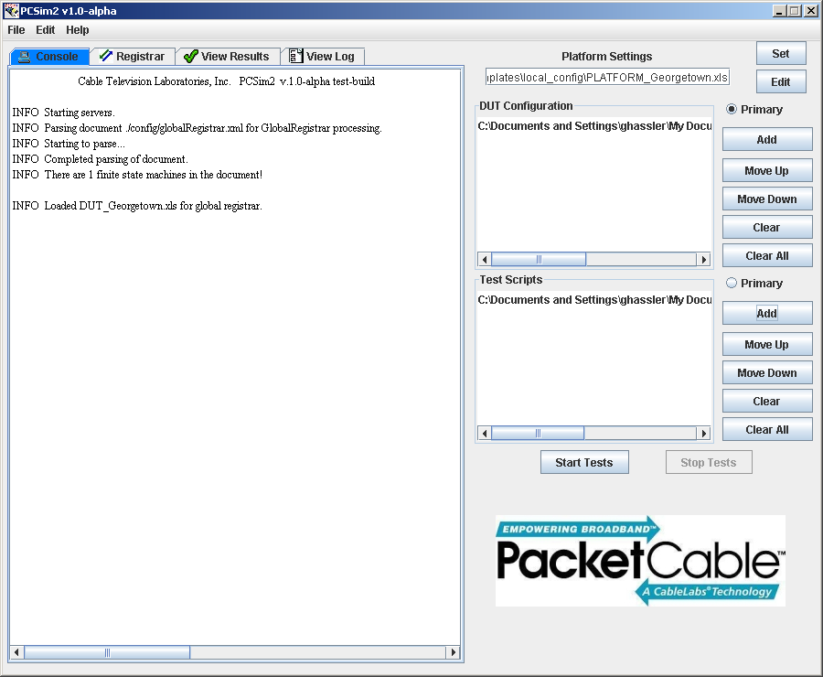
Figure 2 Configuration Area

The remainder of this section is devoted to providing detail information about each of the elements in the Configuration Area.

Platform Settings Subsection
The Platform Settings subsection allows for a single PCF to be identified for use while conducting one or more tests. This subsection consists of the Text Field, Set and Edit buttons.

Text Field
This field is the absolute or relative path to a Platform Configuration File to be used during a test scenario.

Set Button
The Set button allows the user to select a file through a File Dialog window.

Edit Button
This launches the Excel application to edit the current PCF.

DUT Configuration Subsection
The DUT Configuration subsection allows the operator to define one or more DCFs to be included in the list of files. The list consists of the absolute or relative path of one or more DUT Configuration Files. Once the list contains at least one file, the list can be manipulated using the Move Up, Move Down, Clear or Clear All buttons. Also an entry the list can be selected. Once selected a single click of the right mouse button will display a popup menu with an Edit button. Activating the Edit button will launch the Excel application to edit the currently selected DCF.

DUT Configuration List
This is an ordered list of the DCFs to be used during execution of a test run.

Primary Radio Button
This button indicates whether the DCF list is the primary list when construction Test Pairs during the test run.

Add Button
The button adds one or more files to the DCF list.

Move Up Button
The button moves the currently selected entry in the DCF list up one position in the list.

Move Down Button
The button moves the currently selected entry in the DCF list down one position in the list.

Clear Button
Activation of this button removes the currently selected entry from the DCF list.

Clear All Button
This button removes all of the entries in the DCF list.

Test Script Subsection
The Test Scripts subsection operates in a similar manner to the DUT Configuration subsection by allowing a list of Test Scripts files to be utilized by the platform.

Test Scripts List
This is the ordered list of Test Scripts to be executed during the test run.

Primary Radio Button
This button indicates whether the TS list is the primary list when construction Test Pairs during the test run.

Add Button
The button adds one or more files to the TS list.

Move Up Button
The button moves the currently selected entry in the TS list up one position in the list.

Move Down Button
The button moves the currently selected entry in the TS list down one position in the list.

Clear Button
Activation of this button removes the currently selected entry from the TS list.

Clear All Button
This button removes all of the entries in the TS list.

Test Run
This subsection consists only of the Start Tests and Stop Tests buttons. These buttons are used to start and stop a test run.

Start Tests Button
Pressing this button notifies the simulator to begin executing all of the Test Pairs defined by within the configuration area.

Stop Tests Button
Pressing this button notifies the platform to stop executing the currently active Test Pair and all remaining Test Pairs. The currently active Test Pair is marked as a failure with no disposition assigned for any Test Pairs remaining to be executed.

Test Execution Area
Once a test run has started, the test execution area becomes relevant. Each tab shows a different aspect of the test run. The Console tab shows any log information that is to be displayed about the current Test Pair being executed by the system. The Registrar tab shows all of the UE network elements that are currently registered to the system. The View Results tab shows the result of executing each Test Pair in the test run. The View Logs tab is a file view any log file generated in the current test or previous tests.

Figure 3 shows the Test Execution Area being expanded to encompass the entire window simply by double-clicking on any of the tabs. The Test Execution Area can be restored to its’ original size simply by double-clicking once again on one of the tabs.

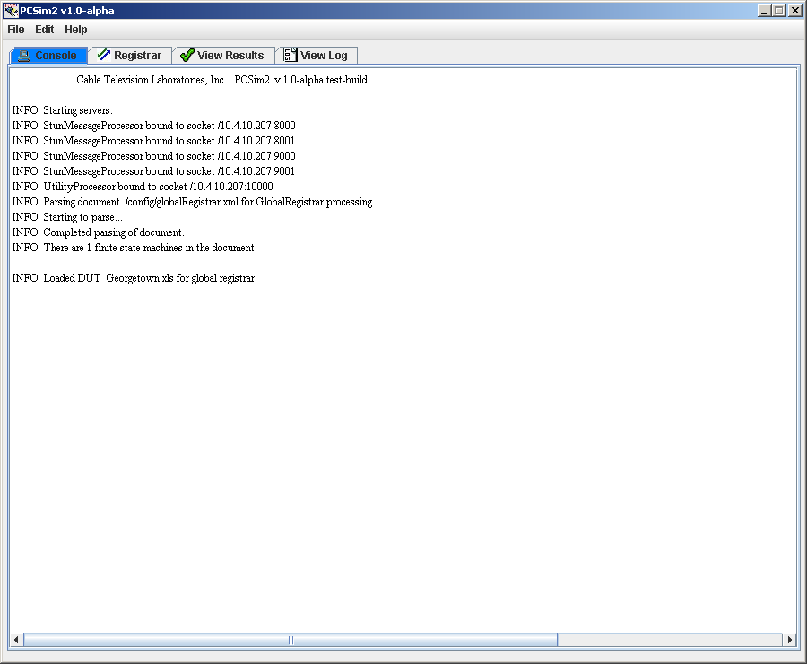
Figure 3 Test Execution Area Expanded

When the UI is in its original view, the current Test Pair can easily be identified simply by viewing the DUT Configuration and Test Script lists. The file from each of these lists currently being used in the test will be highlighted as in the illustration in Figure 4 below.

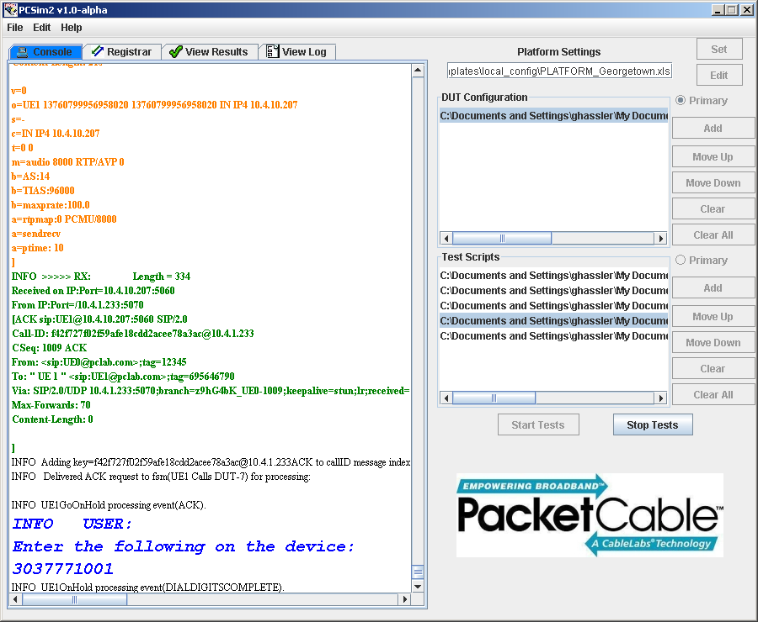
Figure 4 Test Pair Highlight

Console Tab
This tab shows information about the system and the execution of the current Test Pair. This information may change based upon the settings configured in the LCF. The information conveyed in this tab uses color coded that is similar to that employed by the PacketCable 1.x test platform, TclSim.

Figure 5 Console

The figure above shows the Console window as an example test run is being performed.

Registrar Tab
The Registrar tab shows each of the devices that have registered to the PCSim² system. This can be either a network element that has registered to the Global Registrar or it can be a device that has registered to the actual Test Pair being executed. There is currently no distinction between the two.

The tab shows the current status of the registration as one of the following: INITIAL, ACTIVE, INACTIVE, or DENIED. INITIAL means that the device is currently in the process of registering to the registrar but the process has not completed. ACTIVE means that the device has successfully registered and can begin creating SIP session dialogs. INACTIVE specifies that the indicated device has not contacted the platform for registration, but will be processed if it does. DENIED signifies that the identified device has been refused registration. The next item in the window is the Network Element Label currently being used by the platform for the device. The last item shown is the IP Address that the device is currently utilizing to send its’ registration information from.

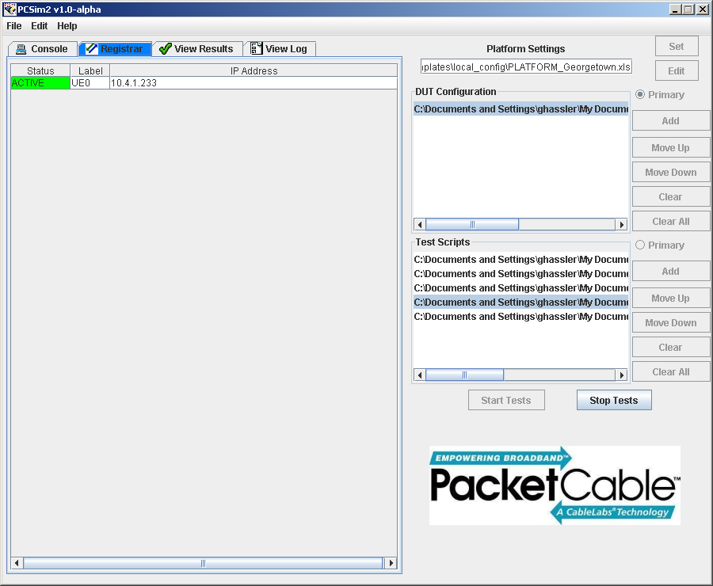
Figure 6 Registrar

View Results Tab
The View Results Tab shows the results of executing each Test Pair. The window shows the Result, the Run number, and the names of the two files constituting the Test Pair. The Result can be one of three values; TESTING, PASSED or FAILED. Figure 7 shows the View Results tab while the system is conducting a test run.

The TESTING value indicates this Test Pair is currently the one being executed. (NOTE: This is also reflected in the Configuration Area by each of the corresponding files being highlighted within their respective lists, see Figure 4.) The PASSED value indicates that the platform did not identify any errors based upon the current settings of the system. The FAILED value indicates that one of the items that the platform is reviewing did not occur as expected and needs further investigation. A FAILED value does not necessary mean that the DUT did something wrong. Examples that might result in a failure but may not be are: the error can be caused by some unexpected message being received by the simulator or an expected message didn’t occur and is not mandatory, but the TS thought that it is.

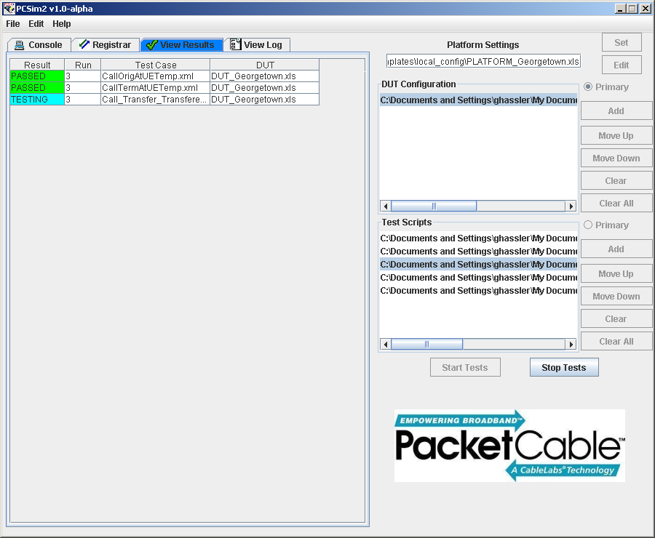
Figure 7 View Results

View Log
This tab allows the user to open any of the log files generated by the platform during its current or previous test runs. It will read the log information and colorize the information similarly to that used in the Console Tab.

It is important to note that the there is more information stored within a log file when compared to the information that will have appeared on the console window. First the log files contain additional information for troubleshooting issues during a test such as timestamp, the class that generated the file, the line number the log message was generated from and the name of the thread that generated the message. Also, differences may occur based upon the controls set in the Log Configuration File. As an example, the LCF may have only informational and higher log level message appearing in the console while requiring debug messages and above to be recorded in the test log file.

Below is an illustration of the platform after it has loaded a test log file for review.
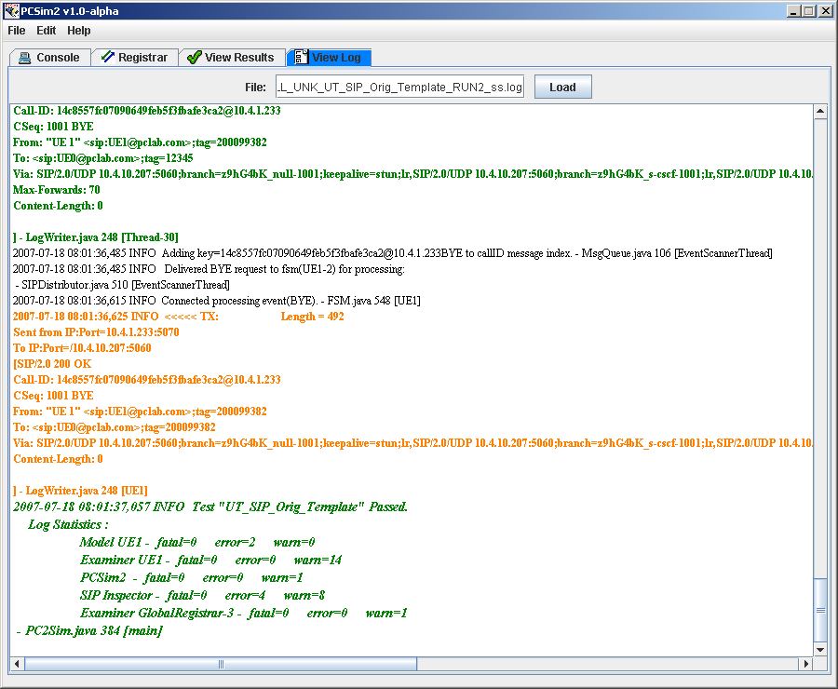
Figure 8 View Log

Menu Bar
The menu bar contains some useful operations for testers to create Batch files, troubleshoot test failures and to identify the version of the system.

File Menu Button
The File Menu Button is used to manipulate Batch files. The caption below shows the operations that may be performed upon a Batch File. The user can Open, Close, Save or Save As a Batch File through this menu button.

Open Button
The button causes a File Dialog box to appear to select a Batch File to be loaded into the Configuration Area of the UI.

Close Button
This button causes all of the Configuration Area information to be cleared. If the information has changed since the last time it was saved, the system will request whether to save the configuration information into a Batch File.

Save Button
The Save button allows the user to write over a previously opened batch file with the current information in the Configuration Area.

Save As Button
This button prompts the user to identify where and under what name to save a Batch File to the network.

Historical Batch File Button(s)
Between the Save As Button and the Exit, but there can appear up to four additional buttons. These buttons are a history of the most recently used batch files by the tool with the most recent appearing first.

Exit Button
The Exit button terminates the tool as soon as it can possibly terminate all of the active operations.

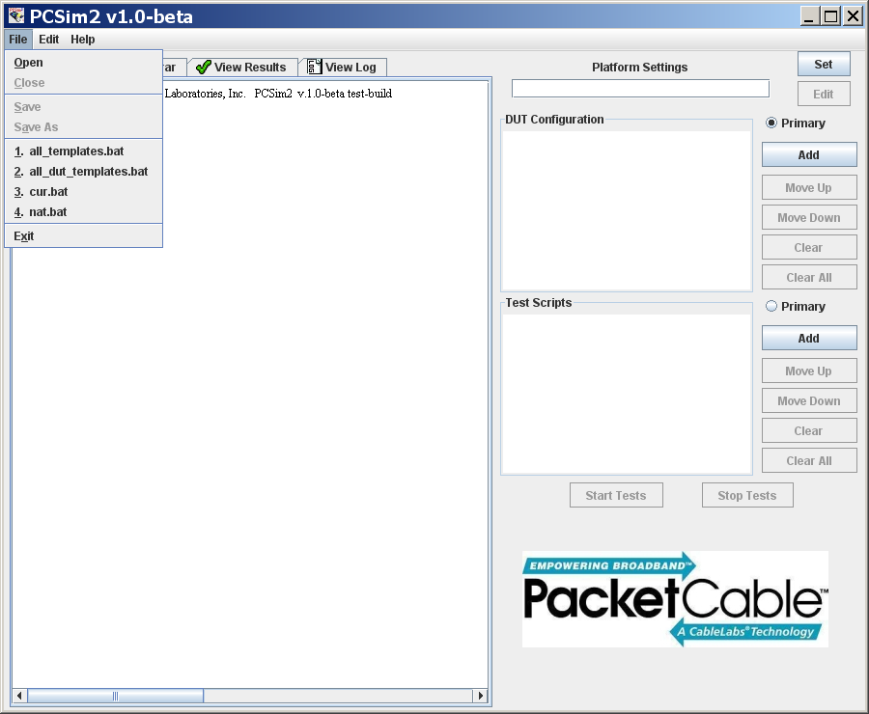
Figure 9 File Menu Items

Edit Menu Button
The Edit Menu Button contains only the Find button. This can be helpful when trying to troubleshoot a particular Test Pair that failed or information in the tab.
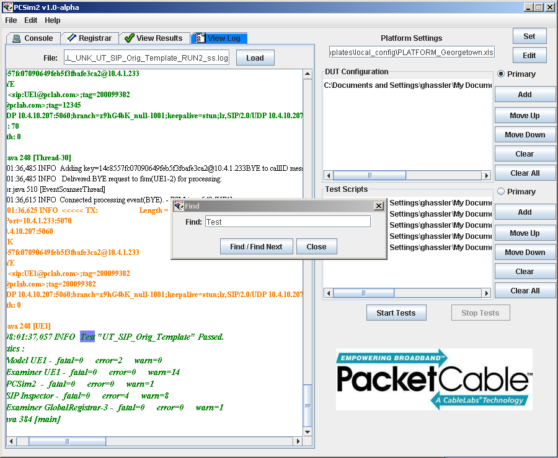
Figure 10 Find

Find Button
The Find button allows the user to search for any case-sensitive occurrence of a string within the currently selected tab of the Test Execution Area. All occurrences of the string are highlighted in yellow and the currently active occurrence is highlighted in purple as seen in the caption below. An example of this is shown in the caption above.

Help Menu Button
This button allows the user to get the current version of the system by clicking on the About button, or displaying the license agreement for PCSim².

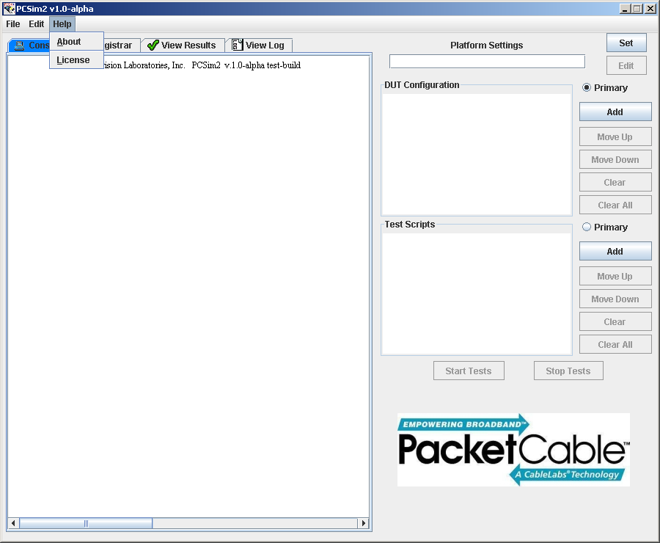
Figure 11 Help Menu Button
About Button
This button displays the current version of the PCSim² software.

License Button
Activation of this button displays the license agreement for the PCSim² system in a dialog box for review by the user.

Configuration Files
This section provides details about each of the configuration files that are used by the PCSim² platform.

Platform Configuration File
The Platform Configuration File contains all of the network architectural data, not relevant to the DUT, needed by the PCSim² to conduct a test run. The information in the file defines all of the details about the network that may be used in any of the tests during the run. Network elements can be simulated or real, but the platform requires knowledge on such things as IP address and port to communicate with it if a Test Pair requires it. NOTE: Elements that appear in grey are not currently used within the simulator but are expected to be needed in future releases of the platform.

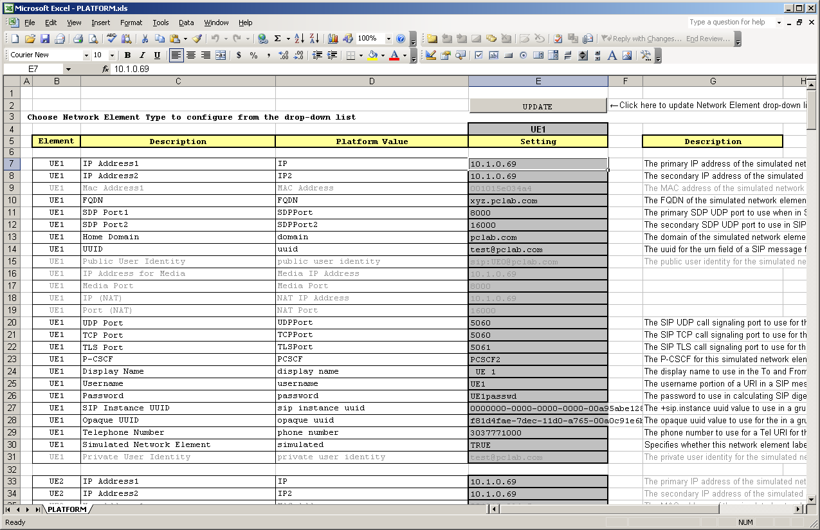
Figure 12 Example Platform Configuration File

Update Button
The update button locates all of the Network Element Labels defined with in the document and adds them to the Network Element drop-down list.

Network Element Drop-Down List
This drop-down list moves the display to the first occurrence of the selected value in the Element column within the file, see Figure 13.

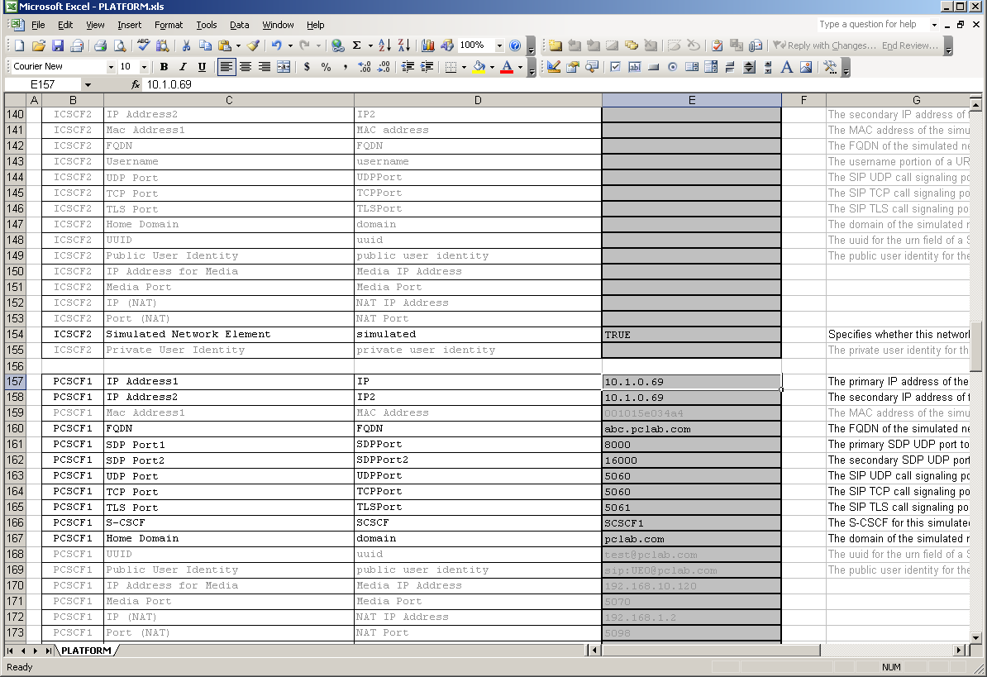
Figure 13 Using the Network Element Drop-down List

Contents
The following defines each of the columns within the Platform Configuration File.

Element
This column specifies the network element label that this configuration field will be associated to during a test.

Description
This column provides a brief description of the configuration field being defined in this row.

Platform Value
This column defines the name of the configuration field within the simulator.

Setting
This is the specific value that the platform will use when operating.

Description
This cell describes the type of valid values that can appear as the setting for this configuration field. If the value should be in a range or limited in some other way, it will also appear here.

DUT Configuration File
Below is an example of the DUT Configuration File. It is divided into three sections. The first section is selecting the type of device that the file is defining from the menu drop-down list. Currently there are four possible selections, Generic-UE, PACM-UE, RST-UE, or E-DVA, as shown in the screen caption below.

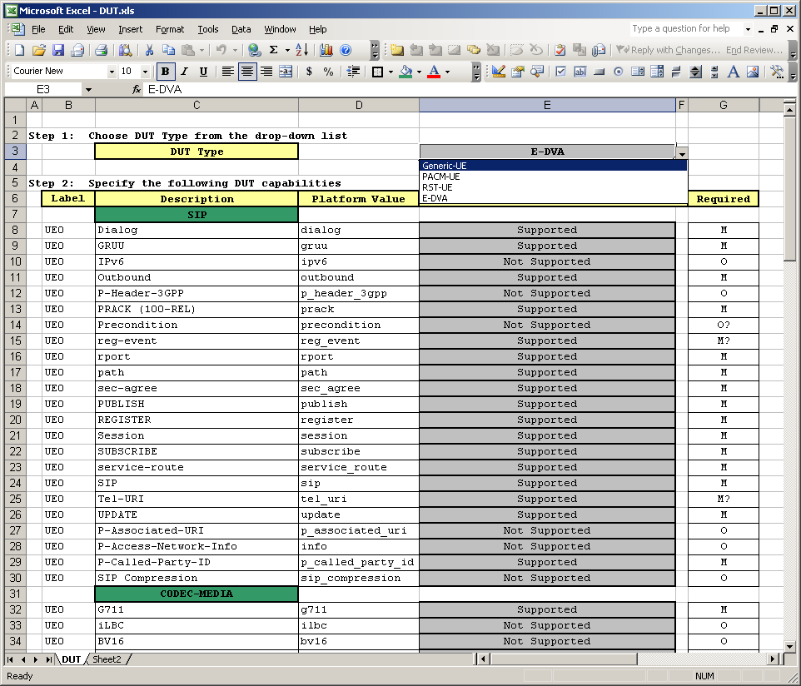
Figure 14 DUT Type Drop-down list

The next section is the capability portion. It specifies whether a capability is Supported or Not Supported by the described device. The first four columns, in section 2 and it continues for section 3, have the same meaning as that of the Platform Configuration File. The next column in this section, Required, specifies whether the associated capability is mandatory or optional based on the type of device.

The third section consists of the values that the PCSim² will use when executing a test with the referred to device. NOTE: Sections 1 and 2 have been deprecated and will be removed in a future release of the platform.

The Description column for the third section describes the type of valid values that can appear as the setting for this configuration field. If the value should be in a range or limited in some other way, it will also appear here.

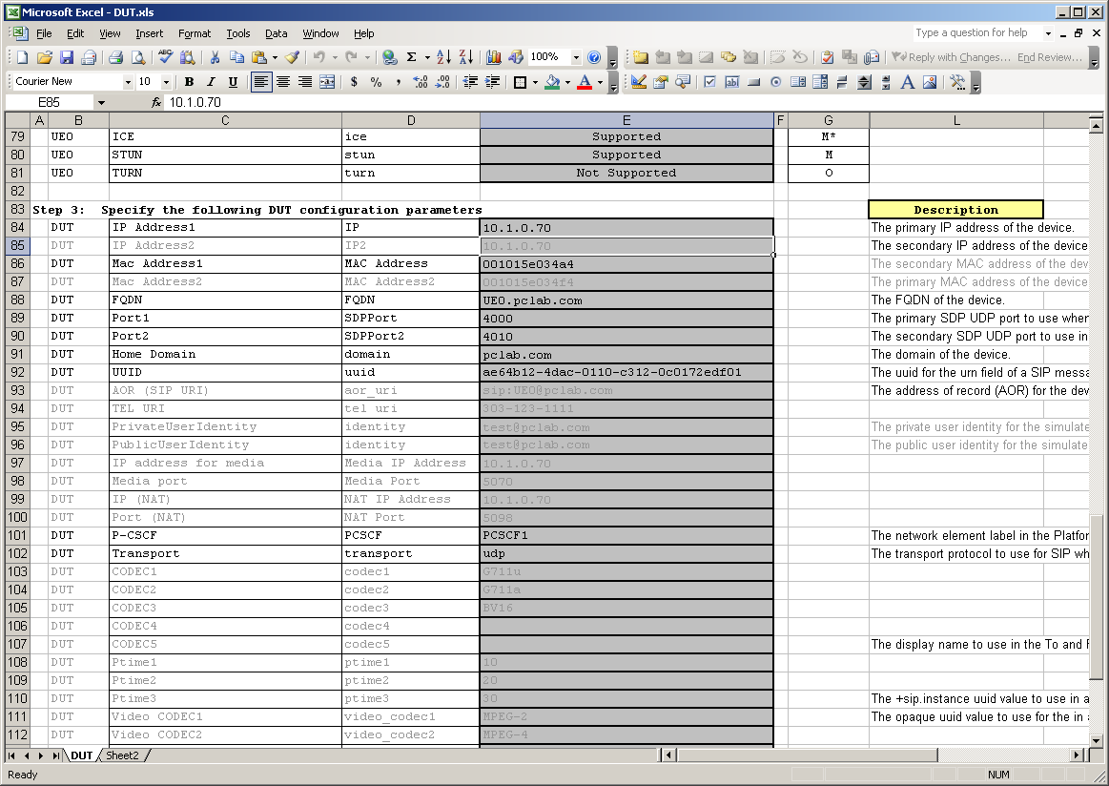
Figure 15 DUT Configuration Settings

Log Configuration File
The LCF controls what information is shown in the Console window, recorded in the Application log file and recorded in the Test log file. Each of these pieces can have different information requirements based solely upon contents the LCF which is read when the system starts. The LCF that the platform will use is always called LogConfig.txt and should be located in the config directory. Below is an example of the LCF.

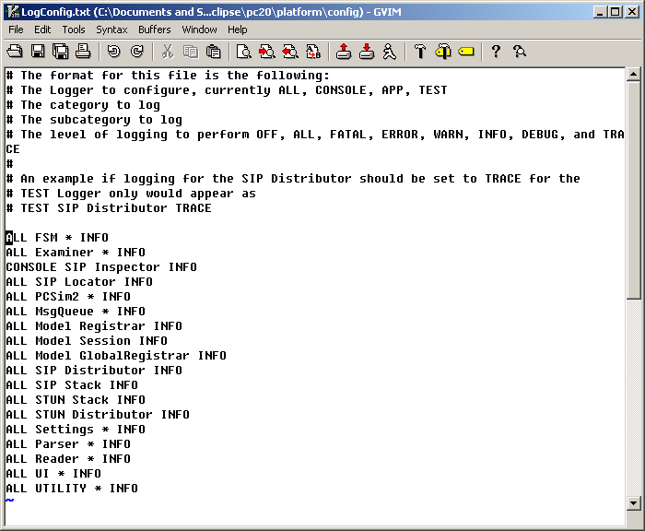
Figure 16 Example Log Configuration File

Comments can be added in the file simply by starting any line with the “#” character. Each line of the file should contain 4 elements divided by white space. The first element specifies the destination of the particular log event. It should be CONSOLE, APP, or TEST to reflect the Console, the Application log file or the Test log file respectively. The value ALL is also acceptable to indicate the log information should be sent to all of the destinations.

The second element on a line should be the Category of logging. The PCSim² has segmented the system into several operational area for limiting the log information to only data that a user is interested in during a test. The system currently defines the following categories:
ALL, Examiner, FSM, LogMsg, Main, Model, MsgQueue, Parser, PCSim2, Reader, SIP, STUN, Settings, UI, and UTILITY.

The third element is the Subcategory of logging. This is used to provide further granularity of some of the categories. Not all categories have a subcategory. In Figure 16, SIP provides an example of subcategories with the Distributor and Stack values. The value “*” is a wildcard value that allows all subcategory to operate in a similar manner.

The last element is the log level to be performed on this Category-Subcategory. Logging will occur for any events that have an equal log level or greater. The log levels supported by the system are listed below in order from highest to lowest:
OFF, ALL, FATAL, ERROR, WARN, INFO, DEBUG and TRACE.

Appendix A – Voicetronix OpenLine4 Card Support
The platform has been optional support for the Voicetronix OpenLine4 Telephone card. The card allows for the automatic execution of common telephony operations by the PCSim² platform.

System Setup
Once you have the PCI card installed into a PC computer, you will need to download the appropriate libraries and source code for the operating system that you are using (currently only Windows 2000 and Windows XP have been tested). NOTE: Due to an error in the build for Windows 2.4.3 build of the libvpb.dll. Follow the instructions for correcting setFlash issue below.

Due to an error in the build for Windows follow the instructions from Voicetronix to install the device drivers and to setup the registry.

Windows (32-bit)
After the device drivers have been installed, copy the PlxApi.dll and libvpb.dll library to the
<installation directory>\lib\win32. Before using PCSim², you will need to perform the steps in the setFlash issue section below in order for the libraries to function properly with PCSim².

setFlash issue
An issue has been identified in the last build produced by Voicetronix. The base compilation did not include the setFlash procedure in the exposed API of the libvpb.dll. The resolution to this issue is to update the compilation definition and rebuild the library. Below is a description of the steps necessary to correct the issue.

- Download the vpb-driver-2.4.3 version of the source code from Voicetronix.
- Using your favorite text editor, open the src/vpbapi.def file for editing.
- Add vpb_set_flash to the file on a separate line from any other entry.
- Save the file.
- Using your preferred C/C++ compiler, create a new version of the libvpb.dll.
- Replace the <installation directory>\lib\win32\libvpb.dll library with this locally generated copy of the library.

Windows (64-bit)
The OpenLine4 cards are no longer supported on Windows, so there is no support for Windows 64-bit operating systems.

Linux
Support for the Linux version of the cards is currently planned for future development.

The Global Registrar can not be active at the same time that a PC2 XML Test Script is testing a device for SIP registration. A test run that include SIP registration testing should have the Global Registrar disabled.
By default a Test Pair is considered to have PASSED a test until an error is encountered.

