**7 Sub-Project – Website Development**

**[Adam Morrison]**

In this chapter I will discuss the following topics:

* Introduction
* Sub Project Aims & Objectives
* Web Development Research
* Web Development Outcome
* Problems & Solutions
* Future Development and Plans
* Justification of resources used to host & develop the website

**7.1 Introduction**

AntiForensic Solutions is an electronic commerce retailer specializing in the sale of anti forensic tool kits. As such it is vital that the company has a professional website, suited to fit the needs of modern day users. My role within the team was to design a dynamic website ready to be deployed on the web. As well as a distinctive company logo that clearly expresses our brand name.

**7.2 Sub Project Aims & Objectives**

**7.2.1 Key Aims & Objectives**

As I was the soul website designer I sought to stick to these aims & objectives bellow to unsure the outcome of the website design was successful. I also had to design a logo for the company which suited the later two aims listed below.

* **Professionalism** – Showcasing the company in a good light through the website
* **Functionality** – Accessibility and reliability with the e commerce system
* **Recognized Brand** – Creating a suitable logo related to what the company offers
* **Global Recognition** – Marketing through the website to attract new customers
* Allow users to purchase products through the website with an easy step-by-step system
* Promote the brand and products through means of the website
* Insert tutorial pages for each of the products available, including detailed instructions (instructions *created by Hamza*) and clear example videos (videos *created by Krystian*)

**7.2.2 Websites functional needs**

The website had to be carefully designed from the outset to meet the criteria listed above. As an e commerce company the website was not only the companies global brand but also the means of selling our range of products. Customers need to trust us as a retailer in order to purchase our products, this initial trust can be gained through clear brand recognition or through a professional website design.

**7.3 Web Development Research**

**7.3.1 Design**

The standard for website design is changing rapidly. I looked carefully at where the trend was moving and set out my research on some of the top e commerce websites. I discovered that all of the highly rated websites have a clean easy to use layout, mainly using a white background for content areas and an “impact page” where the company brand is clearly displayed in front of a strong background image. I looked into freely available information on the impact of web design on users. From this research I found “65% of users will not trust a website if it has an unprofessional appearance” [Visual.ly, 2016]. There was also statistics available on website structure and appearance, such as Blue being the most popular colour (24%) chosen by users. I looked into different colour pallets and found a website that offers free colour pallets [Color-hex.com]. I eventually decided to use the following colour palatte. (See Figure below)



**7.3.2 Development Process**

* Information Gathering

The first stage of the development process was to gather and process as much key information as possible. I set out by asking the other team members exactly what was required of the website. We decided the purpose of the website would be to sell our products to customers and market our brand globally. The goal was to have a functional e commerce website with a professional and clean appearance. I also had to find out who the target market would be in order to make the content of the website relevant.

* Planning

The planning stage of the process tied in, almost exclusively, with the information gathering process. Once I had collected all the information possible it was time to analyse it and create a clear structure and plan for the development of the website and logo. I also had to decide what web development architecture I would use for creating the website. This linked to the first stage with research into all the different technologies available.

* Design

I had a clear idea of how to make the design fit into what the company was about. From my research I created a comprehensive list of the requirements of the website design. I then used this information to create some initial drafts for the website design.

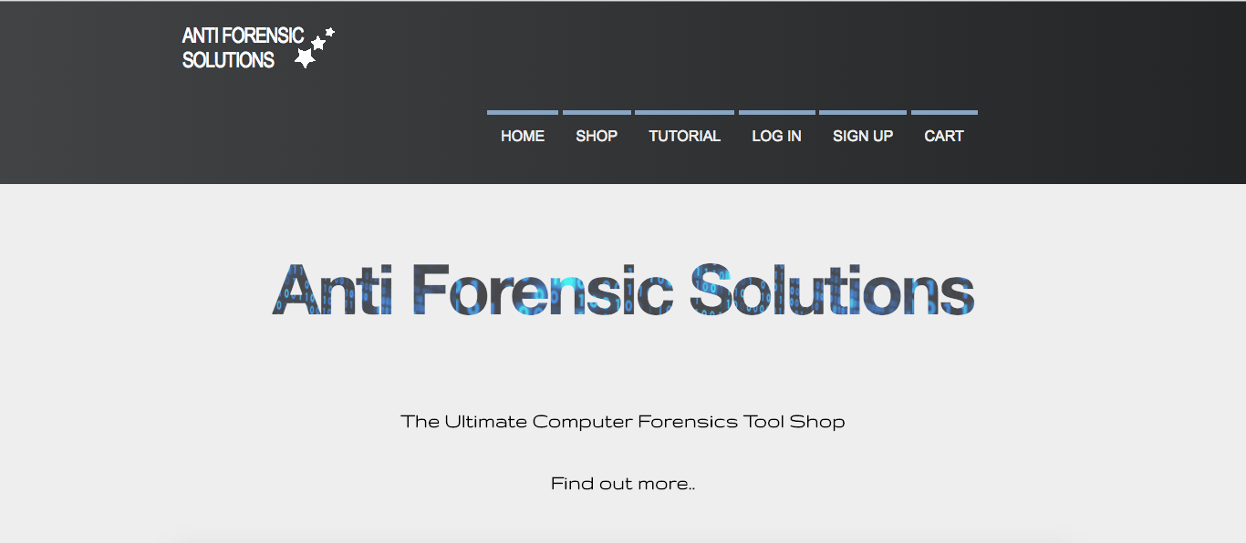

This was the first design I came up with which gave me a general structure to build upon throughout the development.

* Development

I was now at the stage where I could actually start creating a functional website. I used the designs of the logo and some mock up website designs as a basis. I first created the front end of the website using HTML 5 and CSS3 in sublime text editor. Once I had a near complete website I was then able to start working on the server side part of the website using Java Apache Tomcat (JSP & Servlets).

* Testing

Once the website was completed I began testing the functionality of forms and scripts. I also tested the websites optimisation for different browsers / screen sizes. I tested the website on the following:

* 22 Inch – Chrome / IE / Mozilla
* 11 Inch – Chrome / Safari
* 29 Inch – Chrome / Safari / Mozilla
* Maintenance

Once the website is up and running maintenance is key to keeping it functioning smoothly. I will check on a regular basis for updates to keep the website secure. With web technologies constantly changing I will have to keep myself up-to-date with current news in the industry to ensure the website runs to the highest quality.

**7.3.3 Technical Requirements**

As it was going to be a dynamic website with a working e commerce system it had to be developed using a number of different architectures. The front-end programming was developed using Sublime Text 3, which is a free text editor program. I then imported this into an Eclipse ‘Dynamic Web Project’ so I could start work on the functional parts of the website using an Apache Tomcat server and programming in Java. I also had to create a database to store information, such as user credentials and product information.

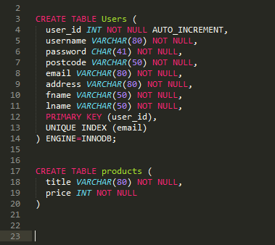

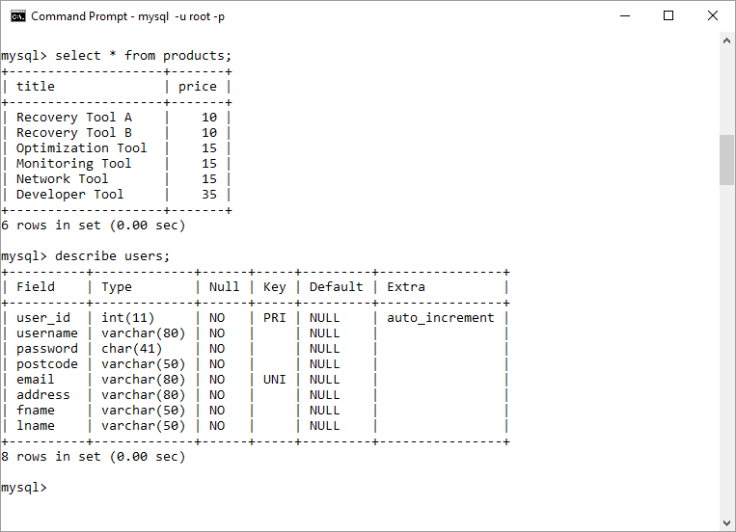

**7.3.4 Legalities**

There are certain requirements a website has to adhere to, more specifically e commerce websites.

There is a new legislation on cookie law. Websites must tell the users if they are using cookies and clearly explain what each cookie does. There is an exemption for cookies that are required for a shopping cart; therefore I did not need to include information on the cookies I used. [ico.org.uk]

I must also include a privacy policy page and contact information for our company, this information I have included in pages accessible from the footer as shown below.



There are a number of laws for e commerce websites. I researched into this and found some key legislations we must comply with on the website. [legislation.gov.uk]

* Acknowledge receipt of the order to the recipient
* Provide correct information to customers

**7.3.5 Online Deployment**

The website will be deployed on a Tomcat server using cloud hosting. I have looked in to all the different web host providers and decided Amazon Web Services would be the best option, at least for the first year. It offers a secure cloud based system capable of running Java Tomcat.

**7.4 Web Development Outcome**

**7.4.1 Website Design Outcomes**

* Clear structure and consistent layout on all pages
* Easy navigation throughout all pages
* Clean design, not too animation heavy to decrease loading time

**7.4.2 Logo Design Outcomes**

* Expresses what the company is about
* Clear brand consistent with the website design
* Company name used as the main structure of the logo

**7.4.3 Finished Product**



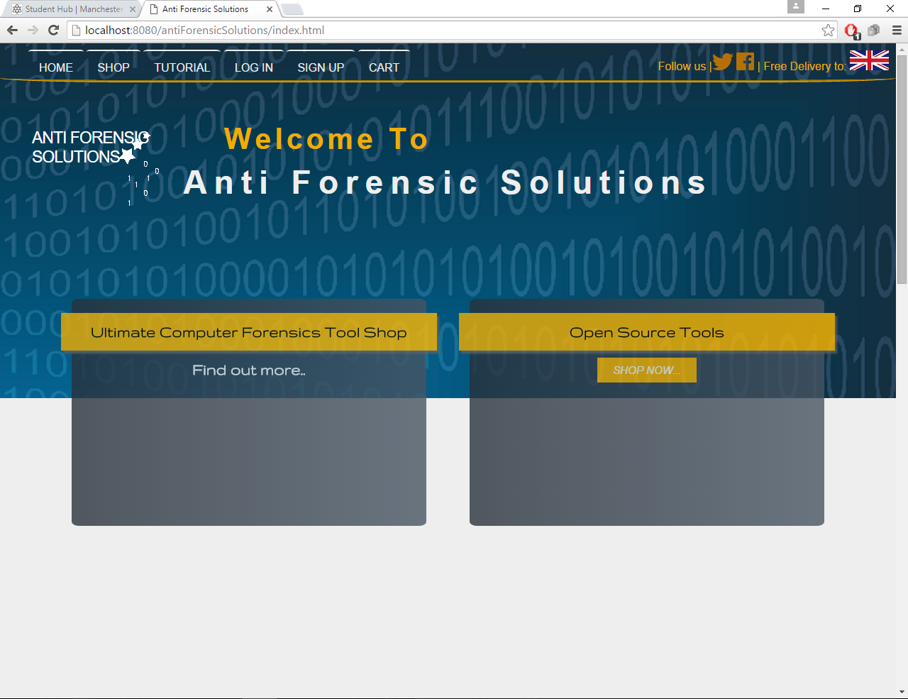

This is the home page presented to the user when they visit the website. It has clear navigation to all pages as well as the social media links. The first of the two promotion boxes takes the user to the tutorial page where there are embedded YouTube videos showing the products in use, and the later of the two takes the user to the online shop.

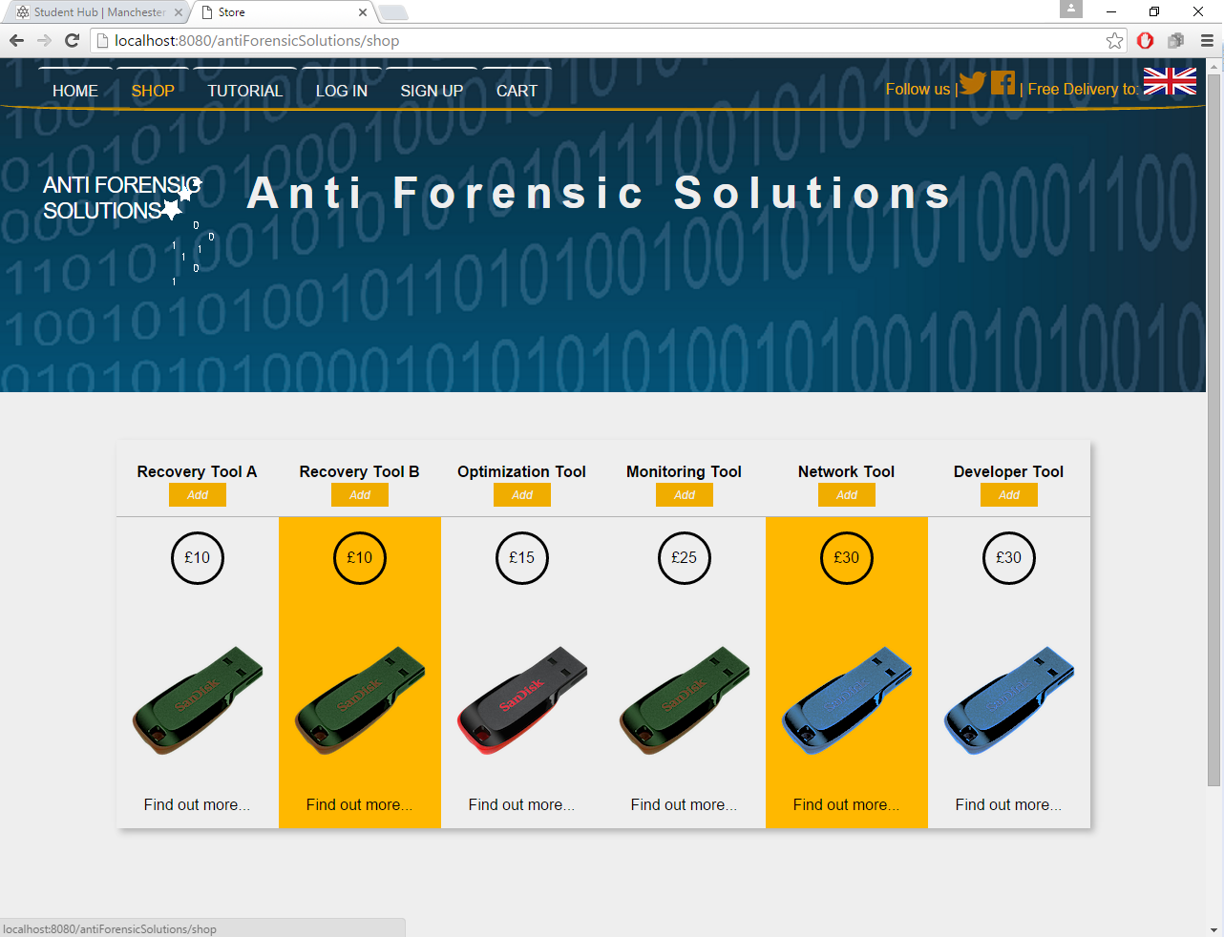

This is the shop page on the website. It displays the name of the product and the price (returned from the database), as well as a link to a page where the product is described in detail with comprehensive instructions (*instructions created by Hamza*). There is also a button to allow the user to add the item to the shopping cart.

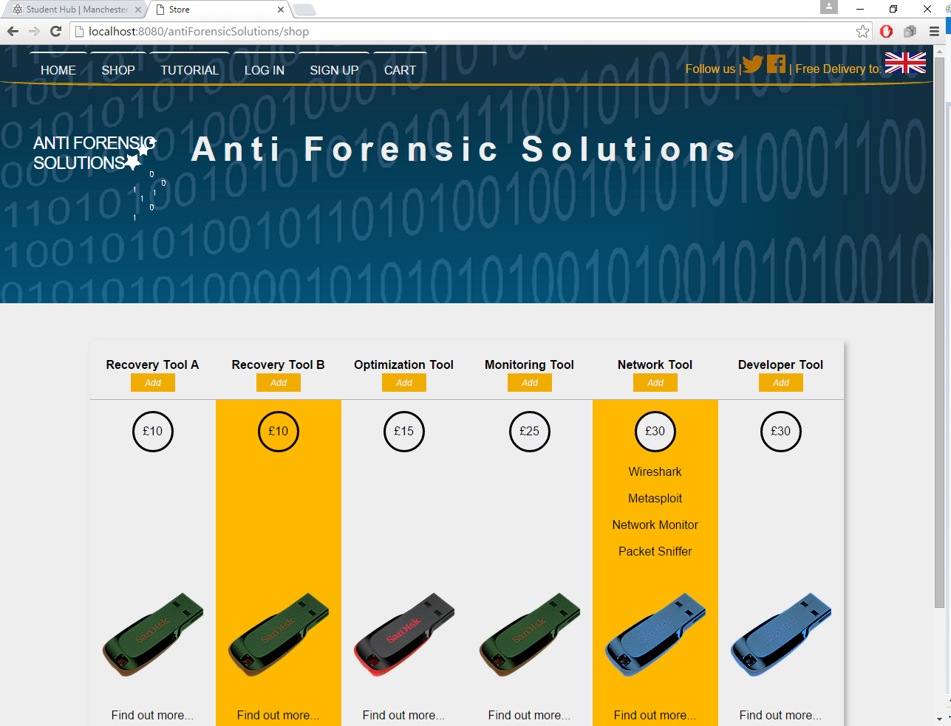

If the user hovers over the price of the product it creates a drop down list underneath giving details as to what is on the product.

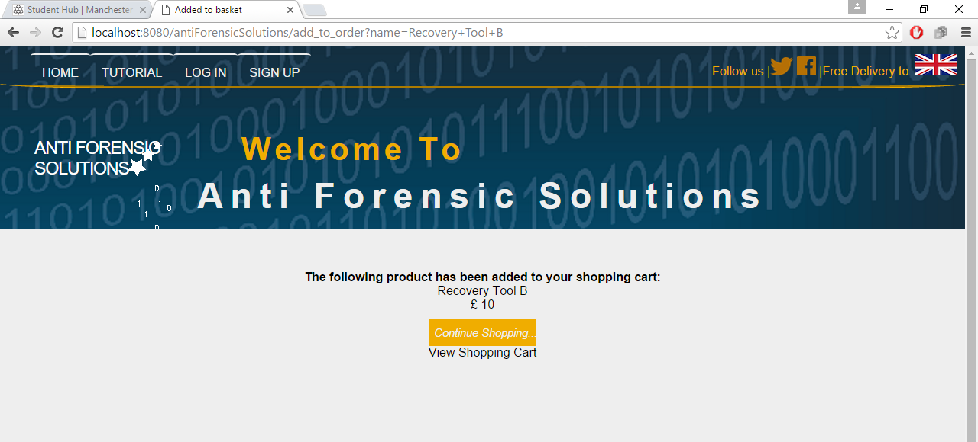

Once a product from the shop page has been added to the cart it takes the user to this page where it displays the product information. The user can choose to continue shopping or view the shopping cart.

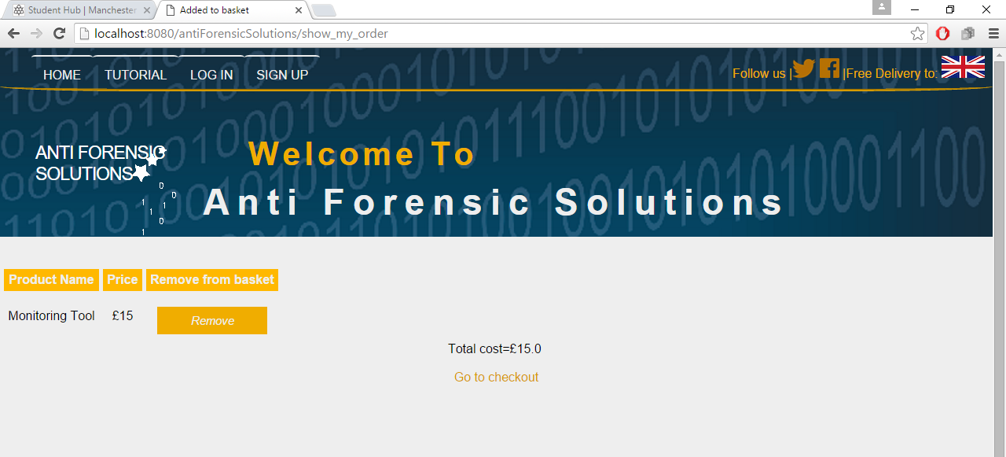

Here is the shopping cart with the product inside and the total price. There is also a link to remove the product from the shopping cart.

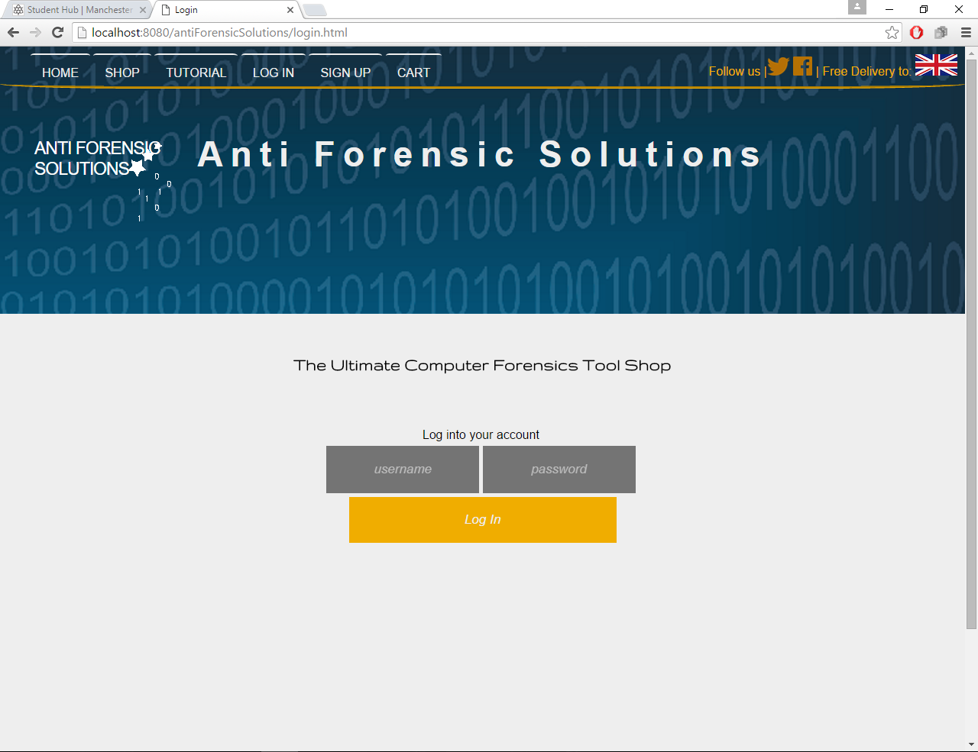

The user also has the option to log into their personalised account page to view their order history

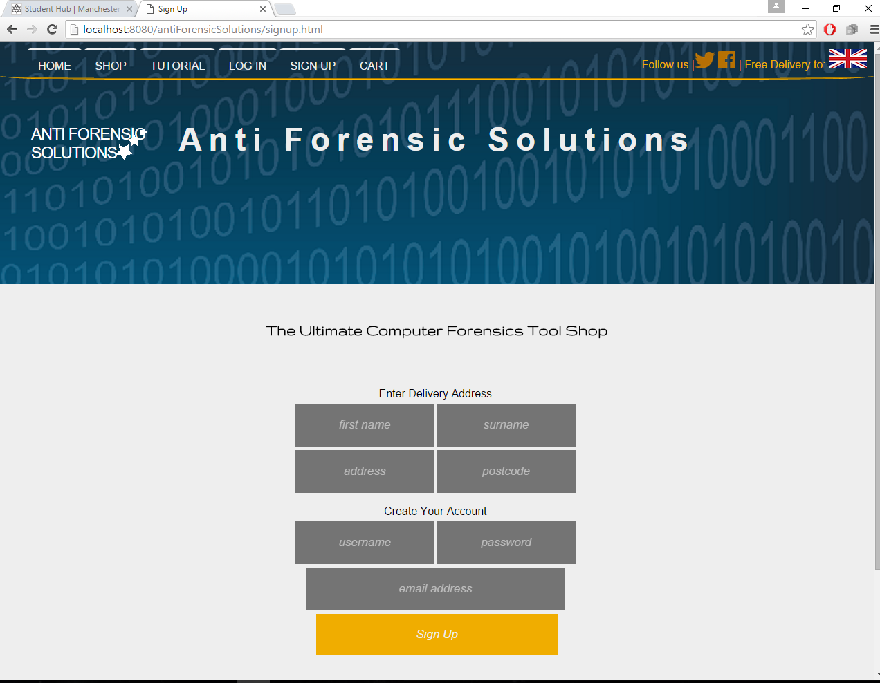

On the sign up page the user can enter their delivery details, which will be saved in the database.

**7.5 Problems & Solutions**

**7.5.1 Problems & Solutions**

One problem I came across was trying to get the web application to appear correctly on different screen sizes, with no incompatibility issues on varying browsers. I had to include a number of fallback methods within the CSS to ensure the browser displayed the web page similar to as I intended.

**7.6 Future development and plans**

**7.6.1 Google Analytics**

I plan on adding Google Analytics to the website to help us measure our growth and learn about how the users navigate our site so we can optimize it even further to suit their needs.

**7.6.2 Google and Facebook Login**

The majority of web users have either a Google account or a Facebook account. Some people might be put off by using the website if they have to create an account. Allowing them to use their Google or Facebook account to log in will not only speed up the process for them, but also offer a secure way for them to use the website.

**7.6.3 SSL Certificate**

Before the website can be deployed to the web I will need to purchase and set up an SSL certificate to keep our customers data safe and secure. After researching all the providers of SSL certificates I have decided the best option available is GlobalSign inc.

**7.6.4 PayPal**

As customers will be purchasing products from us using the website I will add an option for them to use PayPal as a payment method. This allows them to securely pay for goods with their credit/debit cards. It is a simple feature to add to the website and we just need to set up a business account to get started.

**7.6.5 Domain Name Registration**

I have compiled a list of potential domain names and checked them against DomainCheck to see if any of them are available. The domain “AntiForensicSolutions.com” is available for purchase and is the most suitable domain for our company. We also have the option of purchasing other top level domains to go with that, such as “.co.uk”.

**7.7 Justification of resources used to host & develop the website**

**7.6.1 Host Provider**

Here is a graphical list of the host providers I looked into.

Out of these host providers it was clear that Amazons Web Service was the best option for our company. Not only is it one of the most popular web hosts available, used by companies such as Netflix and Slack, it is also free for 12 months. After the 12 months have expired the price plan is very reasonable as it scales depending on your usage, thus reducing unnecessary costs.

**7.6.1 Technologies**

All the software I used to develop the website was completely free. I felt it was unnecessary to pay for software for developing the website. Apache tomcat was the obvious choice for the server side software as it the most widely used and free.

**7.8 Sources of Information**

<http://www.color-hex.com/color-palette/1837>

<http://visual.ly/why-good-web-design-so-important-your-business>

<https://ico.org.uk/for-organisations/guide-to-pecr/cookies-and-similar-technologies/>

<http://www.legislation.gov.uk/uksi/2002/2013/contents/made>

<https://www.globalsign.com/en/ssl/domain-ssl/>

<http://www.google.com/analytics/#?modal_active=none>

<https://developer.paypal.com>

<http://www.mochahost.com/java_servers.php>

<http://www.2020media.com/tomcat/java-tomcat>