**8 Sub-Project – Advertising and Social Media**

**[Collins Nyange]**

In this chapter I will discuss the following topics:

* Introduction
* Sub Project Aims & Objectives
* Advertising Research
* Social Media Research
* Problems & Solutions

**8.1.1 Subtitle**

**8.1 Introduction**

Anti-Forensic Solutions are a creative and efficient company, specialising in producing secure bootable pendrives to improve PC performance as well as recovering important data on our PC's, laptops as well as mobile phones. Our service aims to decrease the pressure, time and money as bringing solutions right to our clients. As a method of getting to reach out to our clients, weve used Social Network platforms such as Instagram, Facebook and Web banners.

**8.2 Sub Project Aims & Objectives**

**8.2.1 Subtitle**

Social Networks is an increasing exposure for Companies, increasing each year. As from our research we conducted in our University there's a great majority of students connected to various social network platforms. Facebook being the highest followed by Instagram as well as Snapchat. As a team we discussed that Facebook and Instagram being a great start to advertise our Company and expose ourselves to the public/Market. Our company will emphasise on services and support to differentiate ourselves from software and/or product sales oriented companies.

Our aim is to;

* Produce exposure to our clients,
* Produce Market insight,
* Establishing and improving our sales.

**8.3 Advertising Research**

**8.3.1 Subtitle**

Advertising research is a specialised form of marketing research conducted to improve efficiency of advertising. Our company have used customized research, conducted for a specific client to address that client's needs.

Our advertising research will focus on ads and direct an understading about our profile through our own website we designed as well as posting ads onto social media platforms i.e. Facebook, and Instagram as well as engaging with clients moreover bridging the expanding gap in the market need for password/wireless recovery, data protection, improving pc/laptop's performance and monitoring network activity.

Pre-market research can be conducted to optimize ads for any medium optimize advertisement for any medium: radio, television, (print newspaper or magazine), billboard, or internet. Our Company have created billboards and posters to advertise our profile. Moreover due to costs magazines, newspapers and television require a large amount of money as the platform would increase our awareness to the community. This is one improvement we could add, if we could administer more capital this would be very ideal for Anti-Forensic Solutions to create even a higher market insight.

Our target is PC and laptop users, our products are user friendly and do not require high IT skills. From Ages 13 to as far as 60+. We will target these population with posters, Facebook ads and maintain communications with the online communities i.e. Facebook, and make use of our specialist abilities to offer intermittent help and advice in forums on our website to raise our profile, build a reputation and gain trust.

Anti-Forensics Solutions will trial the effectiveness of web banner advertising and monitoring the success rate depending on the interest conclusion as a result. Depending on size of banner, average cost of advertising monthly is ~£(6 – 25) per thousand impressions but it would need to be trendy and eye catching therefore periodically changing the design, in order to try and counter the decline.

We will also trial the effectiveness of posters to advertise our profile, this would include time and commitment with the team speaking with nearby businesses e.g. Il Padrino and Abduls takeaway opposite of the All Saints Park and ask if we could put up our posters in their store. Fortunately this does not require any costs as it is free to use these stores to put up our posters. We will advertise our launching event through our posters as well as a summary of our products. They will be eye catching and designed to provide enough information needed. We would need to produce these posters for what we want to achieve thus meeting our objectives

Figure 8.1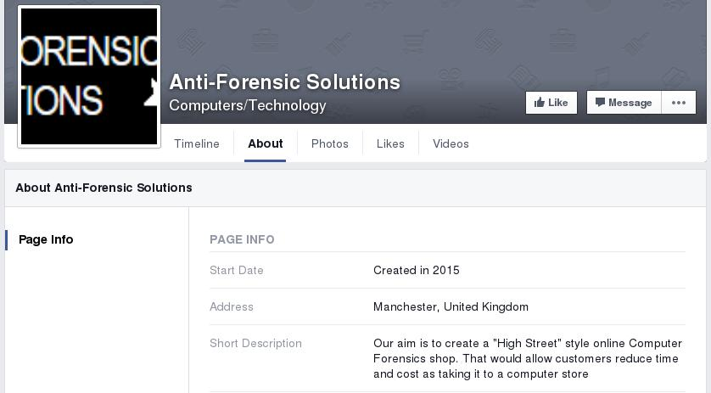

In figure 8.1 shows the facebook profile page I have created. I have stated out mission and a brief summary of who we are.

As you can see from figure 8.1 we have created a facebook page however is going to be improved with time, as firstly we need to look into our website ,local advertising as well as newspapers and magazines. Newspaper and magazines would be included for later use as it is another great form of producing exposure. Although resources would be very important on this stage as we would include more people in our Department so as to write articles for different magazines, producing our own blogs and communicating with people in need of help.

**8.4 Social Media Research**

Social media is a form of peer-to-peer communication that has become a popular way to connect with new and existing customers. Online social media and networks have a growing role in marketing, which has important implications for how consumers, channels, and companies perform. In social media settings, consumers provide online feedback about products, and this feedback is visible to other agents, including other consumers, channel partners, competitors, and investors. - [https://www.ama.org/publications/E-publications/Pages/ama-journal-reader-july-14-social-media.aspx#sthash.hL9atNkv.dpuf](https://www.ama.org/publications/E-publications/Pages/ama-journal-reader-july-14-social-media.aspx" \l "sthash.hL9atNkv.dpuf)

Due to the nature of our product/business , we require a high SEO and social media advertising is needed. Our company decided on creating a social media account such as Instagram, its fairly easy to set-up and use. Firstly, an email account is needed to create an account, I created a gmail account as it is secure as compared to Hotmail but still has its cons as Gmail collects data from the users and could lead to complications. Compared to Hotmail, Gmail offers more security as hackers have always get their way with their database.

Firstly we used Instagram, it is a great platform to connect with customers, as it has grown immensely ever since it started, although it does require time to advertise the account. We have linked it with our website and Facebook as well. This would allow us to increase our market exposure. With the rising population and increasing use of the Internet with new technology, in a few years to come most of the population will be connected with social media accounts.

As studies shows around 40% of the world population has an internet connection today. In 1995, it was less than 1%. The number of internet users has increased tenfold from 1999 to 2013.

Therefore we have created a website of our own currently being developed by our Web Development department, led by Adam Morrison and Collins Nyange. It will declare our company mission statement and will present our company and our services in a very clear, very professional, easily accessible format. Moreover customers could register on our website and will be able to order online as soon as our products go on sale. Our website is aesthetically pleasing and simple to navigate around. It can currently be reached via www.anti-forensicsolutions.biz and will soon be launched onto the University Domains.

Secondly Facebook is another platform we created to reach out to greater community of people thus creating a greater market insight. Our page would consist of our Company profile and updates of our products and also provide a community forum whereby everyone can leave a commment. And with our Social Network department would be able to consult with people one to one and assisting them with whatever they require 24/7. This would benefit us as studies show that the daily active users facebook is **1.01 billion** on average for September 2015, an increase of 17% year-over-year. This shows the amount of people we could reach out to worldwide.

Although using a social media is an advantage for our company but it has it disadvantages, firstly it is time consuming. Utilizing a facebook page to produce exposure with the customers is very time-consuming if done right. In addition watching out for negative comments, as a business such as ourselves we will try respond in a respectful and professional manner. Secondly advertisements is cost effective in order for Facebook to promote our page. Paying £4 as a starter to reach out locally for a specific amount of time and increases with the area radius in which you want to advertise for your company. However social network ad campaigns would increase the traffic to our website and improve rankings on search engines as well.

**8.5 Problems & Solutions**

In conclusion social media and advertising is a great strategy any business can use to create exposure to the clients/market. Through our website we established how customers would be able to buy our products as well as communication; moreover creating a link of both our Facebook and Instagram accounts. It is important that we continue to market our company effectively, to maintain the balance between profit and loss, and compare with our competitors as well as keeping our strategies focussed on our growth. Our advertising will evolve and change as necessary to stay updated meeting our short term as well as long term goals.

One solution we will implement in the future is exploring the benefits of TV and Radio advertising, and capitalize on further online advertising services such as Youtube and Google ads. We could implement the Cost Per Click internet marketing strategy into our advertising campaign with Google Ads. We are currently aware of no threat posed by competitors when searching Anti-Forensic Solutions therefore we would decide on a reasonable cost to ensure the links between our website will be first to displayed on the seach results.

We encountered that TV and Radio advertising has a great costs. A rough perspective, a week long campaign that uses a 30 second ad without production costs could cost anything from £500 on a local station and can increase to £10,000 on a national station. As we continue to grow as a company, from increasing sales and profits we could afford to advertise into higher level of advertisement strategies.

Time and resources is one of the biggest drawbacks we encountered of having a facebook page. Our Social Media team understood that it does take time after setting up the facebook page for people to start following us. As well as maintaining the page takes time, resources and energy. Therefore our company would require a dedicated member of staff to monitor and respond to posts on a regular basis, and fortunately I, Collins Nyange have been appointed to do so. Moreover we did encouter that it is cost effective advertising on Facebook however a reasonable advertising budget would be essential to the success of our Facebook page. We have exeperienced very slow growth however in time and essential budget we are projecting an a rise of activity in both our website and social media platforms.

There are other social networks we could have used such as Google+ but none come close to Facebook's overwhelming user base of 1 billion. In my view, if your willing to put the time and resources into your business's Facebook page the positives outweigh the negatives. Setting up the Facebook page and how we utilized its applicatins for our business depended on our Company on a case to case basis. Our first case basis was encourage a market insight as well as increasing exposure with our clients.

In conclusion with the increase numbers of facebook and Internet users gradually increase each year it is a great potential for new businesses to utilize to gain a market insight and produce exposure. Thus sales would start to rise as we would be achieving clients. Thus our aims would be met through this marketing strategy. Although there are various negatives however the positives outweigh these. Social media and advertising is very important for a business to create exposure. Additional advertisements such as Google+, LinkedIn and Snapchat could be a great potential and increase our market insight. As a company we would discuss and implement new ways we could add these in achieving our long term goals.

IN THE NEXT CHAPTER…

In the following chapter, the Marketer, Asahd Mahmood will provide an evaluation on the current market and deliver an outline for a proposed launch event to kick-start the Company.