# **10 Project Review and Analysis (Conclusion)**

# **[Dale Stubbs]**

Within this chapter I will discuss the following four topics:

* Project Strengths
  + Cohesiveness
  + Communication
  + Time Management
* Project Weaknesses
  + Attendance
  + Deficiency of knowledge
* Communication Analysis
  + Student Email
  + Moodle
  + Team meetings
  + Google Drive
* Have responsibilities been carried out?
  + Tasks completed
  + Deadline met
* Overall Conclusion

This will provide an insight into the operation of the project and emphasise any problem areas that became apparent whilst also enlightening all of the areas where we excelled.

## **10.1 Project Strengths**

### **10.1.1 Cohesiveness**

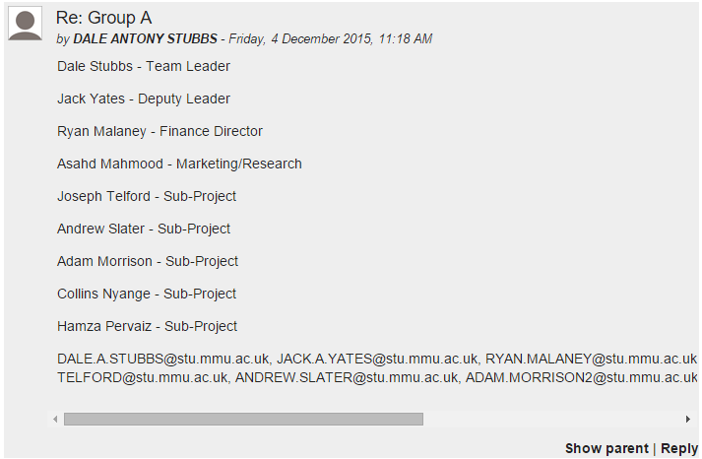Our greatest asset was our cohesiveness from the offset. Within the first twenty minutes of creating the team everyone had made a decision as to which title each of the members was going to take on. As I was the oldest, and therefore the most experienced, member of the team I was elected as Team Leader and within minutes everyone was assigned their chosen roles with absolutely no conflict to attempt to resolve. Initially we had nine team members and a tenth was added following the Christmas Break. Adding the tenth member to the team was a challenge however we succeeded nonetheless.

### **10.1.2 Communication**

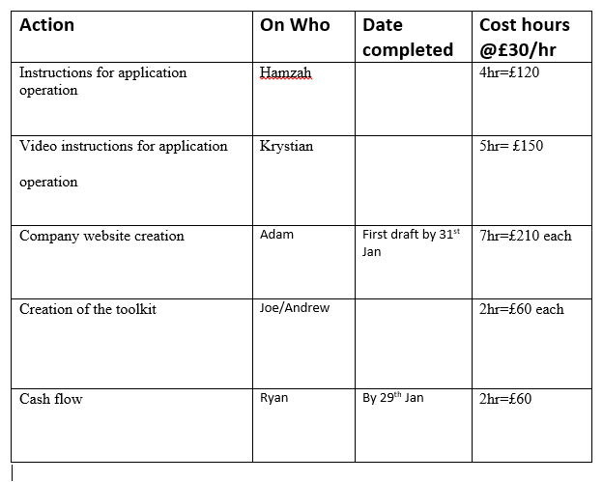Throughout the project we utilised multiple forms of communication which will be analysed later within this chapter. The effectiveness of the communication resources we required was key to the overall success of this project as communication is key within most aspects of life. We found that the most effective source of communication was the scheduled team meetings on a Friday morning during our Professional Development lab session. This source of communication was especially effective for analysing the requirements that each team member required in order to meet their ‘internal’ deadline and allow the subsequent team member to proceed unimpaired.

**To be replaced with mock-up meeting minutes**

### **10.1.3 Time Management**

Time management was also one of the most demanding aspects of this project. All of the team members had multiple commitments to other projects and subjects meaning their time management skills were tested almost to the limit of fracture! Even though we all had other commitments to fulfil we mostly managed to maintain our deadlines with only one deadline extension required. This was an unbelievable feat in itself. Ten different team members mostly keeping to their specified deadlines and producing two separate reports as well as a fully functioning prototype of the product in only fourteen weeks is the result of dedication from each and every team member. The only extension required was in order for the team member to obtain additional training on the tools required due to lack of experience with the aforementioned tools.

**To be replaced with Gantt Chart**

## **10.2 Project Weaknesses**

### **10.2.1 Attendance**

The attendance to the additional group meetings was our largest pitfall. Whilst the attendance to the Friday morning scheduled labs was largely well attended the additional meetings that were arranged were sparsely attended and therefore almost a complete waste of time. This was largely due to clashes with timetables as was to be expected with a team of ten members. Also I was absent for a lot of time myself due to family illness that, unfortunately, needed to come before my University. I did however still maintain the lines of communication with the rest of the team.

### **10.2.2 Deficiency of Knowledge**

The lack of background knowledge of the required tools, business trade and all other aspects of the project really hindered our progress at the start of the project. It required much more research and training than we first anticipated so we needed to allow more time for the initial starting point of the project. All of the team members are Computer Forensics and Security students and are not trained for business analysis or accounts so these areas needed extensive research and multiple attempts at each intersection in order to correctly proceed.

### **10.3.1 Student Email**

## **10.3 Communication Analysis**

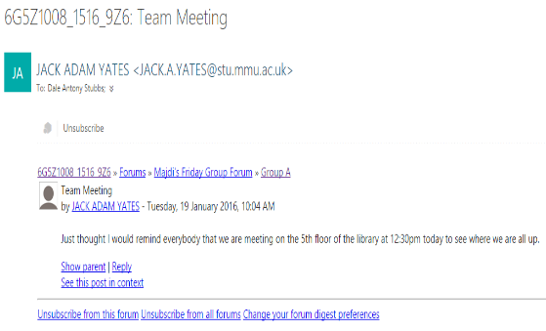The email addresses provided by the University were the single biggest communication tool used online. It was originally the only way that most of the team members were able to communicate with each other and, as such, was an indispensable tool. We were originally instructed NOT to use any form of digital communication (e.g. Facebook Messenger, Skype, Text Message etc.), with the one exception of the forum provided on Moodle, as the tutors had no way to monitor these communications between the team members and therefore every team member subscribed to the forum made available to us on Moodle with their University provided email address. This allowed for every member to read and reply to every other team members’ messages posted within the forum.

### **10.3.2 University Moodle**

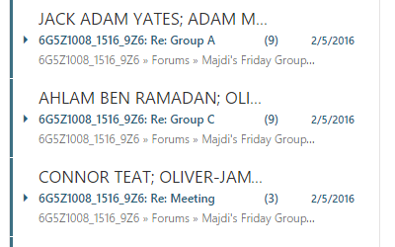The aforementioned Moodle forum provided to us was a great tool for communication however it had one simple but quite large flaw, every team from Madji’s Friday AM lab who subscribed to the forum received notifications from all other pathways. This initiated an influx of messages to each team member from other members of our own team and every other team too. This created a very perplexing arrangement as with each notification followed the opening of an email that potentially had nothing to do with our team. Aside from this flaw the communication via this medium was very good and well maintained by each team member.

### **10.3.3 Team Meetings**

Out of all of the communication mediums the team felt that the team meeting were the best form of communication. As mentioned earlier within this chapter all of the predetermined team meetings were very well attended. This allowed every member to effectively state exactly where they were up to within their own topic of the project and what, if any, help was required and from who. It also allowed the finance leader to interrogate the team members in order for him to assign wages for that particular week. A weekly action plan was created every week to allow team members to ensure that they knew exactly what was required of them for any given week.

The minutes that were taken during these meetings also allow for the team to look back to the previous week and to discover if there was anything that needed doing for the current week and to ask if it had been completed (similar to the action plan but with more details).

### **10.3.4 Google Drive**

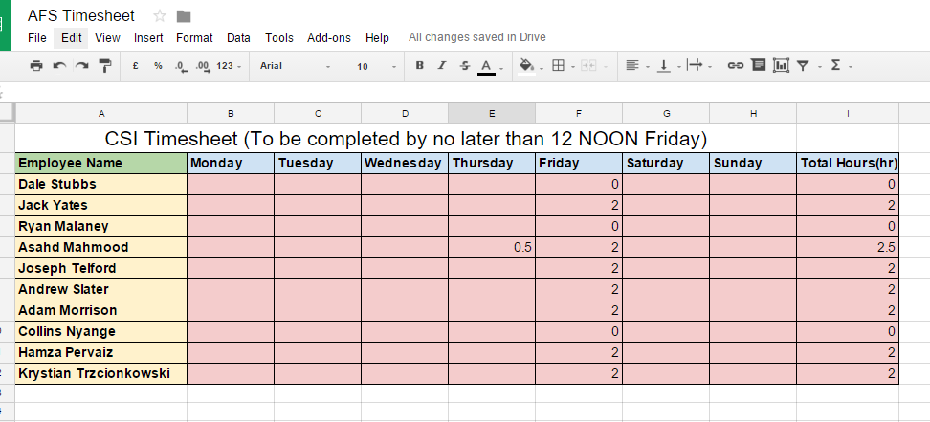I used my personal Google Drive to allow shared access to any files that were required (access granted upon request for the tutors). This tool was very useful when filling out the weekly timesheet for the group. Every member was responsible for putting their own hours onto the timesheet and then proving what they did during the specified hours at the team meeting. If the hours weren’t added to the timesheet by 12 noon on the Friday then no wages were issued in that week.

### **10.4.1 Tasks Completed**

## **10.4 Responsibilities Maintained**

Although one of the tasks went over its original deadline every team member completed their given tasks and the project was completed fully. All of the sub-projects have been completed and merged together to make the final product and a prototype has been created for the purposes of showcasing the product during the upcoming poster event. For a team of ten members it was unthinkable at the start of the project that everyone would get their respective jobs done as there is usually one or two team members that attempt to coast through the task and let everyone else do the work for them. This was not the case within our team, everyone worked together when required to and also pulled their own weight when they needed to push on alone.

### **10.4.2 Deadlines Met**

At the beginning of the project a Gantt chart was created to facilitate in the time management aspect of this project. Each team member was given their tasks based on their roles and deadlines were issued to each task. Only one deadline was missed during this entire project yet, even though this deadline was missed, the action was still completed and had little effect on the subsequent tasks. The project went on to be fully completed by the specified deadline with great success.

## **10.5 Overall Conclusion**

*“There is always strength in numbers. “* (A-Z Quotes, 2016)

The quote above is accurate when it comes to large organisations and items of that scale. The same cannot be said when attempting to organise a very small project like the one we have just completed. Although ten members is not considered a large team it is still incredibly difficult in organising and manipulate a team of this size. However when all is said and done the team did pull together and complete exactly what we originally set out to do and that was to create a new product and to have it ready to be released to the general public and I am proud to say that we have completed that task and completed it well.