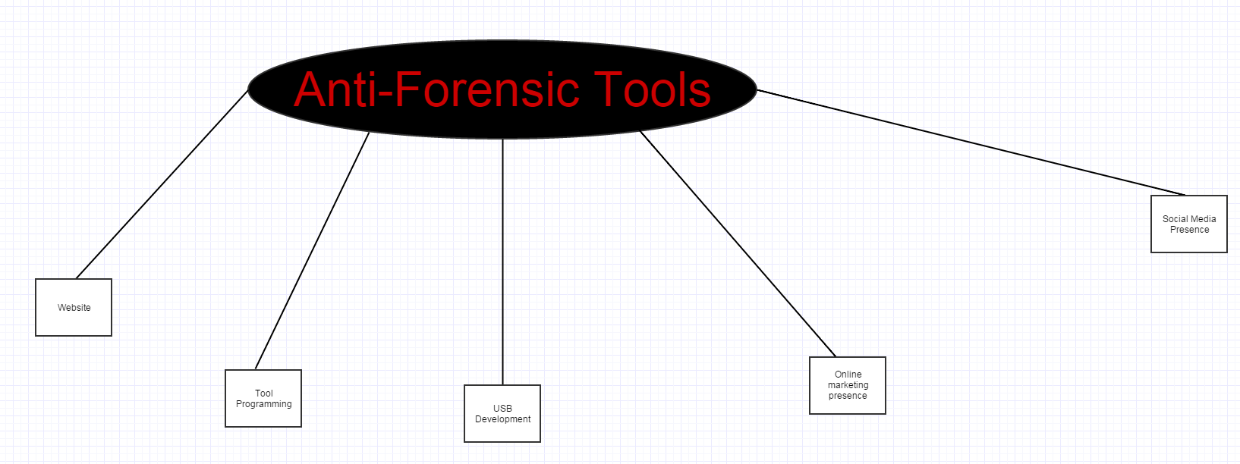Leader:

Sub-Project

Sub-Project

Sub-Project

Sub-Project

Sub-Project

Deputy Leader:

Finance:

Marketing: