**Project Proposal**

**Level 2**

**Blockchain-Based Vehicle Registration and Ownership Management System**

Troyrangers

Faculty of Information Technology

University of Moratuwa

2022

Page Break

**Project Proposal**

**Level 2**

**Blockchain-Based Vehicle Registration and Ownership Management System**

Troyrangers

|  |  |
| --- | --- |
| Dissanayake D.M.B.M. | 204047J |
| Herath P.A.U.D. | 204074M |
| Jayathilaka P.H.P. | 204087F |
| Pathirana S.P.S.N. | 204150T |
| Rathnayaka A.M.D.B. | 204179N |

Supervisor:

Dr. Thanuja A.L.A.R.R.

Department of Computational Mathematics

University of Moratuwa

 ………………………………….

(Signature)

Faculty of Information Technology

University of Moratuwa

2022

Page Break

**Contents**

Page Break

1. **Introduction**

Due to the development of blockchain, centralized organizations can be replaced with a decentralized collection of assets and participants. In 2014, Ethereum, a second-generation blockchain, was released, enabling programmers to execute smart contracts on a distributed ledger. Developers and companies can design financial apps using smart contracts that leverage cryptocurrencies and other token types for things like decentralized financing (DeFi), crowdfunding, decentralized exchanges, data archiving, etc. Recent developments in distributed ledger technology have produced ideas that reduce costs and simplify value exchange. Today, digital assets might be represented as tokens that existed in the blockchain network by utilizing the benefits of blockchain and considering the governance concerns, which simplifies their transmission and traceability, boosts their transparency and strengthens their security.

In the context of blockchain technology, there are two main categories of tokens: fungible tokens, where each token has an identical value, and non-fungible tokens (NFTs), which have special properties and cannot be exchanged. Non-fungible tokens are actually digital assets with a special ID that are kept on a blockchain. The concept of NFT was first introduced in Ethereum Improvement Proposals (EIP)-721 and then developed in EIP-1155. Beginning in early 2021, NFTs developed into one of the most popular blockchain applications that attracted attention on a global scale. They might be computer recreations of actual things. The ownership of digital goods (such as images, music, movies, and virtual creations) that can be traded is documented in blockchain smart contracts. As one of the first NFTs on Ethereum, CryptoPunks has created approximately 10,000 collectible punks and contributed to the growth of the ERC-721 Standard[1].

In our Blockchain Based Vehicle Registration and Ownership Management System, we are minting an NFT for the purpose of representing a vehicle as a digital asset. Through that, we can register vehicles. Not only that, but also transfer the ownership of vehicles securely when we are buying or selling them.

1. **Background and Motivation**

Digitizing nonreal things has been tested until now. But digitizing real-world things have not yet. Our project is mainly focusing on changing the ownership of a vehicle online. That means this system will use to digitize a real-world thing like a vehicle. This ownership transferring of vehicles can’t be done transparently and securely using a centralized database. A centralized database is essentially a database type that is kept, located, and maintained exclusively in a single place[2]. But to address this problem using blockchain technology gives more additional features. Blockchain is a decentralized, immutable database that makes it easier to track assets and record transactions in a corporate network[3]. A centralized database and a blockchain have differences according to their architecture, immutability, data handling, and transparency. Due to the immutability, transparency, and security of these blockchains, it is better to use blockchain technology to address our problem because transferring vehicle ownership has to be more secure[4]. If anyone needs to change data in a blockchain that hacker has to change more than fifty percent of that blockchain nodes, and it is impractical to do such a thing. That’s why blockchains coming handy for secure transactions like changing vehicle ownership.

Nowadays, NFT (Non-Fungible Tokens) is very popular among investors due to the digital value given to intangible things. One of the major reasons which resulted in this popularity is the blockchain technology behind these systems. NFTs, or non-fungible tokens, are blockchain-based tokens that individually represent a special asset like a work of art, a piece of digital material, or other media [5].

Nowadays although all the systems are computerized in many fields there can happen, changing data without permission. It is a huge problem today. Therefore, our reference company “Crede Technologies” have come up with a great idea to allow digital information to be recorded and distributed, but not edited. They wanted to do this process related to the vehicle ownership field. Therefore, we decided to use Blockchain Technology to develop their intention as our project.

Nowadays in Sri Lanka, still the vehicle registering and transferring process is done through the physical documents and computerized somewhat far. But it will be a great investment if we can introduce this system for Sri Lanka.

1. **Major Issue – Mutability**

The word "mutability" refers to the attribute of changeability[6]. Ownership of a vehicle must not be changed by others unnecessarily. But when using a centralized database unauthorized people can change data and we can’t track those changes. Therefore, this is a huge security burden for this kind of high security needed system. This is our major problem.

1. **Aim & Objectives**

Aim: The aim of our project is to develop a system for registering and transferring vehicle ownership from one person to another in a secure manner with the use of Blockchain Technology.

Objectives:

* Study the problem of registering and transferring vehicle ownership from one person to another through the documentation.
* Facilitate digitizing the system of registering and transferring vehicle ownership from one person to another.
* Create the ability to generate a digital id for verifying person and vehicle identity.
* Design the appropriate system including all user requirements.
* Develop the system for solving the problem.
* Evaluation of the proposed solution.
* Preparation of final documentationPage Break

1. **Blockchain Based Vehicle Registration and Ownership Management System**

As the solution for the identified problem, we decided to implement a Blockchain Based Vehicle Registration and Ownership Management System. Our main intention of Blockchain-Based Vehicle Registration and Ownership Management System is digitizing the registration and management system of vehicles. We want to implement our system with transparency as the security is the most required factor in these days. Therefore, it is not much better to use centralized database and therefore as the best way, we use a Blockchain.

The main task of our Blockchain Based Vehicle Registration and Ownership Management System is convert a physical asset into a digital asset. As an example, in our system we convert vehicle asset into a NFT (Non-Fungible Token). And also, we can track all the important information such as transfer date of the vehicle, the person who owned the vehicle after transferring, in a super secure manner.  There is a special process that happened in registering the vehicle. When we are registering the vehicle, we can create (mint) NFT with an important description of the vehicle including all the details. According to that, there can be photographs of the vehicle according to the standards, and also all the information related to the vehicle which are included in the Vehicle Registration Book. Not only that, but also, we create a vehicle marketplace to provide the facility of selling and buying vehicles. In here we can buy and sell vehicles as we wish. In this process, transferring the ownership of the vehicle is happened through the NFT. When there is a vehicle is not in a usable condition that means removed from the usage, we can burn the required NFT. But the information related to that NFT will be remain forever in that blockchain.

In the current situation, there is not a proper way to show a person’s digital id. That means a person can’t be legally identified. Because of that we have to issue a digital verifiable ID for them. As we can identify the vehicle owner through this digital verifiable ID, we can use this ID to login and logout the digital marketplace. We are introducing a new cryptocurrency to do the transactions in this vehicle marketplace. For creating this digital ID the Indy blockchain have to be used.

To implement this project’s web-based part, react and Django frameworks will be used. And also, there will be a mobile application parallel to this project and for that, react native will be used.

Page Break

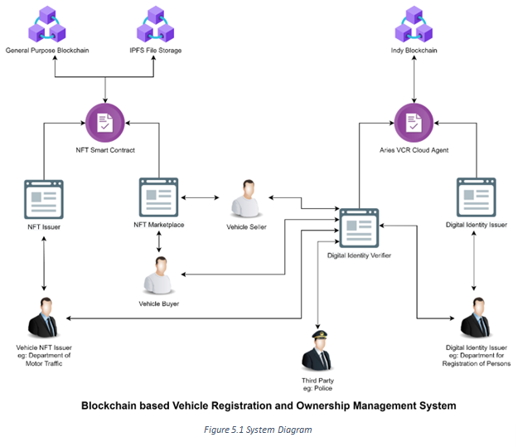

1. **Resource Requirements**

* 2 x 4 cores; 4GB RAM; 100GB SSD; Ubuntu 18.04 servers for deploy testing blockchains.
* 2 cores; 2GB RAM; 100GB SSD; Ubuntu 22.04 server to host 4 web servers.
* 5 High performance laptops for development team
* High speed internet connection
* Pycharm Python IDE
* Webstrom JS IDE
* Figma to design frontend
* Github for version controlling
* Jira for project management
* Page Break

1. **References**

[1] S. M. H. Bamakan, N. Nezhadsistani, O. Bodaghi, and Q. Qu, “Patents and intellectual property assets as non-fungible tokens; key technologies and challenges,” *Sci. Reports 2022 121*, vol. 12, no. 1, pp. 1–13, Feb. 2022, doi: 10.1038/s41598-022-05920-6.

[2] “Difference between Centralized Database and Distributed Database - GeeksforGeeks.” https://www.geeksforgeeks.org/difference-between-centralized-database-and-distributed-database/ (accessed Sep. 21, 2022).

[3] “What is Blockchain Technology? - IBM Blockchain | IBM.” https://www.ibm.com/topics/what-is-blockchain (accessed Sep. 21, 2022).

[4] “Blockchain vs Database: Understanding The Difference.” https://101blockchains.com/blockchain-vs-database-the-difference/ (accessed Sep. 21, 2022).

[5] “Non-Fungible Tokens (NFTs) Explained | AWS Blockchain.” https://aws.amazon.com/blockchain/nfts-explained/ (accessed Sep. 21, 2022).

[6] “Mutability - Definition, Meaning & Synonyms | Vocabulary.com.” https://www.vocabulary.com/dictionary/mutability (accessed Sep. 25, 2022).

1. Page Break**Appendix - Plan of Action**

|  |  |  |  |  |  |  |  |  |  |  |  |  |
| --- | --- | --- | --- | --- | --- | --- | --- | --- | --- | --- | --- | --- |
|  | **2022** | | | | **2023** | | | | | | | |
|  | **Sep** | **Oct** | **Nov** | **Dec** | **Jan** | **Feb** | **Mar** | **Apr** | **May** | **Jun** | **July** | **Aug** |
| Study about blockchain, React, Django |  |  |  |  |  |  |  |  |  |  |  |  |
| Requirements gathering and analysis |  |  |  |  |  |  |  |  |  |  |  |  |
| System Develop |  |  |  |  |  |  |  |  |  |  |  |  |
| Implement web application |  |  |  |  |  |  |  |  |  |  |  |  |
| Implement mobile application |  |  |  |  |  |  |  |  |  |  |  |  |
| System Testing |  |  |  |  |  |  |  |  |  |  |  |  |
| Finalize the project |  |  |  |  |  |  |  |  |  |  |  |  |