Food Go development report
  - Website and mobile progress
Prepared for the Food Go project owner
12 November 2026
Food Go has a working discovery preview and a React Native mobile foundation. The Supabase SDK connection now passes a read-only check. You can search example venues, save places, plan trails and try the restaurant draft. Application accounts, live venue data and production services still need the setup explained in this report.
The website and mobile code are kept in the same repository and are designed to use one shared venue database. An owner should enter a venue once, with approved information then appearing in both the marketplace and the game.

What you can review now
Area | Current position
Discovery and collections | Working preview with clearly labelled example venues and dishes.
Restaurant onboarding | Three-step draft with validation, review and an in-page preview.
Accounts | Local Supabase SDK connection verified. Account routes remain disabled while database setup, provider settings and release safeguards are completed.
Android and iOS | React Native source and Android, iOS and Expo web JavaScript exports passed on 11 November. Signed store builds and real phone testing are still required.
Live restaurant service | Ownership checks, published listings, check-ins, bookings and payments still need implementation or connection.

The screenshots were captured on 11 November and show the existing interface. The SDK setup does not change the map or screens. Example bookmarks are plans, not proof of a visit. No venue is published and no reward is earned by completing a local preview.

Reading this report
The following pages explain the important screens, the technical and security work, and the remaining launch work. The final two sections list the subscriptions to buy and the actions required from your side.
Project source and development history

Exploring places
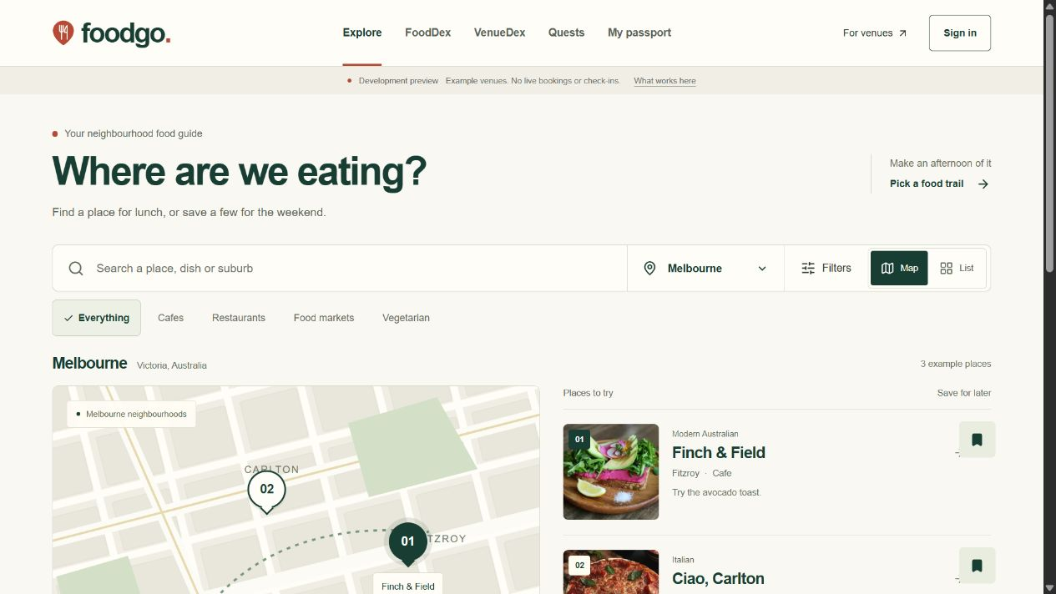
The revised desktop Explore screen with example places.
The Explore screen is the starting point. An explorer chooses a city, searches for a dish, cuisine or suburb, and narrows the results by venue type. Map and list controls offer two ways to browse the same example venues.
The revised layout puts the map and useful venue details before decorative marketing content. Clear names and direct labels help people decide where to look next. The illustration is not a live navigation map and does not collect location data.
The example listings currently cover Melbourne. Selecting another city must show an honest empty result rather than suggesting that participating venues have already joined throughout Australia.

Try it
- Choose Melbourne and search for a cuisine or suburb.
- Change the category, switch the view and select a map marker.
- Save a place, then open VenueDex to find it again.

Website on a phone
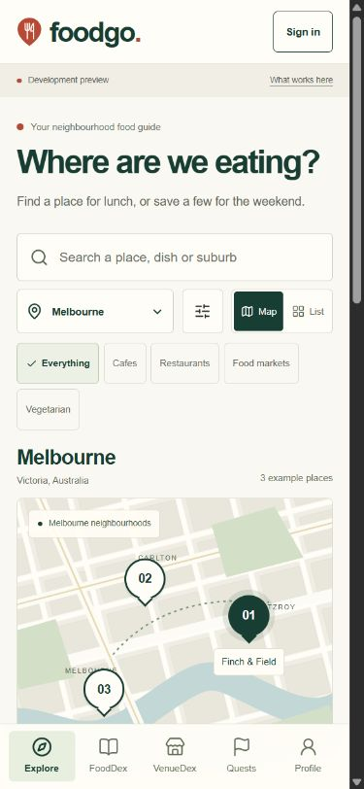
The website at a phone width. This is not a native device screenshot.
The phone layout uses a bottom navigation bar and one main page scroll. The content changes width instead of creating a second scrolling panel.
React Native source and Android, iOS and Expo web JavaScript exports passed on 11 November. Signed store builds and real phone testing are still required.
Native Android and iOS device testing is still required. The React Native application is separate from this mobile-width website view. Live camera, QR and location features are not connected.

React Native app preview
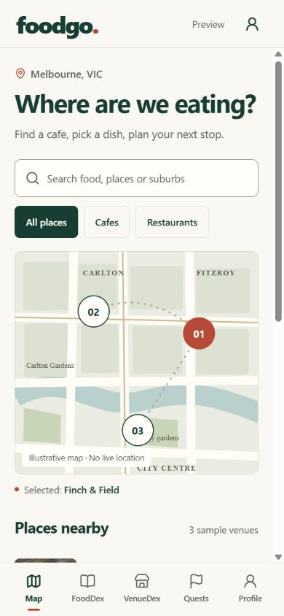
The React Native application running through Expo Web in a browser.
This is the React Native application running through Expo Web in a browser. It is a different application from the mobile-width Next.js website shown earlier. It lets us review the mobile app's shared screens, navigation, example map and planning controls.
The browser preview does not prove native iPhone or Android behavior. Device testing is still needed for permissions, cameras, safe areas, touch behavior and performance. Production JavaScript exports are build checks, not app-store packages or device certification.
The mobile example saves and plans last only for the current app session. They do not sync with the website or an account.
The mobile source uses the same five main sections: Map, FoodDex, VenueDex, Quests and Profile. Saved examples and plans do not create verified visits or earned rewards.

Looking at a venue
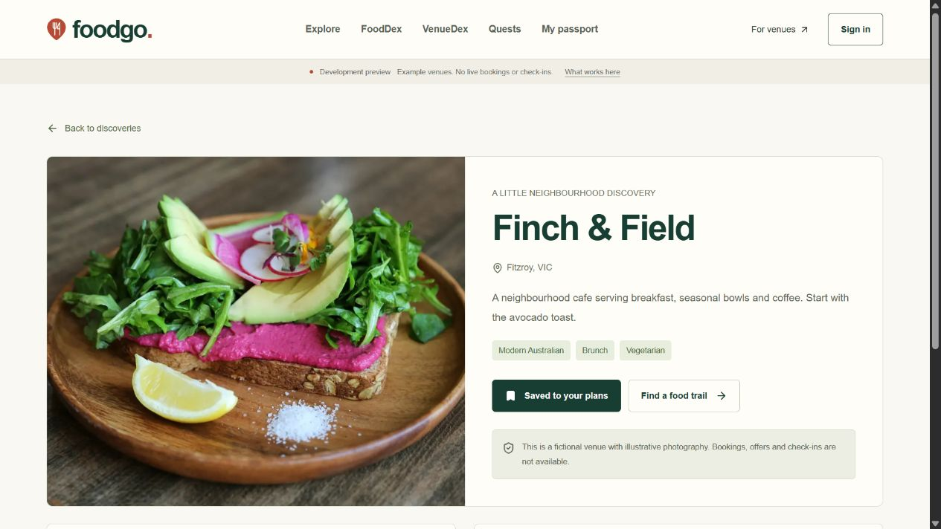
An example venue page with a save action and signature dish idea.
A venue page brings together its name, suburb, food style, photograph and example signature dish. The save control adds the place to the user's planning list. The food trail link opens the available example adventures.
The current venue names, address descriptions and participation are fictional. The photographs illustrate food. Real opening hours, menu prices and dietary information will need to come from verified venue owners.

Try it
Open a venue, save it and use the food trail link. The save action should change its label and the saved count.

FoodDex
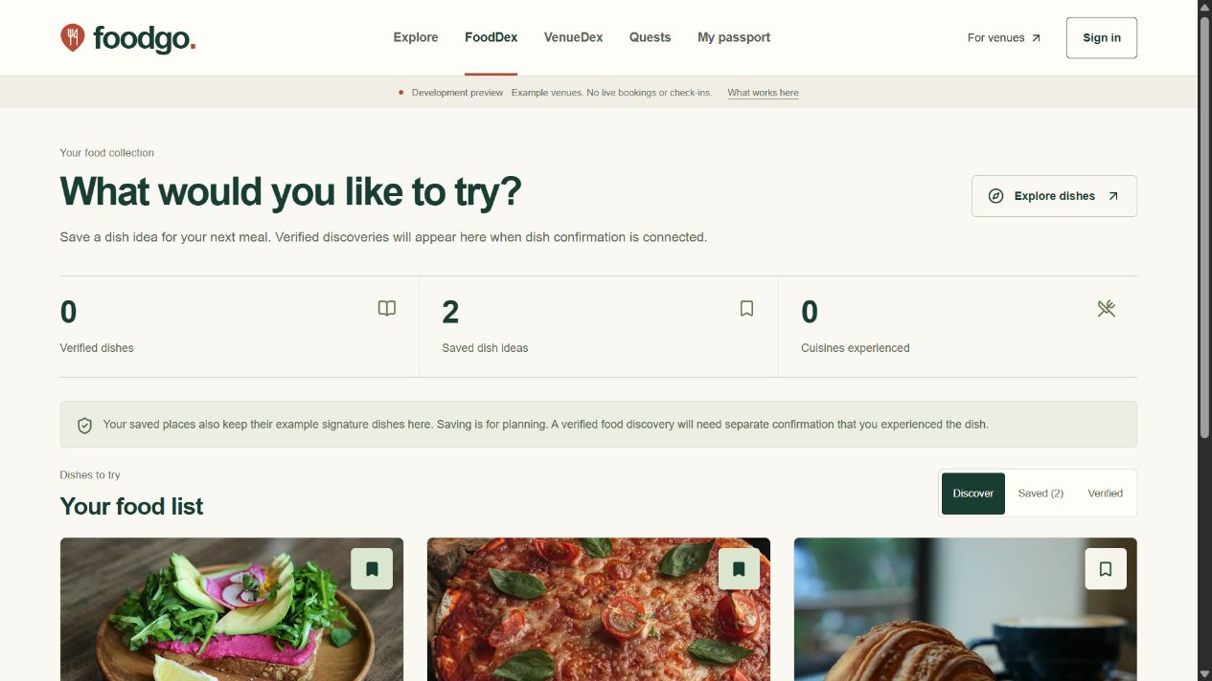
Dish ideas are separate from verified food experiences.
FoodDex helps an explorer keep track of dishes to try. Saving an example place also keeps its signature dish in the planning list. The user can switch between the available dish ideas, saved ideas and verified dishes.
Verified dishes stay at zero in this stage. A restaurant visit alone cannot prove that someone ate a particular dish. The live product will need separate evidence for a dish experience, such as staff confirmation or an eligible redemption.

Try it
Save an example dish idea, then switch between the discovery, saved and verified views. The verified count remains zero.

VenueDex
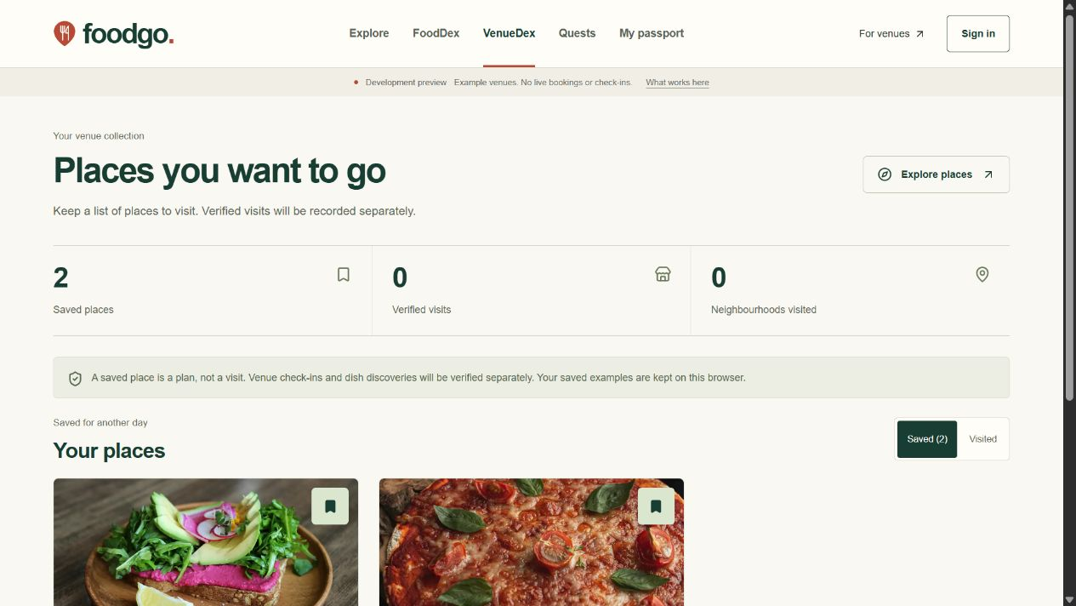
Saved places and verified visits are kept separate.
VenueDex keeps saved places together. An explorer can open a venue page or remove a bookmark. The browser keeps these example bookmarks so they remain available when the page is revisited.
Saved places and visited places are separate. Verified visits stay at zero until the secure check-in system is connected. The stored browser values are example venue identifiers, not passwords, payment information or a private location history.

Try it
Open a saved place or remove its bookmark. A saved place must not become a verified visit.

Quests and trails
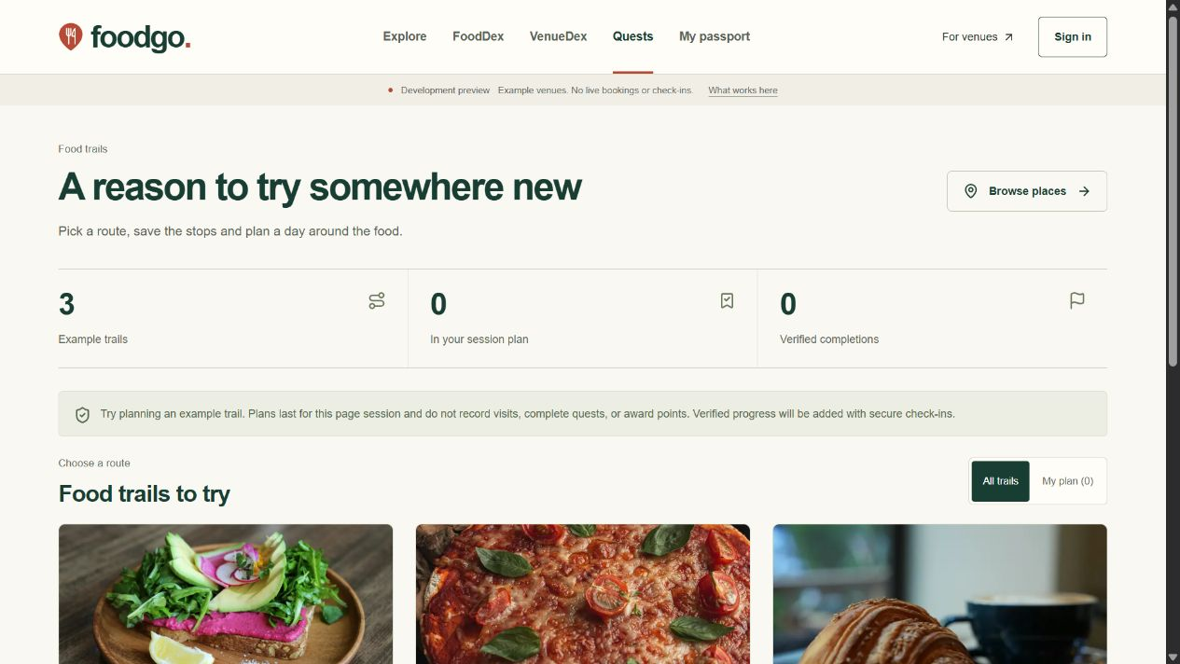
Example trails can be added to the current plan.
The trail screen offers example routes built around food interests. An explorer can add or remove a trail from the current page's plan and switch to the planned-trails view.
Planning a trail does not award points or complete it. Verified progress remains at zero. When check-ins are introduced, the server will need to check the evidence and prevent the same event from awarding a reward twice.

Try it
Add a trail to the plan, open the planned view and remove it again. Verified progress must remain zero.

Explorer profile
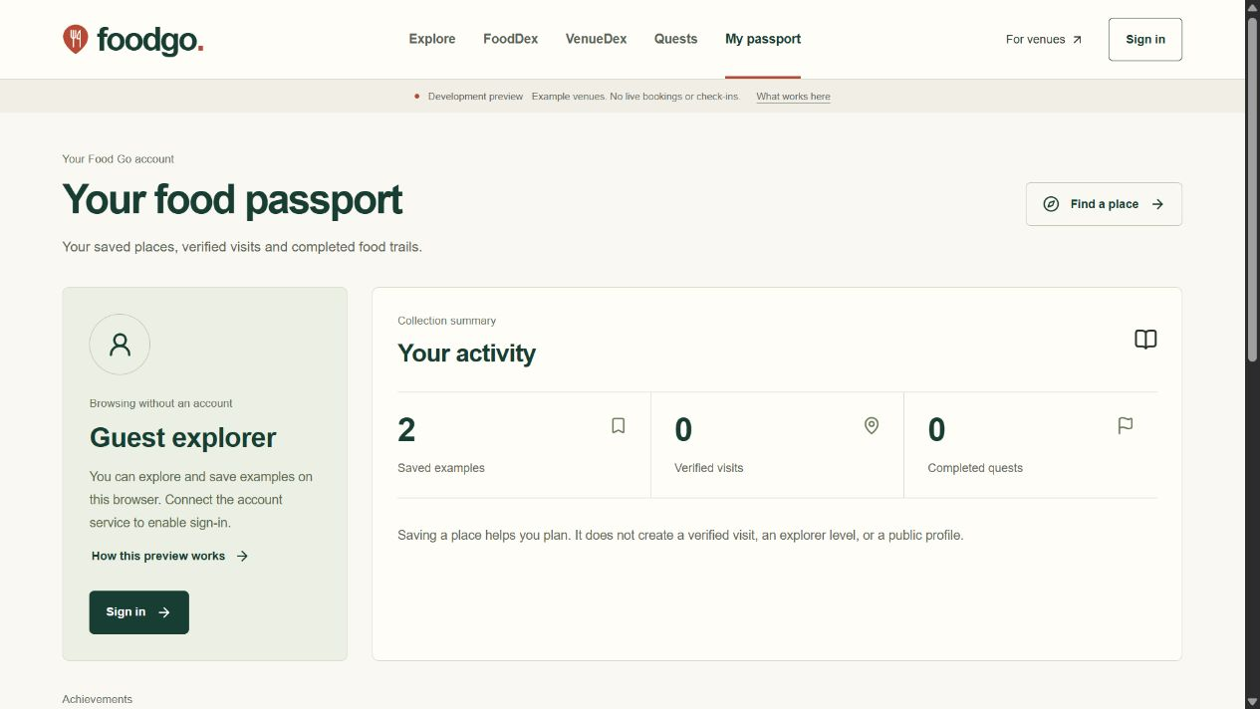
The profile reflects the current preview account state.
The profile page shows the current preview account state, the saved example count and the space for future verified visits and achievements. The user can clear saved browser examples.
The preview does not create a public identity or invent an explorer level. A real passport will depend on a signed-in account and trusted visit records. The account deletion process must be completed and tested before public accounts launch.

Try it
Check the saved count and clear the example bookmarks. No invented level or earned badge should appear.

Restaurant partner entry
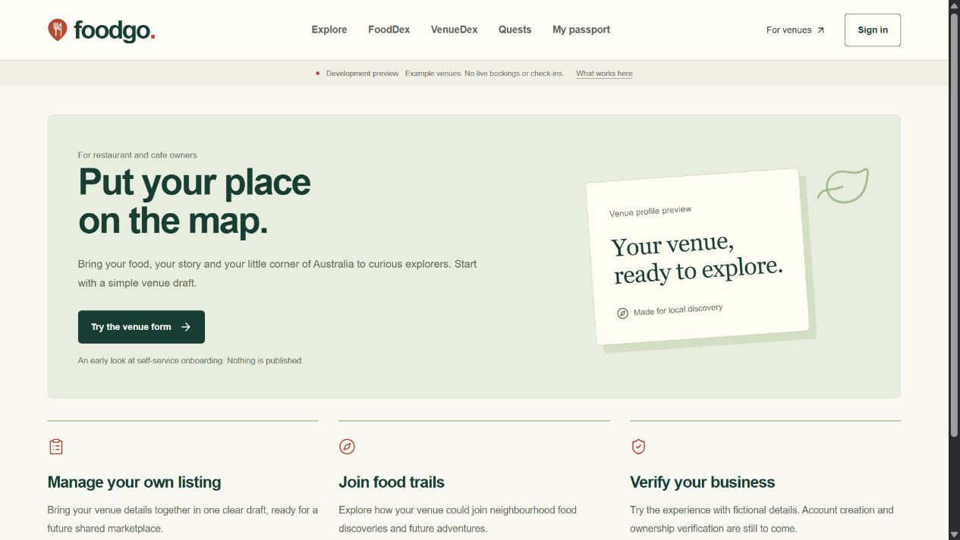
The partner entry page opens the venue draft.
The partner page is the starting point for restaurant and cafe owners. It explains the owner tools and opens the three-step venue draft. The owner can try the flow before the live registration and verification service is enabled.
The draft is the current working feature. A live partner dashboard for managing published venues, staff, menus, redemptions and billing is still to be built. The entry page does not imply that those services are already operating.

Try it
Open the venue draft and complete it with fictional details. No account, contract or published restaurant is created by this preview.

Restaurant onboarding
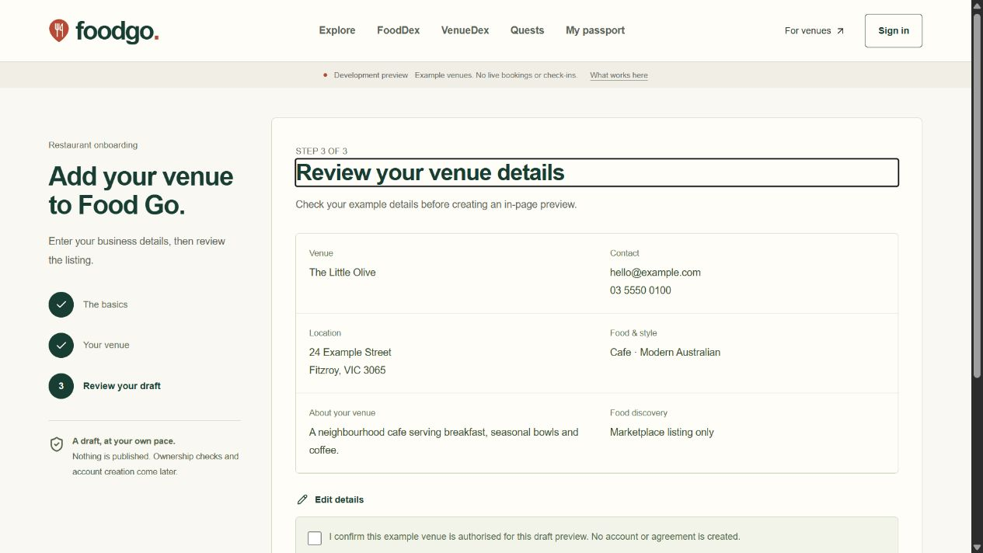
The restaurant draft review before an in-page preview.
The restaurant page introduces the owner tools and opens the venue draft. The draft groups information into three steps: contact details, venue details and a final review. It checks required fields and explains how to correct invalid information.
The owner can go back, edit the details, reset the draft and create an in-page listing preview. The current draft exists in page memory. Reloading clears it. No restaurant is published, no email is sent and no ownership claim is approved by completing this preview.
The live version will need verified ownership, duplicate venue checks and a controlled publication process. An owner must not be able to approve their own verification by changing a browser value.

The owner journey
- Start with the venue name and contact details.
- Add the location, food style and a short description.
- Review the details, edit if needed and create a preview.

Accounts and recovery
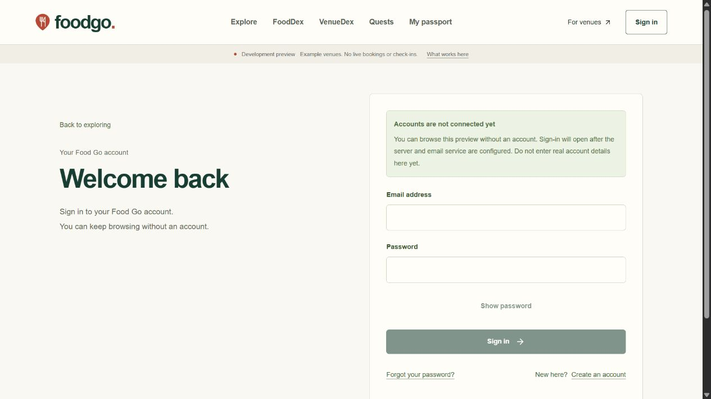
The account screen states whether its connection is ready.
Sign-in, registration, confirmation callbacks, password recovery and sign-out now have server code and screens. The server checks the identity with Supabase, limits accepted input and keeps session cookies out of browser scripts. Recovery uses a signed permission linked to one user with a ten-minute lifetime. The code also refreshes connected sessions while the website is used.
The project connection is configured locally and the read-only SDK check passes. Application account routes remain disabled while database setup, callback URLs, email delivery and release safeguards are completed. No live account or email delivery has been tested.
Account deletion and CAPTCHA integration are not implemented yet. Before public registration opens, we need to complete that work, agree reliable one-use handling for recovery links and test confirmation, sign-out, expiry and recovery against the real account service.

Supabase connection update
On 12 November, the app connection details were saved in an ignored local environment file. They include the project URL, the publishable key and a new cookie signing secret generated from 32 random bytes. Neither application accounts nor the production account release flag was enabled. The service-role and secret keys were not used.
The live read-only check reached Supabase successfully using the publishable key. The public account settings report that email and password sign-in is enabled, email confirmation is required and direct provider registration is enabled. Closing the Food Go account routes does not disable Supabase's own registration API.
The SDK also made a zero-row request to the venues catalogue. It reported that the venues relation is unavailable through the Data API schema cache. This is not a complete database inventory and does not prove that the database is empty. The project region, email sender and callback configuration have not been verified.
The SDK is the library used by the application to call Supabase. It can sign users in and access data allowed by the project's policies. Changing database structure, email settings and callback URLs requires separate management access, such as an authorised CLI session, Management API token or database connection. That access is not available in the current setup.
The database migration now stops if it would collide with existing application tables, the private schema, a storage bucket or an incompatible PostGIS installation. A separate read-only preflight helps the developer review the target before applying the migration. No database migration or policy test has run against the hosted project.
No account was created, no email was sent and no application data or dashboard setting was changed by the connection check. The next step is to rotate the exposed privileged keys, arrange management access securely, review the preflight and complete the test database setup. Never post replacement secrets or management tokens in chat or the report.

Security and remaining work
The website checks input before it is used. It limits public search requests and rejects unsupported parameters. The current restaurant write endpoint stays closed, including for a request coming from the correct website, until the trusted publication workflow is ready.
Browser rules restrict scripts and prevent other sites from placing the app inside a frame. A different script nonce is generated for each page request. A nonce is a one-use value that allows the expected page scripts to run. The production policy does not allow unsafe script evaluation.
We have written database tables and access rules that separate public listings from private contact records. The rules reserve venue approval, staff-role changes and points for trusted server workflows. Venue visits and dish discoveries have separate records. The rules still need to be applied to the test database and checked with real database requests.
The repository includes checks for code types, input behavior, browser headers, routes and dependency advisories. It also contains database tests for two organisations and their private records. The live database tests have not been run without a configured test database.
The help page explains what the preview can do and how example preferences are stored. Missing venue pages return a real not-found response. An application error screen gives the user a way to try again without displaying private technical details.
Security also needs operations after launch. Someone must apply updates, monitor failures, review suspicious behavior, test backups and handle reported content. No subscription or codebase can make a service impossible to attack.

Checks completed
- On 12 November, both code type checks and all 25 local tests pass, including 8 isolated connection-check tests.
- All 8 static security checks pass. The website production build passes with the configured project and closed account routes.
- A live read-only SDK check accepts the publishable key. Account settings are readable; the venue catalogue is not yet ready.
- The 87 local website HTTP assertions and Android, iOS and Expo web JavaScript exports passed on 11 November.
- The production dependency audit reports zero known vulnerabilities as checked on 11 November 2026. This is not a security guarantee.
- Recorded browser checks cover search, filters, map selection, bookmarks, trail plans and the restaurant draft. Checked layouts have no horizontal overflow or competing vertical panels.

What remains
Live database access tests and native phone testing are still required. We also need real venue ownership checks, saved server drafts, secure uploads, publication, live maps, verified visits and dishes, rewards, offers, bookings and administration tools. Payments and community features follow the agreed business model.
The next step is secure management access to a confirmed test project. Review the database preflight, apply the migration and run the 23 policy assertions only on a disposable database. Then test account, email and tenant access flows before saving real venue information.

Subscriptions to buy
You do not need to buy a subscription to review the local preview. Set up the client-owned accounts first. Use free test allowances where they are suitable, then upgrade before production or when the next feature needs them.
Prices checked on 11 November 2026. These starting prices are in US dollars. Tax, additional usage and currency conversion can change the invoice.
Service | When to arrange it | Starting price
Supabase | Free project for connected testing. Choose Sydney. Upgrade to Pro before production. | Free test plan  Pro US$25/month
Test database | Keep testing separate from live data. A free project can be used first. This price is for an additional Micro project on a paid plan. | US$10/month
Vercel Pro | When hosting this commercial website. Additional developer seats and usage cost more. | US$20/month
Resend | Before testing public confirmation and recovery emails. Free plan has a 100-email daily limit. | Free 3,000/month  Pro US$20/month
Expo services | For cloud app builds and updates. The paid plan is optional. | Free limited plan  Starter US$19/month
Apple Developer | Prepare the organisation account before iPhone distribution. Local pricing may vary. | US$99/year
Google Play | Before Android testing tracks and distribution. | US$25 once
Domain and email | Before branded emails and public hosting. The client should own the domain. | Provider dependent

Start connected testing with free Supabase and Resend allowances. Commercial website hosting and a production database start at about US$45 per month. An additional paid test project adds US$10. Paid email adds US$20 when needed, giving a US$75 example. Optional Expo Starter brings it to US$94. These subtotals exclude tax, extra usage, maps, domains, monitoring, backups and staff.
React Native, Next.js and the Expo development tools do not need a paid framework licence. Both mobile platforms are designed to use one shared backend once connected. Standard Vercel hosting includes HTTPS.
Arrange a map billing account when live maps are implemented. Set usage limits and restrict the keys. Keep permanent venue information owner-supplied or appropriately licensed. Choose Stripe only after agreeing whether Food Go collects dining money or customers pay restaurants directly.
Important setup notes: Supabase email delivery needs a custom sender for public accounts. Database backups do not include the uploaded photo files.

What you need to do
1. Rotate the privileged keys exposed in chat and screenshots through Supabase. Keep replacements in an approved secret store. Keep business accounts under the client, enable multi-factor authentication and invite developers instead of sharing passwords.
2. Confirm the business name, logo, public support email and website domain. The domain should be owned by the client. Do not buy an expensive domain or an annual hosting bundle without agreeing the name and hosting plan.
3. Confirm a separate Sydney test project. Arrange CLI or Management API access securely, without posting tokens in chat. Review the read-only database checks, apply the migration there and run the 23 database policy tests only on a disposable test database.
4. Configure the exact app callback URLs and a domain sender. Your developer can set SPF, DKIM and DMARC records. Test confirmation, recovery, failed delivery and session expiry before public registration.
5. Decide how owners will prove authority to manage a venue. Choose the evidence, who reviews exceptions and what happens when two people claim the same business. Knowing an ABN or business name is not enough on its own.
6. Provide a small set of real pilot venues with permission to use their information and photographs. Supply addresses, opening hours, menus and signature dishes. Agree who will maintain this information after launch.
7. Decide what counts as a verified venue visit and a verified dish experience. Agree whether staff confirmation, a QR code, a redemption or transaction evidence is required. A visit and a dish experience need separate rules.
8. Confirm whether the first booking feature is an enquiry or a confirmed reservation. Decide whether the customer pays the restaurant directly. These choices change the payment, refund and support work.
9. Arrange an Australian review of the privacy policy, terms, offers and safety wording. Decide the target age group, profile privacy defaults, retention periods and overseas service disclosures. Choose the person responsible for complaints, moderation and privacy requests.
10. Prepare Apple and Google organisation account details, including the company name, address, website, contact person and D-U-N-S number. Apple also checks that the account holder has legal authority to represent the business. Start verification early and confirm the final app identifiers before signing release builds. Apple requirements and Google requirements
11. Provide access to an iPhone and an Android phone for testing. Ask a small group of intended users and venue owners to try the important flows. Include larger text sizes, screen readers, slow connections and declined permissions.
12. Agree the launch scope and operating budget. Start with enough venues in a pilot area to make the experience useful. Nationwide infrastructure can be ready before nationwide venue coverage exists.

