**Flipkart Assignment Project**

Created maven project and added all the needed dependencies in pom file then build the project.

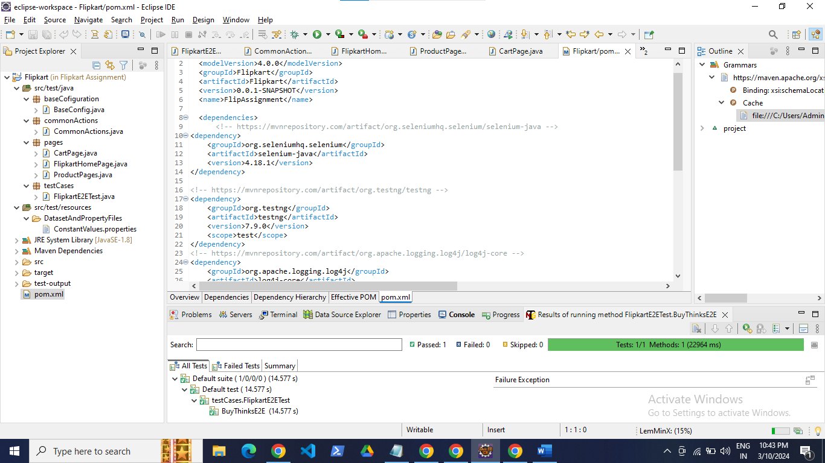

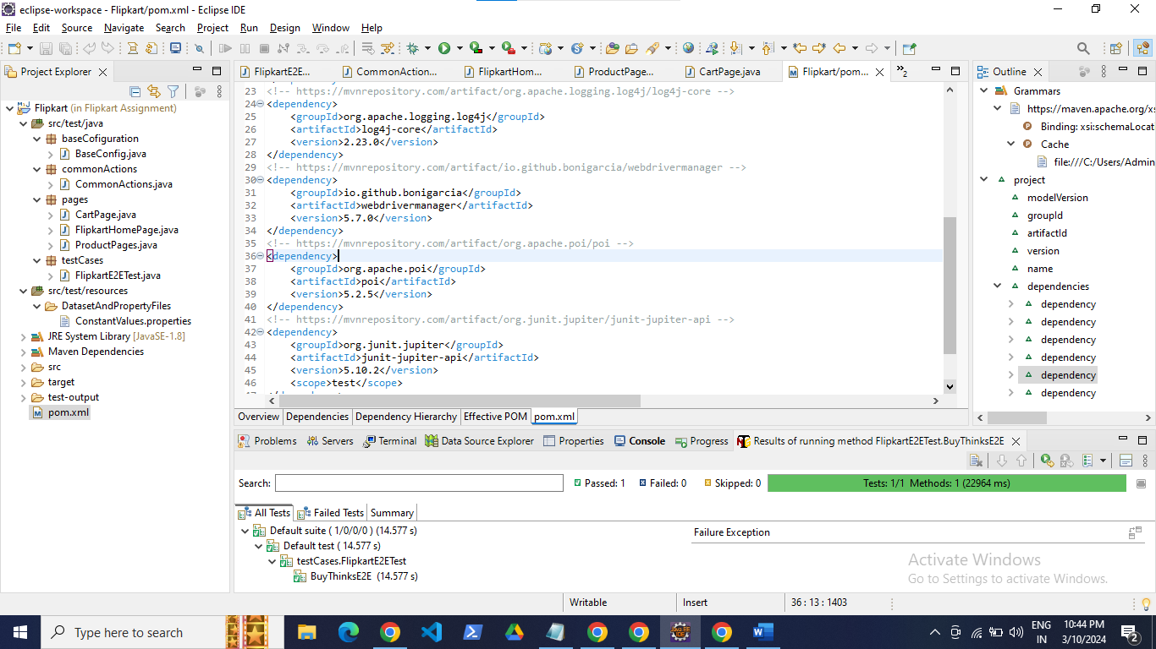

Under src/test/java I had created the base config class, common action class and page classes.

BaseConfig

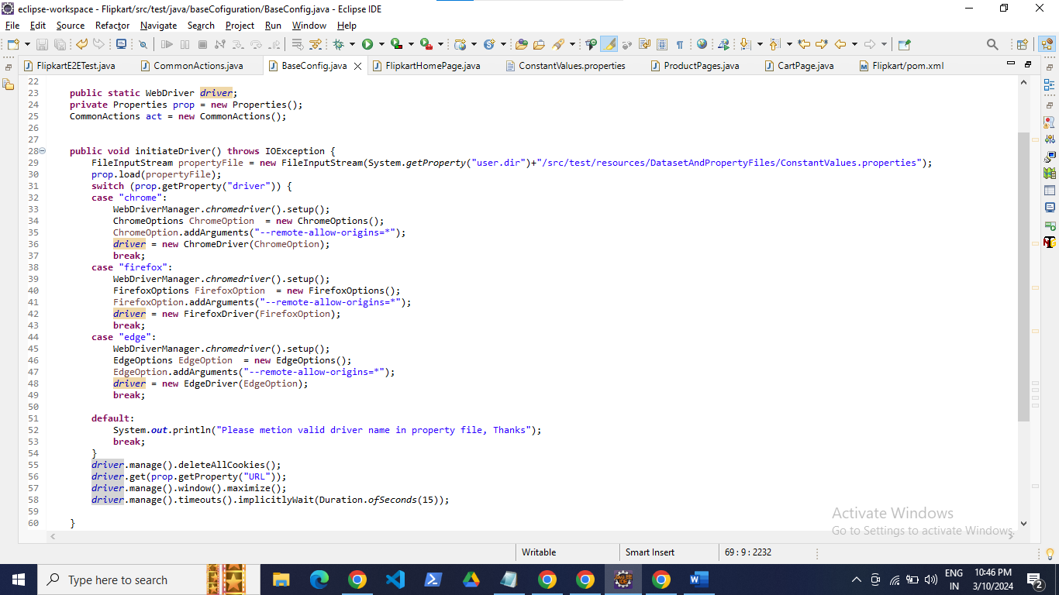

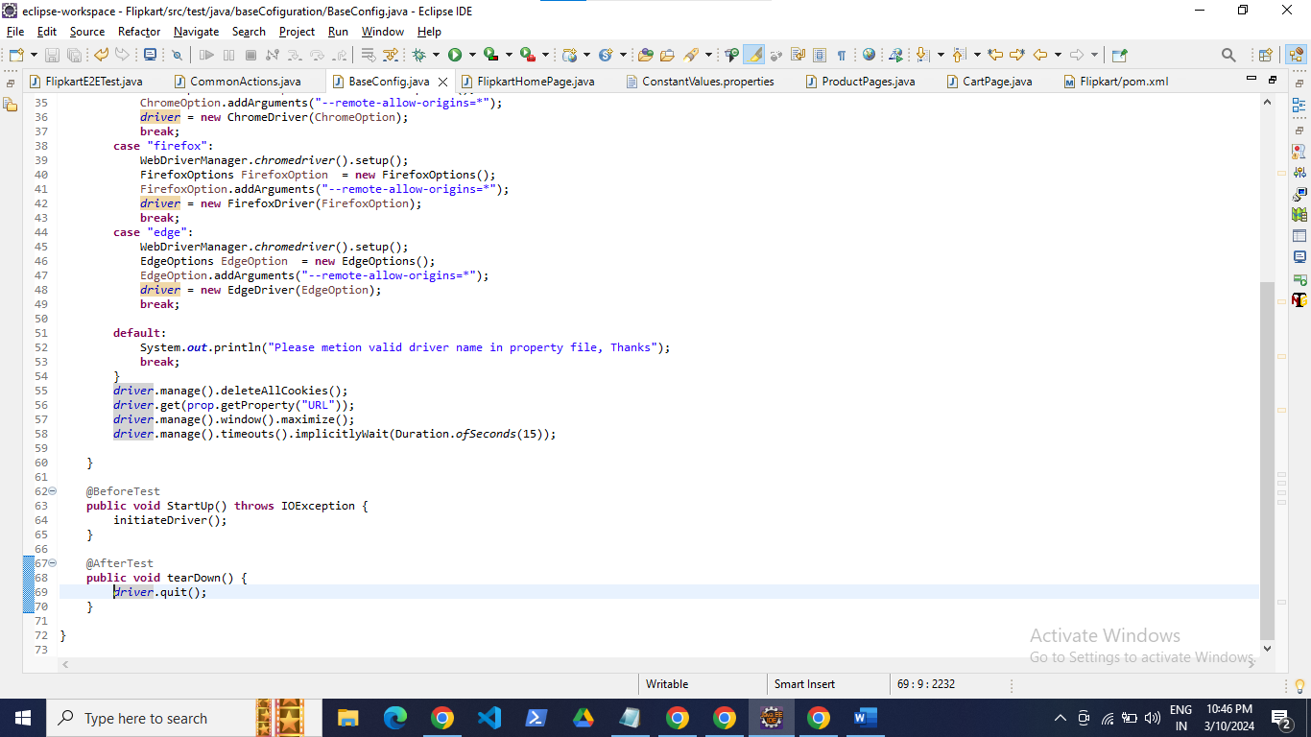

This class contains browser configurations and things need to be prepared before class and after class.

Common Action

This class contains all the common actions such as click, enter text, get text and explicit waits that can be used all over the project where it is needed.

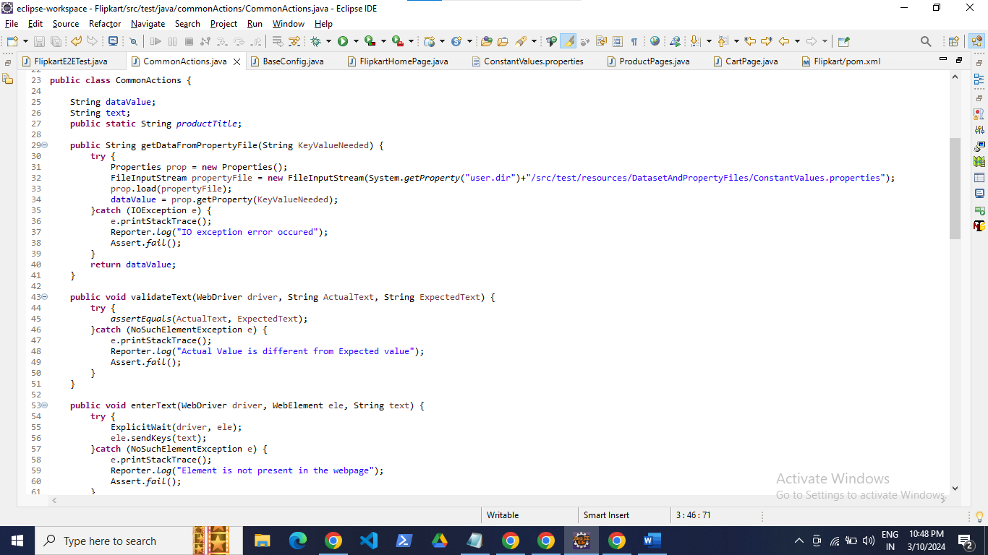

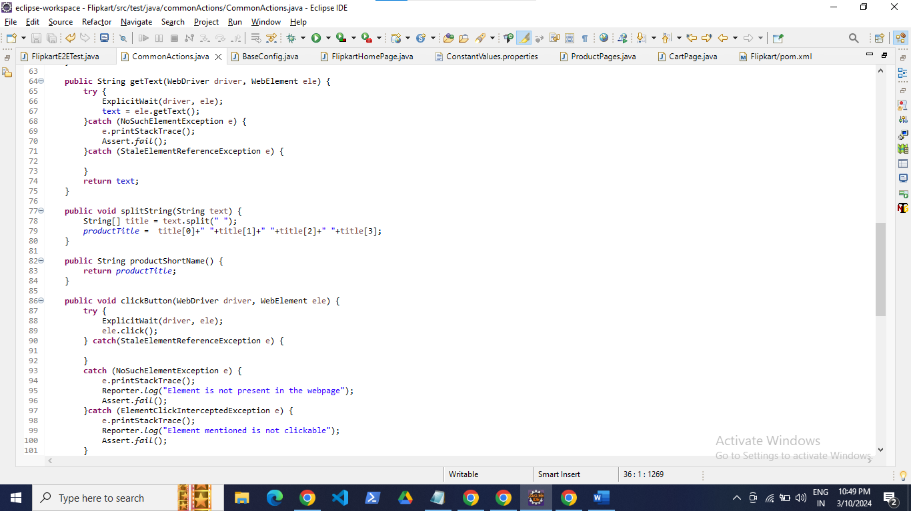

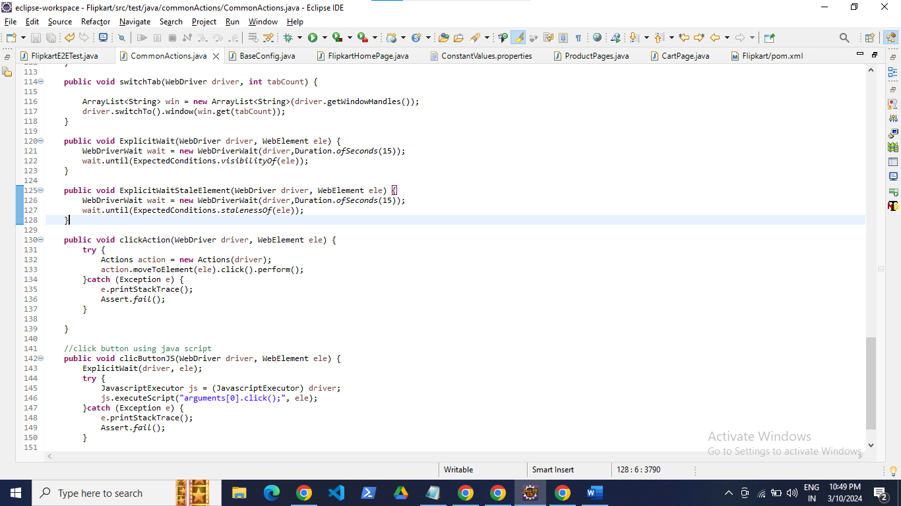

Page class

This class contains the WebElements and the methods where the action need to be performed.

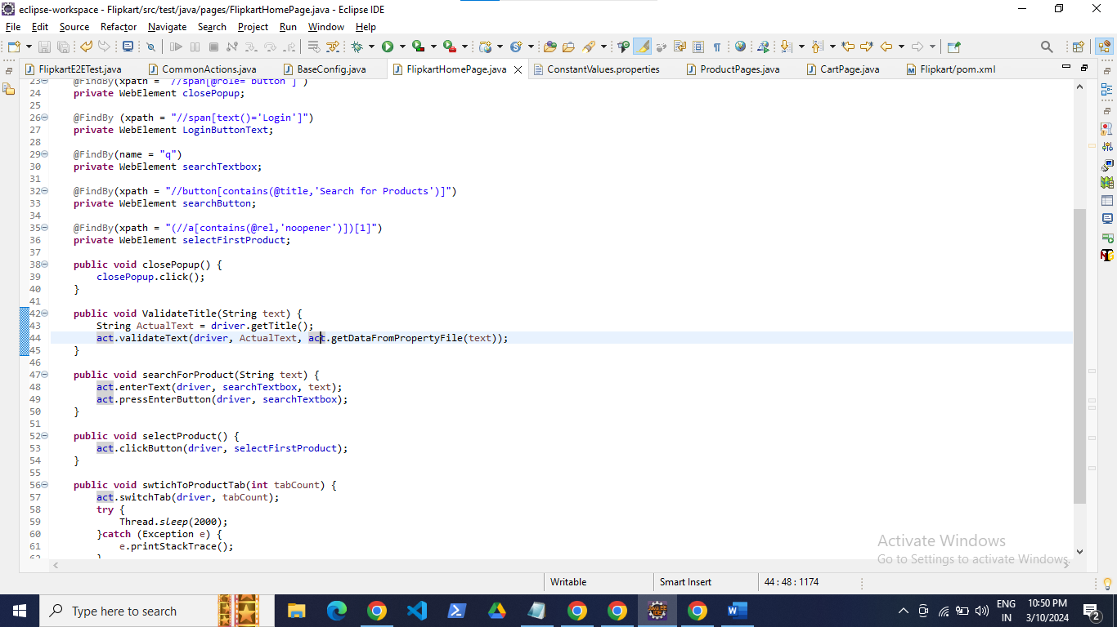

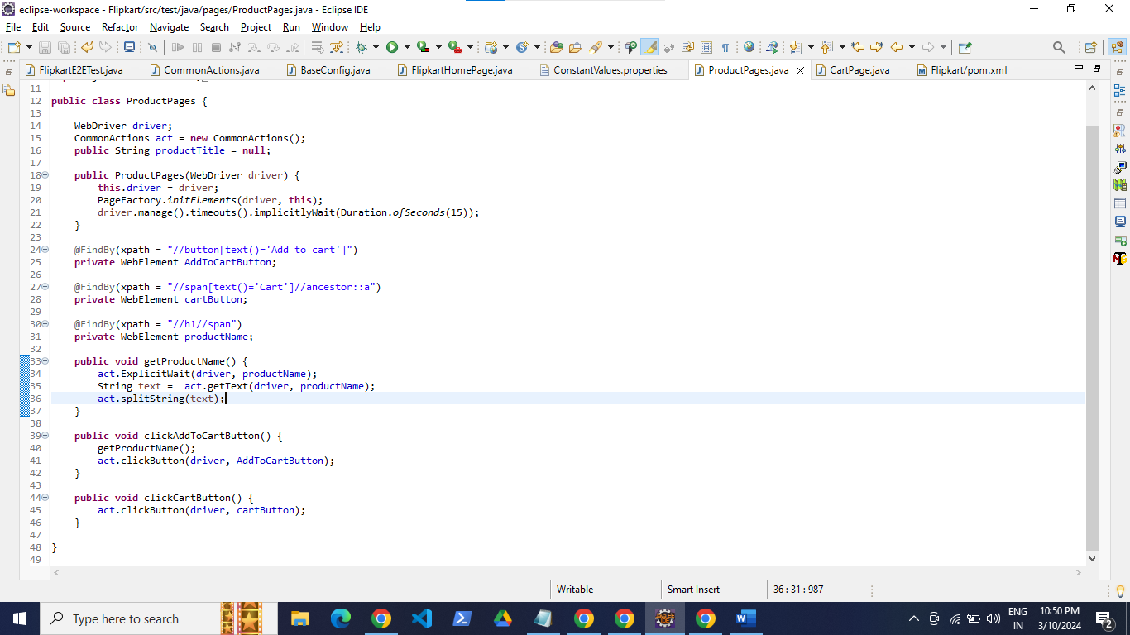

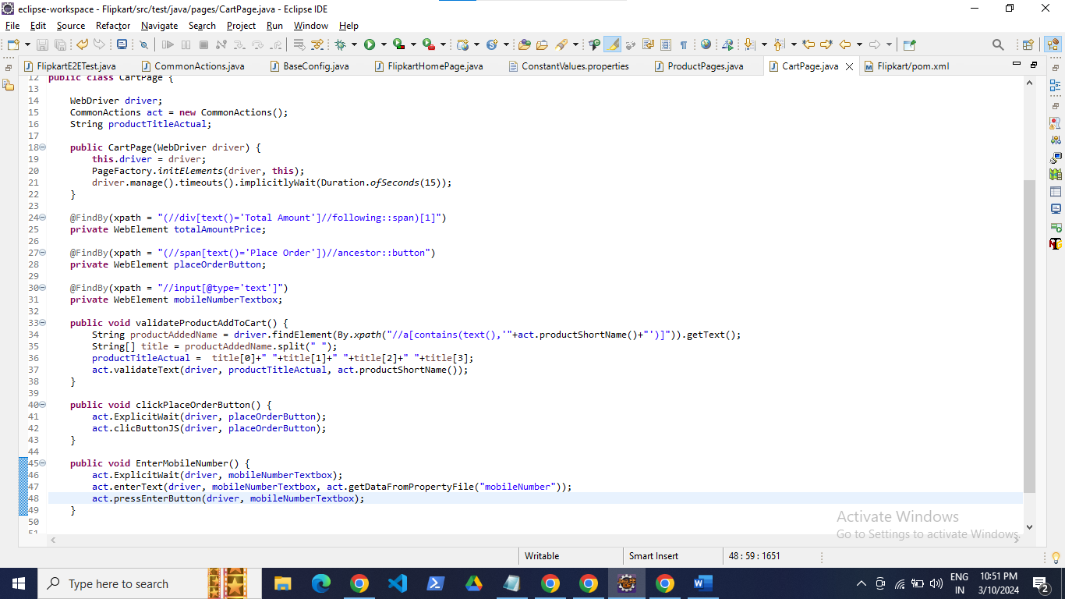

TestCase package FlipkartE2E test

This class contains the test steps flow to open flipkart webpage, search product, select the product, add to cart and place order.

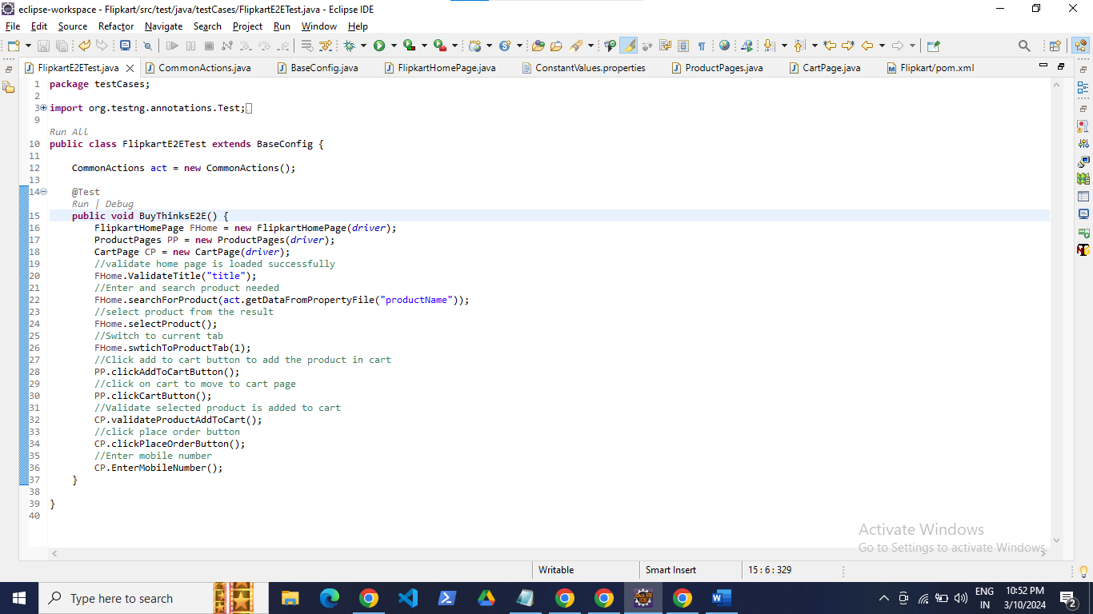

**Property file**

This property file contains the constant values such as url, driver name etc.

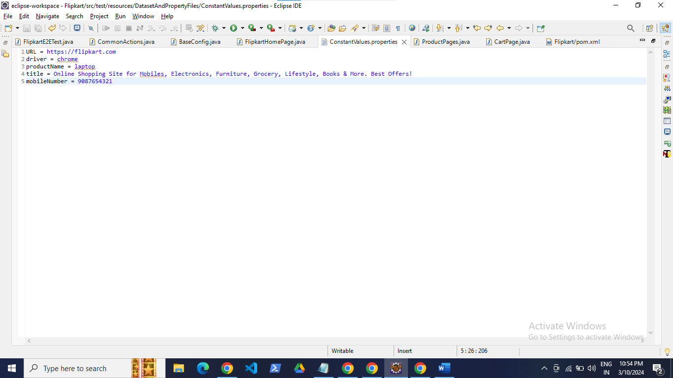

Note:

While proceeding for order placement its asking for login where it compels to enter OTP that is been send to mobile this action can’t be done so till that step I had completed the assignment with framework.

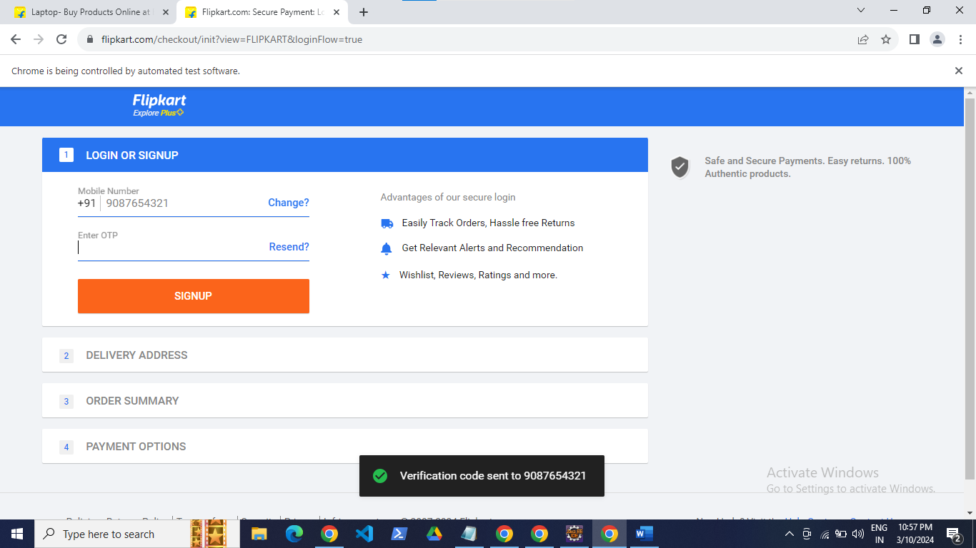

Test results:

