B. Tech. (ECE) PROJECT REPORT 2025-26

Annexure-1

Diabetic Retinopathy detection using Machine Learning Algorithms

A Project Report

Submitted by:

Zuhayer Anjum Barbhuiya (2214008)
Satyam Das (2214049)
Arindom Sarmah (2214106)
Ramayanam Satya Shankar Lakshmi Narayana (2214122)
Podili Karthik (2214125)
Rishi Kumar Jha (2214178)

Supervisor Name

Dr. Wasim Arif



DEPARTMENT OF ELECTRONICS AND COMMUNICATION ENGINEERING

NATIONAL INSTITUTE OF TECHNOLOGY SILCHAR,

SILCHAR, ASSAM (INDIA)-788010

March 2026

NATIONAL INSTITUTE OF TECHNOLOGY SILCHAR, ASSAM, INDIA

B. Tech. (ECE) PROJECT REPORT 2025-26

Annexure-2

DECLARATION

We hereby declare that the project entitled “Diabetic Retinopathy detection using Machine Learning Algorithms” is our original work and the project has not formed the basis for the award of any other degree, diploma, fellowship or any other similar titles.

Signature of the Student

Place:

Date:

NATIONAL INSTITUTE OF TECHNOLOGY SILCHAR, ASSAM, INDIA

B. Tech. (ECE) PROJECT REPORT 2025-26

Annexure-3

CERTIFICATE

This is to certify that the project titled “Diabetic Retinopathy detection using Machine Learning algorithms” is the bona fide work carried out by

- Zuhayer Anjum Barbhuiya - 2214008
- Satyam Das - 2214049
- Arindom Sarmah - 2214106
- Ramayanam Satya Shankar Lakshmi Narayana - 2214122
- Podili Karthik - 2214125
- Rishi Kumar Jha - 2214178

students of B. Tech. (ECE) of National Institute of Technology Silchar (An Institute of National Importance under MHRD, Govt. of India), Silchar, Assam, India during the academic year 2025-26.

Name and Signature of the Supervisor

Place:

Date:

NATIONAL INSTITUTE OF TECHNOLOGY SILCHAR, ASSAM, INDIA
B. Tech. (ECE) PROJECT REPORT 2025-26

Annexure-4

 |  | Table of Contents
 | Title Page |  | i
 | Declaration of the Student |  | ii
 | Certificate of the Guide |  | iii
 | Abstract |  | iv
1. | INTRODUCTION |  |  |  | 1
2. | LITERATURE REVIEW |  |  |  | 2
3. | METHODOLOGY / PROPOSED WORK |  |  |  | 3
4. | WORK DONE TILL NOW |  |  |  | 4
5. | SYSTEM MODEL / ARCHITECTURE |  |  |  | 6
6. | WORK PLAN FOR NEXT PHASE |  |  |  | 8
7. | EXPECTED OUTCOMES |  |  |  | 9
8. RESULTS / OUTPUTS |  |  |  |  | 10

NATIONAL INSTITUTE OF TECHNOLOGY SILCHAR, ASSAM, INDIA

Abstract

Diabetes causes a dangerous eye condition called diabetic retinopathy (DR), which destroys the retina. Permanent blindness may result if it is not detected in time. In order to identify symptoms of the illness, doctors currently have to manually examine eye pictures. Due to the fact that there are millions of patients but not enough eye specialists to exa-mine them all, this procedure is extremely costly, time-consuming, and challenging. Furthermore, there is a significant chance that errors or minor details will be overlooked because the task is being done by humans.
To solve this problem, this study uses Artificial Intelligence (AI) and Transfer Learning. Specifically, we use a powerful model called ResNet50. Instead of training a computer from scratch, we use "Transfer Learning," which allows the model to use knowledge it already has to identify complex patterns in eye images. ResNet50 is especially good at this because its structure allows it to look deep into the details of an image without losing important information. The goal of this research is to create a fast, automatic system that can tell how severe a patient's DR is. By using this technology, we can provide a "second opinion" that is both accurate and consistent. This system will help doctors screen more patients in less time, ensuring that people get the treatment they need before they lose their sight.

- Introduction
Diabetes mellitus is a chronic medical disorder in which the body either produces insufficient insulin or cannot use it adequately, resulting in excessive blood sugar levels1. This disease has become a major public health problem, impacting millions of individuals globally. According to the International Diabetes Federation, roughly 537 million persons have diabetes as of 2021, and this figure is likely to rise dramatically in the years ahead2. Diabetes places a significant pressure on healthcare systems and can result in major consequences if not controlled effectively. One such consequence is diabetic retinopathy (DR). About one-third of diabetics get DR.
The blood vessels in the retina are affected by this and is a leading cause of blindness in diabetic patients. It can develop in anyone who has type-1 or type-2 diabetes. Risks are pronounced the longer someone has diabetes. Moreover, it increases if blood sugars are not managed well.
There are two stages of diabetic-retinopathy: Non-proliferative diabetic retinopathy (NPDR) and proliferative diabetic retinopathy (PDR). NPDR is the early stage of DR and is caused by leaky blood vessels while PDR is the more advanced stage and happens when the retina starts growing new blood vessels (also called neovascularization).
Common symptoms of DR include more floaters, blurry vision, blank or dark areas in field of vision, poor night vision, colours appearing faded or washed out, loss of vision.
Timely screening for diabetic retinopathy is essential in averting serious complications. Detecting diabetic retinopathy early is crucial before it advances to later stages when treatment becomes challenging and less effective. In the initial phases of the illness (when symptoms are low or nonexistent), prompt treatment can avert significant vision impairment by tackling issues before permanent damage takes place. Doctors can slow down or stop disease advancement through measures such as improved glycemic management or laser treatments

- Literature Review
- A deep-learning based model for diabetic retinopathy grading - Akhtar S et al. The research achieved the development of a high-performance deep learning model called RSG-Net that automates the detection and severity grading of the disease
- Machine Learning-based Diabetic Retinopathy Early Detection and Classification Systems- A Survey – Dathar A. Hasan et al. The study finds that machine learning, particularly the ResNet50 deep convolutional neural network, effectively detects and classifies Diabetic Retinopathy (DR) severity.
- Diabetic Retinopathy Detection using Machine Learning – R Revathy et al. The study proposes an automated hybrid machine learning model that extracts features like exudates and haemorrhages to detect diabetic retinopathy with 82% accuracy. By combining classifiers such as SVM, KNN, and Random Forest, the system achieved a precision of 0.8119 and effectively identified 36 out of 49 test samples correctly
- DREAM: Diabetic Retinopathy Analysis Using Machine Learning – Roychowdhury S et al. Researchers found that the Gaussian Mixture Model (GMM) is most effective for classifying bright lesions, while the k-Nearest Neighbor (kNN) algorithm performs best for red lesions.
- Diabetic Retinopathy: Present and Past – Gupta A et al. The presence and combination of specific lesions—such as red dots (microaneurysms), shiny white deposits (hard exudates), and yellow/white superficial lesions (cotton wool spots)—are used to determine the severity of the disease.
- Diagnosis of diabetic retinopathy using machine learning techniques – R Priya et al. Among the models tested, the Support Vector Machine (SVM) consistently outperformed others, achieving the highest diagnostic accuracy of 97.6%.

- Methodology / Proposed Work
Our methodology is a systematic five-step process, beginning with input image acquisition followed by image pre-processing, data splitting,training the models on training data and finally performing evaluation on test dataset.
• Dataset Acquired: The project commenced with the acquisition of dataset which consisted of sample retina images. These were obtained from an open source platform for machine learning purposes.
• Image Pre-Processing : Due to non-uniformity with the images in the dataset, we performed preprocessing on the data. This consisted of multiple steps. First the mean colour was subtracted. Then 10% of outer boundary was removed. This was followed by splitting the data.
• Data Splitting : We divide our collection of images into two blocks namely Training Set and Test Set. Training Set is used to teach the model what Diabetic retinopathy looks like while test set is kept hidden from the model until the very end to see if it actually learned correctly.
• Models Trained: A state-of-the-art algorithm ResNet50 was fitted and trained on the 70% training data with success. After fitting the models, the performance analysis was conducted on the held-out 30% of the test set.
• Evaluation : The model runs on the test set and analysis is done using the defined metrics: F1-score, precision, recall and QWK.

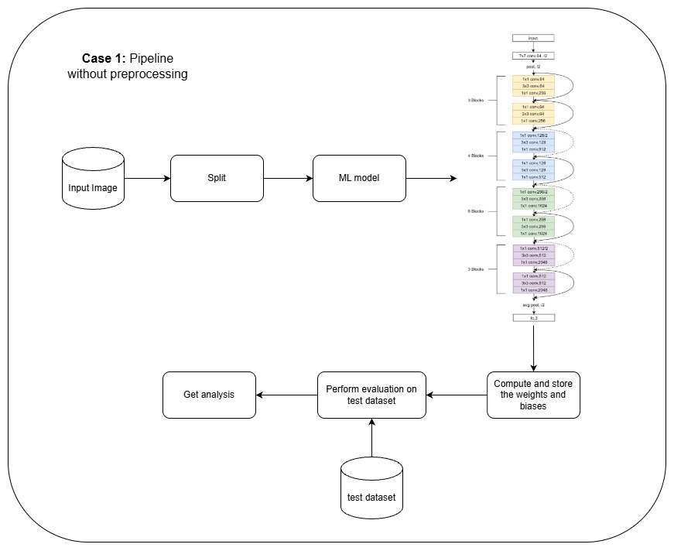
Fig 1. Pipeline without preprocessing.
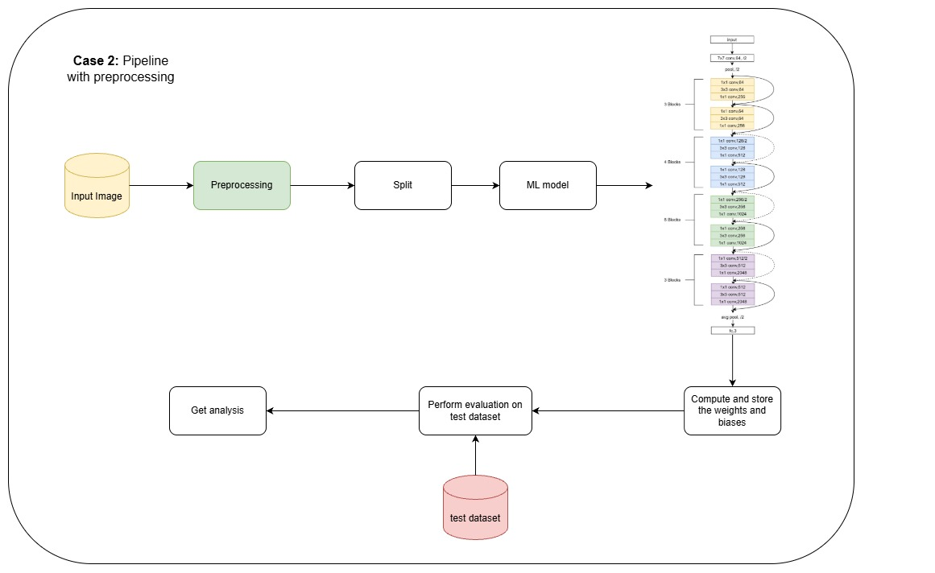
Fig 3. Pipeline with preprocessing.

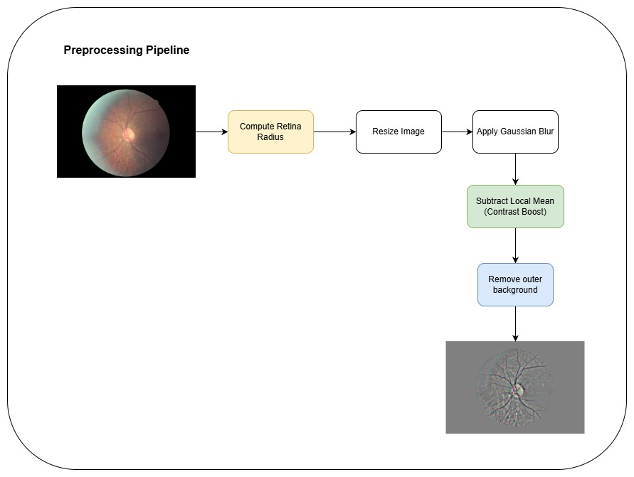
Fig 3. Preprocessing Pipeline.

4. Work Done till Now
- Acquiring the dataset
This process involved collecting images of retinas from an open source platform. The dataset consisted of a wide variety of images of retina. We collected and prepared a labelled retina fundus image dataset for five-class Diabetic Retinopathy severity classification (0-4) starting from 0 (no issues) to 4 (proliferative retinopathy)

- Image Pre-processing
This involved image resizing, normalization and data augmentation. Retinal cameras often produce very large, high-resolution images. However, deep learning models like ResNet50 require all input images to be the exact same size Resizing ensures the neural network receives a consistent data structure. Without resizing, the model would be unable to process the varying dimensions of different hospital records. Normalization changes the pixel values (usually to a range between 0 and 1). It helps the model focus on the actual disease (like spots or bleeding) rather than being distracted by how bright or dark the photo is. It also helps the model learn much faster. Data augmentation creates "new" images from our existing ones by slightly changing them. This teaches the ResNet50 model that a diseased eye is still diseased, even if it is tilted or seen from a different angle. It prevents the model from simply "memorizing" the training photos and helps it perform better on real-world patients it has never seen before.

- Model training
This involved training a deep learning model for multi-class Diabetic Retinopathy detection. Training to test ratio was put at 70:30

- Model Training and Evaluation for Multiclass Classification
- Evaluated performance using Accuracy, Precision, Recall, F1-score, Confusion Matrix, and Quadratic Weighted Kappa (QWK).
- Achieved 87.03% test accuracy and 0.74 QWK score.
- Analysed confusion matrix and identified performance limitations in Severe (Class 3) and Proliferative (Class 4) DR stages.

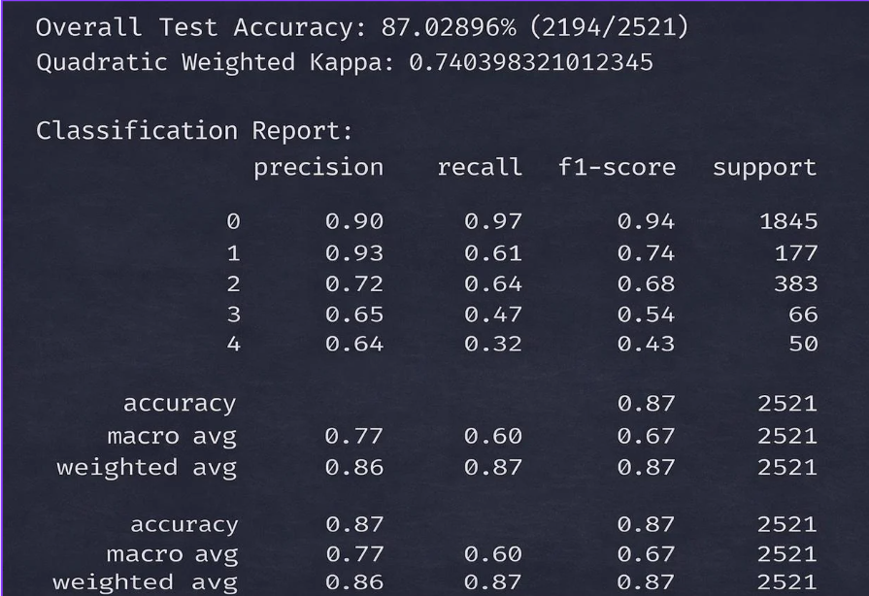
Fig 4. Classification report for ResNet50.
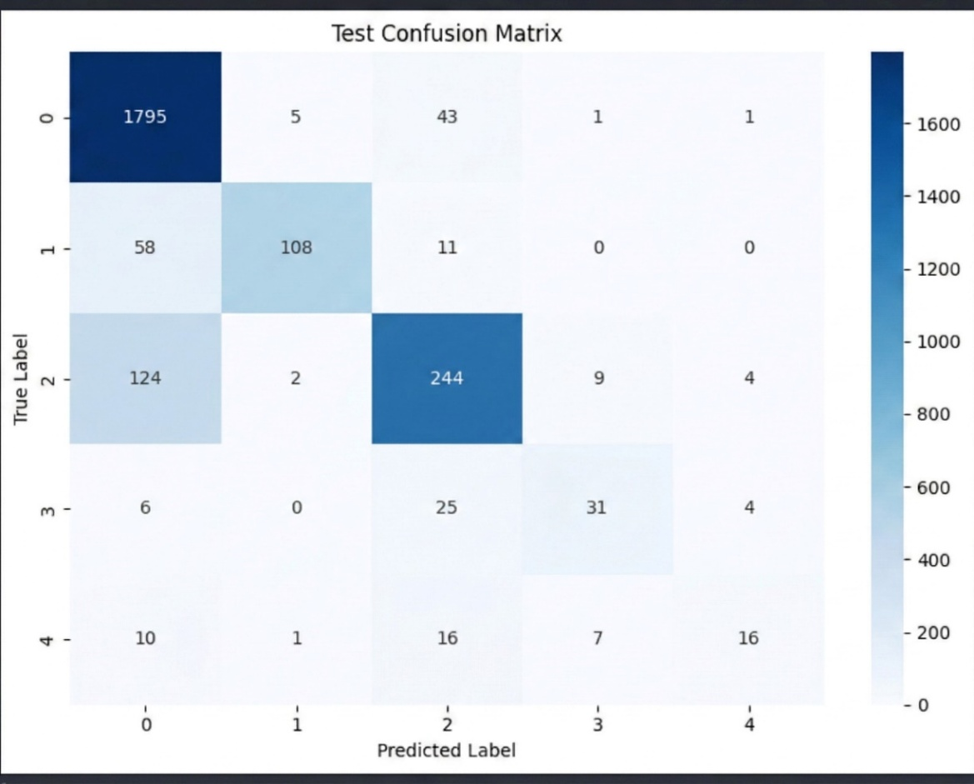
Fig 5. Confusion Matrix for ResNet50.

- SYSTEM MODEL / ARCHITECTURE
- Initial Challenge: The Vanishing Gradient Problem
Goal: Understand why adding more layers to a standard Deep Neural Network often leads to lower accuracy.
The Issue: In traditional models, as the network becomes deeper, the "gradient" (the signal used for learning) becomes so small that the early layers stop updating. This makes it nearly impossible to train very deep systems.
- Core Innovation: The Residual Block (Skip Connections)
Goal: Allow the network to be much deeper (e.g., 50 or 101 layers) without losing information.

Mechanism:
Standard Path: The data passes through several convolutional layers to learn complex patterns like retinal lesions or haemorrhages.
Shortcut Path (Skip Connection): The original input is "passed over" these layers and added directly to the output at the end of the block.
Rationale: Instead of forcing every layer to learn a completely new representation from scratch, the model only has to learn the difference (the residual) between the input and the output. If a layer isn't helpful, the model can simply learn to "skip" it by setting the weights to zero.

- Application: Transfer Learning for Medical Imaging
Goal: Use a model that has already seen millions of general images to jump-start the detection of Diabetic Retinopathy.
Method: We use a "Pre-trained" ResNet50. The early layers already know how to identify basic shapes (lines, circles, edges). We then "fine-tune" the final layers to specifically identify medical markers like microaneurysms and exudates in the eye.

Result: This significantly reduces training time and requires much less data to achieve high accuracy compared to building a model from scratch.

- WORK PLAN FOR NEXT PHASE
The confusion matrix shows that the model did not achieve acceptable performance for Class 3 (Severe DR) and Class 4 (Proliferative DR), mainly due to misclassification and class imbalance. In future work, we will focus on improving detection accuracy for these advanced stages using better class balancing and model optimization techniques.
Additionally, we plan to implement CLAHE (Contrast Limited Adaptive Histogram Equalization) for enhanced image preprocessing to improve retinal feature visibility and achieve better classification results.

- EXPECTED OUTCOMES
The proposed Diabetic Retinopathy (DR) detection model is expected to achieve strong and clinically relevant performance in automated severity classification. As QWK is the primary evaluation metric for DR severity assessment, this demonstrates that the model can reliably perform multiclass classification aligned with clinical standards.

The confusion matrix is expected to show that most predictions fall along the diagonal, reflecting accurate classification across severity levels, with limited misclassification mainly between visually similar or adjacent classes. Training performance trends are expected to demonstrate stable convergence, characterized by a consistent reduction in training loss and a steady increase in training accuracy. Although a slight gap between training and testing accuracy may indicate mild overfitting, the model is expected to maintain acceptable generalization capability. Overall, the system is projected to function as a dependable AI-assisted screening tool for early detection and severity grading of Diabetic Retinopathy.

8. REFERENCES
[1] S. Akhtar et al., “A deep-learning based model for diabetic retinopathy grading,”.
[2] A. Hasan et al., “Machine Learning-based Diabetic Retinopathy Early Detection and Classification Systems- A Survey,”.
[3] R. Revathy et al., “Diabetic Retinopathy Detection using Machine Learning,”.
[4] S. Roychowdhury et al., “DREAM: Diabetic Retinopathy Analysis Using Machine Learning,”.
[5] A. Gupta et al., “Diabetic Retinopathy: Present and Past,”.
[6] R. Priya et al., “Diagnosis of diabetic retinopathy using machine learning techniques,”
[7] EyePACS, “EyePACS: Free platform for retinopathy screening.” [Online]. Available: https://www.eyepacs.com.
[8] Emma Dugas, Jared, Jorge, and Will Cukierski. Diabetic Retinopathy Detection. https://kaggle.com/competitions/diabetic-retinopathy-detection, 2015. Kaggle.

