What is Protocol?
- Protocol is a set of rules that defines how the communication can happen between two devices
- Every machine is designed with a set of protocols(rules) to communicate
- *Devices agree on common protocols before they communincate
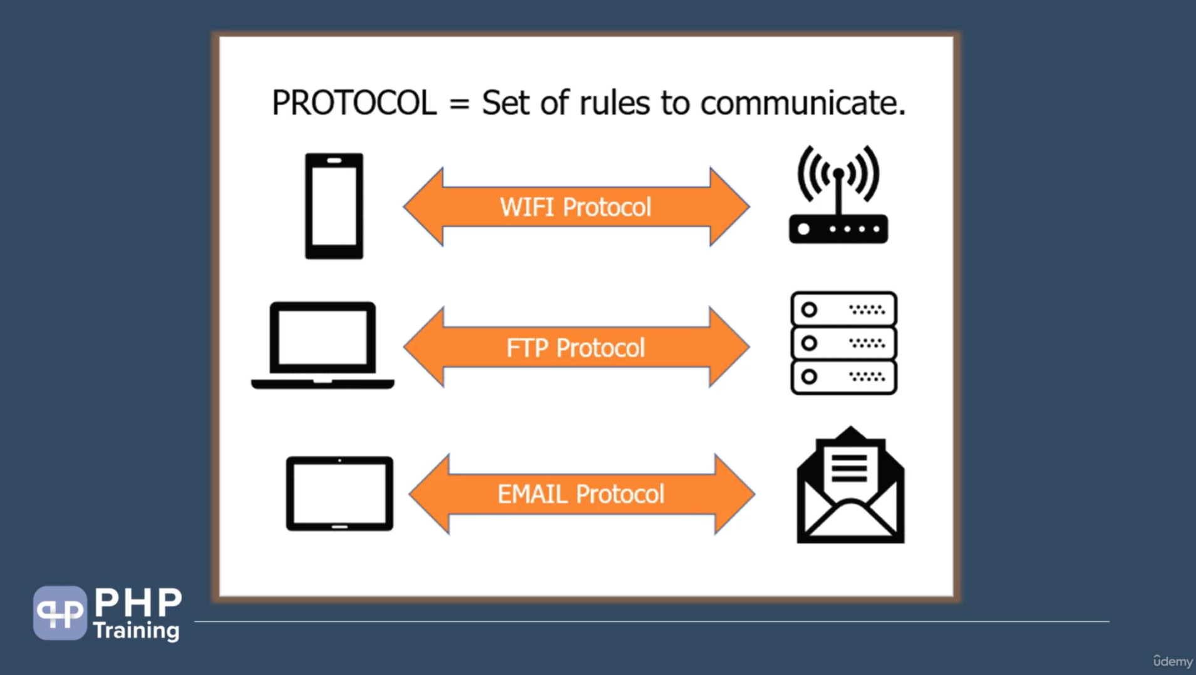

What is Internet?
- Internet is a network where group of computers connected with a single wire
- Systems connected to internet are able to communicate and exchange data
- You can connect to internet to access others computers and exchange data with other computers via TCP/IP protocols

What is TCP/IP protocols?
- TCP stands for transmission control protocol which is used to transfer data
- In order to transfer data TCP must know the IP address of the computer
- Every computer has a unique IP address which is used to identify that computer on internet and communicate and transfer data
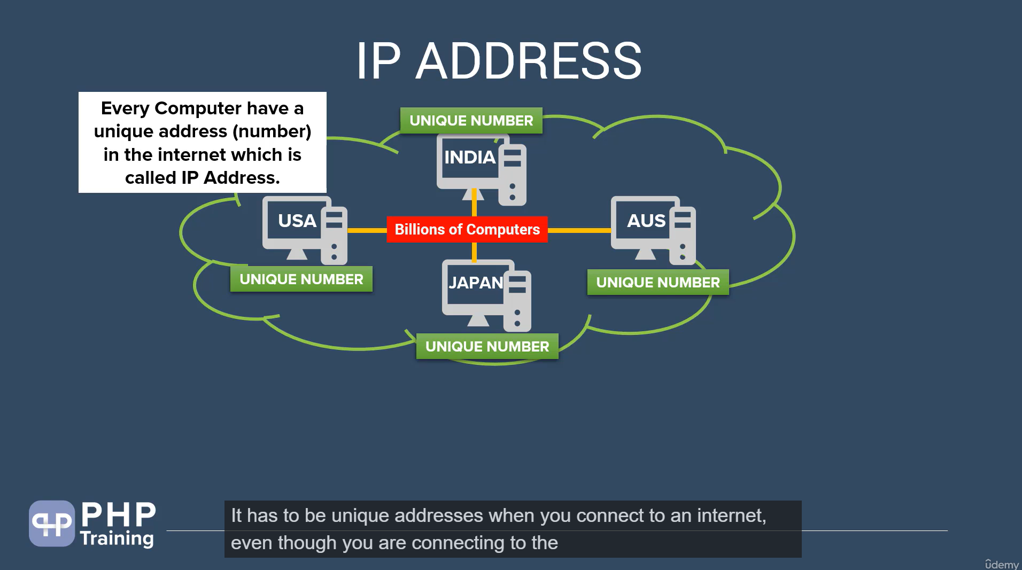
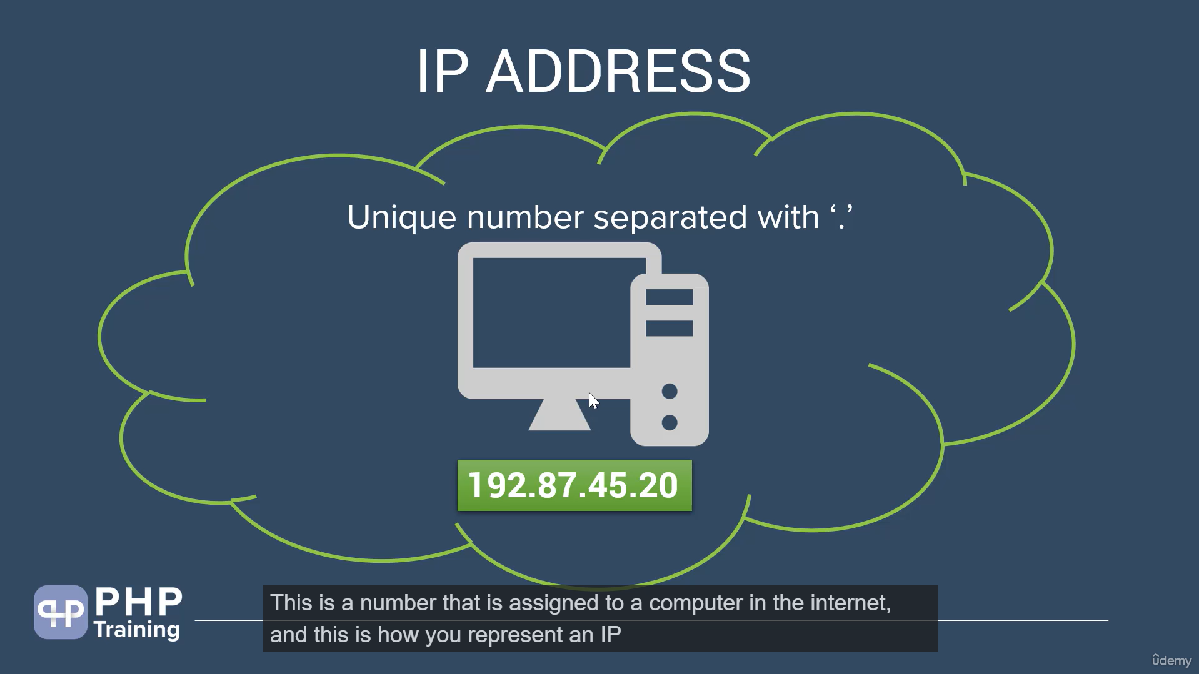

How to find your own IP address
- just type ipconfig in your cmd
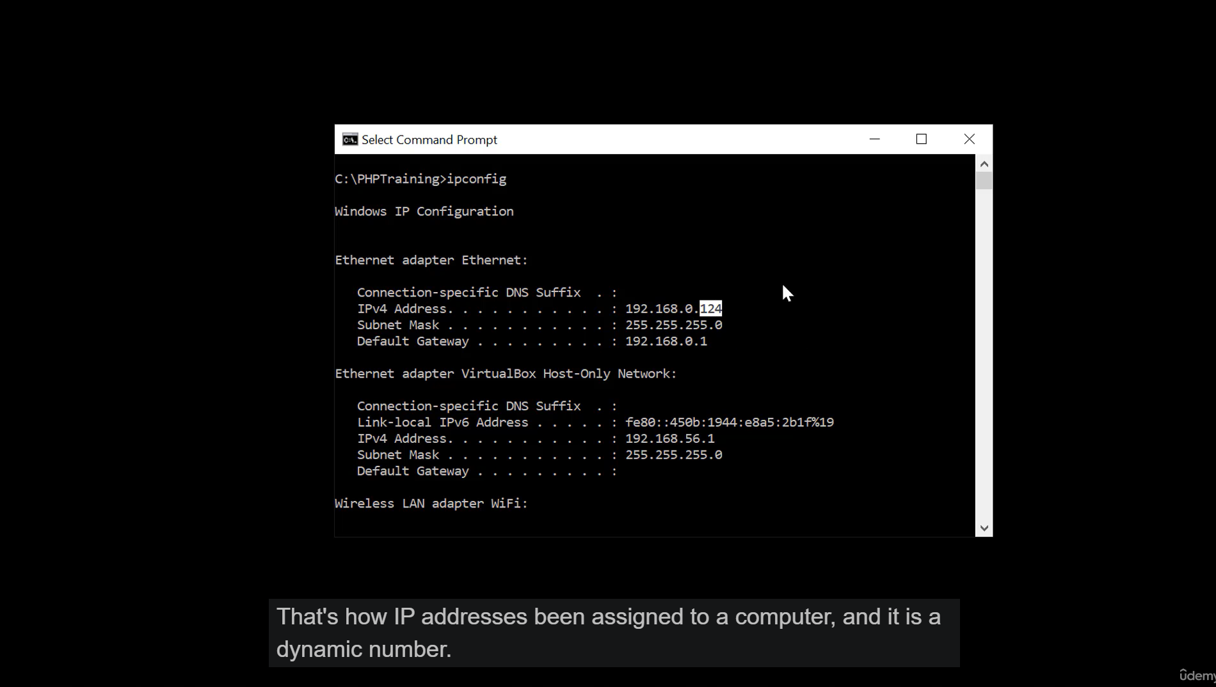

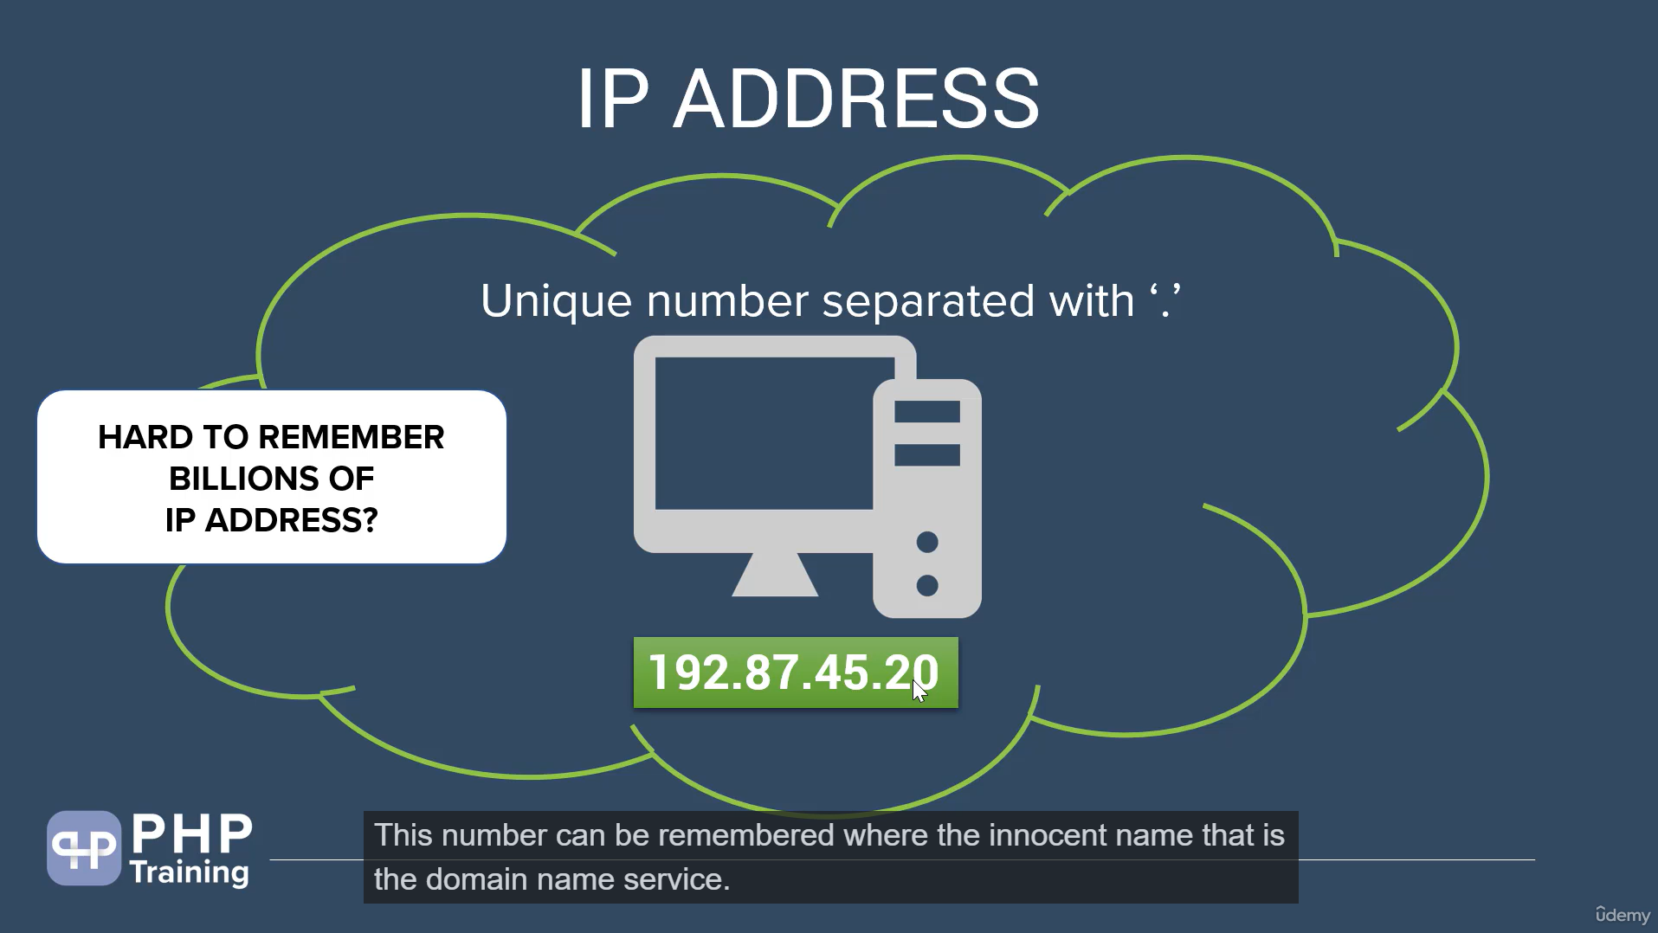

Hard to remember this IP addresses here where the concept of DNS comes in it like giving name to a phone number while saving it in your contact list

What is DNS?
- DNS stands for Domain Name System
- DNS name or Host name is the easy to remember names assigned to IP addresses of computer in internet.
- DNS server helps to convert hostname to IP address.
- You have to purchase the domain name and map the IP address to the Domain name

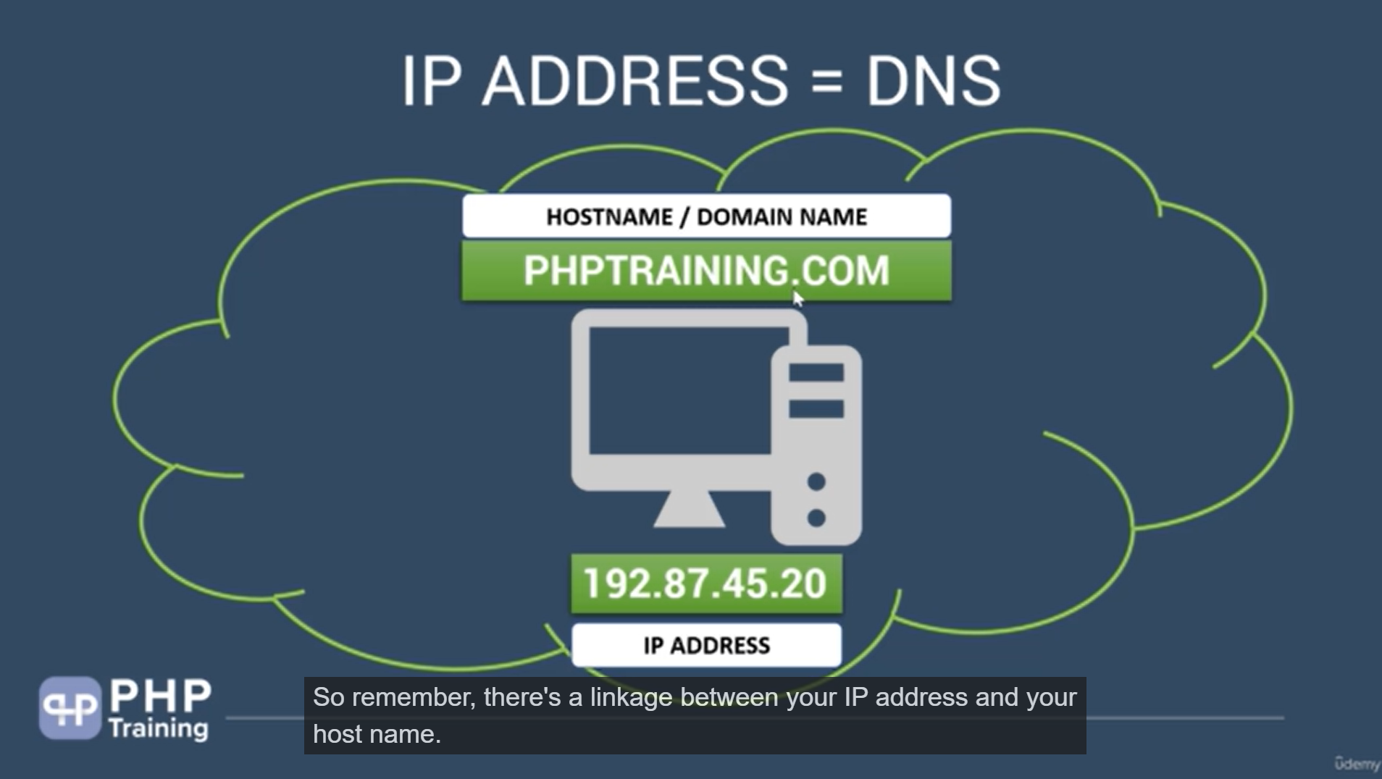
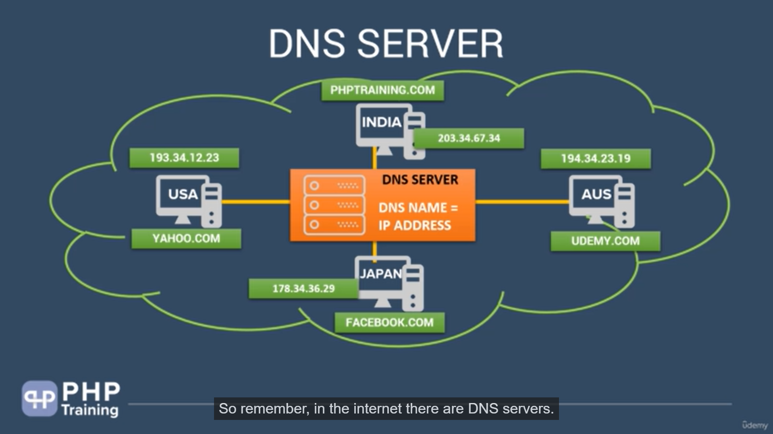

TCP only sends data in 0 and 1 irrespective of the format, it don’t care what u are sending so here comes the concept of HTTP

What is HTTP protocol?
- HTTP sands for Hyper text transfer protocol
- HTTP is an application protocol that is used to transfer data like images , video and files over the web
- HTTP protocol is built over the top of TCP protocol
- HTTP uses TCP/IP protocol to transfer the data packets between the systems.

