# #3 Hello Spring

## Tutorial: Build a spring boot application using intellij idea

### Create your new project with intellij

Open up IntelliJ and click on the Create New Project option.

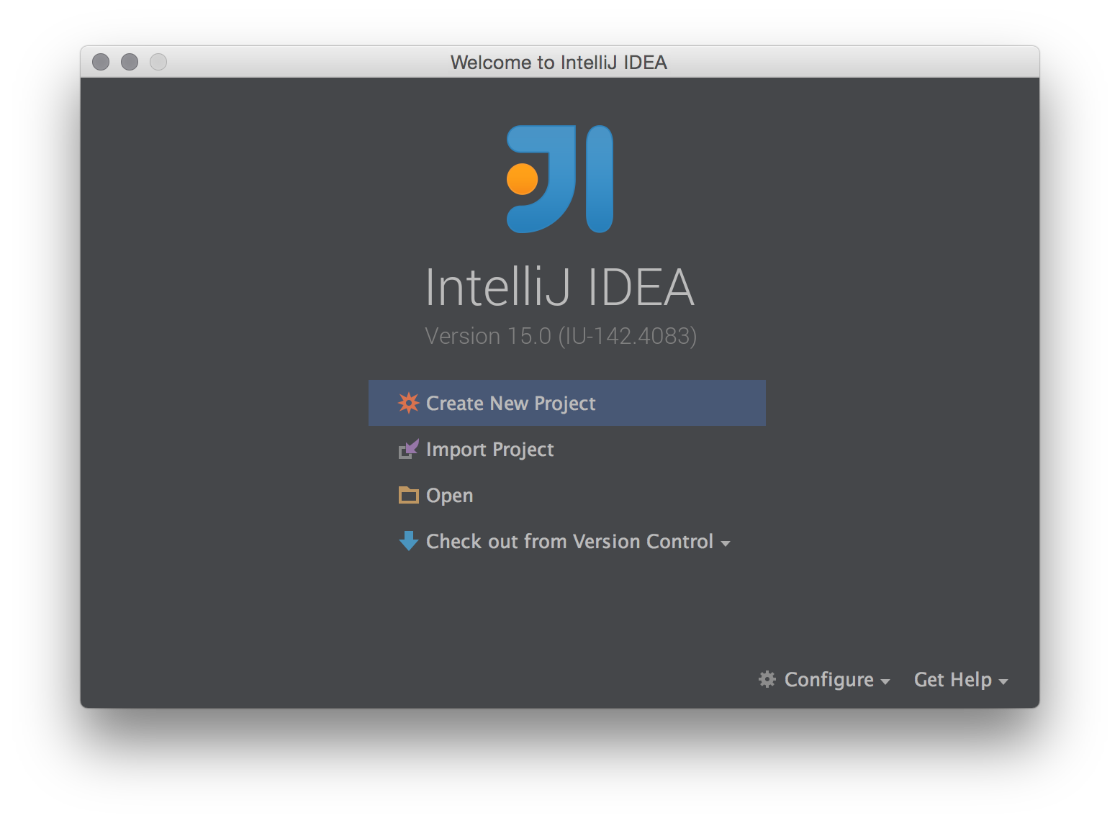

Next, select Spring Initializr from the project type in the left panel, select your Project SDK and then click Next. The Initializr Service URL should already be populated.

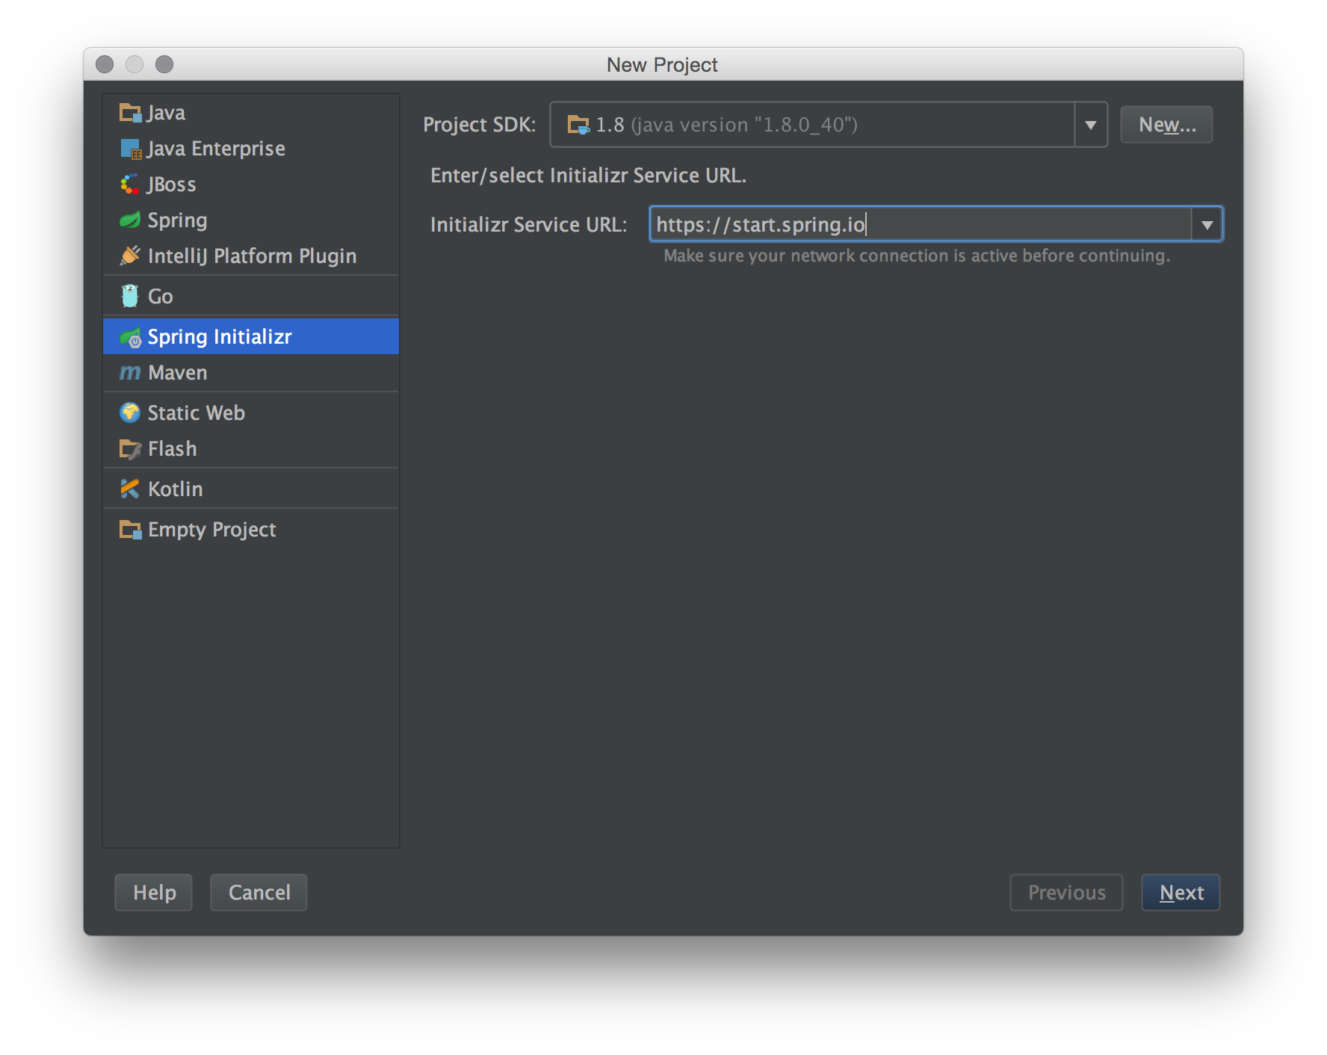

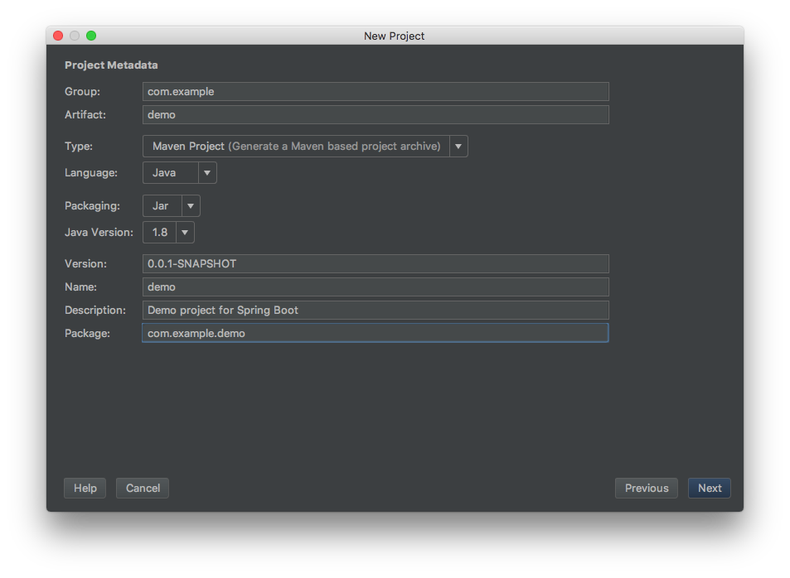

Next select any Spring Framework dependency your project will require. here you should choose

* Web -> Web
* Template Engines -> Thymeleaf

Click Next once you’ve selected all your dependencies.

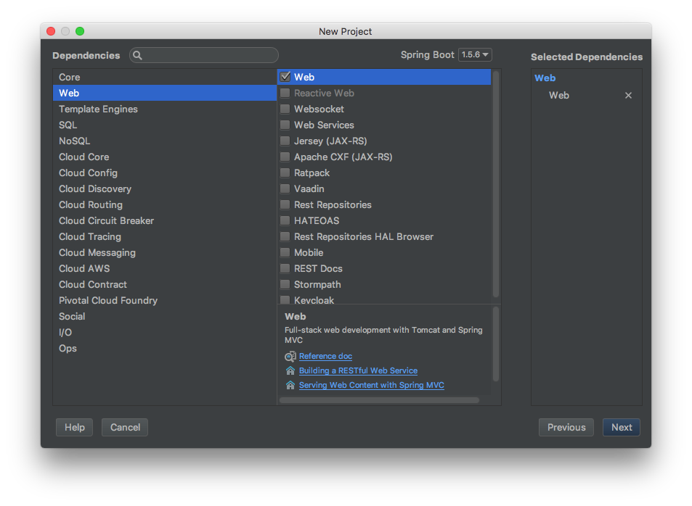

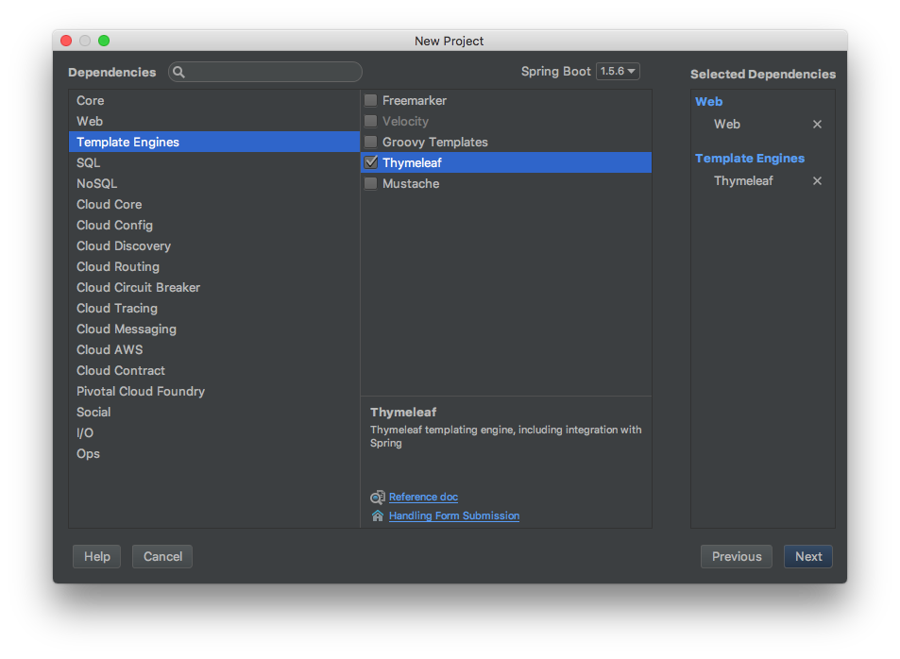

*(heavily inspired by https://patrickgrimard.io/2014/08/14/how-to-build-a-spring-boot-application-using-intellij-idea/)*

_

© clbo@kea.dk

_