Abstract
Detailed finite element models(DFEMS) are quickly becoming the new standard for all new development of aerospace structures. However, as refined as the DFEMs are becoming, they still tend to be highly refined loads models and not true stress models. This forces analysts to revert back to using simple kt charts from resources like Peterson. This is often overly conservative with geometry that is not truly reflective of the designed geometry. For a flat plate model containing compounding Kts, this paper will develop a python based finite element solver that will create a “break out” FEM model, re-meshing critical locations with refined 8 noded quadrilateral elements, while leaving the surrounding non-critical elements as 4 noded quadrilateral elements. To bridge the higher and lower order element mesh, 7 noded transition elements are developed and implemented. Freebody loads are then applied from the DFEM to get true stress concentration values that can be used for classical Linear Elastic Fracture Mechanics analysis of a corner cracked plate.
Results of the refined mixed mesh plate will be compared against classical elasticity solutions to ensure validity. Additionally, results will be compared against traditional element refinement methods relying on a substantial increase in lower order elements to determine the performance differences between the two refinement methods.

Problem Overview
Within the industry of Fatigue and Damage Tolerance (F&DT) engineering for aviation, Damage Tolerance (DT) analysis is done using commercially available Linear Elastic Fracture Mechanics (LEFM) like NASGROW or AFGROW. Figure 1 shows a typical through thickness crack edge crack for a finite width plate subject to tension load. In this solution, beta accounts for the changes in stress intensity as the crack grows along the width of the plate.

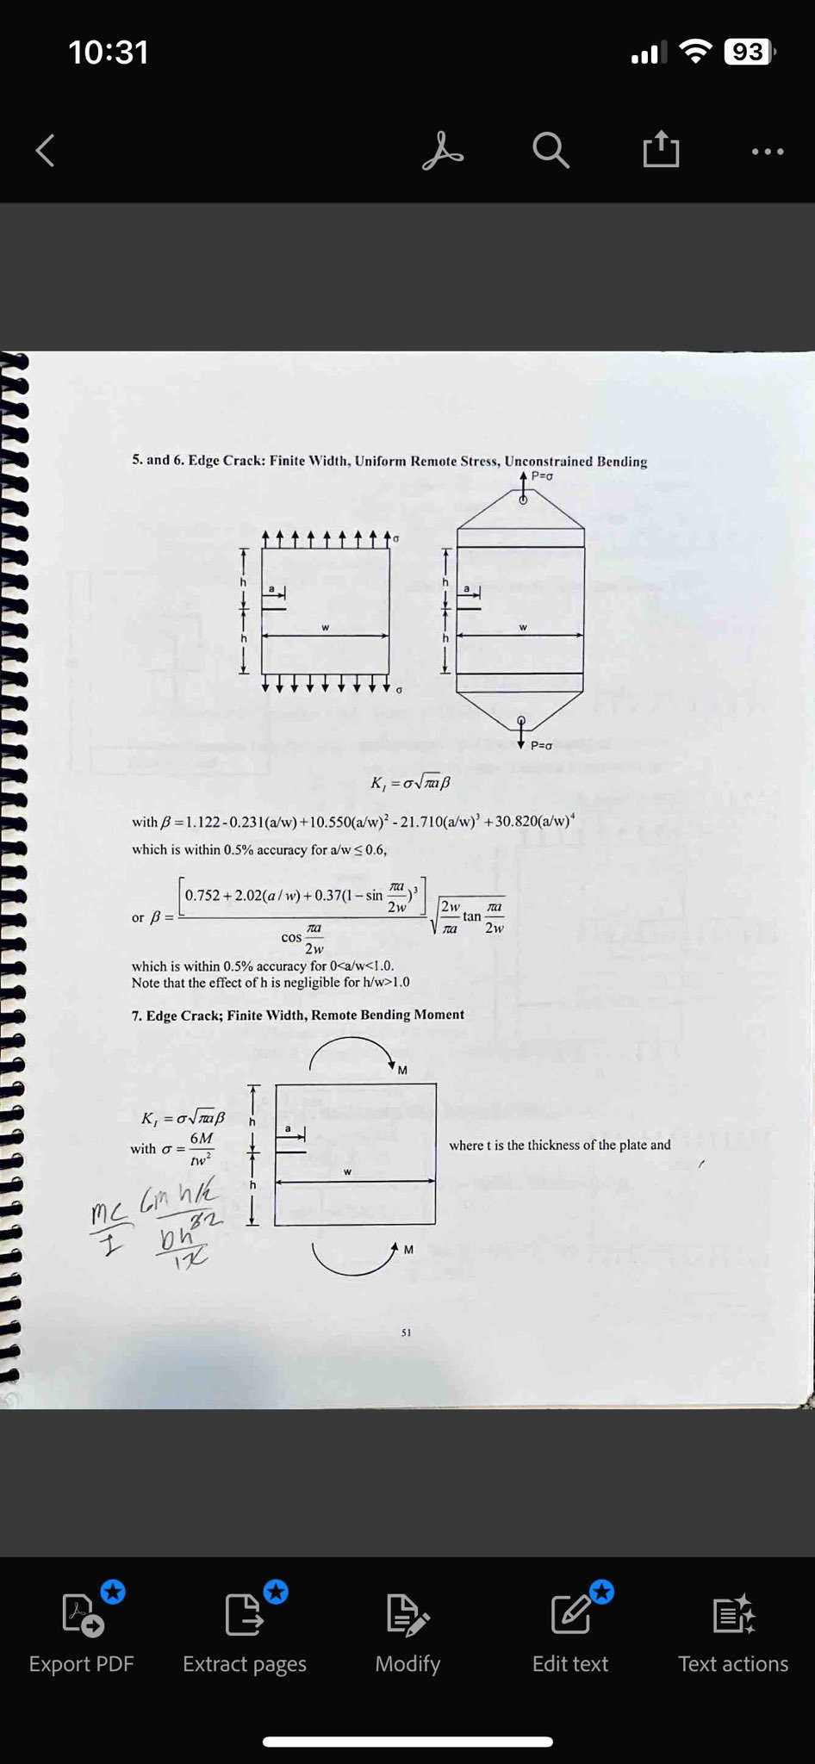
Figure 1: Example Through Thickness Edge Crack Finite Width Plate Solution [1]

However, in actual aerostructures, a pure finite width plate is never actually seen. Thus, it is necessary to make assumptions between actual geometry and the solution’s assumed geometry. For example, a representative vertical frame is shown in Figure 2, and Figure 3 shows the idealized structure that would match the solutions assumed geometry.
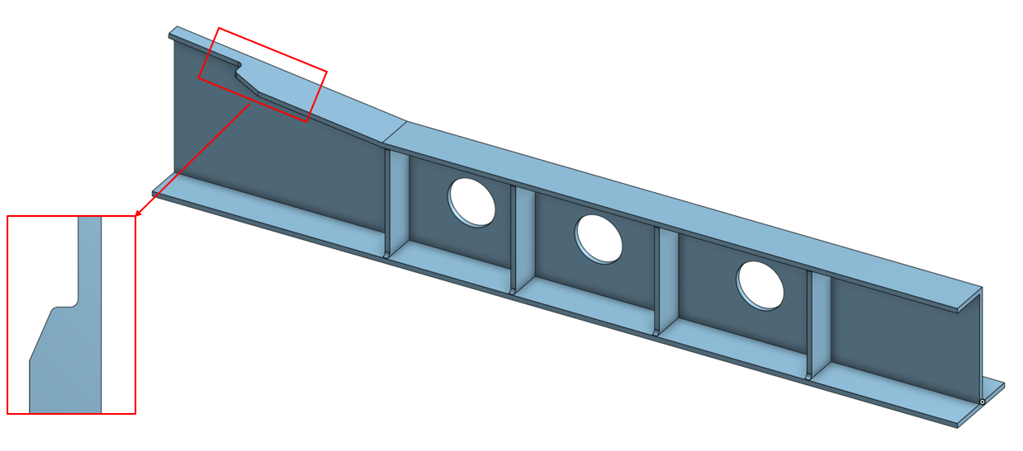
Figure 2: Representative Vertical Frame

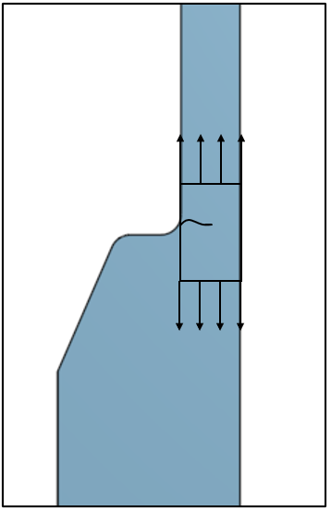
Figure 3: Assumed Finite Width Through Thickness Edge Crack Specimen

However, with the actual geometry reducing plate widths with the runout into a fillet, a stress concentration will be present. The through thickness edge crack for a finite width plate has no means of capturing this stress concentration thus a Kt must be calculated and applied on top of the traditional solutions beta. This changes the stress intensity calculation to be as shown below.
$$K=σKtβ*\sqrt{πa}$$
Traditionally this Kt value would be calculated from an industry standard handbook like Peterson’s Stress Concentrations [2]. However, again the models within [2] do not perfectly match the actual structure. Leading to analyst having to choose between possibly overly conservative vs possibly un-conservative Kt value.
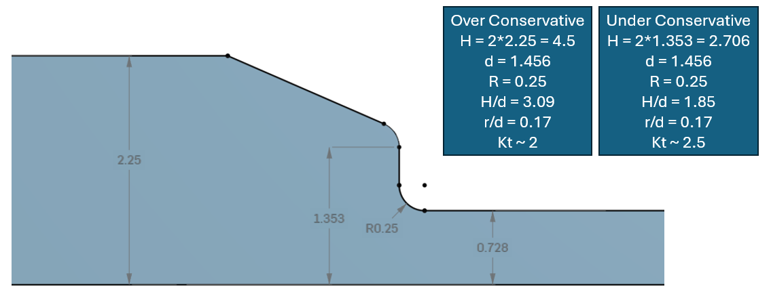Figure 4: Kt Comparisons

Typical AVFEM would mesh the part shown in Figure 3 to level of detail shown in Figure 5.
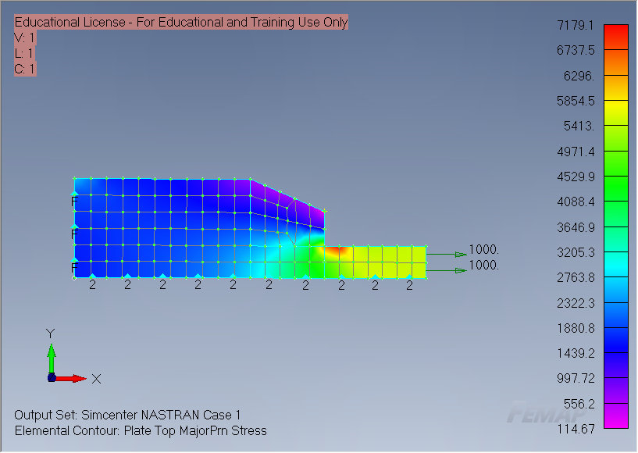
Figure 5: AVFEM Representation

With this subprime mesh shown and the limitations of LEFM solutions and Kt solutions explained, the goal of this paper is to develop a finite element solver within python that is capable of solving standard Nastran elements like: 3 node triangles, 4 node quadrilaterals, and 8 node quadrilaterals. Additionally, the solver will be capable of solving transition elements that are 6 or 7 node quadrilaterals. These transition elements bridge the gap between 4 node and 8 node quadrilaterals.

Finite Element Method Derivation
The four parts of the structural problem.
- Constitutive
- Kinematics
- Equilibrium
- Boundary Conditions

Constitutive Equations
The constitutive equations relate stress to strain using hookes law. Two assumptions can be made that either the element is in plane strain ($ϵ_{zz}=0)$or the that the element is in plane stress $(σ_{zz}=0)$. Both relations are given below. As the assumed thickness throughout all plates, plane stress is used in all analysis.
Stress vector:
$${\left\{σ\right\}}_{3d}={\left[\begin{matrix}σ_{x} & σ_{y} & σ_{z} & τ_{xy} & τ_{yz} & τ_{zx}\end{matrix}\right]}^{T}$$
$${\left\{σ\right\}}_{2d}=[\begin{matrix}σ_{x} & σ_{y} & τ_{xy}]\end{matrix}$$
Strain vector:
$${\left\{ϵ\right\}}_{3d}={\left[\begin{matrix}ϵ_{x} & ϵ_{y} & ϵ_{z} & γ_{xy} & γ_{yz} & γ_{zx}\end{matrix}\right]}^{T}$$
$${\left\{ϵ\right\}}_{2d}=[\begin{matrix}ϵ_{x} & ϵ_{y} & ϵ_{xy}]\end{matrix}$$

The constitutive equations to relate strain to stress can be done with Hooke’s law assuming either plane stress or plain strain with matrix [D].
$$\left\{σ\right\}=\left[D\right]\left\{ϵ\right\}$$
The plane strain relation is defined as the following for the 2 dimensional assumption
$$\left\{\begin{matrix}σ_{x} \\ σ_{y} \\ τ_{xy}\end{matrix}\right\}=\frac{E}{\left(1+ν\right)\left(1-2ν\right)}\left[\begin{matrix}1-ν & ν & 0 \\ -ν & 1 & 0 \\ 0 & 0 & \frac{1-2ν}{2}\end{matrix}\right]\left\{\begin{matrix}ϵ_{x} \\ ϵ_{y} \\ γ_{xy}\end{matrix}\right\}$$

The Plane stress relation is defined as the following can be used for the 2d assumption
$$\left\{\begin{matrix}σ_{x} \\ σ_{y} \\ τ_{xy}\end{matrix}\right\}=\frac{E}{1-v^{2}}\left[\begin{matrix}1 & ν & 0 \\ ν & 1 & 0 \\ 0 & 0 & \frac{1-ν}{2}\end{matrix}\right]\left\{\begin{matrix}ϵ_{x} \\ ϵ_{y} \\ γ_{xy}\end{matrix}\right\}$$

Kinematic Equations, Equilibrium
For a liner-elastic body the total potential energy assuming small strain
$$Π\left(u\right)=U_{I}\left(u\right)-U_{E}\left(u\right)$$
Where $U_{I}$ is the internal potential energy (strain energy) and $U_{E}$ is the external potential energy in the form of external forces and u is the displacement field.
The internal potential energy is defined as strain energy which is the work done by the internal stresses while deforming a body from zero strain to its final strain state.
$$dU=σ^{T}dϵ$$
Need to integrate the strain over the entire volume
$$U=\int_{V}{\int_{0}^{ϵ}{σ^{T}}dϵ}$$
Stress is related to strain by the constitutive matrix $σ=Dϵ$
$$U=\int_{V}{\int_{0}^{ϵ}{{\left(Dϵ\right)}^{T}dϵ}}$$
Integrating with respect to epsilon yields
$$U\left(u\right)=\frac{1}{2}\int_{V}{ϵ^{T}DϵdV}$$
External Work
Assuming there are no body forces or surface tractions
$$U_{E}\left(u\right)=\sum_{i}{u_{i}^{T}P_{i}}$$
This gives the potential energy statement of:
$$Π\left(u\right)=\frac{1}{2}\int_{V}{ϵ^{T}DϵdV}-\sum_{i}{u_{i}^{T}P_{i}}$$

By definition the virtual work is equal to zero. Therefore, taking the first variation of the potential energy statement gives
$$δΠ\left(u\right)=0$$
$$δΠ=δU_{I}-δU_{E}=\int_{V}{ϵ^{T}DδϵdV}-\sum_{i}{δu_{i}^{T}P_{i}}=0$$
Gives
$$\int_{V}{ϵ^{T}DδϵdV}=\sum_{i}{δu_{i}^{T}P_{i}}$$
Relating strains to displacements gives
Where $ϵ, u$ are defined as
$\left\{u\right\}=\left[N\right]\{d\}$ Where N is the matrix of shape functions
$\left\{ϵ\right\}=\left[∂\right]\left[u\right]$ Strain is known to be the partial derivatives of displacement
{d} is the elemental degrees of freedom ie $\{\begin{matrix}u_{1} & v_{1} & u_{2} & v_{2}\end{matrix}\}$
Therefore, substituting u into the epsilon gives
$$\left\{ϵ\right\}=\left[∂\right]\left[N\right]\{d\}$$
Next, the B matrix is defined as the partial derivatives of the shape functions
$\left\{B\right\}=\left[∂\right][N]$ therefore substituting into the strain displacement relationship gives
$$\left\{ϵ\right\}=\left[B\right]\{d\}$$
$$\int_{V}{B^{T}DBdV}\{d\}=\sum_{i}{δu_{i}^{T}P_{i}}$$
Therefore, the stiffness matrix is
$$K_{e}=\int_{V}{B^{T}DBdV}$$
For the 2 case the volume spans x, y and the constant in the z for a constant thickness t.
$$K_{e}= t\int_{y}{\int_{x}{{\left[B\right]}^{T}\left[D\right][B] dx dy}}$$

Deriving the B Matrix
Starting from the strain displacement formula provided previously
$$\left\{ϵ\right\}=\left[B\right]\left\{d\right\}$$
Strain is the change in displacement with respect to a given direction
$$ϵ_{x}=\frac{∂u}{∂x}, ϵ_{y}=\frac{∂v}{∂y}, γ_{xy}=\left(\frac{∂u}{∂y}+\frac{∂v}{∂x}\right)$$
Re-arranging in matrix form
$$\left\{\begin{matrix}ε_{x} \\ ε_{y} \\ γ_{xy}\end{matrix}\right\}=\left[\begin{matrix}1 & 0 & 0 & 0 \\ 0 & 0 & 0 & 1 \\ 0 & 1 & 1 & 0\end{matrix}\right]\left\{\begin{matrix}\frac{∂u}{∂x} \\ \frac{∂u}{∂y} \\ \frac{∂v}{∂x} \\ \frac{∂v}{∂y}\end{matrix}\right\}$$
The core logic of the finite element logic is to use shape functions to approximate the global displacements where u, and v are approximated by the shape functions N.
$$\hat{u}\left(x, y\right)= \sum_{i=1}^{n}{N_{i}\left(x, y\right)u_{i}}, \hat{v}\left(x,y\right)= \sum_{i=1}^{n}{N_{i}\left(x,y\right)v_{i}}$$
$$\left\{\begin{matrix}\hat{u} \\ \hat{v} \end{matrix}\right\}=\left[\begin{matrix}N_{i} & 0 \\ 0 & N_{i}\end{matrix}\right]\left\{\begin{matrix}u_{i} \\ v_{i}\end{matrix}\right\}$$
Computing the derivatives
$$\left\{\begin{matrix} \hat{u},_{x} \\ \hat{u},_{y} \\ \hat{v},_{x} \\ \hat{v},_{y}\end{matrix}\right\}=\left[\begin{matrix}N_{i,x} & 0 \\ N_{i,y} & 0 \\ 0 & N_{i,x} \\ 0 & N_{i,y}\end{matrix}\right]\left\{\begin{matrix}u_{i} \\ v_{i}\end{matrix}\right\}$$
Substituting into the strain displacement relationship
$$\left\{\begin{matrix}ε_{x} \\ ε_{y} \\ γ_{xy}\end{matrix}\right\}=\left[\begin{matrix}1 & 0 & 0 & 0 \\ 0 & 0 & 0 & 1 \\ 0 & 1 & 1 & 0\end{matrix}\right]\left[\begin{matrix}N_{i,x} & 0 \\ N_{i,y} & 0 \\ 0 & N_{i,x} \\ 0 & N_{i,y}\end{matrix}\right]\left\{\begin{matrix}u_{i} \\ v_{i}\end{matrix}\right\}$$
This simplifies to
$$\left\{\begin{matrix}ε_{x} \\ ε_{y} \\ γ_{xy}\end{matrix}\right\}=\left[\begin{matrix}N_{i,x} & 0 \\ 0 & N_{i,y} \\ N_{i,y} & N_{i,x}\end{matrix}\right]\left\{\begin{matrix}u_{i} \\ v_{i}\end{matrix}\right\}$$
Therefore, the B matrix is where i is each node within the element
$$B_{i}=\left[\begin{matrix}N_{i,x} & 0 \\ 0 & N_{i,y} \\ N_{i,y} & N_{i,x}\end{matrix}\right]$$

Boundary Conditions
Boundary conditions for all analysis are limited to being a fixed constraint of either x, y or both eliminating translation in these directions. It is assumed that there are no rotations and everything remains planar.

Stiffness Derivation

Calculation in the Global System
The previously shown elemental stiffness calculation’s volume can be calculated across x, y for a quadrilateral element. This approach is feasible for perfectly square elements. However, it becomes challenging to determine the proper integration limits when the element becomes distorted. Virtually every element within a FE model has some level distortion. Thus the elements will be mapped from the global coordinate systems into an idealized natural coordinate system as shown in Figure 6.
$$[K_{e}]= t\int_{y}{\int_{x}{{\left[B\right]}^{T}\left[D\right][B] dx dy}}$$

Calculation in the Element Natural Coordinate system
The natural coordinate system for the quadrilateral element is in the $ξ,η$ system with the 4 corners at (-1, -1), (1, -1), (1, 1), (-1, 1). Regardless of the element’s physical position, rotation, or skew; it will always map to the same four points.
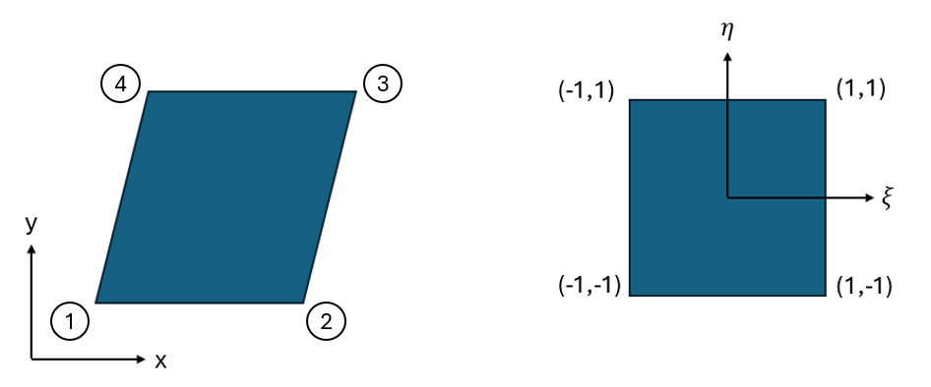
Figure 6: Global to Natural Coordinate System
As shown previously the displacements can be defined as
$$\left\{\begin{matrix}u \\ v\end{matrix}\right\}=\left\{\begin{matrix}∑N_{i}(x,y)u_{i} \\ ∑N_{i}(x,y)v_{i}\end{matrix}\right\}$$
However, the shape functions here are defined in the x, y coordinate system. The natural coordinate system with the coordinates $ξ, η$ demands that the shape functions be functions of $ξ, η$.
Where N are the shape functions that can be used for a liner quadrilateral elements which are also used in the mapping from the global and natural coordinate systems
$N_{1}=\frac{1}{4}\left(1-ξ\right)\left(1-η\right)$, $N_{2}=\frac{1}{4}\left(1+ξ\right)\left(1+η\right)$
$N_{3}=\frac{1}{4}\left(1+ξ\right)\left(1+η\right)$, $N_{4}=\frac{1}{4}\left(1-ξ\right)\left(1+η\right)$
The problem encountered is that the shape functions are in term so of $ξ, η$ and not u, v. Thus a coordinate transformation must take place.
$$\left[\begin{matrix}x_{i} \\ y_{i}\end{matrix}\right]=\left[ J \right]\left[\begin{matrix}ξ_{i} \\ η_{i}\end{matrix}\right]$$
The Jacobian is defined as:
$$\left[ J \right]=\left[\begin{matrix}\frac{∂x}{∂ξ} & \frac{∂x}{∂η} \\ \frac{∂y}{∂ξ} & \frac{∂y}{∂η}\end{matrix}\right]$$
And the determinant of the Jacobian is
$$\left|J\right|=\frac{∂x}{∂ξ}\frac{∂y}{∂η}-\frac{∂x}{∂η}\frac{∂y}{∂ξ}$$
The bounds of the integration can now be written in-terms of $ξ, η$ with the following relation
$$dxdy=\det\left[ J \right]dξdη$$
Therefore
$$\left[k_{e}\right](x, y)=t∫{\left[B\right]}^{T}\left[C\right]\left[B\right]det⁡[ J] dξdη$$

Element Strain Displacements are given by
$$\left\{ε\right\}=\left[B\right]\left\{d\right\}$$
$$\left\{\begin{matrix}ε_{x} \\ ε_{y} \\ γ_{xy}\end{matrix}\right\}=\left[\begin{matrix}1 & 0 & 0 & 0 \\ 0 & 0 & 0 & 1 \\ 0 & 1 & 1 & 0\end{matrix}\right]\left\{\begin{matrix}\frac{∂u}{∂x} \\ \frac{∂u}{∂y} \\ \frac{∂v}{∂x} \\ \frac{∂v}{∂y}\end{matrix}\right\}$$
To get results in terms of $ξ, η$ the multivariable chain rule is used.
$$\frac{∂u}{∂x}=\frac{∂u}{∂ξ}\frac{∂ξ}{∂x}+\frac{∂u}{∂η}\frac{∂η}{∂x}, \frac{∂u}{∂y}=\frac{∂u}{∂ξ}\frac{∂ξ}{∂y}+\frac{∂u}{η}\frac{∂η}{∂y}$$
$$\frac{∂v}{∂x}=\frac{∂v}{∂ξ}\frac{∂ξ}{∂x}+\frac{∂v}{∂η}\frac{∂η}{∂x}, \frac{∂v}{∂y}=\frac{∂v}{∂ξ}\frac{∂ξ}{∂y}+\frac{∂v}{η}\frac{∂η}{∂y}$$
Re-writing in matrix form
$$\left\{\begin{matrix}u,_{x} \\ u,_{y} \\ v,_{x} \\ v,_{y}\end{matrix}\right\}=\left[\begin{matrix}ξ,_{x} & η,_{x} & 0 & 0 \\ ξ,_{y} & η,_{y} & 0 & 0 \\ 0 & 0 & ξ,_{x} & η,_{x} \\ 0 & 0 & ξ,_{y} & η,_{y}\end{matrix}\right]\left\{\begin{matrix}u,_{ξ} \\ u,_{η} \\ v,_{ξ} \\ v,_{η}\end{matrix}\right\}$$
Substituting in the strain displacement relation
$$\left\{\begin{matrix}ε_{x} \\ ε_{y} \\ γ_{xy}\end{matrix}\right\}=\left[\begin{matrix}1 & 0 & 0 & 0 \\ 0 & 0 & 0 & 1 \\ 0 & 1 & 1 & 0\end{matrix}\right]\left[\begin{matrix}ξ,_{x} & η,_{x} & 0 & 0 \\ ξ,_{y} & η,_{y} & 0 & 0 \\ 0 & 0 & ξ,_{x} & η,_{x} \\ 0 & 0 & ξ,_{y} & η,_{y}\end{matrix}\right]\left\{\begin{matrix}u,_{ξ} \\ u,_{η} \\ v,_{ξ} \\ v,_{η}\end{matrix}\right\}$$
$$\hat{u}\left(ξ,η\right)= \sum_{i=1}^{n}{N_{i}\left(ξ, η\right)u_{i}}, \hat{v}\left(ξ,η\right)= \sum_{i=1}^{n}{N_{i}\left(ξ,η\right)v_{i}}$$
$$\left\{\begin{matrix}\hat{u} \\ \hat{v} \end{matrix}\right\}=\left[\begin{matrix}N_{i} & 0 \\ 0 & N_{i}\end{matrix}\right]\left\{\begin{matrix}u_{i} \\ v_{i}\end{matrix}\right\}$$
Computing the derivatives
$$\left\{\begin{matrix} \hat{u},_{ξ } \\ \hat{u},_{η} \\ \hat{v},_{ξ} \\ \hat{v},_{η}\end{matrix}\right\}=\left[\begin{matrix}N_{i,ξ} & 0 \\ N_{i,η} & 0 \\ 0 & N_{i,ξ} \\ 0 & N_{i,η}\end{matrix}\right]\left\{\begin{matrix}u_{i} \\ v_{i}\end{matrix}\right\}$$
As the shape functions are functions of $ξ, η$ their derivatives can be taken
Substituting in the final strain displacement relation shows the following where i is the index of nodes
$$\left\{\begin{matrix}ε_{x} \\ ε_{y} \\ γ_{xy}\end{matrix}\right\}=\left[\begin{matrix}1 & 0 & 0 & 0 \\ 0 & 0 & 0 & 1 \\ 0 & 1 & 1 & 0\end{matrix}\right]\left[\begin{matrix}ξ,_{x} & η,_{x} & 0 & 0 \\ ξ,_{y} & η,_{y} & 0 & 0 \\ 0 & 0 & ξ,_{x} & η,_{x} \\ 0 & 0 & ξ,_{y} & η,_{y}\end{matrix}\right]\left[\begin{matrix}N_{i,ξ} & 0 \\ N_{i,η} & 0 \\ 0 & N_{i,ξ} \\ 0 & N_{i,η}\end{matrix}\right]\left\{\begin{matrix}u_{i} \\ v_{i}\end{matrix}\right\}$$
With the B Matix being
$$\left[B\right]=\left[\begin{matrix}1 & 0 & 0 & 0 \\ 0 & 0 & 0 & 1 \\ 0 & 1 & 1 & 0\end{matrix}\right]\left[\begin{matrix}ξ,_{x} & η,_{x} & 0 & 0 \\ ξ,_{y} & η,_{y} & 0 & 0 \\ 0 & 0 & ξ,_{x} & η,_{x} \\ 0 & 0 & ξ,_{y} & η,_{y}\end{matrix}\right]\left[\begin{matrix}N_{i,ξ} & 0 \\ N_{i,η} & 0 \\ 0 & N_{i,ξ} \\ 0 & N_{i,η}\end{matrix}\right]$$
This can be simplified into the following.
$$\left[B\right]=\left[\begin{matrix}ξ,_{x} & η,_{x} & 0 & 0 \\ 0 & 0 & ξ,_{y} & η,_{y} \\ ξ,_{y} & η,_{y} & ξ,_{x} & η,_{x}\end{matrix}\right]\left[\begin{matrix}N_{i,ξ} & 0 \\ N_{i,η} & 0 \\ 0 & N_{i,ξ} \\ 0 & N_{i,η}\end{matrix}\right]$$
$$B=\left[\begin{matrix}ξ,_{x}N_{i,ξ}+η,_{x}N_{i,η} & 0 \\ 0 & ξ,_{y}N_{i,ξ}+η,_{y}N_{i, η} \\ ξ,_{y}N_{i,ξ}+η,_{y}N_{i, η} & ξ,_{x}N_{i,ξ}+η,_{x}N_{i,η}\end{matrix}\right]$$
$$\left\{\begin{matrix}ε_{x} \\ ε_{y} \\ γ_{xy}\end{matrix}\right\}=\left[\begin{matrix}ξ,_{x}N_{i,ξ}+η,_{x}N_{i,η} & 0 \\ 0 & ξ,_{y}N_{i,ξ}+η,_{y}N_{i, η} \\ ξ,_{y}N_{i,ξ}+η,_{y}N_{i, η} & ξ,_{x}N_{i,ξ}+η,_{x}N_{i,η}\end{matrix}\right]\left\{\begin{matrix}u_{i} \\ v_{i}\end{matrix}\right\}$$
Returning back to the elemental stiffness calculation, all required variables are now known

$$\left[k_{e}\right](x, y)=t∫∫{\left[B\right]}^{T}\left[C\right]\left[B\right]det⁡[ J] dξdη$$

Gauss Quadrature
While programs like python with sympy or Maple can perform symbolic integration, it is inefficient compared to numerical methods. Gause integration says that an integral can be evaluated as a summation of functions evaluated at integration points with weights applied.
$$\int_{-1}^{1}{f\left(x\right)dx= \sum_{i=1}^{1}{w_{i}f\left(x_{i}\right)}}$$
For double integration
$$\int_{-1}^{1}{\int_{-1}^{1}{f\left(x,y\right)dxdy}= \sum_{i=1}^{n}{\sum_{j=1}^{n}{w_{i}w_{j}f\left(x_{i}, y_{i}\right)}}}$$
Substituting into the stiffness calculation
$$\left[k_{e}\right](x, y)=t\sum_{i=1}^{n}{\sum_{j=1}^{n}{[w_{i}w_{j}}}{\left[B\right]}^{T}\left[C\right]\left[B\right]det⁡[ J] dξdη]$$
Insert the table showing the different orders of weights and points
The Gauss Points and Weights shown in Figure 7 are selected by the polynomial order of the element’s shape functions.
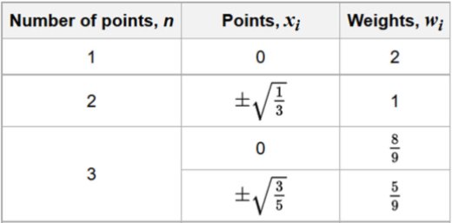
Figure 7: Gauss Quadrature Weights and Points [3]
The shape functions for each element are shown below
Table 1: Gauss Points and Weights Per Element Type
Element | Shape Function (Ex) | Gauss Points | Gauss Weights
CTRIA3 | $$1-ξ-η$$ | 1/3 | 0.5
CQUAD4 | $$0.25*(1-ξ)(1-η)$$ | $$±\frac{\sqrt{1}}{3}$$ | 1
CQUAD6 | $$\frac{η*ξ}{4}-\frac{η}{4}+\frac{ξ^{2}}{2}-\frac{ξ}{4}-\frac{1}{4}$$ | $$±\frac{\sqrt{1}}{3}$$ | 1
CQUAD7 | $$0.25*ξ(1-ξ)(η-1)$$ | $$-\sqrt{\frac{3}{5}}, 0, \sqrt{\frac{3}{5}}$$ | $$\frac{5}{9}, \frac{8}{9}, \frac{5}{9}$$
CQUAD8 | $$-\frac{1}{4}(1-η)(1-ξ)(1+ξ+η)$$ | $$-\sqrt{\frac{3}{5}}, 0, \sqrt{\frac{3}{5}}$$ | $$\frac{5}{9}, \frac{8}{9}, \frac{5}{9}$$

Element Shape Functions

CTRIA3
Some Text Here
Nodal Point | Shape Function | $$\frac{∂N}{∂ξ}$$ | $$\frac{∂N}{∂η}$$
N1: (0,0) | $$1-ξ-η$$ | -1 | -1
N2: (1, 0) | $$ξ$$ | 1 | 0
N3: (0, 1) | $$η$$ | 0 | 1
Sone Text Here

CQUAD4
Some Text Here
Nodal Point | Shape Function | $$\frac{∂N}{∂ξ}$$ | $$\frac{∂N}{∂η}$$
N1: (-1, -1) | $$\frac{1}{4}(1-ξ)(1-η)$$ | $$0.25η-0.25$$ | $$0.25ξ-0.25$$
N2: (1, -1) | $$\frac{1}{4}(1+ξ)(1-η)$$ | $$0.25-0.25η$$ | $$-0.25ξ-0.25$$
N3: (1, 1) | $$\frac{1}{4}(1+ξ)(1+η)$$ | $$0.25η+0.25$$ | $$0.25ξ+0.25$$
N4: (-1, 1) | $$\frac{1}{4}(1-ξ)(1+η)$$ | $$-0.25η-0.25$$ | $$0.25-0.25ξ$$

fdafdas

CQUAD8
Some Text Here
Nodal Point | Shape Function | $$\frac{∂N}{∂ξ}$$ | $$\frac{∂N}{∂η}$$
N1: (-1, -1) | $$-\frac{1}{4}(1-η)(1-ξ)(1+ξ+η)$$ | $$0.25(-η-2ξ)(η-1)$$ | $$0.25(-2η-ξ)(ξ-1)$$
N2: (1, -1) | $$-\frac{1}{4}(1-η)(1+ξ)(1-ξ+η)$$ | $$0.25(η-1)(η-2ξ)$$ | $$0.25(2η-ξ)(ξ+1)$$
N3: (1, 1) | $$-\frac{1}{4}(1+η)(1+ξ)(1-ξ-η)$$ | $$0.25\left(η+1\right)\left(η+2ξ\right)$$ | $$0.25(2η+ξ)(ξ+1)$$
N4: (-1, 1) | $$-\frac{1}{4}(1+η)(1-ξ)(1+ξ-η)$$ | $$0.25\left(-η+2ξ\right)(η+1)$$ | $$0.25(-2η+ξ)(ξ-1)$$
N5: (0, -1) | $$\frac{1}{2}(1-η)(1-ξ)(1+ξ)$$ | $$ξ(η-1)$$ | $$0.5ξ^{2}-0.5$$
N6: (1, 0) | $$\frac{1}{2}(1-η)(1+ξ)(1+η)$$ | $$0.5-0.5η^{2}$$ | $$η(-ξ-1)$$
N7: (0, 1) | $$\frac{1}{2}(1+η)(1-ξ)(1+ξ)$$ | $$ξ(-η-1)$$ | $$0.5-0.5ξ^{2}$$
N8: (-1, 0) | $$\frac{1}{2}(1-η)(1-ξ)(1+η)$$ | $$0.5η^{2}-0.5$$ | $$η(ξ-1)$$

Some text here

CQUAD7
Some text here
Nodal Point | Shape Function | $$\frac{∂N}{∂ξ}$$ | $$\frac{∂N}{∂η}$$
N1: (-1, -1) | $$\frac{1}{4}\left(1-ξ\right)\left(1-η \right)-\frac{1}{2}N_{5}$$ | $$0.25η-0.5ξ\left(η-1\right)-0.25$$ | $$0.25ξ(1-ξ)$$
N2: (1, -1) | $$\frac{1}{4}\left(1+ξ\right)\left(1-η\right)-\frac{1}{2}N_{5}-\frac{1}{2}N_{6}$$ | $$0.25η^{2}-0.25η-0.5ξ(η-1)$$ | $$0.5η\left(ξ+1\right)-0.25ξ^{2}-0.25ξ$$
N3: (1, 1) | $$\frac{1}{4}\left(1+ξ\right)\left(1+η\right)-\frac{1}{2}N_{6}-\frac{1}{2}N_{7}$$ | $$0.25η^{2}+0.25η+0.5ξ(η+1)$$ | $$0.5η\left(ξ+1\right)+0.25ξ^{2}+0.25ξ$$
N4: (-1, 1) | $$\frac{1}{4}\left(1-ξ\right)\left(1+η\right)-\frac{1}{2}N_{7}$$ | $$-0.25η+0.5ξ\left(η+1\right)-0.25$$ | $$0.25ξ(ξ-1)$$
N5: (0, -1) | $$\frac{1}{2}(1-ξ^{2})(1-η)$$ | $$ξ(η-1)$$ | $$0.5ξ^{2}-0.5$$
N6: (1, 0) | $$\frac{1}{2}\left(1+ξ\right)\left(1-η^{2}\right)$$ | $$0.5-0.5η^{2}$$ | $$-η\left(ξ+1\right)$$
N7: (0, 1) | $$\frac{1}{2}(1-ξ^{2})(1+η)$$ | $$ξ(η+1)$$ | $$0.5-0.5ξ^{2}$$

Some text here

CQUAD6
Some Text Here
Nodal Point | Shape Function | $$\frac{∂N}{∂ξ}$$ | $$\frac{∂N}{∂η}$$
N1: (-1, -1) | $$\frac{1}{4}\left(1-ξ\right)\left(1-η \right)-\frac{1}{2}N_{5}$$ | $$0.25η-0.5ξ\left(η-1\right)-0.25$$ | $$0.25ξ(1-ξ)$$
N2: (1, -1) | $$\frac{1}{4}\left(1+ξ\right)\left(1-η\right)-\frac{1}{2}N_{5}-\frac{1}{2}N_{6}$$ | $$0.25η^{2}-0.25η-0.5ξ(η-1)$$ | $$0.5η\left(ξ+1\right)-0.25ξ^{2}-0.25ξ$$
N3: (1, 1) | $$\frac{1}{4}\left(1+ξ\right)\left(1+η\right)-\frac{1}{2}N_{6}$$ | $$0.25η(η+1)$$ | $$0.5η\left(ξ+1\right)+0.25ξ^{2}+0.25ξ$$
N4: (-1, 1) | $$\frac{1}{4}\left(1-ξ\right)\left(1+η\right)$$ | $$-0.25η-0.25$$ | $$0.25ξ(ξ-1)$$
N5: (0, -1) | $$\frac{1}{2}(1-ξ^{2})(1-η)$$ | $$ξ(η-1)$$ | $$0.5ξ^{2}-0.5$$
N6: (1, 0) | $$\frac{1}{2}\left(1+ξ\right)\left(1-η^{2}\right)$$ | $$0.5-0.5η^{2}$$ | $$-η\left(ξ+1\right)$$

Some Text Here

References

[1] | B. L. S. a. W. J. Horn, Failure, Fracture Mechanics, Fatigue, and Damage Tolerance, Wichita State University Department of Aerospace Engineering.

ElementRepository.py

KeCalc.py

