Christopher Villarreal
Module 5 Assignment 2 – MySQL Functions
#1 – NOW

When it might be used
The NOW() function returns the ‘current’ time at the point of the query running of the current date and time from the system.
It can be used in also every situation, primarily security logging, for when you want to keep a timed record of when actions are done. A similar way can be done in python with printing out a time and date function, but this would be stored at a database level.
Alias for column header
AS ‘Current Timestamp’
Screenshot
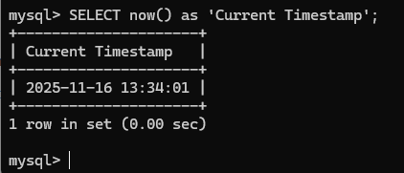

#2 – FORMAT
When it might be used
Format() can be used when we want to display the numbers to a human-friendly way in terms of formatting large numbers, decimas, percentages, etc. It will not change the value itself, simply just adjust to viewing.

Alias for column header
AS ‘Formatted Wallet’
Screenshot
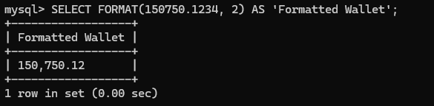

#3 – INSERT
When it might be used
The INSERT() function allows us to replace a part of a string, which can be used as a variety things such as fixing malformed inputs, modifying log messages, and a variety of other things like maybe tags and prefixes on a blog database.
Alias for column header
AS ‘Modified String’
Screenshot
