Christopher Villarreal
  - Module 8 – Assignment 2 – Update & Delete
  - November 30, 2025
  - GitHub Repo: https://github.com/DatBoiWeep/csd-310

Output
Part One
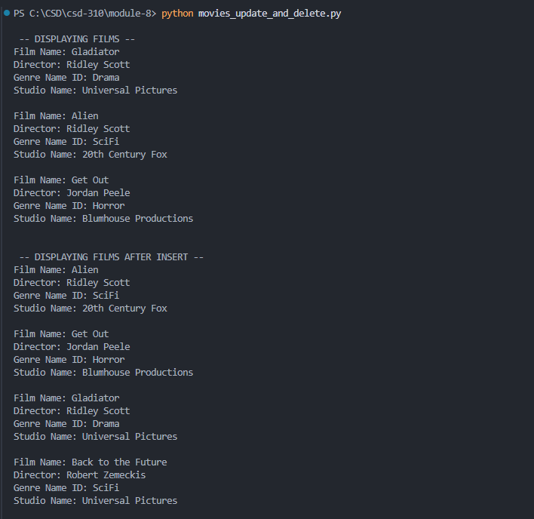

Part Two
