Christopher Villarreal
Module 6 Assignment 2
November 23, 2025
Part 5
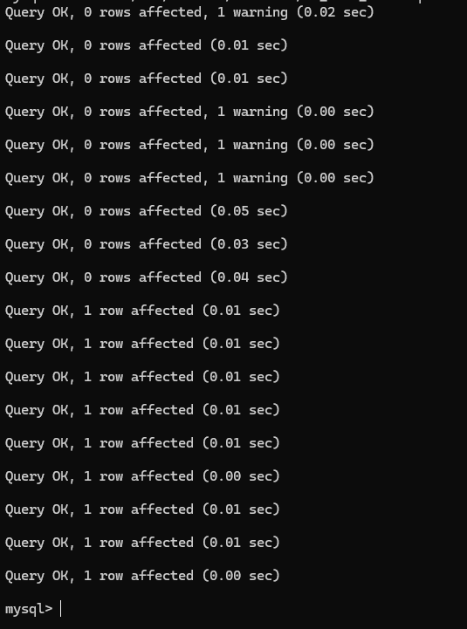
Part 6
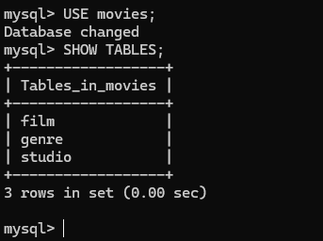
Mysql_test.py Run
