Christopher Villarreal
Module 2 Assignment 3 (M 2.3)

ERD – Image
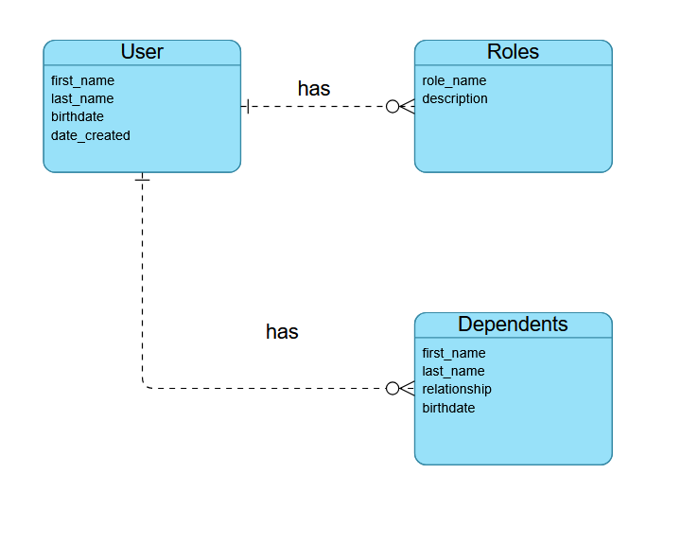

NoSQL Data Structure – Image
