Christopher Villarreal
Module 4 – Assignment 2
Initial Database Connection
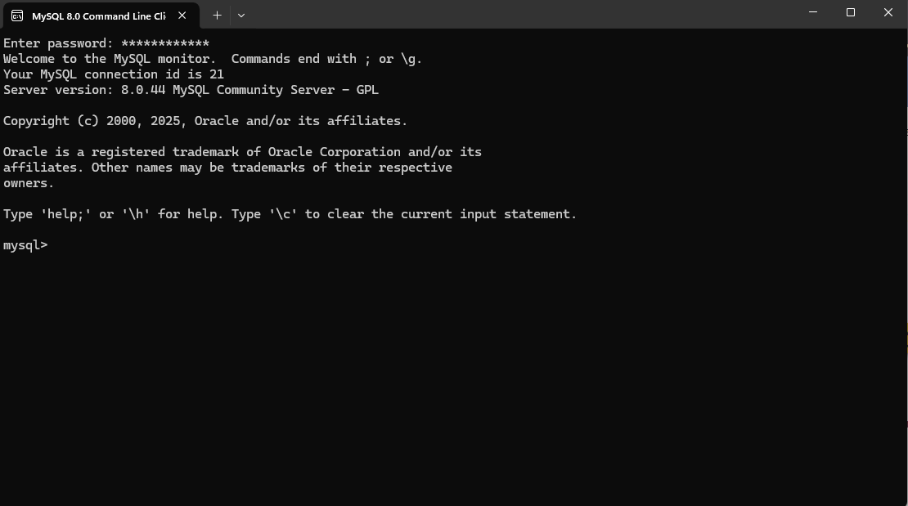
Create ‘movies’ table
