Group 2:
Mitchel Cotton
Carli McAvoy
Johnathan Smith
Christopher Villarreal
Milestone #3

Report 1: Summary list of current clients and their asset value


Report 2: Average amount of asset value from all clients
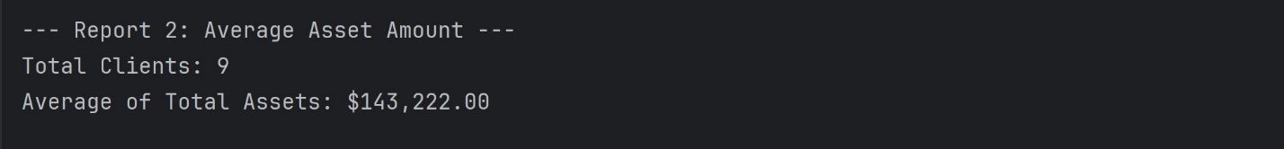

Report 3: New clients added in the past six months


Report 4: Clients that have more than 10 transactions in one month

