Christopher Villarreal
Module 6 Assignment 2
Revised Main Flowchart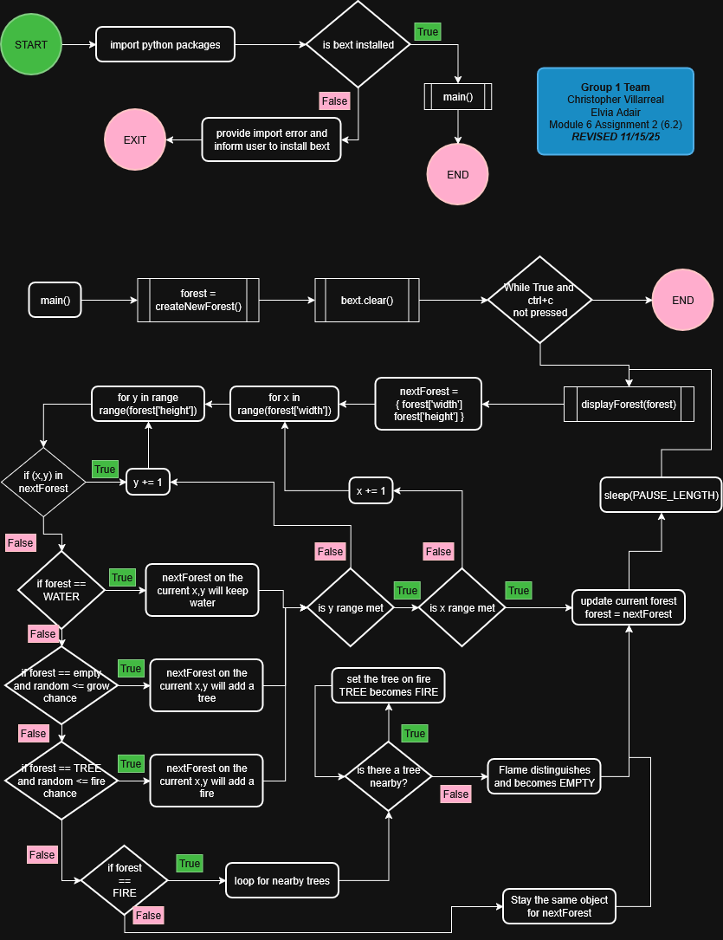
displayForest function – flowchart
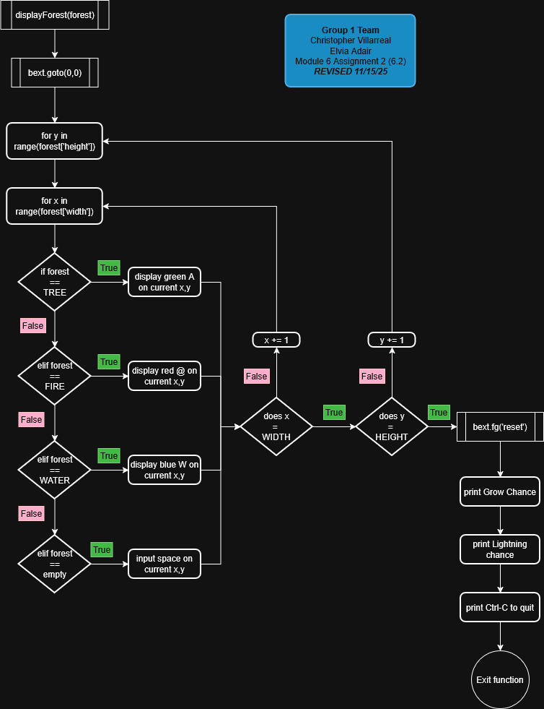
createNewForest function – flowchart
