Initial Flowchart of sitka_highs.py
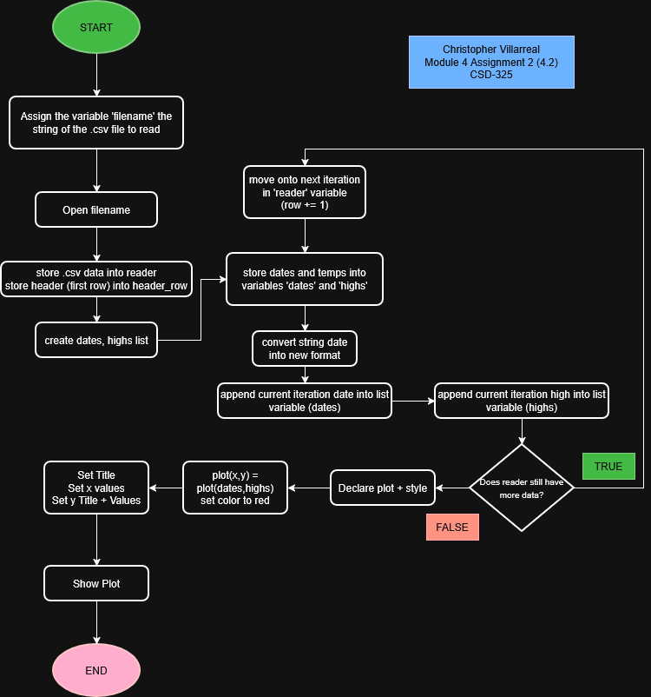

Revised Flowchart of the updated sitka_high_low_cwv.py
(Formally sitka_highs.py)
