HƯỚNG DẪN LẮP MẠCH CODE

CÂU 1: XOAY BIẾN TRỞ

CODE:

int led[6] = {8,9,10,11,12,13};

void setup() {

for(int i=0;i<6;i++)

{

pinMode(led[i],OUTPUT);

}

Serial.begin(9600);

}

void loop() {

// put your main code here, to run repeatedly:

int value = analogRead(A5);

Serial.println(value);

for(int i=0;i<6;i++)

{

digitalWrite(led[i],HIGH);

delay(value);

}

for(int i=5;i>=0;i--)

{

digitalWrite(led[i],LOW);

delay(value);

}

}

LẮP MẠCH:

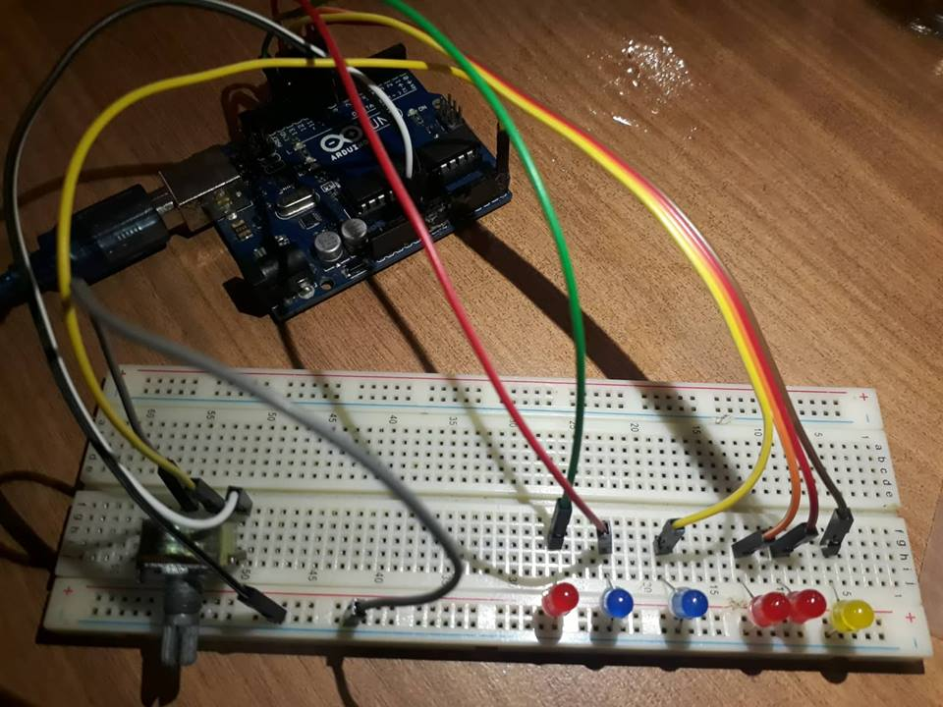

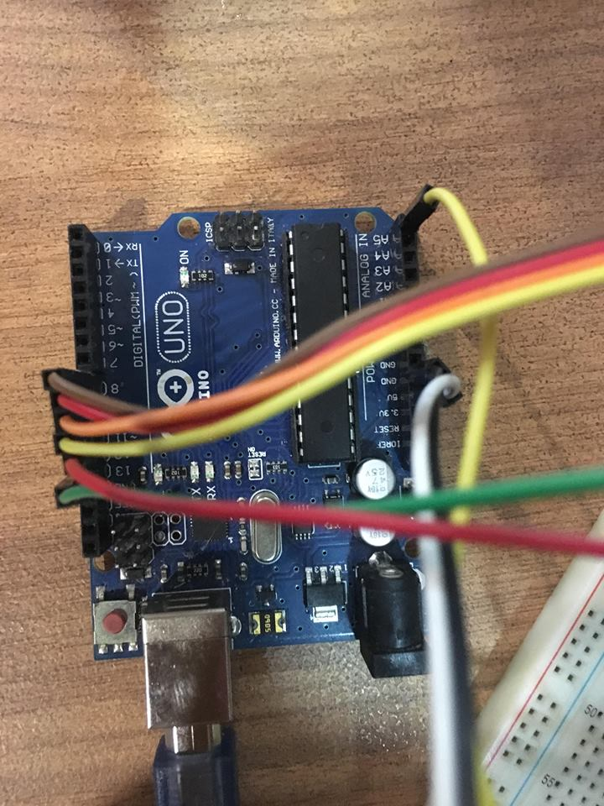

CÂU 2: SERIAL

CODE:

int ledPins[] = {9, 10, 11};

int R = 9;

int G = 10;

int B = 11;

int pinCount = 3;

void setup() {

Serial.begin(9600);

Serial.flush();

for (int thisPin = 0; thisPin < pinCount; thisPin++) {

pinMode(ledPins[thisPin], OUTPUT);

}

}

void splitString(char* str)

{

int i = 0;

while (str[i] != NULL) {

String led = "";

led += str[i++];

while (str[i] > 47 && str[i] < 58) {

led += str[i];

i++;

}

char ledBuffer[led.length() + 1];

led.toCharArray(ledBuffer, led.length() + 1);

setLED(ledBuffer);

}

}

void setLED(char* led) {

String temp = "";

for (int i = 1; i < strlen(led); i++) {

temp += led[i];

}

int value = temp.toInt();

switch (led[0]) {

case 'R' :

analogWrite(R, value);

Serial.print("Red led value: ");

Serial.println(value);

break;

case 'G' :

analogWrite(G, value);

Serial.print("Green led value: ");

Serial.println(value);

break;

case 'B' :

analogWrite(B, value);

Serial.print("Blue led value: ");

Serial.println(value);

break;

default :

Serial.print("Wrong char detected: ");

Serial.println(led[0]);

}

}

void loop() {

if (Serial.available()) {

int index = 0;

delay(100);

int numChar = Serial.available();

String str = "";

for (int i = 0; i < numChar; i++) {

str += char(Serial.read());

}

Serial.print("Input: ");

Serial.println(str);

char buffer[numChar];

str.toCharArray(buffer,numChar);

splitString(buffer);

}

}

LAP MACH:

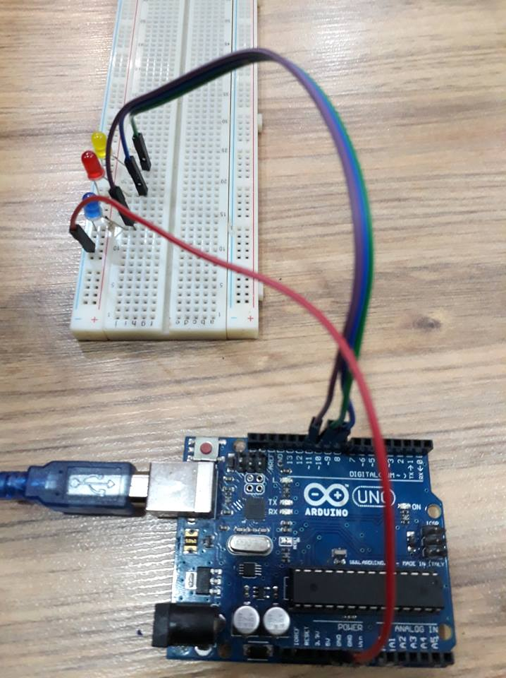

CÂU 3 : LED MA TRẬN

DỄ KHÔNG LÀM…

CÂU 4: THẺ SD

CODE:

/*

SD card read/write

This example shows how to read and write data to and from an SD card file

The circuit:

* SD card attached to SPI bus as follows:

** CS - pin 4 (for MKRZero SD: SDCARD_SS_PIN)

** SCK - pin 13

** MOSI - pin 11

** MISO - pin 12

created Nov 2010

by David A. Mellis

modified 9 Apr 2012

by Tom Igoe

This example code is in the public domain.

*/

#include <SPI.h>

#include <SD.h>

File myFile;

void setup() {

// Open serial communications and wait for port to open:

Serial.begin(9600);

while (!Serial) {

; // wait for serial port to connect. Needed for native USB port only

}

Serial.print("Khoi dong SD card...");

if (!SD.begin(4)) { // check loi

Serial.println("Loi khoi dong!");

while (1);

}

Serial.println("Khoi dong SD card thanh cong");

if(SD.exists("test01.txt")){

SD.remove("test01.txt");

}

myFile = SD.open("test01.txt", FILE_WRITE); //tao 1 file moi là test.txt

if (myFile) {

Serial.print("Dang viet vao file...");

myFile.println("Nam dep trai"); // noi dung viet vao file

// close the file:

myFile.close();

Serial.println("Ket thuc");

} else {

// if the file didn't open, print an error:

Serial.println("error opening test.txt");

}

Serial.println("mo file test.txt de doc du lieu");

myFile = SD.open("test01.txt"); // mo lai file test01 trong the nho ra xem

if (myFile) {

Serial.println("test01.txt:");

while (myFile.available()) {

Serial.write(myFile.read()); // ghi noi dung trong file ra ngoai

}

// close the file:

myFile.close();

} else {

// if the file didn't open, print an error:

Serial.println("error opening test.txt");

}

}

void loop() {

}

LẮP MẠCH:

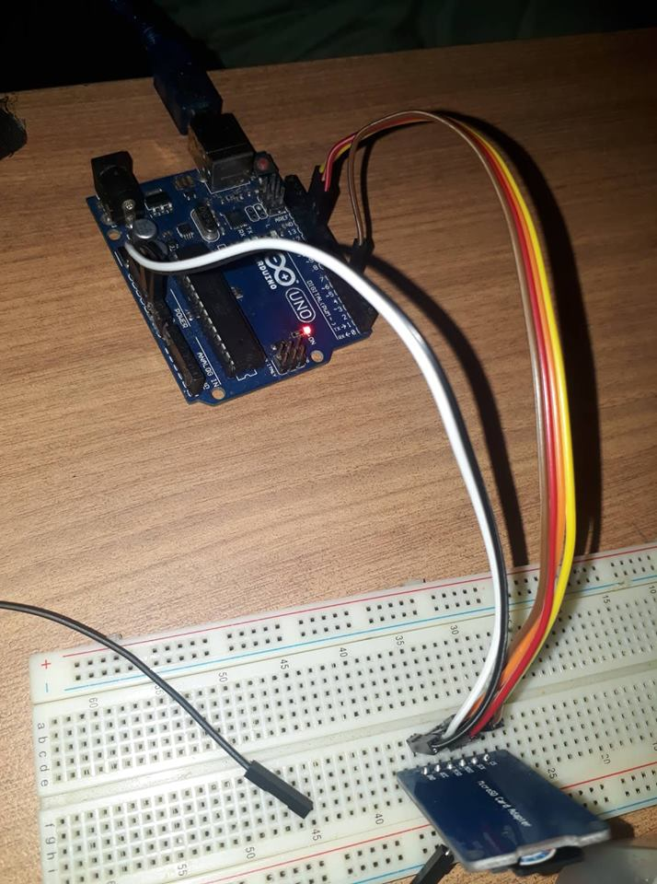

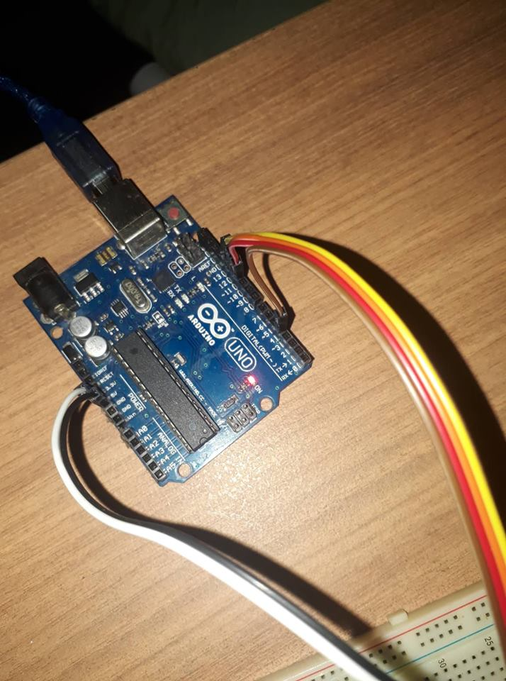

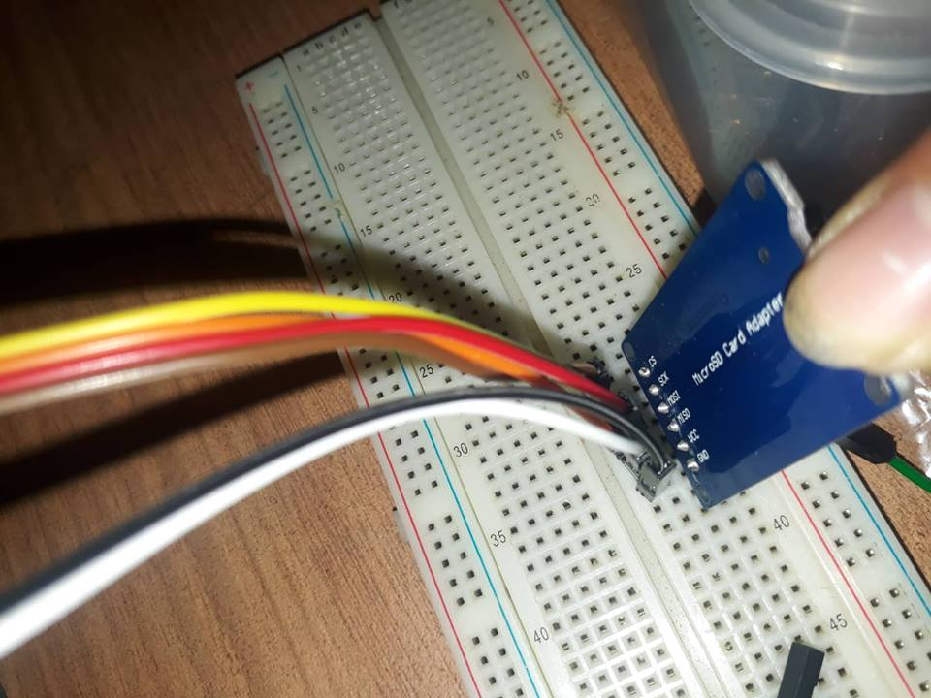

CÂU 5 : THẺ TỪ RFID

CODE:

/*

* Signal Pin Pin Pin Pin Pin Pin

* -----------------------------------------------------------------------------------------

* RST/Reset RST 9 5 D9 RESET/ICSP-5 RST

* SPI SS SDA(SS) 10 53 D10 10 10

* SPI MOSI MOSI 11 / ICSP-4 51 D11 ICSP-4 16

* SPI MISO MISO 12 / ICSP-1 50 D12 ICSP-1 14

* SPI SCK SCK 13 / ICSP-3 52 D13 ICSP-3 15

*/

#include <deprecated.h>

#include <MFRC522.h>

#include <MFRC522Extended.h>

#include <require_cpp11.h>

#include <SPI.h>

const int LED = 8;

#define SS_PIN 10

#define RST_PIN 9

MFRC522 mfrc522(SS_PIN, RST_PIN);

unsigned long uidDec, uidDecTemp;

byte bCounter, readBit;

unsigned long ticketNumber;

void setup() {

pinMode(LED, OUTPUT);

Serial.begin(9600);

SPI.begin();

mfrc522.PCD_Init();

Serial.println("Hay quet the de hien thi ID...");

}

void loop() {

if ( ! mfrc522.PICC_IsNewCardPresent()) {

return;

}

if ( ! mfrc522.PICC_ReadCardSerial()) {

return;

}

uidDec = 0;

Serial.println("************************************************");

Serial.println(" ID cua the la: ");

for (byte i = 0; i < mfrc522.uid.size; i++)

{

uidDecTemp = mfrc522.uid.uidByte[i];

uidDec = uidDec*256+uidDecTemp;

}

Serial.print(" [");

Serial.print(uidDec);

if(uidDec == 2152423291){

digitalWrite(LED,HIGH);

delay(1000);

}else{

}

//--------------------------------

if(uidDec == 2410317097){

digitalWrite(LED,LOW);

delay(1000);

}else{

}

Serial.println("]");

Serial.println("................................................");

delay(1000); //change value if you want to read cards faster

mfrc522.PICC_HaltA();

mfrc522.PCD_StopCrypto1();

}

LẮP MẠCH:

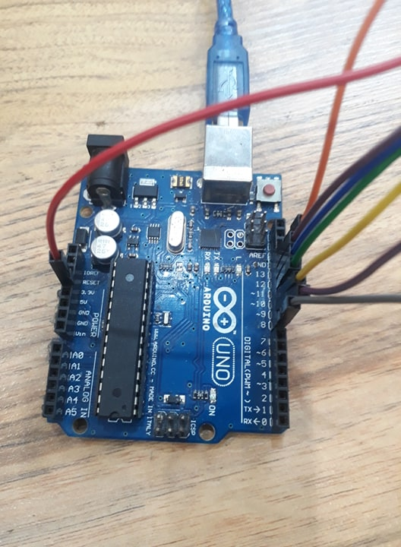

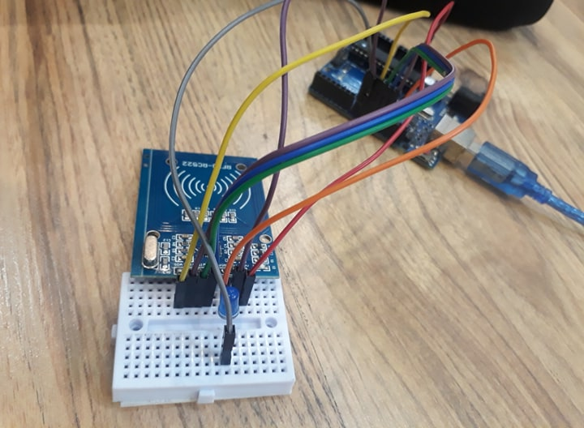

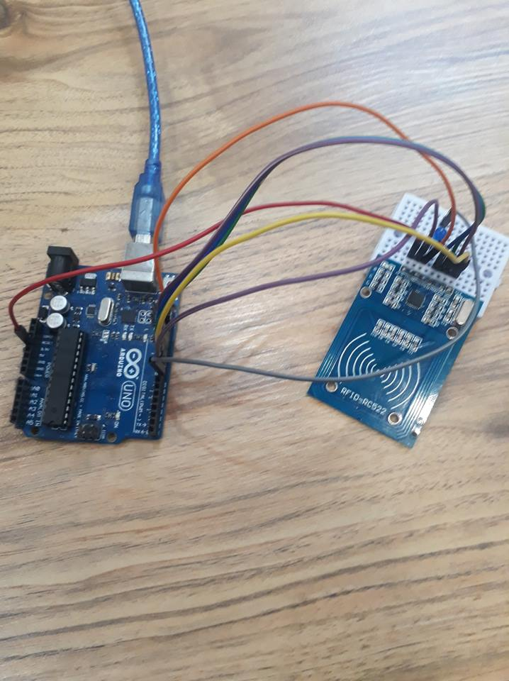

CÂU: 6 WIFI

CODE :

#include "DHT.h"

#define LED_PIN 13

#define CMD_SEND_BEGIN "AT+CIPSEND=0"

#define CMD_SEND_END "AT+CIPCLOSE=0"

#define TDHshop_PROTOCOL_HTTP 80

#define TDHshop_PROTOCOL_HTTPS 443

#define TDHshop_PROTOCOL_FTP 21

#define TDHshop_PROTOCOL_CURRENT TDHshop_PROTOCOL_HTTP

#define TDHshop_CHAR_CR 0x0D

#define TDHshop_CHAR_LF 0x0A

#define TDHshop_STRING_EMPTY ""

#define TDHshop_DELAY_SEED 1000

#define TDHshop_DELAY_1X (1*TDHshop_DELAY_SEED)

#define TDHshop_DELAY_2X (2*TDHshop_DELAY_SEED)

#define TDHshop_DELAY_3X (3*TDHshop_DELAY_SEED)

#define TDHshop_DELAY_4X (4*TDHshop_DELAY_SEED)

#define TDHshop_DELAY_0X (5*TDHshop_DELAY_SEED)

bool hasRequest = false;

const int DHTPIN = 2;

const int DHTTYPE = DHT11;

DHT dht(DHTPIN, DHTTYPE);

void setup()

{

delay(TDHshop_DELAY_0X);

Serial.begin(115200);

pinMode(LED_PIN, OUTPUT);

digitalWrite(LED_PIN, LOW);

initESP8266();

}

void loop()

{

float h = dht.readHumidity();

float t = dht.readTemperature();

while(Serial.available())

{

bufferingRequest(Serial.read());

}

if(hasRequest == true)

{

String htmlResponse = "<!doctype html>"

"<html>"

"<head>"

"<title>TDHshop.com.vn</title>"

"</head>"

"<body>"

"<h1>ESP8266 DEMO</h1>"

"<h2>Temperature: </h2>"

"<p>" + String(t) + "&#8451" + "</p>"

"<h2>Humidity: </h2>"

"<p>" + String(h) + "%" + "</p>"

"<form action='' method='GET'>"

"<input type='radio' name='LED' name='TDHshop' value='TDHshop_ON' /> LED ON<br/>"

"<input type='radio' name='LED' name='D2K' value='TDHshop_OFF' /> LED OFF<br/>"

"<input type='submit' value='Submit' />"

"</form>"

"</body>"

"</html>";

String beginSendCmd = String(CMD_SEND_BEGIN) + "," + htmlResponse.length();

deliverMessage(beginSendCmd, TDHshop_DELAY_1X);

deliverMessage(htmlResponse, TDHshop_DELAY_1X);

deliverMessage(CMD_SEND_END, TDHshop_DELAY_1X);

hasRequest = false;

}

}

void initESP8266()

{

deliverMessage("AT+RST", TDHshop_DELAY_2X);

deliverMessage("AT+CWMODE=2", TDHshop_DELAY_3X);

deliverMessage("AT+CWSAP=\"MINHDEPTRAI\",\"123456789\",1,4", TDHshop_DELAY_3X);

deliverMessage("AT+CIFSR", TDHshop_DELAY_1X);

deliverMessage("AT+CIPMUX=1", TDHshop_DELAY_1X); // để cho phép các kết nối TCP

deliverMessage(String("AT+CIPSERVER=1,") + TDHshop_PROTOCOL_CURRENT, TDHshop_DELAY_1X); //để tạo 1 TCP server

}

void bufferingRequest(char c)

{

static String bufferData = TDHshop_STRING_EMPTY;

switch (c)

{

case TDHshop_CHAR_CR:

break;

case TDHshop_CHAR_LF:

{

TDHshopProcedure(bufferData);

bufferData = TDHshop_STRING_EMPTY;

}

break;

default:

bufferData += c;

}

}

void TDHshopProcedure(const String& command)

{

hasRequest = command.startsWith("+IPD,");

if(command.indexOf("TDHshop_OFF") != -1)

{

digitalWrite(LED_PIN, LOW);

}

else if(command.indexOf("TDHshop_ON") != -1)

{

digitalWrite(LED_PIN, HIGH);

}

}

void deliverMessage(const String& msg, int dt)

{

Serial.println(msg);

delay(dt);

}

GHI CHÚ: CÓ THÊM THƯ VIÊN ( CÁCH THÊM THƯ VIÊN)

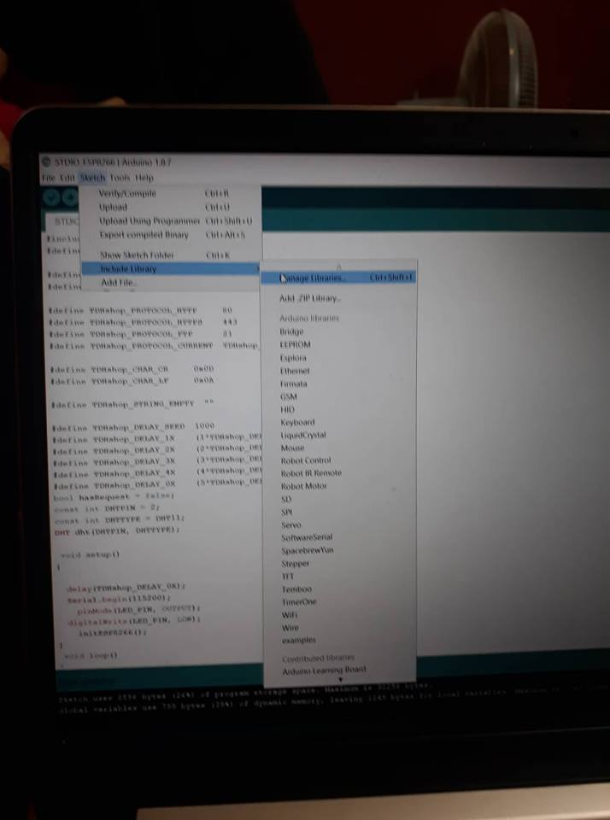

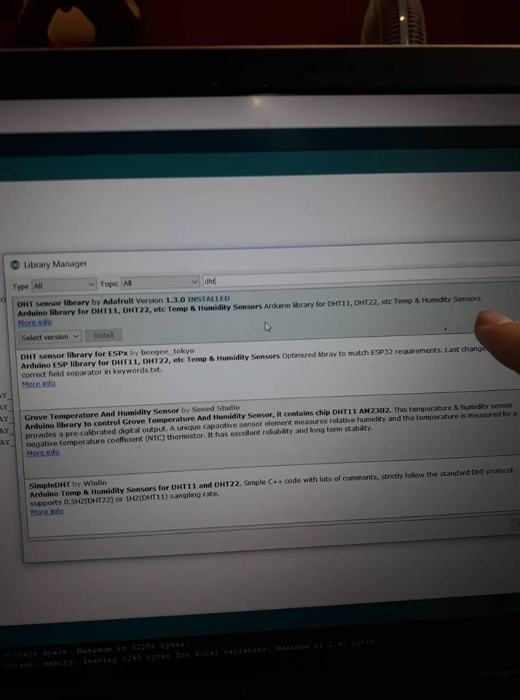

LẮP MẠCH:

