|  |  |
| --- | --- |
| logo ngan.png | **MINISTRY OF EDUCATION AND TRAINING** |
|  |  |
|  |  |
|  |  |
|  |  |

**FPT UNIVERSITY**

Capstone Project Document

**Place Suggesting Intelligent Bot**

|  |  |
| --- | --- |
| **Group 3** | |
| **Group members** | Huỳnh Thành Đạt – Team Leader – SE61273  Trương Châu Minh Huy – Team Member – SE61175  Trần Văn Thành – Team Member – SE61373  Đào Công Thuận – Team Member – 60487 |
| **Supervisor** | Kiều Trọng Khánh |
| **Ext. Supervisor** | N/A |
| **Capstone Project code** | PSIB |

- Ho Chi Minh City, 05/2016 -

*This page is intentionally left blank*

Table of Contents

A. Report No. 1 Introduction 8

1. Project Information 8

2. Introduction 8

3. Current Situation 8

4. Problem Definition 9

5. Proposed Solution 9

5.1. Feature functions 9

5.2. Advantages and disadvantages 10

**5.2.1.** Advantages 10

**5.2.2.** Disadvantages 10

6. Functional Requirements 10

7. Role and Responsibility 10

B. Report No.2 Software Project Management Plan 12

1. Problem Definition 12

1.1. Name of this Capstone Project 12

1.2. Problem Abstract 12

1.3. Project Overview 12

**1.3.1.** **Current Situation** 12

**1.3.2.** **The Proposed System** 12

**1.3.2.2.** **Engine for Bot** 13

**1.3.3.** **Boundaries of the System** 14

**1.3.5.** **Development Environment** 14

**1.3.5.1.** **Hardware requirements** 14

**1.3.5.1.** **Software requirements** 14

2. Project organization 15

2.1. Software Process Model 15

2.2. Roles and responsibilities 16

2.3. Tools and Techniques 17

3. Project Management Plan 18

3.1. Product Backlog 18

3.2. Deliverables 19

3.3. All Meeting Minutes 19

4. Coding Convention 19

C. Report No. 3 Software Requirement Specification 21

1. User Requirement Specification 21

1.1. Guest requirement 21

1.2. Member requirement 21

1.3. Student requirement 21

1.4. Company manager requirement 21

1.5. Staff requirement 22

1.6. Administrator requirement 22

1.7. System requirement 22

2. System Requirement Specification 22

2.1. External Interface Requirement 22

**2.1.1.** User Interface 22

**2.1.2.** Hardware Interface 22

**2.1.3.** Software Interface 23

**2.1.4.** Communication Protocol 23

2.2. System Overview Use Case 23

2.3. List of Use Case 24

**2.3.1.** <Guest>Overview Use Case 24

**2.3.1.1.** <Guest>Sign in 24

**2.3.1.2.** <Guest>Search vacancy 28

**2.3.2.** <Administrator>Overview Use Case 30

**2.3.2.1.** <Administrator>Manage Event 30

**2.3.2.1.1.** <Administrator>Create Event 30

**2.3.2.1.2.** <Administrator>Update Event 32

**2.3.2.2.** <Administrator>Manage Company 35

**2.3.2.2.1.** <Administrator>Send Email 35

**2.3.2.3.** <Administration> Manage Thread 36

**2.3.2.3.1.** <Administration>Create Thread 37

**2.3.2.3.2.** <Administration>Edit Thread 40

**2.3.2.3.3.** <Administration>Active Thread 43

**2.3.2.3.4.** <Administration>Deactivate Thread 46

**2.3.2.4.** <Administration> Manage Fee 49

**2.3.2.4.1.** <Administration>Create Fee 49

**2.3.2.4.2.** <Administration>Edit Fee 53

**2.3.2.4.3.** <Administration>Delete Fee 56

**2.3.3.** <Staff>Overview Use Case 59

**2.3.3.1.** <Staff>Manage interview 59

**2.3.3.1.1.** <Staff>View statistic 60

**2.3.3.1.2.** <Staff> Approve 62

**2.3.3.1.3.** <Staff> Add interview record 65

**2.3.3.1.4.** <Staff> Create interview 68

**2.3.3.1.5.** <Staff> Update interview 71

**2.3.4.** < Company manager>Overview Use Case 74

**2.3.4.1.** <Company manager> Manage vacancy 74

**2.3.4.1.1.** <Company manager>Create vacancy 74

**2.3.4.1.2.** <Company manager>Edit vacancy 78

**2.3.4.1.3.** <Company manager>Enable/Disable vacancy 81

**2.3.4.2.** <Company manager>Manage staff 84

**2.3.4.2.1.** <Company manager>Add staff 84

**2.3.4.2.2.** <Company manager>Update staff info 87

**2.3.4.2.3.** <Company manager>Active/Deactive staff 90

**2.3.4.3.** <Company manager>Manage interview 93

**2.3.4.3.1.** <Company manager>Approve 93

**2.3.4.3.2.** <Company manager>View statistic 96

**2.3.4.4.** <Company Manager> Manage Thread 98

**2.3.4.4.1.** <Company Manager>Create Thread 98

**2.3.4.4.2.** <Company Manager>Edit Thread 101

**2.3.4.4.3.** <Company Manager>Delete Thread 104

**2.3.4.5.** <Company Manager>Register Event 107

**2.3.4.6.** < Company Manager >Manage QR Code 110

**2.3.4.6.1.** <Administrator>Create QR Code 110

**2.3.5.** <Student>Overview Use Case 112

**2.3.5.1.** <Student>Manage Resume 112

**2.3.5.1.1.** <Student>Create Resume 112

**2.3.5.1.2.** <Student>Update Resume 114

**2.3.5.1.3.** <Student>Delete Resume 116

**2.3.5.2.** <Student>Search vacancy 118

**2.3.5.3.** <Student>Attempt Event 121

**2.3.6.** <System>Overview Use Case 124

3. Software System Attribute 124

3.1. Usability 124

**3.1.1.** Graphic User Interface 124

**3.1.2.** Usability 124

**3.1.3.** Installation 124

3.2. Reliability 124

3.3. Availability 124

3.4. Security 125

3.5. Maintainability 125

3.6. Portability 125

3.7. Performance 125

4. Conceptual Class Diagram 125

Figure list

Figure 1: System Overview Use Case 20

Figure 2: <Guest>Overview Use Case 21

Figure 3: <Guest>Sign in 21

Figure 4: <Guest>Search vacancy 23

Figure 5: <Guest>Overview Use Case 25

Figure 6: <Administrator>Manage Event 25

Figure 7: <Administrator>Create Event 26

Figure 8: <Administrator>Update Event 27

Figure 9: <Administrator>Manage Company 29

Figure 10: <Administrator>Send Email 29

Figure 11: <Administration>Manage Thread 31

Figure 12: <Administration> Create Thread 31

Figure 13: <Administration> Edit Thread 33

Figure 14: <Administration> Active Thread 35

Figure 15: <Administration> Deactivate Thread 37

Figure 16: <Administration>Manage Fee 39

Figure 17: <Administration> Create Fee 39

Figure 18: <Administration> Edit Fee 41

Figure 19: <Administration> Delete Fee 44

Figure 20: <Staff>Overview Use Case 46

Figure 21: <Staff>Manage interview 46

Figure 22: <Staff> View statistic 47

Figure 23: <Staff> Approve 48

Figure 24: <Staff> Add interview record 50

Figure 25: <Staff>Create interview 52

Figure 26: <Staff> Update interview 54

Figure 27: <Manager>Overview Use Case 56

Figure 28: <Company manager>Manage vacancy 56

Figure 29: <Company manager>Create vacancy 57

Figure 30: <Company manager> Edit vacancy 59

Figure 31: <Company manager> Enable/Disable vacancy 61

Figure 32: <Company manager>Manage staff 63

Figure 33: <Company manager>Add staff 63

Figure 34: <Company manager> Update staff info 66

Figure 35: <Company manager>Active/Deactive staff 68

Figure 36: <Company manager> Manage interview 70

Figure 37: <Company manager>View statistic 72

Figure 38: <Company Manager>Manage Thread 73

Figure 39: <Company Manager> Create Thread 74

Figure 40: <Company Manager> Edit Thread 76

Figure 41: <Company Manager> Delete Thread 78

Figure 42: <Company Manager> Register Event 80

Figure 43: <Company Manager>Manage QR Code 82

Figure 44: <Administrator>Create QR Code 82

Figure 45: <Staff>Overview Use Case 84

Figure 46: <Student>Create Resume 84

Figure 47: <Student>Create Resume 85

Figure 48: <Student>Update Resume 86

Figure 49: <Student>Delete Resume 88

Figure 50: <Student>Search vacancy 89

Figure 51: <Student> Attempt Event 90

Figure 52: <Staff>Overview Use Case 92

Figure 53: Conceptual Class Diagram 94

**Definitions, Acronyms, and Abbreviations**

|  |  |
| --- | --- |
| **Name** | **Definition** |
| **PSIB** | **Place Suggesting Intelligent Bot** |
|  |  |

# Report No. 1 Introduction

## Project Information

* Project name:  **Place Suggesting Intelligent Bot**
* Project Code: **PSIB**
* Product Type: **Web Application & Engine**
* Start Date: **09-May-2016**
* End Date: **19-August-2016**

## Introduction

In this document, we introduce a solution for users who want to find a coffee shop or small shop that its foods are delicious and affordable in a quickly way when they are locating somewhere.

Nowadays, Facebook and Facebook Messenger are more and more popular and appear on every platform. E-commerce pages on Facebook was common with every people. But those E-commerce pages on Facebook do not have function auto answer and the owners have to answer their customer by them self. It takes a lot of time and sometimes they can miss the inboxes. Based on the demand of the users, we proposed a solution for them in Vietnam.

We build a system, which help the owner E-commerce pages on Facebook to solve their current problems. In the process of analysis, we believe that Message Platform of Facebook and Api.ai are popular and suitable to build the bot can answer message automatically and intelligently. By using Facebook Messenger, user can ask the page directly and the bot will reply right after that. Beside of that we also provide a function to train for the bot, make the bot more intelligent.

We hope that our solution will make a big change in Vietnam with the most convenient with the latest technology trend that will go nowhere.

## Current Situation

Users are locating in somewhere, and they want to find some place to meet their friend at coffee shop or they just want to eat something, but they do not know where to go, or user go to the strange place, don’t know who to ask.

Some popular behaviors of users are using the smartphone with 3G to search on google or “around me”, foody, diadiemanuong applications; or asking residents; or asking friends, … However, those tasks are time-consuming and not very effective; and sometimes you are shy, scary, or not confident to communicate, or your language is a barrier to yourself. However, those applications are not supported their API.

## Problem Definition

Below are disadvantages of the current situation:

* **Disadvantages:**
* Spend too much cost: the product or service provider must have owner to contact with customer when customer need information. Owner may always available to solve all customer demand. It cost time and human resource.
* Information is overview: due to the huge number of customer. The owner just can provide the information in a brief way.
* Lack/wrong information: when user use search engine to find the place they want. The result may not give a right information they need. There are to much result but less information.
* User must do too much steps: use search engine, ask for friend, contact to provider, view the product, view review. Earch step must be use different tool.
* Bad user experience: user must be use many tool to meet a request. The change between many tool make they tired and give up if they cannot have a information they want.

## Proposed Solution

Our proposed solution is to build a system name “PSIB” that is chat bot engine integrating with Messenger Platform, which can suggest for customer depend on their demand. We also design a Web application to help user training bot to make it more intelligent.

PSIB system include a Web application and an engine processing bot.

### Feature functions

* Web application (for admin):
* Manage data: set schedule for update and crawler data into database. Beside that, admin can have an action on crawler web to choose which information need to save in database.
* Manage bot: Export a file that correct to format of api.ai and update core bot in api.ai
* Web application (for user):
* Train bot: user can training bot by example and syntax to max it more intelligent.
* Processing engine bot:
* Process with api.ai: processing with entity and intent in api.ai, process keyword and collect the response when user ask.
* Processing with Facebook Messenger Platform: process in structured message for send and response, processing with location and connect with api.ai.

### Advantages and disadvantages

#### Advantages

* + - * Can integrate with existed application, Facebook Messenger, do not need to build the new one. Our engine can run on web, android, ios and window phone.
      * Can train the bot more and more intelligent: the system can collect common requests from clients. It helps user can train the system how to react with it.
      * Reduce time, cost and human resources: users do need to reply their clients request, the bot can do it automatically.

#### Disadvantages

* + - * System requires user must have the Internet to communicate with it.
      * Require initial data before the system can operate.
      * User need to train the system manually, it can not learn by it-self yet.
      * Run on facebook, that is also our disadvantage. This is we totally depend on this platform and can not run in others social network.

## Functional Requirements

Function requirement of the system are listed as below:

* **Admin component**
* Manage data: Schedule and select data to crawler.
* Manage bot: manage interact with api and has tool to export json.
* **User component**
* Train bot: training bot by example. Update bot intent and entity using api.ai sdk.
* **Bot component**
* Process Api.ai: connect with api and processing response.
* Process Facebook Messenger platform: processing message with reply and response. Display structured message and processing location of user.

## Role and Responsibility

|  |  |  |  |  |
| --- | --- | --- | --- | --- |
| **No** | **Full Name** | **Role** | **Position** | **Contact** |
| 1 | Kiểu Trọng Khánh | Project Manager | Supervisor | KhanhKT@fpt.edu.vn |
| 2 | Huỳnh Thành Đạt | Developer | Leader | DatHTSE61273@fpt.edu.vn |
| 3 | Trương Châu Minh Huy | Developer | Member | HuyTCMSE61175@fpt.edu.vn |
| 4 | Trần Văn Thành | Developer | Member | ThanhTVSE61373@fpt.edu.vn |
| 5 | Đào Công Thuận | Developer | Member | ThuanDC60487@fpt.edu.vn |

# Report No.2 Software Project Management Plan

## Problem Definition

### Name of this Capstone Project

Official name: Place Suggesting Intelligent Bot

Vietnamese name: Chat bot gợi ý địa điểm thông minh

Abbreviation: PSIB

### Problem Abstract

As current in Vietnam, E – Commerce are growing up and up every day. Many E – Commerce pages on Facebook appear. Using page on Facebook are convenient with the owner because they do not need to spend money to build another website with the same demand, but it always takes too much time to answer the inboxes of customers. So we use the Facebook Message Platform and Api.ai building a bot to resolve this problem. The bot can answer automatically and give information to customers by Facebook Messenger.

But the problem is messenger Platform is new tools to integrate our own bot in order to create a custom experience for our unique audience. But the biggest problem is how to a bot can recognize natural language that is inputted by users.

There are some frameworks help us to solve this problem like api.ai or wit.ai. Both api.ai and wit.ai are new technology with us.Therefore, we need to find out how it works and how to apply it to show our problems.

### Project Overview

#### **Current Situation**

Situation below are the problems encountered in this project:

**Data Dependant and lack of consistency:** do not own data and depend on data from other website, depend on Api.ai framework. Data from each website is different. We have to make it consistency and complete.

**Lack of syntax:** cannot cover all syntax of language.

**Ambiguous location from customer:** because Facebook do not allow developer get current location of their user automatically, we have to send request to get location of them.

**Vietnamese problem:** Api.ai does not support official machine learning for Vietnamese, so we have to define by ourselves.

#### **The Proposed System**

According to the framework researches, we found out that the Facebook Message Platform is very capable of resolve the problem for E – Commerce page on Facebook. Because Facebook messenger has the biggest number of user in the world. Every month has more than 900 users active. So, we choose this platform to easily connect with user.

In the process natural language, we found that there are 2 api that is wit.ai and api.ai is the best api for us to process language. Wit.ai is support Vietnamese, but it’s just beta and when we launched with this api, it’s not correctly conversation. And when we researched, we found that the Bots Community are using api.ai more than wit.ai. And we found that, api.ai is a good syntax and machine learning better than wit.ai, but the weakness is don’t support Vietnamese. But, we choose Api.ai to build an engine for the bot and use Facebook Message Platform to transfer message from bot to customer.

To resolve Vietnamese problem in Api.ai, we need to research more about syntax in Vietnamese and build a standard for the bot in order to combine with api.ai easily.

We also build a highly available web server to maintain the main system to work 24/7 and make sure that if customer need ask for the information from the bot, there will be always available.

Our system includes two subsystems:

* Engine for bot process natural language from customer and use Facebook Message Platform to transfer message.
* Web crawler to get data from other website and standardize data to add to database, support the owner training their bot.
  + - * 1. **Website**

Main web application is common communication portal for administrators to craw data from other website and the place for the owner training their bot.

For administrators:

* Get all data from the website
* Get data following the post on the website.

For the bot owner:

* Training bot with synonyms.

##### **Engine for Bot**

The engine process natural language from customer using Api.ai framework. Convert the sentence into word entities, understand it as an request of customer and give back the customer a suitable response.

The engine can study the synonym of existed entities when the ownsers train for bot.

Processing with messenger platform, engine can send and receive message with structure and handle many type of message from text message, attachment,…

#### **Boundaries of the System**

* The system is intended for customers such as student, teacher, worker, teenager or anyone need to find some places for demand of foods.
* The language of system is Vietnamese.
* The complete product includes:
* The engine combines Facebook Messenger Platform and Api.ai to process natural language and transfer response message.
* A web application for owner to manage and train bot to make it more intelligent.
* A Web Crawler is used to extract data from foody.vn and diadiemanuong.com.
  + - 1. **Future plan**

Current engine only supports the owner to training their bot by using the synonyms. Training work are still manually. So we design the engine easily to scale bigger:

* **Training with syntax:** The owner can train new syntax and control their bot completely.
* **Run on many social platform:** We intend to build this bot engine can run not only facebook messenger, but also skype, slack...
* **Build service for store or restaurant:** We intend to make it widely and build a product or service for stores or restaurant with their domain.
* **Add payment method into platform:** support user can oder product in messenger platform.

#### **Development Environment**

##### **Hardware requirements**

* Follow the specification of Facebook

|  |  |  |
| --- | --- | --- |
|  | **Minimum** | **Recommended** |
| Operating system | Windows 7 | Windows 10 |
| Internet Connection | Cable, Wireless speed 300 Kbps | Cable, Wireless speed 1.5 Mbps or faster |
| Computer Processor | Intel Core dual 2Ghz | Intel Core i5 or faster |
| Computer Memory | 2GB | 4GB |

##### **Software requirements**

* Browser: Safari, Chrome, Microsoft Edge, Internet Explorer.
* App: Facebook messenger app in Android, IOS or Windowphone.
* Run in facebook messenger.

## Project organization

### Software Process Model

The model use for developing this project is Scrum model. We choose this model because of following reason:

* Because api.ai and facebook api is the new technology with us, we need to stay together to learn and build system effectively. So, working in group is best solution for us. And this is a type of Scrum, we research 🡪 work 🡪 do again 🡪 check.
* For our solution, it is very suitable for us to self-organize and face-to-face communication between team member.
* Easy for us to change requirement.

OVERVIEW DIAGRAM

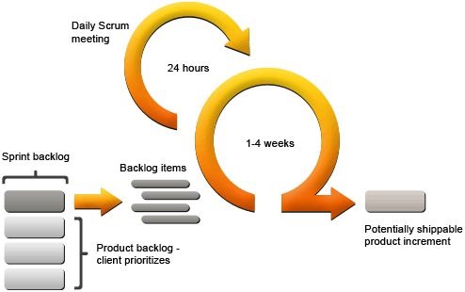

Figure 3-1 Scrum model

(Image source: http://www.certiconglobal.com/)

### Roles and responsibilities

| **No.** | **Full name** | **Team Role** | **Scrum Team Role** | **Responsibilities** |
| --- | --- | --- | --- | --- |
| 1 | Kiều Trọng Khánh | Supervisor | Product Owner | * Specify user requirements * Control the development process * Support in technique and business logic. |
| 2. | Huỳnh Thành Đạt | Team Leader  Developer | Scrum Master | * Manage process. * Planning Scrum implementations. * Create system architecture design. * Support technique. * Create product Increment. * Create test plan. * Configure developing environment. * Code. * Test. * Write document and reports. |
| 3. | Trương Châu Minh Huy | Developer | Scrum Team Member | * Commit individual product on time * Support each other to complete team work * Create product Increment. * Code. * Test. * Write document and reports. |
| 4 | Trần Văn Thành | Developer | Scrum Team Member | * Commit individual product on time * Support each other to complete team work * Code * Test |
| 5 | Đào Công Thuận | Developer | Scrum Team Member | * Commit individual product on time * Support each other to complete team work * Code * Test |

### Tools and Techniques

|  |  |  |
| --- | --- | --- |
| Tool | | |
| Developing tool | Engine | - JetBrains WebStorm 2016.1.1 |
| Web Application | - Spring Tool Suite 3.7.3.RELEASE |
| Managing Database | - MySQL Workbench 6.3.6 | |
| Source Control | - Git v2.6.4 (server github.com) | |

|  |  |  |
| --- | --- | --- |
| Technique | | |
| Developing tool | Front end | * JSP v2.3.1 * HTML v5.0 * jQuery v1.12.3 * CSS3 |
| Back end | * Java v1.7 * Spring MVC v4.2.1.RELEASE * Selenium v2.53.0 * HtmlUnit v2.13 * JavaScript ECMAScript 6 * Apiai v2.0.3 * Express v4.13.4 * Facebook Graph api v.2.6 |
| Web servers | | * TomCat portal v7.0 * NodeJS v4.4.4 |
| Database Management System | | * MySQL v5.6 |

## Project Management Plan

### Product Backlog

| **Story  ID** | **Features** | **Task  ID** | **Task description** | **Sprint** |
| --- | --- | --- | --- | --- |
| 1 | Create Product Backlog | 1.1 | Create Product backlog | 1 |
| 2 | Create Introduction document | 2.1 | Create Introduction document | 1 |
| 2.2 | Review Introduction document | 1 |
| 3 | Learning facebook api and api.ai | 3.1 | Learning facebook api and api.ai | 1 |
| 4 | Create mockup UI | 3.1 | Log in UI | 1 |
| 3.2 | Daskboard UI | 1 |
| 3.3 | Manage/ Config schedule crawler UI | 1 |
| 3.5 | Training bot UI | 1 |
| 4 | Create Software Project Management Plan | 4.1 | Problem definition | 2 |
| 4.2 | Project organization | 2 |
| 4.3 | Project management plan | 2 |
| 4.4 | Coding convention | 2 |
| 5 | Create Software Requirements Specifications | 5.1 | User Requirement Specification | 3 |
| 5.2 | External Interface Requirement | 3 |
| 5.3 | Use case diagram | 2 |
| 5.4 | Software System Attributes | 3 |
| 5.5 | Database diagram | 2 |
| 6 | Create Software Design Description | 6.1 | Design Overview | 4 |
| 6.2 | System Architectural Design | 4 |
| 6.3 | Component Diagram | 4 |
| 6.4 | Detailed Description of Components | 4 |
| 6.5 | Sequence Diagram | 3 |
| 6.6 | User Interface Design | 2 |
| 6.7 | Database Design | 4 |
| 7 | Create Software Test Documentation | 7.1 | Test Plan | 12 |
| 7.2 | Test Cases | 12 |
| 7.3 | Checklists | 12 |
| 8 | Software User’s Manual | 8.1 | Installation Guide | 13 |
| 8.2 | User’s Guide | 13 |

### Deliverables

|  |  |  |  |  |
| --- | --- | --- | --- | --- |
| **No** | **Deliverable** | **Delivery date** | **Delivery location** | **Note** |
| 1 | Introduction Document, Task list | 16/5/2016 | FU – CMS | Report No.1 |
| 2 | Software Project Management Plan | 23/5/2016 | FU – CMS | Report No.2 |
| 3 | Software Requirements Specification |  | FU – CMS | Report No.3 |
| 4 | Software Design Description |  | FU – CMS | Report No.4 |
| 5 | Software Test Documentation Guide Implementation (Coding) |  | FU – CMS | Report No.5 |
| 6 | Software User’s Manual |  | FU – CMS | Report No.6 |

* For each sprint, deliverables is *potentially shippable product*, which can be a part of documents or runnable software application which is implementation of some program features.

### All Meeting Minutes

All Meeting Minutes are put in folder

https://github.com/DatHT/CP_Document/tree/master/meeting_minute

## Coding Convention

Using Java and NodeJS to develop the application.

Summary:

* Naming Convention:
* For variable’s name, use camel case. E.g.: minValue, maxValue…
* For properties name, user camel case E.g.: minValue, maxValue…
* For function name, use camel case. E.g.: searchProduct…
* For class name, use upper camel case. Ex: BankAccount, OrderDetails…
* For constance, use upper case: Ex: KEY_MAP, PAGE_ACCESS_KEY....
* Layout Convention:
* Write only one statement/declaration per line.
* Indent continuation one tab stop (four spaces).
* Add at least one blank line between method definitions and property definitions.
* Use parentheses to make clauses in an expression apparent.
* Limited 80 charaters per line.
* No trailling whitespace.
* Use single quotes. E.g.: var foo=’bar’,
* Commenting Convention:
* Place the comment on a separate line, not at the end of a line of code.
* Begin comment text with an uppercase letter.
* End comment text with a period.
* Insert one space between the comment delimiter (//) and the comment text.
* Do not create formatted blocks of asterisks around comments.

Reference:

<https://google.github.io/styleguide/javaguide.html>

http://www.oracle.com/technetwork/java/javase/documentation/codeconventions-137760.html

# Report No. 3 Software Requirement Specification

## User Requirement Specification

### Guest requirement

Guest is a person who doesn’t have access to the system. Guest can use some functions in the system. To use all functions, guest must login. Guest should have these following abilities:

* Registration.
* Login.
* Scan QR code.
* View Article.
* View vacancy.
* View company’s information.
* Search vacancy.

### Member requirement

Member should have these following abilities:

* Manage profile.
* Logout.
* Get back password.

### Student requirement

Student should have these following abilities:

* Manage resume.
* Submit resume to company.
* Attempt career day event.
* Submit resume to company.
* Attempt interview.

### Company manager requirement

Company manager should have these following abilities:

* Manage staff.
* Manage interview.
* Register event.
* Rent location.
* Create article.
* Manage company information.
* Manage vacancy.
* Manage QR code.

### Staff requirement

Staff should have these following abilities:

* Manage interview.
* Manage company’s information.

### Administrator requirement

Administrator should have these following abilities:

* Manage event.
* Manage account.
* Manage company.
* Manage task.
* Manage fee.
* Manage thread.

### System requirement

System is also an actor, run in the background to keep the system working. System should have these following abilities:

* Auto send mail to student and company.
* Recommend information for student and company.

## System Requirement Specification

### External Interface Requirement

#### User Interface

* The interface of website is clear, do not annoy customer.
* The error, warning messages must be make clear, easy to understand. Error warning does not disturb customer.

#### Hardware Interface

* The system will use the standard hardware and data communications resources of a standard computer.

#### Software Interface

* Firefox Browser, Chromes with Resolution (1024*768) or bigger and support JavaScript and HTML5.

#### Communication Protocol

* Website using HTTP protocol for communication between the web browser and the web server.

### System Overview Use Case

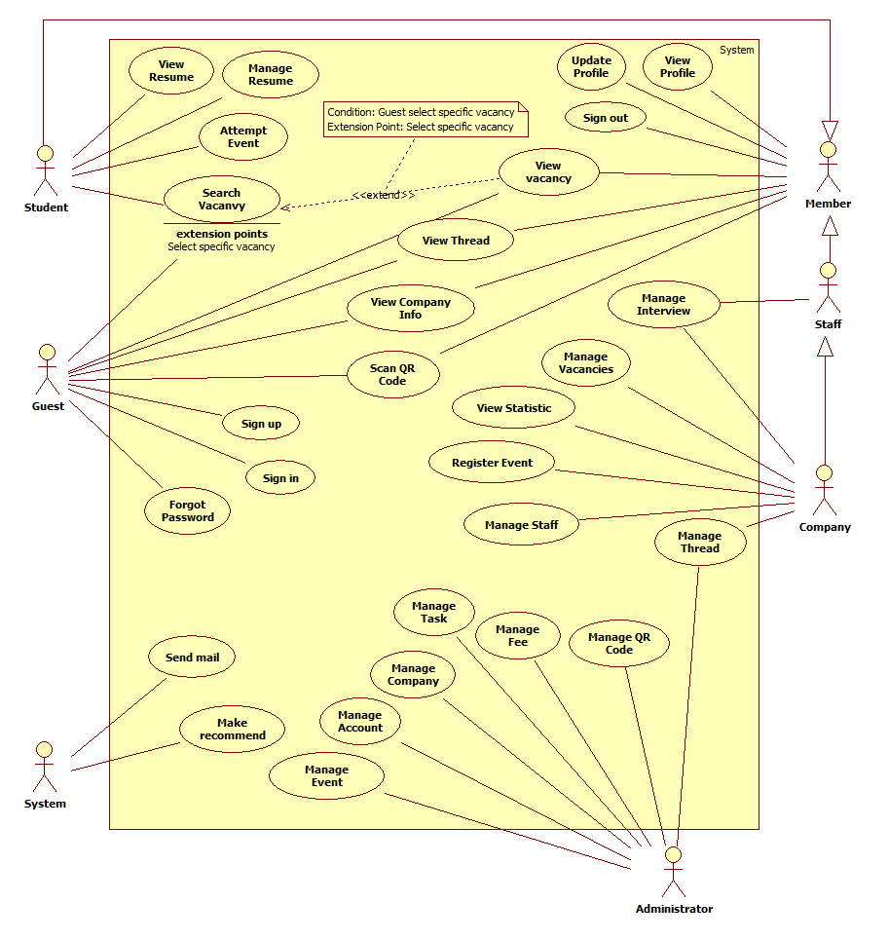

Figure 1: System Overview Use Case

|  |  |  |
| --- | --- | --- |
| **No.** | **Actor** | **Description** |
| 1 | Guest | Visitor who is not logged in to the system. |
| 2 | Member | System’s user. |
| 3 | Student | Student can manage their resume and submit to company. |
| 4 | Administrator | System’s user who can manage all activities in system. |
| 5 | Company manager | Manage staff and company’s information. |
| 6 | Staff | Created by company manager. |
| 7 | System | Automatic functions. |

### List of Use Case

#### <Guest>Overview Use Case

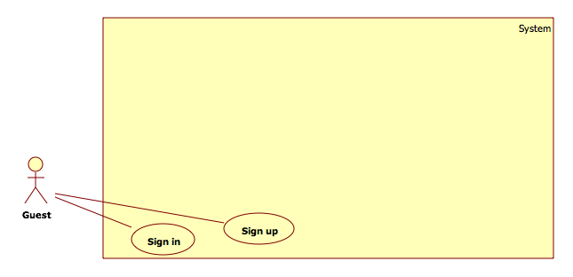

Figure 2: <Guest>Overview Use Case

##### <Guest>Sign in

**Use Case Diagram**

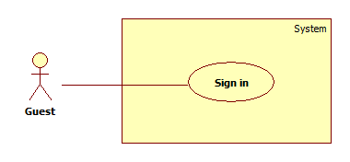

Figure 3: <Guest>Sign in

**Use Case Specification**

|  |  |  |  |
| --- | --- | --- | --- |
|  | | | |
| **Use Case No.** |  | **Use Case Version** | 1.0 |
| **Use Case Name** | <Guest>Sign in | | |
| **Author** | HongBC | | |
| **Date** | 1/12/2015 | **Priority** | Normal |
| **Actor:**   * Guest   **Summary:**   * Guest sign in system.   **Goal:**   * Guest can sign in. If user name does not exist, system will connect to another database to authentication and auto registration.   **Triggers:**   * Guest click “Sign in” button. * Guest access page that request permission.   **Preconditions:**   * Not login yet. * Connection to Moodle database is configured.   **Post Conditions:**   * **Success:** Web session will store member’s information. * **Fail:** Log error to administrator.   **Main Success Scenario:**  Step Actor Action System Response  Guest click “Sign in” button.  Show a sign in form with following information:   * “Tên đăng nhập”: textbox[50] * “Mật khẩu”: password[32] * “Đăng nhập”: button * “Hủy”: button * “Quên mật khẩu”: label   Input value  Click “Đăng nhập”  Check username and password  [Alternative 1]  [Alternative 2]  [Exception 1]  Display welcome message.  **Alternative Scenario:**  No Actor Action System Response  [If username exist and password incorrect]   * Display invalid username or password message.     [If username does not exist]   * Connect to Moodle database then check username, password.   [Alternative 3]  [Exception 2]   * Create new account. * Display welcome message.   [If username and password do not exist in Moodle Database]   * Display invalid username or password message.   **Exceptions:**  No Actor Action System Response  User do not enter username or password   * Display error message.   [System cannot connect to Moodle Database]   * Log error to administrator. * Display invalid username or password message.   **Relationships:**   * N/A   **Business Rules:**   * Administrator can turn on/off external login. If external login turned off, system only check in own database. * Password will be encrypted on server side with following: MD5 (Password) x random salt (16 characters) for each user. * Guest can sign in with either username or email. * Administrator can configure connect to Moodle database. * Session will out of date after 30 minutes. | | | |

##### <Guest>Search vacancy

**Use Case Diagram**

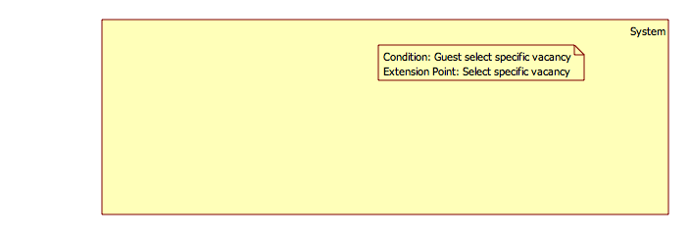

Figure 4: <Guest>Search vacancy

**Use Case Specification**

|  |  |  |  |
| --- | --- | --- | --- |
|  | | | |
| **Use Case No.** |  | **Use Case Version** | 1.0 |
| **Use Case Name** | <Guest>Search vacancy | | |
| **Author** | ThanhVM | | |
| **Date** | 1/12/2015 | **Priority** | Normal |
| **Actor:**   * Guest   **Summary:**   * This use case allow guest to search vacancy.   **Goal:**   * Find information is shown to guest.   **Triggers:**   * Guest clicks “Tìm” in “Tìm kiếm tuyển dụng” page to search information vacancy.   **Preconditions:**   * N/A   **Post Conditions:**   * **Success**: searching information is shown to guest. * **Fail**: Show error message and require guest to try one more time.   **Main Success Scenario:**  Step Actor Action System Response  1 Student input their searching information into “Tìm kiếm” text box.  2 Choose “Nghành nghề” combobox.  3 Choose “Địa điểm” combobox  4 Click “Tìm” button [Exception 1]  5 The page will be shown:   * “Tìm kiếm”: textbox. * “Nghành nghề”: combobox. * “Địa điểm”: combobox. * “Tìm”: button. * A table with column: * “Ứng viên”. * “Kinh nghiệm”. * “Lương”. * “Nơi làm việc”. * “Ngày đăng hồ sơ”.   **Alternative Scenario:**   * N/A   **Exceptions:**  No Actor Action System Response  1 User does not input search information. Show error message “Bạn không được để trống ô tìm kiếm”.  **Relationships: N/A**  **Business Rules: N/A** | | | |

#### <Administrator>Overview Use Case

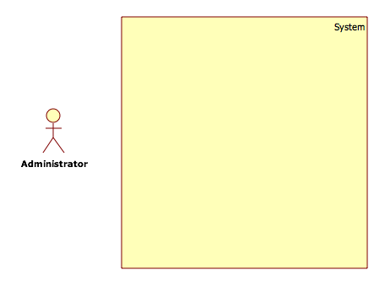

Figure 5: <Guest>Overview Use Case

##### <Administrator>Manage Event

**Use Case Diagram**

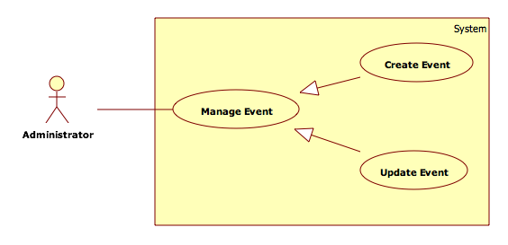

Figure 6: <Administrator>Manage Event

###### <Administrator>Create Event

**Use Case Diagram**

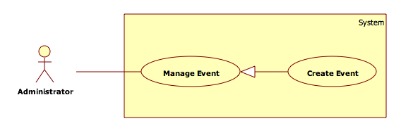

Figure 7: <Administrator>Create Event

**Use Case Specification**

|  |  |  |  |
| --- | --- | --- | --- |
|  | | | |
| **Use Case No.** |  | **Use Case Version** | 1.0 |
| **Use Case Name** | <Administrator>Create Event | | |
| **Author** | ChungNC | | |
| **Date** | 1/12/2015 | **Priority** | Normal |
| **Actor:**   * Administrator   **Summary:**   * This use case allows administrator can create an event.   **Goal:**   * Administrator can create an event.   **Triggers:**   * Administrator clicks “Tạo ngày hội” button.   **Preconditions:**   * Login as administrator.   **Post Conditions:**   * **Success:** Administrator will create an event successful. * **Fail:** Return Quản lý ngày hội page with message the event won’t be created.   **Main Success Scenario:**  Step Actor Action System Response  Administrator clicks “Tạo ngày hội” button.  Ngày hội page, show event in form with following information:   * “Tên ngày hội”: textbox[150] required * “Mô tả về ngày hội”: textbox[1500] required * “Ngày bắt đầu”: dateTimePicker required * “Ngày kết thúc”: dateTimePicker required * “Tạo”: button * “Huỷ”: button   Administrator inputs information.  [Alternative 1]  [Exception 1]  Show create new event successful message.  **Alternative Scenario:**  No Actor Action System Response  [If administrator clicks “Huỷ” button.] Show the event won’t be created message.  **Exceptions:**  No Actor Action System Response  [If administrator does not fill in any information required.]  Show warning at which information are not filled.  **Relationships:**   * N/A   **Business Rules:** | | | |

###### <Administrator>Update Event

**Use Case Diagram**

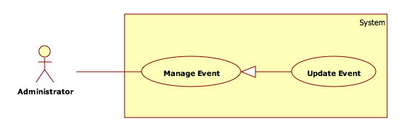

Figure 8: <Administrator>Update Event

**Use Case Specification**

|  |  |  |  |
| --- | --- | --- | --- |
|  | | | |
| **Use Case No.** |  | **Use Case Version** | 1.0 |
| **Use Case Name** | <Administrator> Update Event | | |
| **Author** | ChungNC | | |
| **Date** | 1/12/2015 | **Priority** | Normal |
| **Actor:**   * Administrator   **Summary:**   * This use case allows administrator can update an event.   **Goal:**   * Administrator can update an event.   **Triggers:**   * Administrator clicks “Chỉnh sửa” button.   **Preconditions:**   * Login as administrator.   **Post Conditions:**   * **Success:** Administrator will update an event successful. * **Fail:** Return Quản lý ngày hội page with message the event won’t be updated.   **Main Success Scenario:**  Step Actor Action System Response  Administrator clicks “Chỉnh sửa” button.  Ngày hội page, show event in form with following information:   * “Tên ngày hội”: textbox[150] required * “Mô tả về ngày hội”: textbox[1500] required * “Ngày bắt đầu”: dateTimePicker required * “Ngày kết thúc”: dateTimePicker required * “Sửa”: button * “Huỷ”: button   Administrator inputs information.  [Alternative 1]  [Exception 1]  Show updates an event successful message.  **Alternative Scenario:**  No Actor Action System Response  [If administrator clicks “Huỷ” button.] Show the event won’t be updated message.  **Exceptions:**  No Actor Action System Response  [If administrator does not fill in any information required.]  Show warning at which information are not filled.  **Relationships:**   * N/A   **Business Rules:**   * In update event form, show old information which event will update. | | | |

##### <Administrator>Manage Company

**Use Case Diagram**

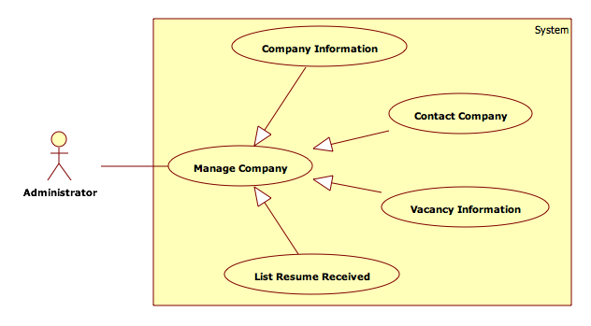

Figure 9: <Administrator>Manage Company

###### <Administrator>Send Email

**Use Case Diagram**

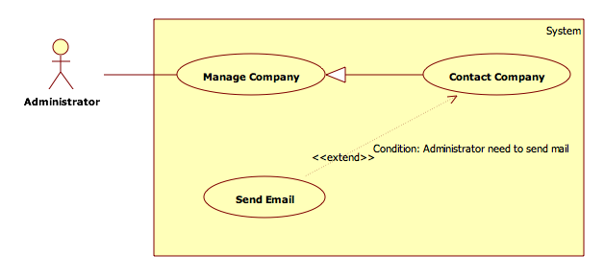

Figure 10: <Administrator>Send Email

**Use Case Specification**

|  |  |  |  |
| --- | --- | --- | --- |
|  | | | |
| **Use Case No.** |  | **Use Case Version** | 1.0 |
| **Use Case Name** | <Administrator>Send Email | | |
| **Author** | ChungNC | | |
| **Date** | 1/12/2015 | **Priority** | Normal |
| **Actor:**   * Administrator   **Summary:**   * This use case allows administrator can send email.   **Goal:**   * Administrator can send email.   **Triggers:**   * Administrator clicks “Gửi email” button.   **Preconditions:**   * Login as administrator.   **Post Conditions:**   * **Success:** Administrator will send email successful. * **Fail:** Return Quản lý công ty page with message the email won’t be sent.   **Main Success Scenario:**  Step Actor Action System Response  Administrator clicks “Gửi email” button.  Quản lý công ty page, show email in form with following information:   * “Gửi”: button * “Huỷ”: button   Administrator inputs information.  [Alternative 1]  [Exception 1]  Show email has be sent successful message.  **Alternative Scenario:**  No Actor Action System Response  [If administrator clicks “Huỷ” button.]  Show the email won’t be sent message.  **Exceptions:**  No Actor Action System Response  [If administrator do not fill in any information required.]  Show warning at which information are not filled.  **Relationships:**   * N/A   **Business Rules:**   * N/A | | | |

##### <Administration> Manage Thread

**Use Case Diagram**

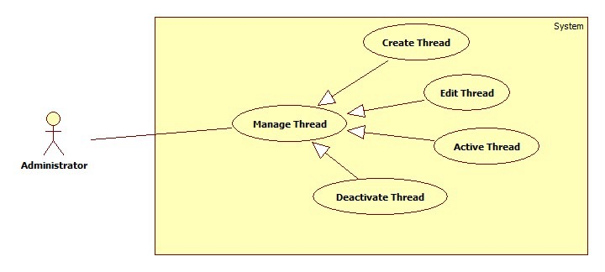

Figure 11: <Administration>Manage Thread

###### <Administration>Create Thread

**Use Case Diagram**

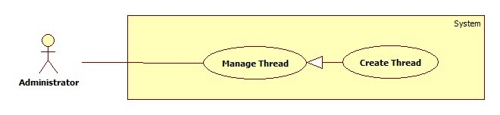

Figure 12: <Administration> Create Thread

**Use Case Specification**

|  |  |  |  |
| --- | --- | --- | --- |
|  | | | |
| **Use Case No.** |  | **Use Case Version** | 1.0 |
| **Use Case Name** | <Administration> Create Thread | | |
| **Author** | HongNT | | |
| **Date** | 1/16/2015 | **Priority** | Normal |
| **Actor:**   * Administration   **Summary:**   * This use case allows an Administration to create information for thread in the system.   **Goal:**   * New information will be created to the database.   **Triggers:**   * User wants to create new thread. * To input thread manually, User must do the following steps:   + Click “Quản lý bản tin” in the menu.   + Click “Đăng bản tin” button.   **Preconditions:**   * User must login to the system with “Administration” role.   **Post Conditions:**   * **Success**: New information will be created to the database. * **Fail**: Show error message on the current page.   **Main Success Scenario:**  Step Actor Action System Response  1 Click menu item “Quản lí bản tin”.  2 Navigate to “Quản lí bản tin” page with contains:   * Đăng bản tin: button * A table with comlum: * Tiêu đề bản tin: label. * Tên công ty: label. * Nội Dung: label. * Event Tham gia: label. * Hoạt Động :Button * Date :Label * Chỉnh sửa bản tin: button. * Xóa Bản Tin:button   3 Administration clicks “Đăng bản tin” button.  4 Navigate to “Đăng bản tin” with contains:   * Tiêu đề bản tin : textbox, min length 10, max length 100, required * Tên công ty: textbox, min length 10, max length 100, required. * Nội Dung: textarea, required. * Event tham gia: dropdown list required. * Đăng bản tin: button. * Hủy bỏ: button.   5 Administration clicks “Đăng bản tin” button.  [Alternative 1]  7 Save new data to the database. Redirect to “Quản lý Bản Tin” page.[Exception 1, 2]  **Alternative Scenario:**  No Actor Action System Response  1 Administration clicks “Hủy bỏ”. Navigate to “Quản lí bản tin” page.  **Exceptions:**  No Actor Action System Response  1 Information is not in range. Show message: “Thông tin có độ dài chính xác. Vui lòng nhập lại!”  2 Information is empty. Show message: “Vui lòng nhập đầy đủ thông tin”.  **Relationships:**   * N/A   **Business Rules:**   * User clicks “Đăng bản tin” button. * This thread will be created information in database. | | | |

###### <Administration>Edit Thread

**Use Case Diagram**

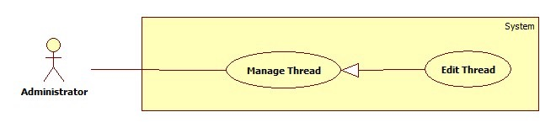

Figure 13: <Administration> Edit Thread

**Use Case Specification**

|  |  |  |  |
| --- | --- | --- | --- |
|  | | | |
| **Use Case No.** |  | **Use Case Version** | 1.0 |
| **Use Case Name** | <Administration> Edit Thread | | |
| **Author** | HongNT | | |
| **Date** | 1/16/2015 | **Priority** | Normal |
| **Actor:**   * Administration   **Summary:**   * This use case allows an Administration to update information for thread in the system.   **Goal:**   * New information will be updated to the database.   **Triggers:**   * User wants to change some information.   **Preconditions:**   * User must login to the system with “Administration” role. * There is at least 1 thread which is created before.   **Post Conditions:**   * **Success**: New information will be updated to the database. * **Fail**: Show error message on the current page.   **Main Success Scenario:**  Step Actor Action System Response  1 Click menu item “Quản lí bản tin”.  2 Navigate to “Quản lí bản tin” page with contains:   * Đăng bản tin: button * A table with comlum: * Tiêu đề bản tin: label. * Tên công ty: label. * Nội Dung: label. * Event Tham gia: label. * Hoạt Động :button * Date :Label * Chỉnh sửa bản tin: button. * Xóa Bản Tin: button.   3 Administration clicks “Chỉnh sửa bản tin” button.  4 Navigate to “Chỉnh sửa bản tin” with contains:   * Tiêu đề bản tin : textbox, min length 10, max length 100, required * Tên công ty: textbox, min length 10, max length 100, required. * Nội Dung: textarea, required. * Event tham gia: dropdown list required. * Chỉnh sửa: button. * Hủy bỏ: button.   5 Administration clicks “Chỉnh sửa” button.  [Alternative 1]  7 Save new data to the database. Redirect to “Quản lý Bản Tin” page.[Exception 1, 2,3]  **Alternative Scenario:**  No Actor Action System Response  1 Administration clicks “Hủy bỏ”. Navigate to “Quản lí bản tin” page.  **Exceptions:**  No Actor Action System Response  1 Information is not in range. Show message: “Thông tin có độ dài chính xác. Vui lòng nhập lại!”  4 Information is empty. Show message: “Vui lòng nhập đầy đủ thông tin”.  **Relationships:**   * N/A   **Business Rules:**   * The old information will be loaded in the page. * User clicks “cập nhật” button. * This thread will be updated information in database. | | | |

###### <Administration>Active Thread

**Use Case Diagram**

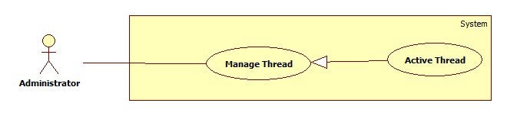

Figure 14: <Administration> Active Thread

**Use Case Specification**

|  |  |  |  |
| --- | --- | --- | --- |
|  | | | |
| **Use Case No.** |  | **Use Case Version** | 1.0 |
| **Use Case Name** | <Administration> Active Thread | | |
| **Author** | HongNT | | |
| **Date** | 1/16/2015 | **Priority** | Normal |
| **Actor:**   * Administration   **Summary:**   * This use case allows an Administration to Active information for thread in the system.   **Goal:**   * New information will be Actived to the database.   **Triggers:**   * User wants to Active new thread. * To input thread manually ,User must do the following steps:   + Click “Quản lý bản tin” in the menu.   + Click “Không Hoạt Động” button.   **Preconditions:**   * User must login to the system with “Administration” role.   **Post Conditions:**   * **Success**: recent information will be active to the database. * **Fail**: Show error message on the current page.   **Main Success Scenario:**  Step Actor Action System Response  1 Click menu item “Quản lí bản tin”.  2 Navigate to “Quản lí bản tin” page with contains:   * Xóa bản tin: button * A table with comlum: * Tiêu đề bản tin: label. * Tên công ty: label. * Nội Dung: label. * Event Tham gia: label. * Không Hoạt Động :button * Date :Label * Chỉnh sửa bản tin: button. * Xóa Bản Tin: button.   3 Administration clicks “Không Hoạt Động” button.  4 That parser is activated. The button text is changed into “Hoạt Động”. Show success message.[Exception 1]  **Alternative Scenario:**  No Actor Action System Response  1 Administration clicks “Hủy bỏ”. Navigate to “Quản lí bản tin” page.  **Exceptions:**  No Actor Action System Response  1 Cannot Active thread due to database connection problem. Show error message.  **Relationships:**   * N/A   **Business Rules:**   * This thread will be active information in database. * Only threads which have “Không hoạt động” status will be activated. | | | |

###### <Administration>Deactivate Thread

**Use Case Diagram**

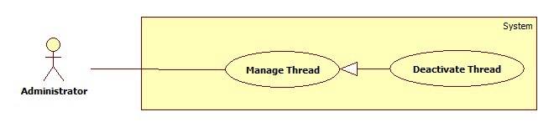

Figure 15: <Administration> Deactivate Thread

**Use Case Specification**

|  |  |  |  |
| --- | --- | --- | --- |
|  | | | |
| **Use Case No.** |  | **Use Case Version** | 1.0 |
| **Use Case Name** | <Administration> Deactivate Thread | | |
| **Author** | HongNT | | |
| **Date** | 1/16/2015 | **Priority** | Normal |
| **Actor:**   * Administration   **Summary:**   * This use case allows an Administration to deactivate information for thread in the system.   **Goal:**   * New information will be deactivated to the database.   **Triggers:**   * User wants to deactivate new thread. * To input thread manually ,User must do the following steps:   + Click “Quản lý bản tin” in the menu.   + Click “Hoạt Động” button.   **Preconditions:**   * User must login to the system with “Administration” role.   **Post Conditions:**   * **Success**: recent information will be Deactivate to the database. * **Fail**: Show error message on the current page.   **Main Success Scenario:**  Step Actor Action System Response  1 Click menu item “Quản lí bản tin”.  2 Navigate to “Quản lí bản tin” page with contains:   * Xóa bản tin: button. * A table with comlum: * Tiêu đề bản tin: label. * Tên công ty: label. * Nội Dung: label. * Event Tham gia: label. * Hoạt Động :button * Date :Label * Chỉnh sửa bản tin: button. * Xóa Bản Tin: button.   3 Administration clicks “Hoạt Động” button.  4 That parser is activated. The button text is changed into “Không Hoạt Động”. Show success message.[Exception 1]  **Alternative Scenario:**  No Actor Action System Response  1 Administration clicks “Hủy bỏ”. Navigate to “Quản lí bản tin” page.  **Exceptions:**  No Actor Action System Response  1 Cannot Deactivate thread due to database connection problem. Show error message.  **Relationships:**   * N/A   **Business Rules:**   * This thread will be Deactivate information in database. * Only threads which have “hoạt động” status will be deactivated. | | | |

##### <Administration> Manage Fee

**Use Case Diagram**

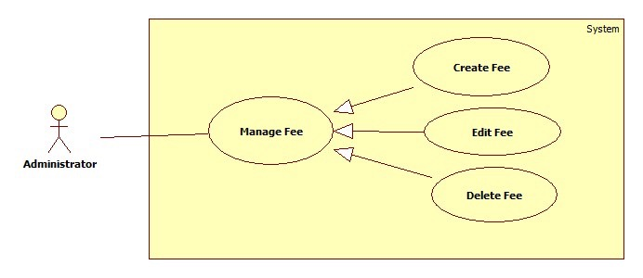

Figure 16: <Administration>Manage Fee

###### <Administration>Create Fee

**Use Case Diagram**

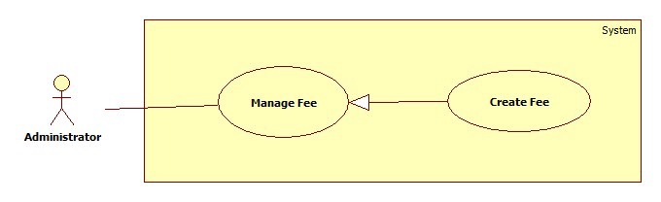

Figure 17: <Administration> Create Fee

**Use Case Specification**

|  |  |  |  |
| --- | --- | --- | --- |
|  | | | |
| **Use Case No.** |  | **Use Case Version** | 1.0 |
| **Use Case Name** | <Administration>Create Fee | | |
| **Author** | HongNT | | |
| **Date** | 1/16/2015 | **Priority** | Normal |
| **Actor:**   * Administration   **Summary:**   * This use case allows an Administration to create information for fee in the system.   **Goal:**   * New information will be created to the database.   **Triggers:**   * User wants to create new fee. * To input fee manually, User must do the following steps:   + Click “Quản lý gian hàng sự kiện” in the menu.   + Click “Thêm gian hàng sự kiện” button.   **Preconditions:**   * User must login to the system with “Administration” role.   **Post Conditions:**   * **Success**: New information will be created to the database. * **Fail**: Show error message on the current page.   **Main Success Scenario:**  Step Actor Action System Response  1 Click menu item “Quản lí gian hàng sự kiện”.  2 Navigate to “Quản lí Gian hàng sự kiện” page with contains:   * Thêm phí gian hàng: button * A table with comlum: * Tên Gian hàng: label * Event Tham gia: label. * Chi phí :Label * Chỉnh sửa phí gian hàng: button. * Xóa phí gian: button.   3 Administration clicks “Thêm phí gian hàng” button.  4 Navigate to “Thêm phí gian” with contains:   * Event Tham gia : Dropdown list required * Tên Gian hàng: Dropdown list required * Chi phí: number required. * Thêm phí: button. * Hủy bỏ: button.   5 Administration clicks “Thêm phí” button.  [Alternative 1]  6 Save new data to the database. Redirect to “Quản lý Gian hàng sự kiện” page.[Exception 1, 2]  **Alternative Scenario:**  No Actor Action System Response  1 Administration clicks “Hủy bỏ”. Navigate to “Quản lí Gian hàng sự kiện” page.  **Exceptions:**  No Actor Action System Response  1 Information is not in range. Show message: “Thông tin có độ dài chính xác. Vui lòng nhập lại!”  2 Information is empty. Show message: “Vui lòng nhập đầy đủ thông tin”.  **Relationships:**   * N/A   **Business Rules:**   * User clicks “Thêm Phí gian hàng” button. * This fee will be created information in database. | | | |

###### <Administration>Edit Fee

**Use Case Diagram**

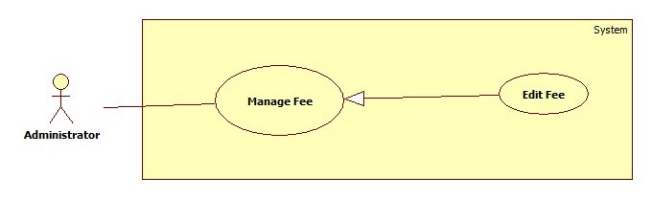

Figure 18: <Administration> Edit Fee

**Use Case Specification**

|  |  |  |  |
| --- | --- | --- | --- |
|  | | | |
| **Use Case No.** |  | **Use Case Version** | 1.0 |
| **Use Case Name** | <Administration> Edit Fee | | |
| **Author** | HongNT | | |
| **Date** | 1/16/2015 | **Priority** | Normal |
| **Actor:**   * Administration   **Summary:**   * This use case allows an Administration to update information for fee in the system.   **Goal:**   * New information will be updated to the database.   **Triggers:**   * User wants to change some information.   **Preconditions:**   * User must login to the system with “Administration” role. * There is at least 1 ground of event which is created before.   **Post Conditions:**   * **Success**: New information will be updated to the database. * **Fail**: Show error message on the current page.   **Main Success Scenario:**  Step Actor Action System Response  1 Click menu item “Quản lí Gian hàng sự kiện”.  2 Navigate to “Quản lí Gian hàng sự kiện” page with contains:   * Thêm phí gian hàng: button * A table with comlum: * Tên Gian hàng: label * Event Tham gia: label. * Chi phí :Label * Chỉnh sửa phí gian hàng: button. * Xóa phí gian hàng: button.   3 Administration clicks “Chỉnh sửa phí gian hàng” button.  4 Navigate to “Chỉnh sửa phí gian hàng” with contains:   * Event Tham gia : Dropdown list required * Tên Gian hàng: Dropdown list required * Chi phí: number required. * Chỉnh sửa: button. * Hủy bỏ: button.   5 Administration clicks “Chỉnh sửa” button.  [Alternative 1]  6 Save new data to the database. Redirect to “Quản lý Gian hàng sự kiện” page.[Exception 1, 2,3]  **Alternative Scenario:**  No Actor Action System Response  1 Administration clicks “Hủy bỏ”. Navigate to “Quản lí Gian hàng sự kiện” page.  **Exceptions:**  No Actor Action System Response  1 Information is not in range. Show message: “Thông tin có độ dài chính xác. Vui lòng nhập lại!”  2 Information is empty. Show message: “Vui lòng nhập đầy đủ thông tin”.  **Relationships:**   * N/A   **Business Rules:**   * The old information will be loaded in the page. * User clicks “Chỉnh sửa” button. * This fee will be updated information in database. | | | |

###### <Administration>Delete Fee

**Use Case Diagram**

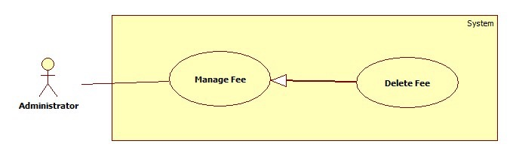

Figure 19: <Administration> Delete Fee

**Use Case Specification**

|  |  |  |  |
| --- | --- | --- | --- |
|  | | | |
| **Use Case No.** |  | **Use Case Version** | 1.0 |
| **Use Case Name** | <Administration> Delete Fee | | |
| **Author** | HongNT | | |
| **Date** | 1/16/2015 | **Priority** | Normal |
| **Actor:**   * Administration   **Summary:**   * This use case allows an Administration to delete information for fee in the system.   **Goal:**   * New information will be deleted to the database.   **Triggers:**   * User wants to delete new fee. * To input fee manually ,User must do the following steps:   + Click “Quản lý Gian hàng sự kiện” in the menu.   + Click “Xóa phí gian hàng” button.   **Preconditions:**   * User must login to the system with “Administration” role. * There is at least 1 ground of event which is created before.   **Post Conditions:**   * **Success**: recent information will be deleted to the database. * **Fail**: Show error message on the current page.   **Main Success Scenario:**  Step Actor Action System Response  1 Click menu item “Quản lí Gian hàng sự kiện”.  2 Navigate to “Quản lí Gian hàng sự kiện” page with contains:   * Thêm phí gian hàng: button * A table with comlum: * Tên Gian hàng: label * Event Tham gia : label. * Chi phí :Label * Chỉnh sửa phí gian hàng: button. * Xóa phí gian hàng: button.   3 Administration clicks “Xóa phí gian hàng” button.  4 Navigate to “Xóa phí gian hàng” with contains:   * Trạng thái :label * Xóa phí gian hàng: button. * Hủy bỏ: button   5 Administration clicks “Xóa phí gian hàng” button.  [Alternative 1]  7 Delete data to the database. Redirect to “Quản lý Gian hàng sự kiện” page.[Exception 1]  **Alternative Scenario:**  No Actor Action System Response  1 Administration clicks “Hủy bỏ”. Navigate to “Quản lí Gian hàng sự kiện” page.  **Exceptions:**  No Actor Action System Response  1 Cannot delete fee due to database connection problem. Show error message.  **Relationships:**   * N/A   **Business Rules:**   * User clicks “Xóa Gian hàng sự kiện” button. * This fee will be Deleted information in database. | | | |

#### <Staff>Overview Use Case

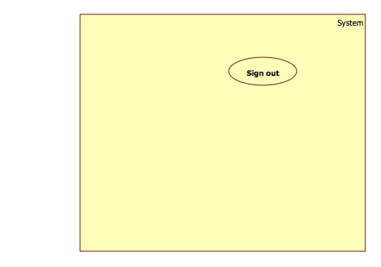

Figure 20: <Staff>Overview Use Case

##### <Staff>Manage interview

**Use Case Diagram**

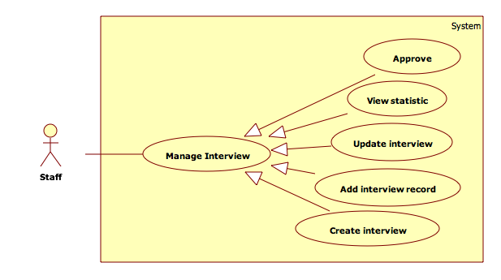

Figure 21: <Staff>Manage interview

###### <Staff>View statistic

**Use Case Diagram**

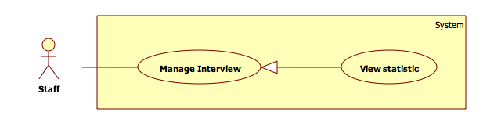

Figure 22: <Staff> View statistic

**Use Case Specification**

|  |  |  |  |
| --- | --- | --- | --- |
|  | | | |
| **Use Case No.** |  | **Use Case Version** | 1.0 |
| **Use Case Name** | <Staff>View statistic | | |
| **Author** | ThanhVM | | |
| **Date** | 1/12/2015 | **Priority** | Normal |
| **Actor:**   * Staff   **Summary:**   * Staff wants to view statistic of interview.   **Goal:**   * View statistic of interview.   **Triggers:**   * Staff click “Xem thống kê” in “Quản lí phỏng vấn” menu.   **Preconditions:**   * Sign in with “Staff” role in the system.   **Post Conditions:**   * **Success**: Show statistic of interview. * **Fail**: show error in the current page.   **Main Success Scenario:**  Step Actor Action System Response  1 Staff clicks “Quản lí phỏng vấn” in menu bar.  [Exception 1]  2 Show sub menu which includes:   * “Xác nhận phỏng vấn”: link. * “Tạo phỏng vấn”: link. * “Chỉnh sửa phỏng vấn”: link. * “Thêm ghi âm phỏng vấn”: link. * “Xem thống kê”: link.   3 Staff clicks “Xem thống kê” link.  4 Show “Xem thống kê” page which includes:   * “Tổng số người gữi”: label. * “Số người đậu”: label. * “Số người rớt”: label. * “Số người chưa phỏng vấn”: label. * Pie chart. * “Thống kê”: button. * “Xuất PDF”: button.   5 Staff clicks “Thống kê” button.  6 Reload page and show statistic view.  **Alternative Scenario:**  No Actor Action System Response  1 Staff clicks “Xuất PDF” button. Website will be printed report PDF file.  **Exceptions:**  No Actor Action System Response  1 Connection failed. Show error message.  **Relationships:**   * N/A   **Business Rules:**   * Staff can view statistic in their company. * PDF file with report format. | | | |

###### <Staff> Approve

**Use Case Diagram**

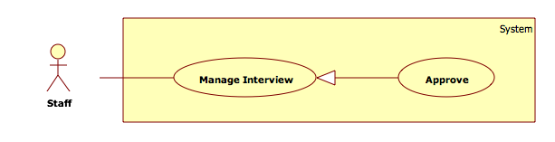

Figure 23: <Staff> Approve

**Use Case Specification**

|  |  |  |  |
| --- | --- | --- | --- |
|  | | | |
| **Use Case No.** |  | **Use Case Version** | 1.0 |
| **Use Case Name** | <Staff> Approve | | |
| **Author** | ThanhVM | | |
| **Date** | 1/12/2015 | **Priority** | Normal |
| **Actor:**   * Staff   **Summary:**   * Staff wants to approve student pass interview.   **Goal:**   * Approve student pass interview.   **Triggers:**   * Staff click “Xác nhận phỏng vấn” in “Quản lí phỏng vấn” menu.   **Preconditions:**   * Sign in with “Staff” role in the system.   **Post Conditions:**   * **Success**: Approve student pass interview success. * **Fail**: show error in the current page.   **Main Success Scenario:**  Step Actor Action System Response  1 Staff clicks “Quản lí phỏng vấn” in menu bar.  [Exception 1]  2 Show sub menu which includes:   * “Xác nhận phỏng vấn”: link. * “Tạo phỏng vấn”: link. * “Chỉnh sửa phỏng vấn”: link. * “Thêm ghi âm phỏng vấn”: link. * “Xem thống kê”: link.   3 Staff clicks “Xác nhận phỏng vấn” link.  4 Show “Xác nhận phỏng vấn” page which includes:   * “Tìm kiếm”: textbox [0, 100]. * “Tìm người phỏng vấn”: button. * Drop down list:   + Người đã tham gia phỏng vấn.   + Chưa chưa được phỏng vấn.   + Người đã đậu phỏng vấn.   + Người đã rớt phỏng vấn.   + Tất cả người tham gia. * Table with column: * “Tên sinh viên”: label. * “Hồ sơ”: link. * “Chuyên nghành”: label. * “Địa chỉ”: label. * “Thời gian phỏng vấn”: label. * “Xác nhận đậu”: button. * “Xác nhận rớt”: button.   5 Staff chose student wants to “Xác nhận đậu” button.  6 Staff click “Xác nhận đậu” button [Alternative 1]   * 7 New information will be updated to the database and show message success. * 8 Change status “Đang Chờ xác nhận” to “Đã đậu phỏng vấn”.   **Alternative Scenario:**  No Actor Action System Response  1 Staff click “Xác nhận rớt” button. Change status “Đang Chờ xác nhận” to “Đã rớt phỏng vấn”.  **Exceptions:**  No Actor Action System Response  1 Connection is fail. Show error message.  **Relationships:**   * N/A   **Business Rules:**   * Approve student will be join interview. * Table show student will be join interview and staff do not approve. * Chose element in drop down list to change information of table. * Staff can not change state interviewee approved by Company manager | | | |

###### <Staff> Add interview record

**Use Case Diagram**

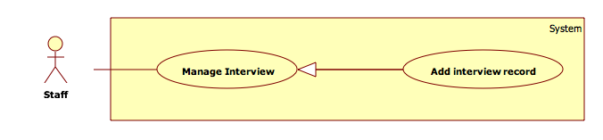

Figure 24: <Staff> Add interview record

**Use Case Specification**

|  |  |  |  |
| --- | --- | --- | --- |
|  | | | |
| **Use Case No.** |  | **Use Case Version** | 1.0 |
| **Use Case Name** | <Staff> Add interview record | | |
| **Author** | ThanhVM | | |
| **Date** | 1/12/2015 | **Priority** | Normal |
| **Actor:**   * Staff   **Summary:**   * Staff wants to upload audio student in interview.   **Goal:**   * Upload audio student in interview.   **Triggers:**   * Staff click “Thêm ghi âm phỏng vấn” in “Quản lí phỏng vấn” menu.   **Preconditions:**   * Sign in with “Staff” role in the system.   **Post Conditions:**   * **Success**: Approve student pass interview success. * **Fail**: show error in the current page.   **Main Success Scenario:**  Step Actor Action System Response  1 Staff clicks “Quản lí phỏng vấn” in menu bar.  [Exception 1]  2 Show sub menu which includes:   * “Xác nhận phỏng vấn”: link. * “Tạo phỏng vấn”: link. * “Chỉnh sửa phỏng vấn”: link. * “Thêm ghi âm phỏng vấn”: link. * “Xem thống kê”: link.   3 Staff clicks “Thêm ghi âm phỏng vấn” link.  4 Show “Thêm ghi âm phỏng vấn” page which includes:   * Danh sách sinh viên phỏng vấn: label. * Table with column: * “Tên sinh viên”: label. * “Hồ sơ”: link * “Chuyên nghành”: label. * “Địa chỉ”: label. * “Thời gian phỏng vấn”: label. * “Thêm ghi âm file”: upload.   5 Staff chose student wants to add interview record.  6 Staff click “Thêm ghi âm file” button  [Alternative 1]  7 The website will show popup upload.  8 Staff add audio interview with url.   * 9 Audio will be saved. * 10 Close popup upload and show message “Thêm ghi âm thành công”.   **Alternative Scenario:**   * N/A   **Exceptions:**  No Actor Action System Response  1 Connection is fail. Show error message.  **Relationships:**   * N/A   **Business Rules:**   * Audio file must be under 10MB size. * Format of audio: mp3, wma, acc. * Can upload 1 file audio. | | | |

###### <Staff> Create interview

**Use Case Diagram**

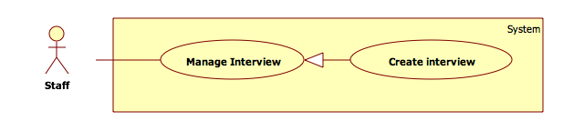

Figure 25: <Staff>Create interview

**Use Case Specification**

|  |  |  |  |
| --- | --- | --- | --- |
|  | | | |
| **Use Case No.** |  | **Use Case Version** | 1.0 |
| **Use Case Name** | <Staff> Create interview | | |
| **Author** | ThanhVM | | |
| **Date** | 1/12/2015 | **Priority** | Normal |
| **Actor:**   * Staff   **Summary:**   * Staff wants to create interview.   **Goal:**   * Staff wants to create interview.   **Triggers:**   * Staff click “Tạo phỏng vấn” in “Quản lí phỏng vấn” menu.   **Preconditions:**   * Sign in with “Staff” role in the system.   **Post Conditions:**   * **Success**: Create interview in the system. * **Fail**: Show error in the current page.   **Main Success Scenario:**  Step Actor Action System Response  1 Staff clicks “Quản lí phỏng vấn” in menu bar.  [Exception 1]  2 Show sub menu which includes:   * “Xác nhận phỏng vấn”: link. * “Tạo phỏng vấn”: link. * “Chỉnh sửa phỏng vấn”: link. * “Thêm ghi âm phỏng vấn”: link. * “Xem thống kê”: link.   3 Staff clicks “Tạo phỏng vấn” link.  4 Show “Tạo phỏng vấn” page which includes:   * “Tên sinh viên”: textbox, [5, 20], required. * “Ngày sinh”: textbox, required. * “Địa chỉ email”: textbox, required. * “Giới tính”: dropdownlist, (“Nam”, “Nữ”) required. * “Người phỏng vấn”: textbox, required. * “Thời gian phỏng vấn”: textbox, required. * “Mô tả phỏng vấn”: textarea, required. * “Ghi âm”: upload. * “Tạo phỏng vấn”: button. * “Làm mới”: button.   5 Staff fills data in the form.  [Exception 2,3,4]  6 Staff click “Tạo phỏng vấn” button.  [Alternative 1]  7 Insert new interview into the database and show message success.  **Alternative Scenario:**  No Actor Action System Response  1 Staff click “Làm mới” button. Clear information in the form.  **Exceptions:**  No Actor Action System Response  1 Connection is fail. Show error message.  2 Information is empty. Show message: “Vui lòng nhập thông tin”.  3 Information is not in range. Show message: “Thông tin có độ dài không chính xác. Vui lòng nhập lại!”  4 Invalid email format. Show error message: “Địa Chỉ Email phải đúng định dạng. Vui lòng nhập lại email!”  **Relationships:**   * N/A   **Business Rules:**   * Email **:** : regular expression: /^[_a-z0-9-]+(\.[_a-z0-9-]+)*@@[a-z0-9-]+(\.[a-z0-9-]+)*(\.[a-z]{2,4})$/. * Staff can create a lot of interview. But, a interviewee can join one interview in. | | | |

###### <Staff> Update interview

**Use Case Diagram**

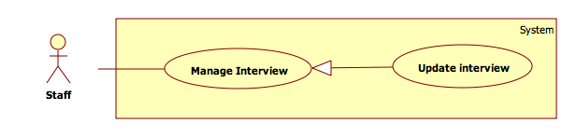

Figure 26: <Staff> Update interview

**Use Case Specification**

|  |  |  |  |
| --- | --- | --- | --- |
|  | | | |
| **Use Case No.** |  | **Use Case Version** | 1.0 |
| **Use Case Name** | <Staff> Update interview | | |
| **Author** | ThanhVM | | |
| **Date** | 1/12/2015 | **Priority** | Normal |
| **Actor:**   * Staff   **Summary:**   * Staff wants to change some information of interview.   **Goal:**   * Staff wants to update interview.   **Triggers:**   * Staff click “Chỉnh sửa phỏng vấn” in “Quản lí phỏng vấn” menu.   **Preconditions:**   * Sign in with “Staff” role in the system.   **Post Conditions:**   * **Success**: Update information interview in the system. * **Fail**: Show error in the current page.   **Main Success Scenario:**  Step Actor Action System Response  1 Staff clicks “Quản lí phỏng vấn” in menu bar.  [Exception 1]  2 Show sub menu which includes:   * “Xác nhận phỏng vấn”: link. * “Tạo phỏng vấn”: link. * “Chỉnh sửa phỏng vấn”: link. * “Thêm ghi âm phỏng vấn”: link. * “Xem thống kê”: link.   3 Staff clicks “Chỉnh sửa phỏng vấn phỏng vấn” link.  4 Show “Tạo phỏng vấn” page which includes:   * “Tên sinh viên”: textbox, [5, 20], required. * “Ngày sinh”: textbox, required. * “Địa chỉ email”: textbox, required. * “Giới tính”: dropdownlist, (“Nam”, “Nữ”) required. * “Người phỏng vấn”: textbox, required. * “Thời gian phỏng vấn”: textbox, required. * “Mô tả phỏng vấn”: textarea, required. * “Ghi âm”: upload. * “Chỉnh sửa”: button. * “Làm mới”: button.   5 Staff update data in the form.  [Exception 2,3,4]  6 Staff click “Chỉnh sửa” button.  [Alternative 1,2]  7 Update new information interview into the database and show message success.  **Alternative Scenario:**  No Actor Action System Response  1 Staff click “Làm mới” button. Clear information in the form.  **Exceptions:**  No Actor Action System Response  1 Connection is fail. Show error message.  2 Information is empty. Show message: “Vui lòng nhập thông tin”.  3 Information is not in range. Show message: “Thông tin có độ dài không chính xác. Vui lòng nhập lại!”  4 Invalid email format. Show error message: “Địa Chỉ Email phải đúng định dạng. Vui lòng nhập lại email!”  **Relationships:**   * N/A   **Business Rules:**   * Email **:** : regular expression: /^[_a-z0-9-]+(\.[_a-z0-9-]+)*@@[a-z0-9-]+(\.[a-z0-9-]+)*(\.[a-z]{2,4})$/. | | | |

#### < Company manager>Overview Use Case

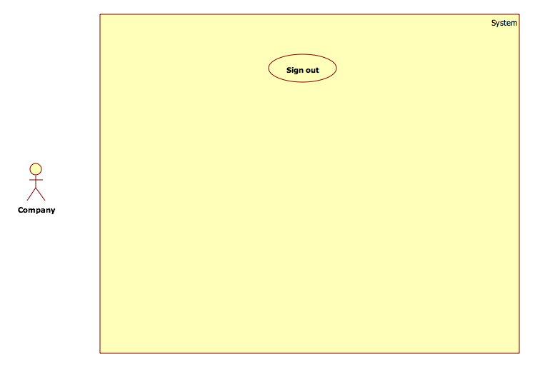

Figure 27: <Manager>Overview Use Case

##### <Company manager> Manage vacancy

**Use Case Diagram**

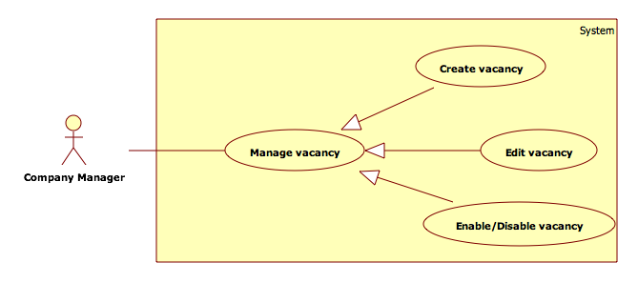

Figure 28: <Company manager>Manage vacancy

###### <Company manager>Create vacancy

**Use Case Diagram**

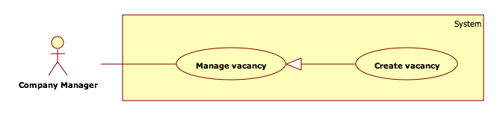

Figure 29: <Company manager>Create vacancy

**Use Case Specification**

|  |  |  |  |
| --- | --- | --- | --- |
|  | | | |
| **Use Case No.** |  | **Use Case Version** | 1.0 |
| **Use Case Name** | <Company manager> Create vacancy | | |
| **Author** | ThanhVM | | |
| **Date** | 1/12/2015 | **Priority** | Normal |
| **Actor:**   * Company manager.   **Summary:**   * This use case allows Company manager to create new vacancy in the system.   **Goal:**   * New vacancy will be added to the system.   **Triggers:**   * User clicks "Đăng tuyển dụng" button in "Quản lý tuyển dụng" menu.   **Preconditions:**   * User must login to the system with “Company manager” role.   **Post Conditions:**   * **Success**: New vacancy will be added to the database. * **Fail**: Show error message on the current page.   **Main Success Scenario:**  Step Actor Action System Response  1 Click menu item “Quản lí tuyển dụng”.  2 Navigate to “Quản lí tuyển dụng” page with contains:   * “Đăng tuyển dụng”: button. * A table with columns: * Tiêu đề tuyển dụng * Tên công ty * Địa chỉ * Giới thiệu công ty * Mô tả công việc * Yêu cầu công việc * Thông tin liên hệ * “Chỉnh sửa tuyển dụng”: button. * “Enable/Disable”: button.   3 Company manager clicks “Đăng tuyển dụng” button.  4 Navigate to “Đăng tuyển dụng” with contains:   * “Tiêu đề tuyển dụng”: textbox [10, 100] required. * “Tên công ty”: textbox [10, 50], required. * “Địa chỉ”: textbox [10, 100], required. * “Giới thiệu công ty”: textarea, required. * “Mô tả công việc”: textarea, required. * “Yêu cầu công việc”: textarea, required. * “Thông tin liên hệ”: textarea required. * “Đăng tuyển dụng”: button. * “Hủy bỏ”: button.   5 Company manager fills data to the form.  [Exception 1,2]  6 Company manager clicks “Đăng tuyển dụng” button.  [Alternative 1]  7 Insert new vacancy to the database and show message success.  **Alternative Scenario:**  No Actor Action System Response  1 Company manager clicks “Hủy bỏ” button. Navigate to “Quản lí tuyển dụng” page:   * “Đăng tuyển dụng”: button * A table with comlum: * Tiêu đề tuyển dụng * Tên công ty * Địa chỉ * Giới thiệu công ty * Mô tả công việc * Yêu cầu công việc * Thông tin liên hệ * “Chỉnh sửa tuyển dụng”: button. * “Enable/Disable”: button.   **Exceptions:**  No Actor Action System Response  1 Information is not in range. Show message: “Thông tin có độ dài chính xác. Vui lòng nhập lại!”  2 Information is empty. Show message: “Vui lòng nhập đầy đủ thông tin!”  **Relationships:**   * N/A   **Business Rules:**   * The company must be join event. * Company manager can create a lot of vacancy. | | | |

###### <Company manager>Edit vacancy

**Use Case Diagram**

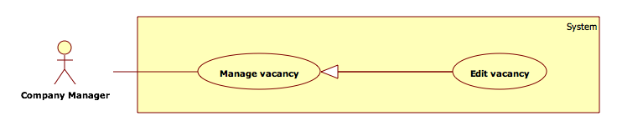

Figure 30: <Company manager> Edit vacancy

**Use Case Specification**

|  |  |  |  |
| --- | --- | --- | --- |
|  | | | |
| **Use Case No.** |  | **Use Case Version** | 1.0 |
| **Use Case Name** | <Company manager> Edit vacancy | | |
| **Author** | ThanhVM | | |
| **Date** | 1/12/2015 | **Priority** | Normal |
| **Actor:**   * Company manager   **Summary:**   * This use case allows Company manager to update vacancy in the system.   **Goal:**   * Vacancy will be updated to the system.   **Triggers:**   * User clicks "Chỉnh sửa tuyển dụng" button in "Quản lý tuyển dụng" menu.   **Preconditions:**   * User must login to the system with “Company manager” role. * At least one vacancy was created.   **Post Conditions:**   * **Success**: New information will be updated to the database. * **Fail**: Show error message on the current page.   **Main Success Scenario:**  Step Actor Action System Response  1 Click menu item “Quản lí tuyển dụng”.  2 Navigate to “Quản lí tuyển dụng” page with contains:   * “Đăng tuyển dụng”: button * A table with comlum: * Tiêu đề tuyển dụng. * Tên công ty. * Địa chỉ. * Giới thiệu công ty. * Mô tả công việc. * Yêu cầu công việc. * Thông tin liên hệ. * “Chỉnh sửa tuyển dụng”: button. * “Enable/Disable”: button.   3 Company manager clicks “Chỉnh sửa tuyển dụng” button.  4 Navigate to “Chỉnh sửa tuyển dụng” with contains:   * “Tiêu đề tuyển dụng”: textbox [10, 100] required. * “Tên công ty”: textbox [10, 50], required. * “Địa chỉ”: textbox [10, 100], required. * “Giới thiệu công ty”: textarea, required. * “Mô tả công việc”: textarea, required. * “Yêu cầu công việc”: textarea, required. * “Thông tin liên hệ”: textarea required. * “Chỉnh sửa”: button. * “Hủy bỏ”: button.   5 Company manager edits data to the form.  [Exception 1,2]    6 Company manager clicks “Chỉnh sửa tuyển dụng” button.  [Alternative 1]  7 Update new vacancy information to the database and show message success.  **Alternative Scenario:**  No Actor Action System Response  1 Company manager clicks “Hủy bỏ”. Navigate to “Quản lí tuyển dụng” page.   * “Đăng tuyển dụng”: button * A table with comlum: * Tiêu đề tuyển dụng. * Tên công ty. * Địa chỉ. * Giới thiệu công ty. * Mô tả công việc. * Yêu cầu công việc. * Thông tin liên hệ. * “Chỉnh sửa tuyển dụng”: button. * “Enable/Disable”: button.   **Exceptions:**  No Actor Action System Response  1 Information is not in range. Show message: “Thông tin có độ dài chính xác. Vui lòng nhập lại!”  4 Information is empty. Show message: “Vui lòng nhập đầy đủ thông tin”.  **Relationships:**   * N/A   **Business Rules:**   * Company manager can edit vacancy of their company. | | | |

###### <Company manager>Enable/Disable vacancy

**Use Case Diagram**

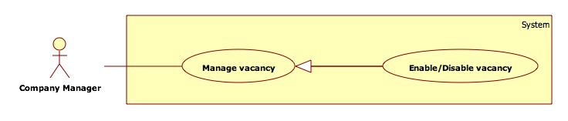

Figure 31: <Company manager> Enable/Disable vacancy

**Use Case Specification**

|  |  |  |  |
| --- | --- | --- | --- |
|  | | | |
| **Use Case No.** |  | **Use Case Version** | 1.0 |
| **Use Case Name** | <Company manager> Enable/Disable vacancy | | |
| **Author** | ThanhVM | | |
| **Date** | 1/12/2015 | **Priority** | Normal |
| **Actor:**   * Company manager   **Summary:**   * This use case allows Company manager to Enable/Disable vacancy in the system.   **Goal:**   * Enable/Disable vacancy will be updated to the system.   **Triggers:**   * User clicks "Enable/Disable" button in "Quản lý tuyển dụng" menu.   **Preconditions:**   * User must login to the system with “Company manager” role.   **Post Conditions:**   * **Success**: Enable/Disable vacancy in system. Show success message. Update information of “Enable” of vacancy table in database. * **Fail**: Show error message on the current page.   **Main Success Scenario:**  Step Actor Action System Response  1 Click menu item “Quản lí tuyển dụng”.  2 Navigate to “Quản lí tuyển dụng” page with contains:   * “Đăng tuyển dụng”: button. * A table with comlum: * Tiêu đề tuyển dụng. * Tên công ty. * Địa chỉ. * Giới thiệu công ty. * Mô tả công việc. * Yêu cầu công việc. * Thông tin liên hệ. * “Chỉnh sửa tuyển dụng”: button. * “Enable/Disable”: button.   3 Company manager chose vacancy wants to Enable/Disable.  4 Company manager clicks “Enable/Disable” button.  [Exception 1]   * 5 New information will be updated to the database. * 6 Reload page and change “Enable”/”Disable”: button to “Disable”/”Enable”: button. * Change “Trạng thái”:”Enable”/”Disable” to “Disable”/”Enable”.   **Alternative Scenario:**   * N/A   **Exceptions:**  No Actor Action System Response  1 Connection failed. Show error message.  **Relationships:**   * N/A   **Business Rules:**   * N/A | | | |

##### <Company manager>Manage staff

**Use Case Diagram**

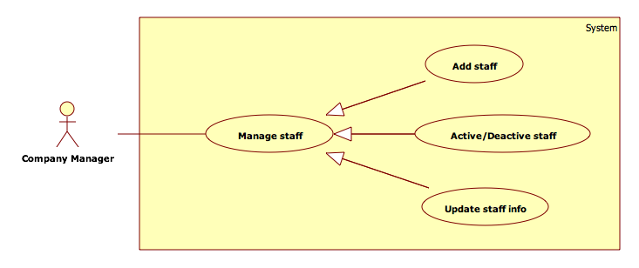

Figure 32: <Company manager>Manage staff

###### <Company manager>Add staff

**Use Case Diagram**

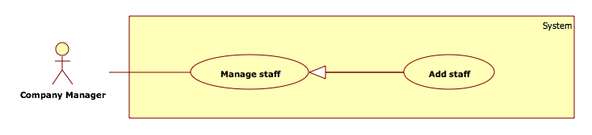

Figure 33: <Company manager>Add staff

**Use Case Specification**

|  |  |  |  |
| --- | --- | --- | --- |
|  | | | |
| **Use Case No.** |  | **Use Case Version** | 1.0 |
| **Use Case Name** | <Company manager> Add staff | | |
| **Author** | ThanhVM | | |
| **Date** | 1/12/2015 | **Priority** | Normal |
| **Actor:**   * Company manager   **Summary:**   * This use case allows company to add new staff in the system   **Goal:**   * New staff will be added to the system.   **Triggers:**   * User clicks "Thêm nhân viên" button in "Quản lí nhân viên" menu.   **Preconditions:**   * User must login the system with “Company manager” role.   **Post Conditions:**   * **Success**: New staff will be added to the database. * **Fail**: Show error message on the current page.   **Main Success Scenario:**  Step Actor Action System Response  1 Click menu item “Quản lí nhân viên”.  2 Navigate to “Quản lí nhân viên” page with contains:   * “Thêm nhân viên”: button * A table with: * Tên nhân viên. * Bộ phận. * Địa chỉ. * Thông tin nhân viên. * Số điện thoại. * Địa chỉ Email. * “Thay đổi thông tin”: button. * “Active/Deactive”: button.   3 Company manager clicks “Thêm nhân viên” button.  4 Navigate to “Thêm nhân viên” page with contains:   * “Tên nhân viên”: textbox [5, 40], required. * “Bộ phận”: textbox [5, 40], required. * “Địa chỉ”: textbox [5, 100], required. * “Thông tin nhân viên”: textarea, required. * “Số điện thoại”: textbox, required. * “Địa Chỉ Email”: textbox, required. * “Thêm nhân viên”: button. * “Đóng”: button.   5 Company manager fills data to the form.  6 Company manager clicks “Thêm nhân viên” button. [Alternative 1]  7 Insert new staff to the database and show message success. [Exception 1,2,3]  **Alternative Scenario:**  No Actor Action System Response  1 Company manager clicks “Đóng” button. Navigate to “Quản lí nhân viên” page with contains:   * “Thêm nhân viên”: button * A table with: * Tên nhân viên. * Bộ phận. * Địa chỉ. * Thông tin nhân viên. * Số điện thoại. * Địa chỉ Email. * “Thay đổi thông tin”: button. * “Active/Deactive”: button.   **Exceptions:**  No Actor Action System Response  1 Information is empty. Show message: “Vui lòng nhập thông tin”.  2 Information is not in range. Show message: “Thông tin có độ dài không chính xác. Vui lòng nhập lại!”  3 Invalid email format. Show error message: “Địa Chỉ Email phải đúng định dạng. Vui lòng nhập lại email!”  **Relationships:**   * N/A.   **Business Rules:**   * “Số điện thoại”: Company manager can fill some letter to note and limited 3 telephone number. * Email **:** : regular expression: /^[_a-z0-9-]+(\.[_a-z0-9-]+)*@@[a-z0-9-]+(\.[a-z0-9-]+)*(\.[a-z]{2,4})$/. * Only Company manager can create account. * When Company manager create staff. The account with Active state. | | | |

###### <Company manager>Update staff info

**Use Case Diagram**

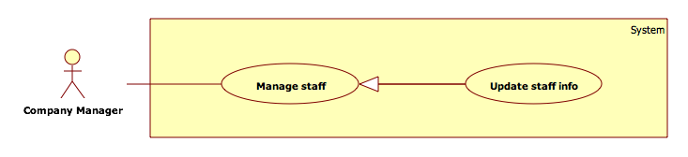

Figure 34: <Company manager> Update staff info

**Use Case Specification**

|  |  |  |  |
| --- | --- | --- | --- |
|  | | | |
| **Use Case No.** |  | **Use Case Version** | 1.0 |
| **Use Case Name** | <Company manager> Update staff info | | |
| **Author** | ThanhVM | | |
| **Date** | 1/12/2015 | **Priority** | Normal |
| **Actor:**   * Company manager.   **Summary:**   * This use case allows Company manager to update staff information in the system.   **Goal:**   * Staff information will be update to the system.   **Triggers:**   * User click "Thay đổi thông tin" button in "Quản lý nhân viên" menu.   **Preconditions:**   * User must login the system with Company manager role.   **Post Conditions:**   * **Success**: New information will be updated to the database. * **Fail**: Show error message on the current page.   **Main Success Scenario:**  Step Actor Action System Response  1 Click menu item “Quản lí nhân viên”.  2 Navigate to “Quản lí nhân viên” page with contains:   * “Thêm nhân viên” button * A table with: * Tên nhân viên. * Bộ phận. * Địa chỉ. * Thông tin nhân viên. * Số điện thoại. * Địa chỉ Email. * “Thay đổi thông tin”: button. * “Active/Deactive”: button.   3 Company manager clicks “Thay đổi thông tin” button.  4 Navigate to “Thay đổi thông tin” page with contains:   * “Tên nhân viên”: textbox [5, 40], required. * “Bộ phận”: textbox [5, 40], required. * “Địa chỉ”: textbox [5, 100], required. * “Thông tin nhân viên”: textarea, required. * “Số điện thoại”: textbox, required. * “Địa Chỉ Email”: textbox, required. * “Chỉnh sửa”: button. * “Đóng”: button.   5 Company manager change data to the form.  6 Company manager clicks “Chỉnh sửa” button. [Alternative 1]  7 Update new staff information to the database. [Exception 1,2,3,4,5,6]  **Alternative Scenario:**  No Actor Action System Response  1 Company manager clicks “Đóng” button. Navigate to “Quản lí nhân viên” page with contains:   * “Thêm nhân viên” button * A table with: * Tên nhân viên. * Bộ phận. * Địa chỉ. * Thông tin nhân viên. * Số điện thoại. * Địa chỉ Email. * “Thay đổi thông tin”: button. * “Active/Deactive”: button.   **Exceptions:**  No Actor Action System Response  1 Information is empty. Show message: “Vui lòng nhập thông tin”.  2 Information is not in range. Show message: “Thông tin có độ dài không chính xác. Vui lòng nhập lại!”  6 Invalid email format. Show error message: “Địa Chỉ Email phải đúng định dạng. Vui lòng nhập lại email!”  **Relationships:**   * N/A   **Business Rules:**   * “Số điện thoại”: Company manager can fill some letter to note and limited 3 telephone number. * Email **:** : regular expression: /^[_a-z0-9-]+(\.[_a-z0-9-]+)*@@[a-z0-9-]+(\.[a-z0-9-]+)*(\.[a-z]{2,4})$/. | | | |

###### <Company manager>Active/Deactive staff

**Use Case Diagram**

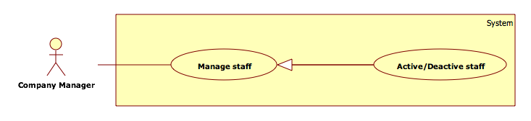

Figure 35: <Company manager>Active/Deactive staff

**Use Case Specification**

|  |  |  |  |
| --- | --- | --- | --- |
|  | | | |
| **Use Case No.** |  | **Use Case Version** | 1.0 |
| **Use Case Name** | <Company manager> Active/Deactive staff | | |
| **Author** | ThanhVM | | |
| **Date** | 1/12/2015 | **Priority** | Normal |
| **Actor:**   * Company manager   **Summary:**   * This use case allows Company manager to active/deactive staff in the system.   **Goal:**   * Active/deactive staff in the system.   **Triggers:**   * Company clicks: * “Quản lí nhân viên” menu bar. * Choose staff wants to active/deactive. * Click “Active/Deactive” icon button.   **Preconditions:**   * User must login the system with Company manager role. * At least 1 staff was created.   **Post Conditions:**   * **Success**: Active/Deactive staff in system. Show success message. Update new information of “Active” attribute of staff table in database. * **Fail**: Show error message on the current page.   **Main Success Scenario:**  Step Actor Action System Response  1 Click menu item “Quản lí nhân viên”.  2 Navigate to “Quản lí nhân viên” page with contains:   * “Thêm nhân viên” button * A table with: * Tên nhân viên. * Bộ phận. * Địa chỉ. * Thông tin nhân viên. * Số điện thoại. * Địa chỉ Email. * Thay đổi thông tin: button * Active/Deactive: button   3 Company manager chose vacancy wants to Active/Deactive.  4 Company manager clicks “Active/Deactive” icon button.  [Exception 1]  5   * New information will be updated to the database * Reload page and change “Active”/”Deactive”: icon button to “Deactive”/”Active” icon button. Change “Trạng thái”:”Active”/”Deactive” to “Deactive”/”Active”.   **Alternative Scenario: N/A**  **Exceptions: N/A**  No Actor Action System Response  1 Error while active/deactive. Show error message.  **Relationships:**   * N/A   **Business Rules:**   * After create success, staff is Active state. * Company manager can change state their staff. * Company manager can not change state company manager. | | | |

##### <Company manager>Manage interview

**Use Case Diagram**

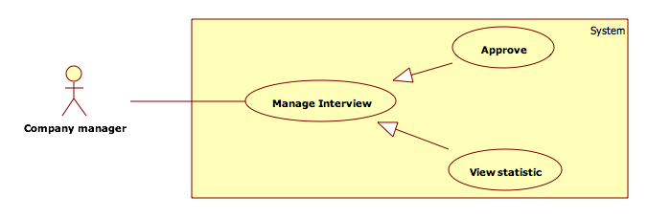

Figure 36: <Company manager> Manage interview

###### <Company manager>Approve

**Use Case Specification**

|  |  |  |  |
| --- | --- | --- | --- |
|  | | | |
| **Use Case No.** |  | **Use Case Version** | 1.0 |
| **Use Case Name** | <Company manager>Approve | | |
| **Author** | ThanhVM | | |
| **Date** | 1/12/2015 | **Priority** | Normal |
| **Actor:**   * Company manager   **Summary:**   * Company manager wants to approve student pass interview.   **Goal:**   * Approve student pass interview.   **Triggers:**   * Company manager click “Xác nhận phỏng vấn” in “Quản lí phỏng vấn” menu.   **Preconditions:**   * Sign in with “Company manager” role in the system.   **Post Conditions:**   * **Success**: Approve student pass interview success. * **Fail**: show error in the current page.   **Main Success Scenario:**  Step Actor Action System Response  1 Company manager clicks “Quản lí phỏng vấn” in menu bar.  [Exception 1]  2 Show sub menu which includes:   * “Xác nhận phỏng vấn”: link. * “Tạo phỏng vấn”: link. * “Chỉnh sửa phỏng vấn”: link. * “Thêm ghi âm phỏng vấn”: link. * “Xem thống kê”: link.   3 Company manager clicks “Xác nhận phỏng vấn” link.  4 Show “Xác nhận phỏng vấn” page which includes:   * “Tìm kiếm”: textbox [0, 100]. * “Tìm người phỏng vấn”: button. * Drop down list: * Người đã tham gia phỏng vấn. * Chưa chưa được phỏng vấn. * Người đã đậu phỏng vấn. * Người đã rớt phỏng vấn. * Tất cả người tham gia. * Table with column: * “Tên sinh viên”: label. * “Hồ sơ”: link. * “Chuyên nghành”: label. * “Địa chỉ”: label. * “Thời gian phỏng vấn”: label. * “Xác nhận đậu”: button. * “Xác nhận rớt”: button.   5 Company manager choose student wants to “Xác nhận đậu” button.  6 Staff click “Xác nhận đậu” button. [Alternative 1]   * 7 New information will be updated to the database and show message success. * 8 Change status “Đang Chờ xác nhận” to “Đã đậu phỏng vấn”.   **Alternative Scenario:**  No Actor Action System Response  1 Company manager click “Xác nhận rớt” button. Change status “Đang Chờ xác nhận” to “Đã rớt phỏng vấn”.  **Exceptions:**  No Actor Action System Response  1 Connection is failed. Show error message.  **Relationships:**   * N/A   **Business Rules:**   * Approve student will be join interview. * Table show student will be join interview and staff do not approve. * Chose element in drop down list to change information of table. * Only company manager can change state approved by company manager | | | |

###### <Company manager>View statistic

**Use Case Diagram**

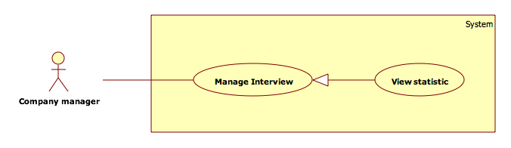

Figure 37: <Company manager>View statistic

**Use Case Specification**

|  |  |  |  |
| --- | --- | --- | --- |
|  | | | |
| **Use Case No.** |  | **Use Case Version** | 1.0 |
| **Use Case Name** | <Company manager>View statistic | | |
| **Author** | ThanhVM | | |
| **Date** | 1/12/2015 | **Priority** | Normal |
| **Actor:**   * Company manager.   **Summary:**   * Company manager wants to view statistic of interview.   **Goal:**   * View statistic of interview.   **Triggers:**   * Company manager click “Xem thống kê” in “Quản lí phỏng vấn” menu.   **Preconditions:**   * Sign in with “Company manager” role in the system.   **Post Conditions:**   * **Success**: Show statistic of interview. * **Fail**: show error in the current page.   **Main Success Scenario:**  Step Actor Action System Response  1 Company manager clicks “Quản lí phỏng vấn” in menu bar.  [Exception 1]  2 Show sub menu which includes:   * “Xác nhận phỏng vấn”: link. * “Tạo phỏng vấn”: link. * “Chỉnh sửa phỏng vấn”: link. * “Thêm ghi âm phỏng vấn”: link. * “Xem thống kê”: link.   3 Company manager clicks “Xem thống kê” link.  4 Show “Xem thống kê” page which includes:   * “Tổng số người gữi”: label. * “Số người đậu”: label. * “Số người rớt”: label. * “Số người chưa phỏng vấn”: label. * Pie chart. * “Thống kê”: button. * “Xuất PDF”: button.   5 Company manager clicks “Thống kê” button.  6 Reload page and show statistic view.  **Alternative Scenario:**  No Actor Action System Response  1 Company manager clicks “Xuất PDF” button. Website will be printed report PDF file.  **Exceptions:**  No Actor Action System Response  1 Connection failed. Show error message.  **Relationships:**   * N/A   **Business Rules:**   * Staff can view statistic in their company. * PDF file with report format. | | | |

##### <Company Manager> Manage Thread

**Use Case Diagram**

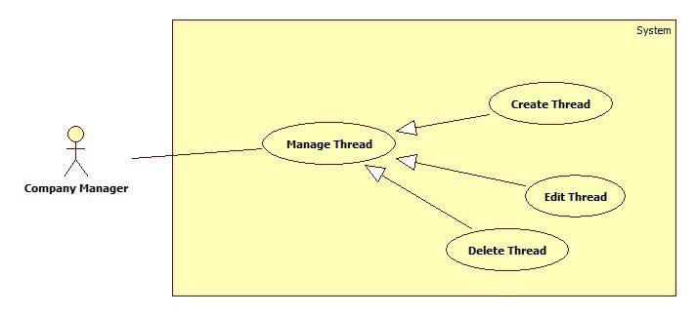

Figure 38: <Company Manager>Manage Thread

###### <Company Manager>Create Thread

**Use Case Diagram**

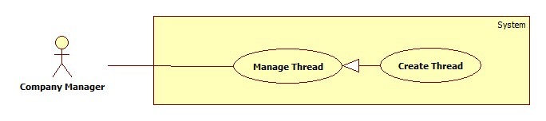

Figure 39: <Company Manager> Create Thread

**Use Case Specification**

|  |  |  |  |
| --- | --- | --- | --- |
|  | | | |
| **Use Case No.** |  | **Use Case Version** | 1.0 |
| **Use Case Name** | <Company Manager> Create Thread | | |
| **Author** | HongNT | | |
| **Date** | 1/16/2015 | **Priority** | Normal |
| **Actor:**   * Company Manager   **Summary:**   * This use case allows a company manager to create information for thread in the system.   **Goal:**   * New information will be created to the database.   **Triggers:**   * User wants to create new thread. * To input thread manually, User must do the following steps:   + Click “Quản lý bản tin” in the menu.   + Click “Đăng bản tin” button.   **Preconditions:**   * User must login to the system with “Company Manager” role.   **Post Conditions:**   * **Success**: New information will be created to the database. * **Fail**: Show error message on the current page.   **Main Success Scenario:**  Step Actor Action System Response  1 Click menu item “Quản lí bản tin”.  2 Navigate to “Quản lí bản tin” page with contains:   * Đăng bản tin: button. * A table with comlum: * Tiêu đề bản tin: label. * Tên công ty: label. * Nội Dung: label. * Event Tham gia: label. * Hoạt Động: label. * Date: label. * Chỉnh sửa bản tin: button. * Xóa Bản Tin: button.   3 Company Manager clicks “Đăng bản tin” button.  4 Navigate to “Đăng bản tin” with contains:   * Tiêu đề bản tin: textbox, min length 10, max length 100, required. * Tên công ty: textbox, min length 10, max length 100, required. * Nội Dung: textarea, required. * Event tham gia: dropdown list required. * Đăng bản tin: button. * Hủy bỏ: button.   5 Company Manager clicks “Đăng bản tin” button.  [Alternative 1]  6 Save new data to the database. Redirect to “Quản lý Bản Tin” page.  [Exception 1, 2]  **Alternative Scenario:**  No Actor Action System Response  1 Company Manager clicks “Hủy bỏ”. Navigate to “Quản lí bản tin” page.  **Exceptions:**  No Actor Action System Response  1 Information is not in range. Show message: “Thông tin có độ dài chính xác. Vui lòng nhập lại!”  2 Information is empty. Show message: “Vui lòng nhập đầy đủ thông tin”.  **Relationships:**   * N/A   **Business Rules:**   * User clicks “Đăng bản tin” button. * This thread will be created information in database. | | | |

###### <Company Manager>Edit Thread

**Use Case Diagram**

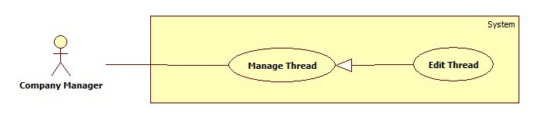

Figure 40: <Company Manager> Edit Thread

**Use Case Specification**

|  |  |  |  |
| --- | --- | --- | --- |
|  | | | |
| **Use Case No.** |  | **Use Case Version** | 1.0 |
| **Use Case Name** | <Company Manager> Edit Thread | | |
| **Author** | HongNT | | |
| **Date** | 1/16/2015 | **Priority** | Normal |
| **Actor:**   * Company Manager   **Summary:**   * This use case allows a company manager to update information for thread in the system.   **Goal:**   * New information will be updated to the database.   **Triggers:**   * User wants to change some information.   **Preconditions:**   * User must login to the system with “Company Manager” role. * There is at least 1 thread which is created before.   **Post Conditions:**   * **Success**: New information will be updated to the database. * **Fail**: Show error message on the current page.   **Main Success Scenario:**  Step Actor Action System Response  1 Click menu item “Quản lí bản tin”.  2 Navigate to “Quản lí bản tin” page with contains:   * Đăng bản tin: button * A table with comlum: * Tiêu đề bản tin: label. * Tên công ty: label. * Nội Dung: label. * Event Tham gia: label. * Hoạt Động: label. * Date: label. * Chỉnh sửa bản tin: button. * Xóa Bản Tin: button.   3 Company Manager clicks “Chỉnh sửa bản tin” button.  4 Navigate to “Chỉnh sửa bản tin” with contains:   * Tiêu đề bản tin: textbox, min length 10, max length 100, required. * Tên công ty: textbox, min length 10, max length 100, required. * Nội Dung: textarea, required. * Event tham gia: dropdown list required. * Chỉnh sửa: button. * Hủy bỏ: button.   5 Company Manager clicks “Chỉnh sửa” button.  [Alternative 1]  6 Save new data to the database. Redirect to “Quản lý Bản Tin” page.  [Exception 1, 2,3]  **Alternative Scenario:**  No Actor Action System Response  1 Company Manager clicks “Hủy bỏ” Navigate to “Quản lí bản tin” page.  **Exceptions:**  No Actor Action System Response  1 Information is not in range. Show message: “Thông tin có độ dài chính xác. Vui lòng nhập lại!”  2 Information is empty. Show message: “Vui lòng nhập đầy đủ thông tin”.  **Relationships:**   * N/A   **Business Rules:**   * The old information will be loaded in the page. * User clicks “cập nhật” button. * This thread will be updated information in database. | | | |

###### <Company Manager>Delete Thread

**Use Case Diagram**

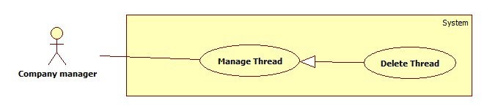

Figure 41: <Company Manager> Delete Thread

**Use Case Specification**

|  |  |  |  |
| --- | --- | --- | --- |
|  | | | |
| **Use Case No.** |  | **Use Case Version** | 1.0 |
| **Use Case Name** | <Company Manager> Delete Thread | | |
| **Author** | HongNT | | |
| **Date** | 1/16/2015 | **Priority** | Normal |
| **Actor:**   * Company Manager   **Summary:**   * This use case allows a company manager to delete information for thread in the system.   **Goal:**   * New information will be deleted to the database.   **Triggers:**   * User wants to delete new thread. * To input thread manually ,User must do the following steps:   + Click “Quản lý bản tin” in the menu.   + Click “Xóa bản tin” button.   **Preconditions:**   * User must login to the system with “Company Manager” role.   **Post Conditions:**   * **Success**: recent information will be deleted to the database. * **Fail**: Show error message on the current page.   **Main Success Scenario:**  Step Actor Action System Response  1 Click menu item “Quản lí bản tin”.  2 Navigate to “Quản lí bản tin” page with contains:   * Xóa bản tin: button * A table with comlum: * Tiêu đề bản tin: label. * Tên công ty: label. * Nội Dung: label. * Event Tham gia: label. * Hoạt Động: label. * Date: label. * Chỉnh sửa bản tin: button. * Xóa Bản Tin: button.   3 Company Manager clicks “Xóa bản tin” button.  4 Navigate to “Xóa bản tin” with contains:   * Hoạt Động: label. * Xóa bản tin: button. * Hủy bỏ: button.   5 Company Manager clicks “Xóa bản tin” button.  [Alternative 1]  7 Delete data to the database. Redirect to “Quản lý Bản Tin” page.  [Exception 1, 2]  **Alternative Scenario:**  No Actor Action System Response  1 Company Manager clicks “Hủy bỏ” Navigate to “Quản lí bản tin” page.  **Exceptions:**  No Actor Action System Response  1 Cannot delete thread due to database connection problem. Show error message.  **Relationships:**   * N/A   **Business Rules:**   * User clicks “Xóa bản tin” button. * This thread will be Deleted information in database. | | | |

##### <Company Manager>Register Event

**Use Case Diagram**

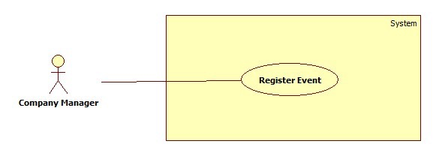

Figure 42: <Company Manager> Register Event

**Use Case Specification**

|  |  |  |  |
| --- | --- | --- | --- |
|  | | | |
| **Use Case No.** |  | **Use Case Version** | 1.0 |
| **Use Case Name** | <Company Manager> Register Event | | |
| **Author** | HongNT | | |
| **Date** | 1/16/2015 | **Priority** | Normal |
| **Actor:**   * Company Manager   **Summary:**   * This use case allows a company manager to register for event in the system.   **Goal:**   * New information will be save to the database.   **Triggers** :   * User wants to register new event.   **Preconditions:**   * User must login to the system with “Company Manager” role.   **Post Conditions:**   * **Success**: New information will be registered to the database. * **Fail**: Show error message on the current page.   **Main Success Scenario:**  Step Actor Action System Response  1 Click “Đăng kí Sự kiện” button.    2 Checking user’s profile that is existed. [Alternative 1]  Navigate to “Đăng kí Sự kiện” page which contains:   * “Thông Tin Công Ty”: panel.   Including information:   * “Email”: label. * “Tên Công ty”: label. * “Điện thoại”: label. * “Địa chỉ”: label. * “Thông Tin Sự kiện”: panel.   Including information:   * “Sự kiện”: Dropdown list * “Chủ đề”: label. * “Ngày Tổ chức”: label.   “Đăng kí Sự kiện” button. [Exceptions1]  “Thoát” button.  3 Company Manager clicks “Đăng kí sự kiện” button.  [Alternative 1]  4 Save new data to the database. Redirect to “Sự kiện ” page.[Exception 1]  **Alternative Scenario:**  No Actor Action System Response  1 Company Manager clicks “Hủy bỏ” Navigate to “Sự kiện” page.  **Exceptions:**  No Actor Action System Response  1 Cannot register event due to database connection problem. Show message.  **Relationships:**   * N/A   **Business Rules:**   * User clicks “Đăng kí sự kiện” button. * Company manager will be registered information in database. | | | |

##### < Company Manager >Manage QR Code

**Use Case Diagram**

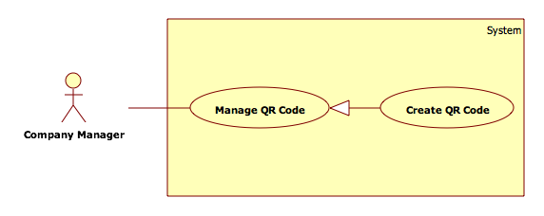

Figure 43: <Company Manager>Manage QR Code

###### <Administrator>Create QR Code

**Use Case Diagram**



Figure 44: <Administrator>Create QR Code

**Use Case Specification**

|  |  |  |  |
| --- | --- | --- | --- |
|  | | | |
| **Use Case No.** |  | **Use Case Version** | 1.0 |
| **Use Case Name** | <Company Manager>Manage QR Code | | |
| **Author** | ChungNC | | |
| **Date** | 1/12/2015 | **Priority** | Normal |
| **Actor:**   * Company manager.   **Summary:**   * This use case allows administrator can create a QR code.   **Goal:**   * Company manager can create a QR code.   **Triggers:**   * Company manager clicks “Tạo QR Code” button.   **Preconditions:**   * Login as company canager.   **Post Conditions:**   * **Success:** Company manager will create a QR Code successful. * **Fail:** Return Quản lý QR Code page with message the QR code won’t be created.   **Main Success Scenario:**  Step Actor Action System Response  Company manager clicks “Tạo QR Code” button.  Tạo QR Code page, show QR code in form with following information:   * “URL”: textbox[4000] required * “Tạo”: button * “Huỷ”: button   Company manager inputs information.  [Alternative 1]  [Exception 1]  Show create new QR code successful message.  **Alternative Scenario:**  No Actor Action System Response  [If company manager clicks “Huỷ” button.]  Show the QR Code won’t be created message.  **Exceptions:**  No Actor Action System Response  [If company manager do not fill in any information required.]  Show warning at which information are not filled.  **Relationships:**   * N/A   **Business Rules:**   * N/A | | | |

#### <Student>Overview Use Case

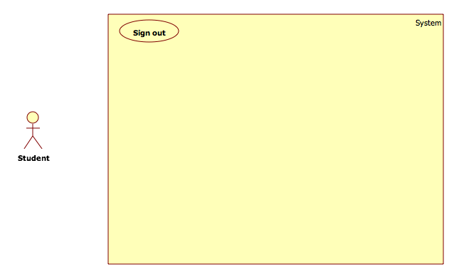

Figure 45: <Staff>Overview Use Case

##### <Student>Manage Resume

**Use Case Diagram**

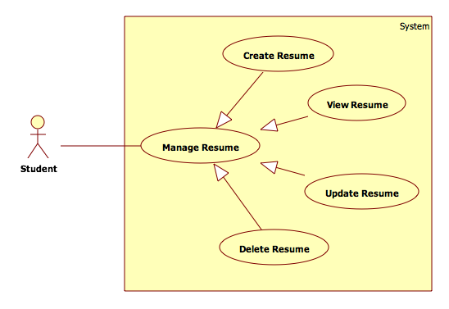

Figure 46: <Student>Create Resume

###### <Student>Create Resume

**Use Case Diagram**

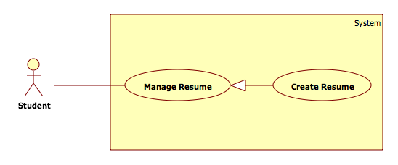

Figure 47: <Student>Create Resume

**Use Case Specification**

|  |  |  |  |
| --- | --- | --- | --- |
|  | | | |
| **Use Case No.** |  | **Use Case Version** | 1.0 |
| **Use Case Name** | <Student>Create Resume | | |
| **Author** | ChungNC | | |
| **Date** | 1/12/2015 | **Priority** | Normal |
| **Actor:**   * Student   **Summary:**   * This use case allows student can create a resume.   **Goal:**   * Student can create a resume.   **Triggers:**   * Student clicks “Đăng ký” button.   **Preconditions:**   * Login as student.   **Post Conditions:**   * **Success:** Student will create a resume successful. * **Fail:** Return Quản lý hồ sơ page with message the resume won’t be created.   **Main Success Scenario:**  Step Actor Action System Response  Student clicks “Đăng ký” button.  Đăng ký page, show resume in form with following information:   * “Kỹ năng”: textbox[250] required * “Ngoại ngữ”: textbox[250] required * “Vị trí tuyển dụng”: textbox[50] required * “Tạo”: button. * “Huỷ”: button.   Administrator inputs information.  [Alternative 1]  [Exception 1]  Show create new event successful message.  **Alternative Scenario:**  No Actor Action System Response  [If student clicks “Huỷ” button.]  Show the resume won’t be created message.  **Exceptions:**  No Actor Action System Response  [If student do not fill in any information required.]  Show warning at which information are not filled.  **Relationships:**   * N/A   **Business Rules:**   * N/A | | | |

###### <Student>Update Resume

**Use Case Diagram**

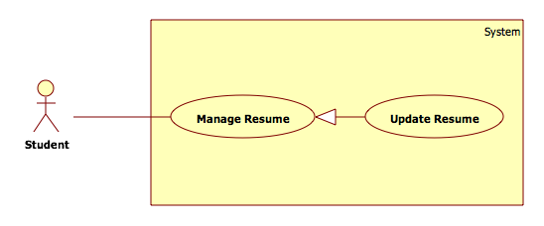

Figure 48: <Student>Update Resume

**Use Case Specification**

|  |  |  |  |
| --- | --- | --- | --- |
|  | | | |
| **Use Case No.** |  | **Use Case Version** | 1.0 |
| **Use Case Name** | <Student> Update Resume | | |
| **Author** | ChungNC | | |
| **Date** | 1/12/2015 | **Priority** | Normal |
| **Actor:**   * Student   **Summary:**   * This use case allows student can update a resume.   **Goal:**   * Student can update a resume.   **Triggers:**   * Student clicks “Chỉnh sửa” button.   **Preconditions:**   * Login as student.   **Post Conditions:**   * **Success:** Student will update a resume successful. * **Fail:** Return Quản lý hồ sơ page with message the resume won’t be updated.   **Main Success Scenario:**  Step Actor Action System Response  Student clicks “Chỉnh sửa” button.  Chỉnh sửa page, show resume in form with following information:   * “Kỹ năng”: textbox[250] required * “Ngoại ngữ”: textbox[250] required * “Vị trí tuyển dụng”: textbox[50] required * “Sửa”: button. * “Huỷ”: button.   Administrator inputs information.  [Alternative 1]  [Exception 1]  Show create new event successful message.  **Alternative Scenario:**  No Actor Action System Response  [If student click “Huỷ” button.]  Show the resume won’t be updated message.  **Exceptions:**  No Actor Action System Response  [If student do not fill in any information required.]  Show warning at which information are not filled.  **Relationships:**   * N/A   **Business Rules:**   * In update resume form, show old information which resume will update. | | | |

###### <Student>Delete Resume

**Use Case Diagram**

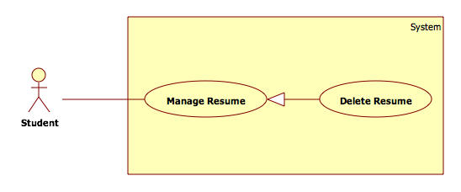

Figure 49: <Student>Delete Resume

**Use Case Specification**

|  |  |  |  |
| --- | --- | --- | --- |
|  | | | |
| **Use Case No.** |  | **Use Case Version** | 1.0 |
| **Use Case Name** | <Student>Delete Resume | | |
| **Author** | ChungNC | | |
| **Date** | 1/12/2015 | **Priority** | Normal |
| **Actor:**   * Student   **Summary:**   * This use case allows student can delete a resume.   **Goal:**   * Student can delete a resume.   **Triggers:**   * Student clicks “Xoá” button.   **Preconditions:**   * Login as student.   **Post Conditions:**   * **Success:** Student will delete a resume successful. * **Fail:** Return Quản lý hồ sơ page with message the resume won’t be deleted.   **Main Success Scenario:**  Step Actor Action System Response  Student click “Delete” button.  Show a delete resume box with following information:   * “Tiếp tục”: button. * “Huỷ”: button.   [Alternative 1]  Show deleted a resume successful message.  **Alternative Scenario:**  No Actor Action System Response  [If student click “Huỷ” button.]  Show message The resume won’t be deleted.  **Exceptions:**   * N/A   **Relationships:**   * N/A   **Business Rules:**   * In delete resume box, which resume will be set attribute active to off and do not delete this resume. | | | |

##### <Student>Search vacancy

**Use Case Diagram**

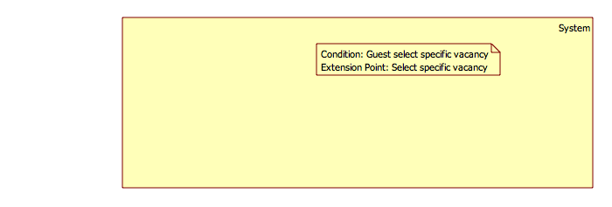

Figure 50: <Student>Search vacancy

**Use Case Specification**

|  |  |  |  |
| --- | --- | --- | --- |
|  | | | |
| **Use Case No.** |  | **Use Case Version** | 1.0 |
| **Use Case Name** | <Student>Search vacancy | | |
| **Author** | ThanhVM | | |
| **Date** | 1/12/2015 | **Priority** | Normal |
| **Actor:**   * Student   **Summary:**   * This use case allow student to search vacancy.   **Goal:**   * Find information is shown to student.   **Triggers:**   * Student clicks “Tìm” in “Tìm kiếm tuyển dụng” page to search information vacancy.   **Preconditions:**   * N/A   **Post Conditions:**   * **Success**: searching information is shown to student. * **Fail**: Show error message and require guest to try one more time.   **Main Success Scenario:**  Step Actor Action System Response  1 Student input their searching information into “Tìm kiếm” text box.  2 Choose “Nghành nghề” combobox.  3 Choose “Địa điểm” combobox.  4 Click “Tìm” button [Exception 1]  5 The page will be shown:   * “Tìm kiếm”: textbox. * “Nghành nghề”: combobox. * “Địa điểm”: combobox. * “Tìm”: button. * A table with column: * “Ứng viên”. * “Kinh nghiệm”. * “Lương”. * “Nơi làm việc”. * “Ngày đăng hồ sơ”.   **Alternative Scenario:**   * N/A   **Exceptions:**  No Actor Action System Response  1 User does not input search information. Show error message “Bạn không được để trống ô tìm kiếm”.  **Relationships: N/A**  **Business Rules: N/A** | | | |

##### <Student>Attempt Event

**Use Case Diagram**

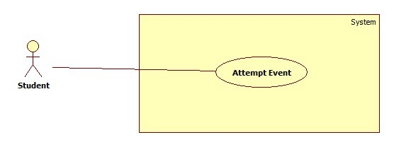

Figure 51: <Student> Attempt Event

**Use Case Specification**

|  |  |  |  |
| --- | --- | --- | --- |
|  | | | |
| **Use Case No.** |  | **Use Case Version** | 1.0 |
| **Use Case Name** | <Student> Attempt Event | | |
| **Author** | HongNT | | |
| **Date** | 1/16/2015 | **Priority** | Normal |
| **Actor:**   * Student   **Summary:**   * This use case allows a Student to Attempt for event in the system.   **Goal:**   * New information will be saved to the database.   **Triggers** :   * User wants to Attempt new event.   **Preconditions:**   * User must login to the system with “Student” role.   **Post Conditions:**   * **Success**: New information will be attempted to the database. * **Fail**: Show error message on the current page.   **Main Success Scenario:**  Step Actor Action System Response  1 Click “Tham gia sự kiện” button.    2 Checking user’s profile that is existed. [Alternative 1]  Navigate to “Tham gia sự kiện” page which contains:   * “Thông Tin Sự kiện”: panel.   Including information:   * “Sự kiện”: Dropdown list. * “Chủ đề”: label. * “Ngày Tổ chức”: label.   “Tham gia Sự kiện” button. [Exceptions1]  “Thoát” button.  3 Student clicks “Tham gia sự kiện” button.  [Alternative 1]  4 Save new data to the database. Redirect to “Sự kiện” page.  [Exception 1]  **Alternative Scenario:**  No Actor Action System Response  1 Student clicks “Hủy bỏ”. Navigate to “Sự kiện” page.  **Exceptions:**  No Actor Action System Response  1 Cannot Attempt event due to database connection problem. Show message.  **Relationships:**   * N/A   **Business Rules:**   * User clicks “Tham gia sự kiện” button. * Student will be attempted information in database. | | | |

#### <System>Overview Use Case

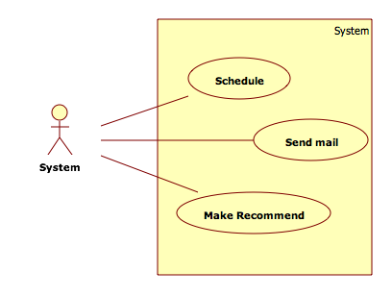

Figure 52: <Staff>Overview Use Case

## Software System Attribute

### Usability

#### Graphic User Interface

* All the texts, label and should be written in Vietnamese

#### Usability

* Admin, company manager, staff, student should need less than one week of training to be productive with the system.
* Guest can use the system easily without training

#### Installation

* The system must be easy to deploy. Customer can deploy successfully and learn to configure, maintain the system within one day of training.
* The attached manual guide must be clear. User can read and do themselves without developer’s help.

### Reliability

* N/A

### Availability

* N/A

### Security

* Privacy: Each role of user has a specific permission to interact with system.
* System always checks authorization and authenticated before doing anything.
* Only admin can grant permission to other roles.
* User password will be encrypted byMD5 2 times.

### Maintainability

* The system is divided into separated modules.
* The code is easy to maintain and upgrade

### Portability

* Any device that running Android OS can install this application easily via Play Store.

### Performance

* System build menu suggestion should be less than 20s.

## Conceptual Class Diagram

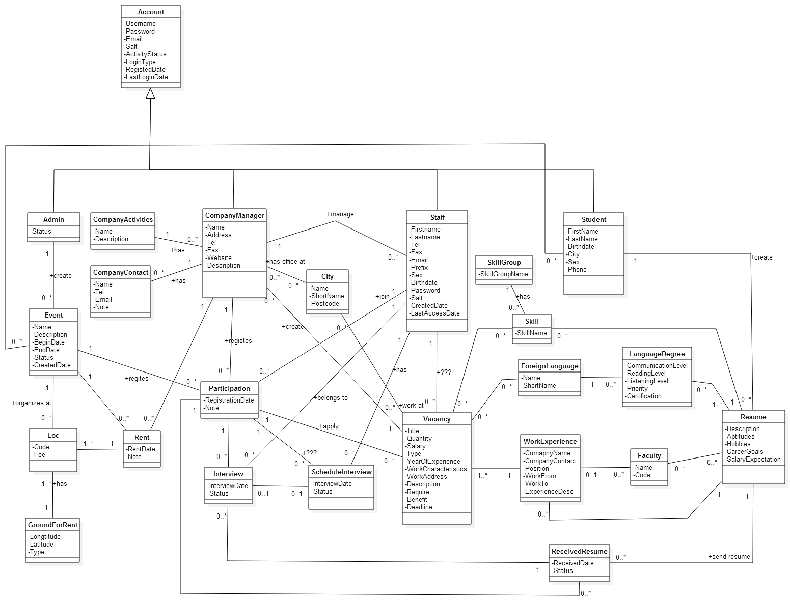

Figure 53: Conceptual Class Diagram

Data Dictionary

|  |  |
| --- | --- |
| **Entity Data dictionary: describe content of all entities** | |
| **Entity Name** | **Description** |
| Admin | Describe authenticated users have role admin, who manage the account in the system. |
| Event | Describe all event in the system |
| Loc | Describe all location of event |
| GroundForRent | Describe all ground for rent |
| Rent | Describe all fee for rent |
| CompanyContact | Describe all company information |
| CompanyActivities | Describe all activities of company |
| Account | Describe all accounts in the system |
| CompanyManager | Describe all manager in company |
| Participation | Describe all company join event |
| City | Describe all city into location of company |
| ScheduleInterview | Describe all schedule of interview |
| Staff | Describe authenticated users have role staff, who manage the system. |
| Vacancy | Describe all vacancy of company |
| SkillGroup | Describe all group of skill |
| Skill | Describe all skill of student |
| ForeinLanguage | Describe all forein language |
| WorkExperience | Describe all experience for work of student |
| Student | Describe authenticated users have role student, who join event to find jobs. |
| RecievedResume | Describe all resume received by company |
| Student | Describe all customer |
| LanguageDegree | Describe all degree of language |
| Faculty | Describe all faculty |
| Resume | Describe all resume of student |