**Arizona State University  
IFT458**

M7A1

**Student**

Chih-Chieh Chang

**Professor**

Dinesh Sthapit

November 12, 2022

* Login.html (live server)

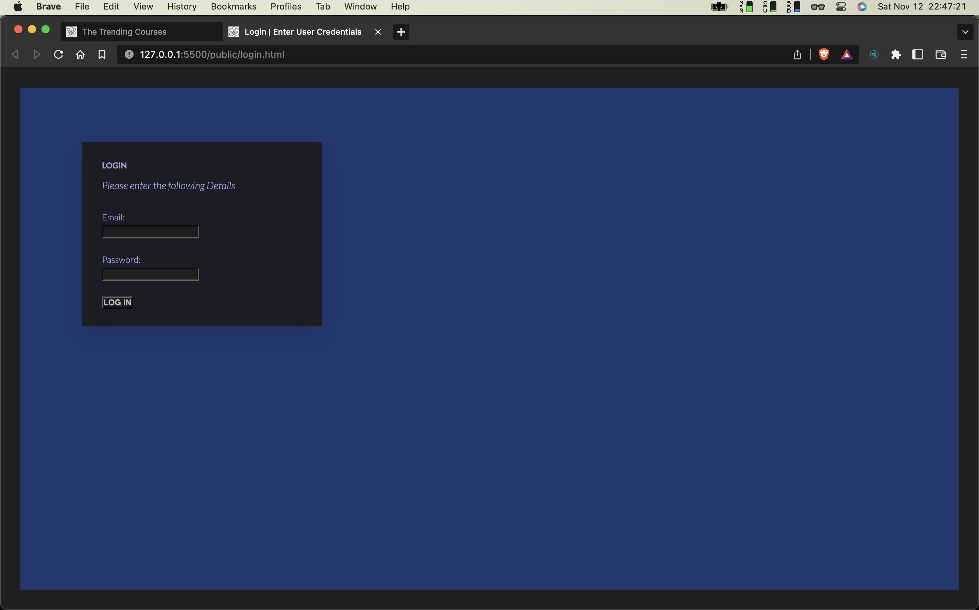

* Login.html

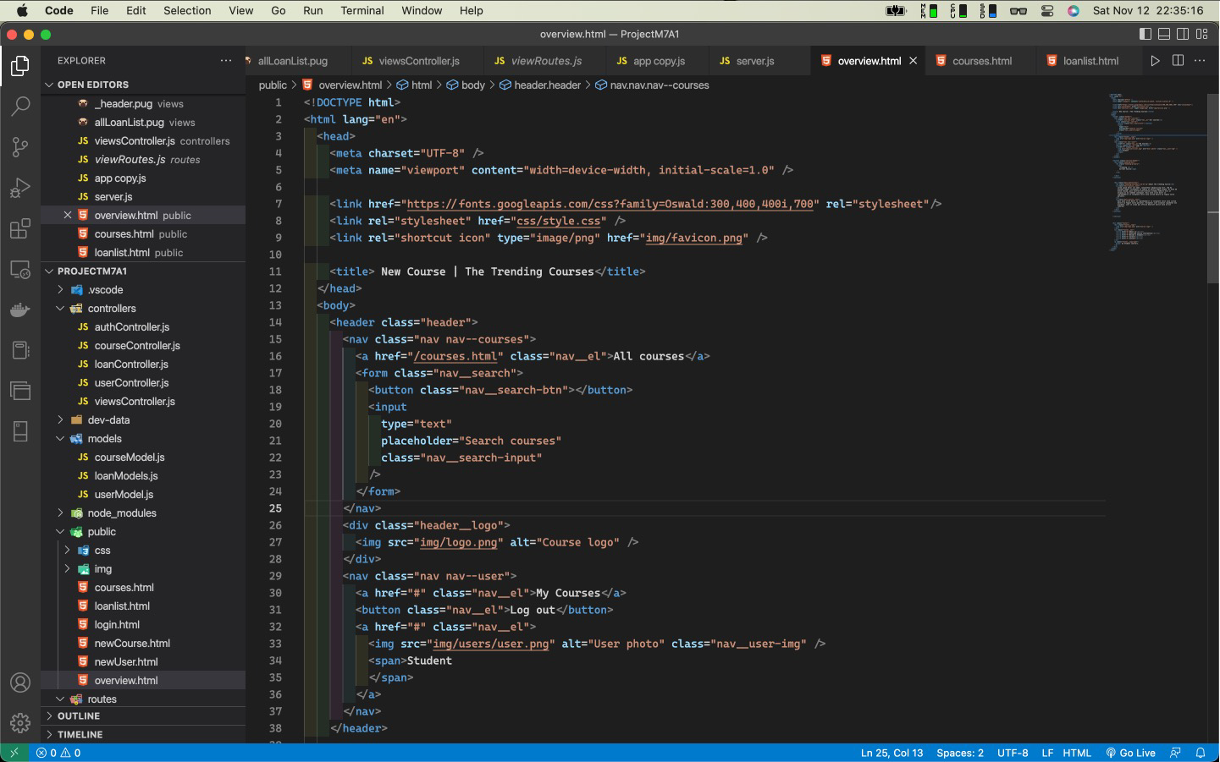

* Login.html (pug engine)

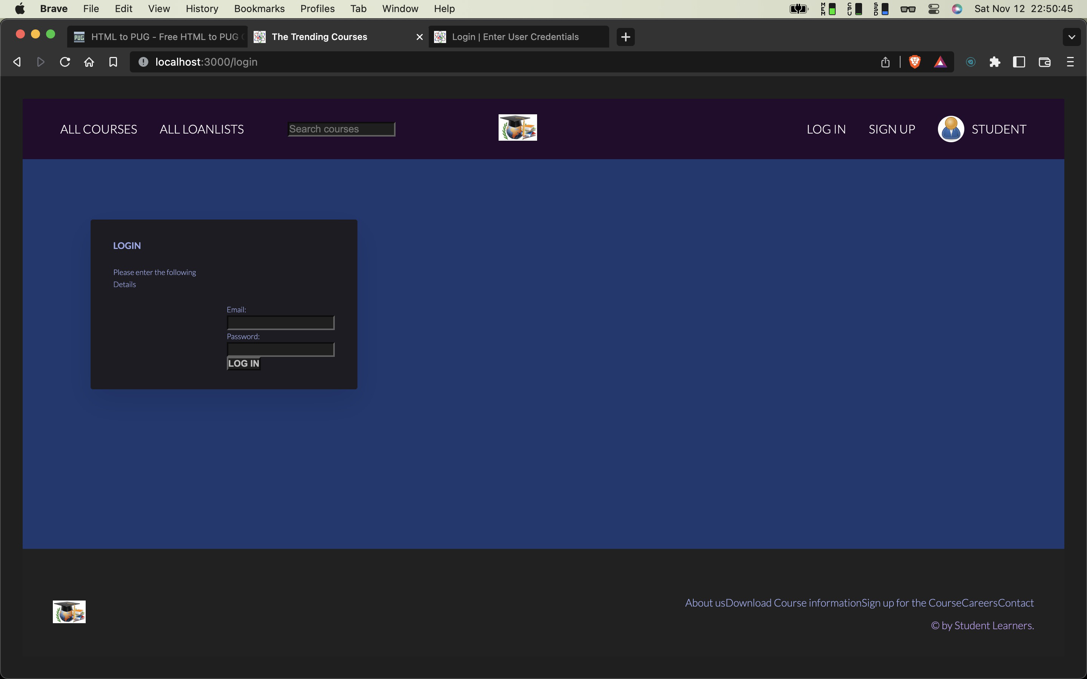

* Login.pug

