Sample Answer for SWE202c

I. CASE STUDY
Green University is a mid-sized institution with approximately 8,000 students and 400 academic staff. Each semester, the university must manage course enrollment for all undergraduate and postgraduate programmers. Currently, students submit paper-based registration forms to their faculty office, and clerks manually enter the data into spreadsheets. This process is error-prone, slow, and creates long queues during the registration window. The university's administration has therefore decided to commission a web-based Course Registration System (CRS) to automate and streamline the entire workflow.
The CRS is expected to serve four main groups of users. Students need to browse the catalogue of available courses, check their eligibility based on completed prerequisites, submit registration requests, and track the status of each request in real time. If a course is fully booked, a student may join an electronic waitlist; should a registered student later drop the course, the system automatically notifies and enrolls the first eligible student on the waitlist. Lecturers need to review the roster of students enrolled in their courses, record midterm and final grades, and release grades to students once the grading period closes. Academic Staff (administrators) are responsible for defining the semester timetable, setting and publishing course quotas, opening and closing the registration window, approving exceptional cases, and generating enrolment and grade-distribution reports. Finally, a System Administrator manages user accounts, configures system parameters, and oversees scheduled data backups.
From a technical standpoint, the university imposes several constraints. The system must remain responsive—handling at least 1,000 simultaneous users during peak registration periods with a page response time under 3 seconds. Because student records and grade data are sensitive, all communication must be encrypted using TLS 1.2 or higher, and access must be governed by a role based access control (RBAC) model so that each user sees only the functions and data relevant to their role. The platform must be available 99.5 % of the time during the semester, with any planned maintenance scheduled outside the registration window. The interface must be accessible on both desktop and mobile browsers and must conform to WCAG 2.1 Level AA accessibility standards. The architecture should also support horizontal scaling so that additional server capacity can be added smoothly as student numbers grow in future years.

II. QUESTION
Answer ALL questions. Base your answers on the Course Registration System case study above. Where diagrams are required, use standard UML notation and label all elements clearly.

Question 1: Software Development Model (2.0 points)
1. Identify and justify the most appropriate software development model (SDLC) for the CRS project. In your justification, address each of the following points: (1.0 points)
- Whether requirements are fully known and stable at the outset
- The need for iterative delivery and regular stakeholder feedback
- Risk factors specific to the CRS (e.g., concurrent-user load, data security)
- Team size, project duration, and the university's change-control process
2. Select ONE alternative SDLC model and compare it with your chosen model in the context of the CRS. Your comparison must include at least two advantages and two disadvantages for each model. (1.0 points)
Giải thích:
- Dấu hiệu chọn mô hình:
  - Đề bài nhắc đến việc cần "iterative delivery" (bàn giao từng phần) và "stakeholder feedback" (phản hồi từ các bên).
→ Đây là đặc trưng của mô hình Agile (Scrum).
  - Hệ thống có nhiều rủi ro về bảo mật và tải người dùng (handling at least 1,000 simultaneous users during peak registration periods), nên cần phát triển và kiểm tra liên tục thay vì làm xong hết mới kiểm tra.
- Mô hình thay thế: Chọn Waterfall (Thác nước) để so sánh vì đây là mô hình đối lập rõ rệt nhất với Agile.

Trả lời:
Part 1: Chosen Model
- Model: Agile (Scrum)
- Justification:
  - Requirements: CRS requirements are not fully known at the start. Users may request changes during development.
  - Feedback: Agile delivers working features every 2-4 weeks. Students and staff can test and give feedback early.
  - Risk: CRS has high security risk (student data) and performance risk (1,000 users). The team must test and fix these risks in each sprint.
  - Team and duration: A small team (5-9 people) builds CRS in 6-12 months. The university reviews and approves changes at the end of each sprint.
Part 2: Comparison
Agile (Scrum)
Advantages (Pros):
- Flexible with changes: You can easily change requirements even during the project.
- Fast delivery: You get a working product after every sprint (2-4 weeks).
- Better teamwork: Regular meetings help the team communicate and work together better.
- High quality: Continuous feedback and reviews help improve the product quickly.
Disadvantages (Cons):
- Hard for large teams: It is difficult to manage if the team has more than 9 people.
- Requires customer time: The customer must be available often to give feedback.
- Needs high discipline: The team must be able to manage themselves without strict control.
- Less documentation: There is often very little detailed documentation at the start.
Waterfall
Advantages (Pros):
- Easy to manage and control: The process is clear, so it is easy to follow and track.
- Full and detailed documentation: Everything is written down clearly at every step.
- Good for small and medium projects: It works well when the goals are simple and do not change.
Disadvantages (Cons):
- Hard to change requirements: It is difficult to go back and change something once you have started.
- High risk if requirements are wrong: If the first plan is not correct, the whole project may fail.
- Long development time: It takes a long time to see the final product because you have to finish every step one by one.

Question 2: UC Modeling (1.5 points)
1. Identify ALL actors in the Course Registration System. For each actor, state their primary goal and whether they are a primary or secondary actor. (0.3 points)
2. List at least EIGHT use cases for the CRS. For each use case, state the initiating actor(s) and a one sentence description of the goal. (0.4 points)
3. Draw a complete UML Use Case Diagram for the CRS. The diagram must include: (0.8 points)
- All identified actors, placed correctly inside or outside the system boundary
- All major use cases inside the system boundary rectangle
- At least ONE <<include>> relationship — provide a brief written rationale
- At least ONE <<extend>> relationship — provide a brief written rationale
- Any actor-generalisation relationships that apply

Giải thích:
- Xác định Actors: Tác nhân chính (Primary) là người trực tiếp sử dụng hệ thống để đạt mục tiêu. Tác nhân phụ (Secondary) thường là hệ thống bên ngoài (trong bài này tập trung vào con người). Dựa vào phần mô tả hệ thống, có 4 nhóm người dùng chính tác động trực tiếp vào hệ thống (Primary Actors).
- Xác định Use Cases: Là các hành động mà Actors thực hiện. Tìm các động từ chỉ hành động của từng Actor trong Case Study. Ví dụ: Sinh viên thì đăng ký môn học , Giảng viên thì nhập điểm.
- Mối quan hệ trong Diagram:
  - Include: Dùng khi một chức năng luôn cần một chức năng khác (Ví dụ: muốn đăng ký khoá học mới thì luôn luôn phải Đăng nhập).
  - Extend: Dùng khi một chức năng chỉ xảy ra trong điều kiện đặc biệt (Ví dụ: chỉ "Vào danh sách chờ" khi môn học đã "Hết chỗ").
  - Generalization: Cả 4 nhóm người dùng đều là một dạng của "User" (người dùng hệ thống), nên có thể vẽ một Actor tổng quát là User để tối ưu.

Trả lời:
Part 1: Actors List
- Student: Register for courses and track status. (Primary)
- Lecturer: Manage student rosters and record grades. (Primary)
- Academic Staff: Manage timetable, quotas, and registration windows. (Primary)
- System Administrator: Manage accounts and system backups. (Primary)
- Email Notification System: Send notifications to students on the waitlist. (Secondary)
Part 2: Use Cases (8 UCs)
- Browse Course Catalogue: Student browse the catalogue of available courses.
- Check Eligibility: Student checks course prerequisites.
- Register for Course: Student submits a registration request.
- Join Waitlist: Student joins a waitlist if course is full.
- Review Roster: Lecturer views the list of enrolled students.
- Record Grades: Lecturer enters student marks.
- Manage Timetable: Academic Staff sets the semester schedule and quotas.
- Manage Accounts: System Administrator manages user accounts.
Part 3: UML Use Case Diagram (Structure)
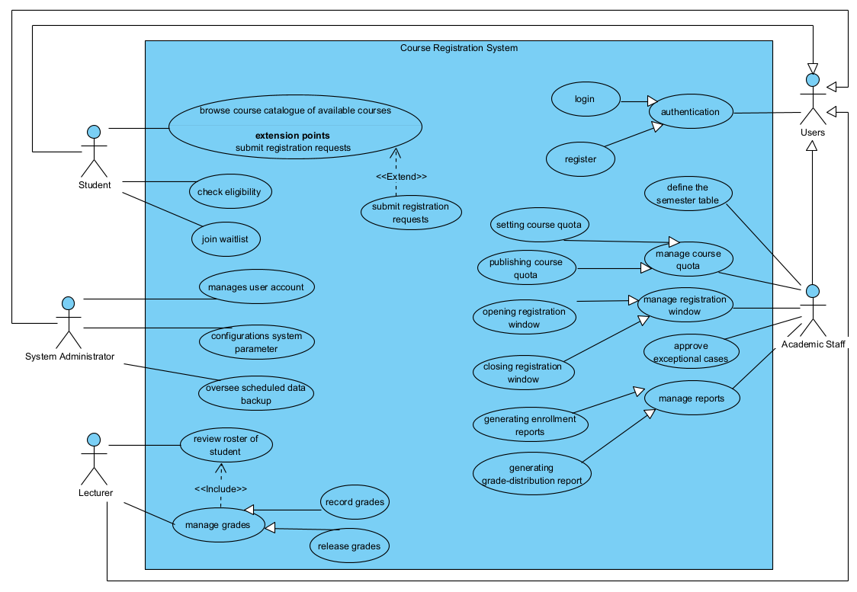

Question 3: UC Specification (1.5 points)
Write a complete Use Case Specification for the use case 'Register for Course'. Use the template in the answer sheet and fill in EVERY field. Partial or missing sections will receive partial credit only.
Giải thích:
Mục tiêu: Viết một bản mô tả chi tiết các bước thực hiện chức năng "Đăng ký môn học".
Dấu hiệu: Dựa vào mô tả ở mục I: Sinh viên chọn môn, hệ thống kiểm tra điều kiện (prerequisites) và chỗ trống (quotas). Nếu hết chỗ thì vào danh sách chờ (Waitlist).
- Người thực hiện (Actor): Sinh viên (Student).
- Điều kiện cần: Sinh viên phải đăng nhập và kỳ đăng ký phải đang mở.
- Các bước chính (Main Flow): Chọn môn → Kiểm tra điều kiện tiên quyết (prerequisite) → Kiểm tra chỗ trống (quota) → Lưu đăng ký.
- Trường hợp lỗi/khác (Alternative Flow): Nếu hết chỗ thì vào danh sách chờ (Waitlist); nếu thiếu môn tiên quyết thì báo lỗi.
- Exception Flow: Các lỗi hệ thống (Ví dụ: Mất kết nối server).
- Business Rules: Quy tắc của trường (Ví dụ: Phải học xong môn A mới được học môn B).
Trả lời:
UC SPECIFICATION TEMPLATE
Use Case Name | Register for Course
Use Case ID | UC-01
Actor(s) | Student
Preconditions | 1. Student is logged in.  2. Registration window is open.
Post conditions | Student is enrolled in the course or on the waitlist.
Main Flow (Basic Path) | 1. Student searches for a specific course.  2. Student selects a course from the search results.  3. System checks prerequisites for the selected course.  4. System checks seat availability (quotas).  5. System checks for schedule conflicts with already enrolled courses.  6. System records the student's registration.  7. System shows a success message.
Alternative Flow A | At Step 4: Missing Prerequisites  B1. System determines the student has not completed one or more prerequisite courses.  B2. System halts the registration process for this specific course.  B3. System retrieves the exact list of the missing prerequisite(s).  B4. System displays an error message detailing the missing prerequisites.  B5. System prompts the student to choose another course and returns to Step 2.
Alternative Flow B | At Step 5: Course is Full - Waitlist  A1. System detects that available seats for the course are exactly 0.  A2. System alerts the student that the course is full and offers a "Join Waitlist" option.  A3. Student clicks to confirm joining the waitlist.  A4. System adds the student's ID to the waitlist queue for this course.  A5. System displays a confirmation message of waitlist status and returns to Step 2.
Exception Flow | If a database or server connection error occurs at any point:  E1. System catches the technical timeout or database error.  E2. System securely logs the error details for the admin.  E3. System safely cancels any pending registration transaction.  E4. System displays a "System error: Please try again later" message.  E5. System redirects the student back to the main homepage.
Business Rules | Prerequisite Rule: Student must have completed all prerequisite courses with a passing grade before enrolling.  Credit Limit Rule: A student cannot register for more than the maximum allowed credits per semester (e.g., 21 credits).  Time Conflict Rule: System must automatically block registration if the chosen course's schedule overlaps with an already registered course.  Waitlist Priority Rule: Waitlist enrollment must strictly follow a first-come, first-served chronological order.  Duplicate Course Rule: A student cannot register for the same course twice in the same semester.
Non-Functional Requirements | Page response and transaction processing time must be under 3 seconds.  System must handle up to 5,000 concurrent student connections during peak registration hours without crashing.

Question 4: Non-functional requirements (1.0 points)
1. From the case study, identify and classify at least FOUR non-functional requirements (NFRs) into appropriate quality categories (e.g., Performance, Security, Availability, Usability, Scalability, Maintainability). For each NFR, write one measurable acceptance criterion. Present your answer as a table with the columns: Category | NFR Description | Acceptance Criterion. (0.9 points)
2. Identify TWO NFRs from your table that may conflict with each other in the CRS context. Clearly explain why the conflict arises and propose a concrete trade-off strategy that the development team could apply. (0.6 points)

Giải thích:
Dấu hiệu: Hãy nhìn vào đoạn cuối của đề bài (Technical Standpoint). Ở đó có các con số cụ thể:
- 1,000 users / 3 seconds → Hiệu năng (Performance).
- TLS 1.2 / RBAC → Bảo mật (Security).
- 99.5% → Độ sẵn sàng (Availability).
- WCAG 2.1 / Desktop & Mobile → Độ tiện dụng (Usability).
Trả lời:
Part 1
Category | NFR Description | Acceptance criterion
Performance | System must handle high traffic during registration. | Support 1,000 users with < 3s response time.
Security | Protect sensitive student and grade data. | Use TLS 1.2 encryption and RBAC.
Availability | System must be online during the semester. | System uptime must be at least 99.5%.
Usability | System must be easy to use for everyone. | Meet WCAG 2.1 Level AA standards.

Part 2: Conflicting NFRs: Performance vs Security
Why conflict: TLS encryption protects data but slows the system down. When 1,000 users register at the same time, it is hard to keep response time under 3 seconds.
Trade-off strategy: Use TLS session caching and load balancing to keep the system both fast and secure.

Question 5: Class Diagram (1.5 points)
1. Identify at least SIX key domain classes for the Course Registration System. For each class, specify at minimum three attributes (with data types) and two methods. Present this as a structured list or mini class-description table before drawing the diagram. (0.6 points)
2. Draw a complete UML Class Diagram that includes: (1.4 points)
- All identified classes with their full attribute and method compartments
- At least ONE inheritance (generalization) relationship — for example, User as a base class for Student, Lecturer, and AcademicStaff
- At least TWO association relationships with correct multiplicity labels at both ends
- At least ONE aggregation OR composition relationship, with the correct diamond notation and a written justification
- At least ONE dependency relationship
Suggested classes (you may add or rename): User, Student, Lecturer, AcademicStaff, SystemAdmin, Course, CourseOffering, Registration, Waitlist, Grade, Semester, Report.

Giải thích:
- Các lớp (Classes): Sơ đồ bao gồm các lớp trọng tâm đại diện cho hệ thống như User, Student, Course, CourseOffering, Registration, Semester và Report.
- Kế thừa (Inheritance): Các lớp Student, Lecturer, Academic_Staff và System_Administrator đều là các người dùng trong hệ thống nên chia sẻ các thông tin định danh chung, do đó tất cả cùng kế thừa từ lớp cha là User.
- Liên kết (Association & Multiplicity): 1 Student có thể tạo ra nhiều (0..) Registration. 1 Lecturer có thể phụ trách giảng dạy nhiều (0..) CourseOffering. Bản Registration sẽ được gắn cứng với 1 CourseOffering cụ thể.
- Kết hợp (Aggregation - Hình thoi rỗng): Mối quan hệ giữa Semester và CourseOffering. Một học kỳ (Semester) bao gồm nhiều lớp học phần (CourseOffering). Đây là mối quan hệ yếu, vì khi học kỳ kết thúc, thông tin của lớp học phần đó vẫn tồn tại trong lịch sử hệ thống chứ không bị xóa sổ.
- Thành phần (Composition - Hình thoi đặc): Mối quan hệ giữa Course và CourseOffering. Nếu một môn học (Course) bị loại bỏ hoàn toàn khỏi chương trình đào tạo, tất cả các lớp học phần (CourseOffering) của môn đó cũng buộc phải bị tiêu hủy. Tương tự với CourseOffering và Waitlist.
- Phụ thuộc (Dependency - Nét đứt): Lớp Report phụ thuộc vào Academic_Staff và Student (những người kích hoạt việc tạo báo cáo). Ngoài ra, Registration phụ thuộc vào Grade để ghi nhận điểm số sau khi khóa học kết thúc.
Trả lời:
Part 1: Structured List of Key Domain Classes (0.6 points)
User
- Attributes: userID: String, email: String, dateOfBirth: LocalDate
- Methods: login(): boolean, updateProfile(): void
Student
- Attributes: studentID: String, major: String, gpa: double
- Methods: registerCourse(courseID: String): boolean, viewGrades(): List
Course
- Attributes: courseID: String, courseName: String, credits: int
- Methods: getPrerequisite(): String, updateInfo(): void
CourseOffering
- Attributes: offeringID: String, schedule: String, maxSeats: int
- Methods: getAvailableSeats(): int, closeEnrollment(): void
Registration
- Attributes: regID: String, regDate: Date, status: String
- Methods: submit(): void, cancel(): void
Semester
- Attributes: semesterID: String, term: String, year: int
- Methods: beginSemester(): String, lockRegistration(): void

Part 2: Complete UML Class Diagram
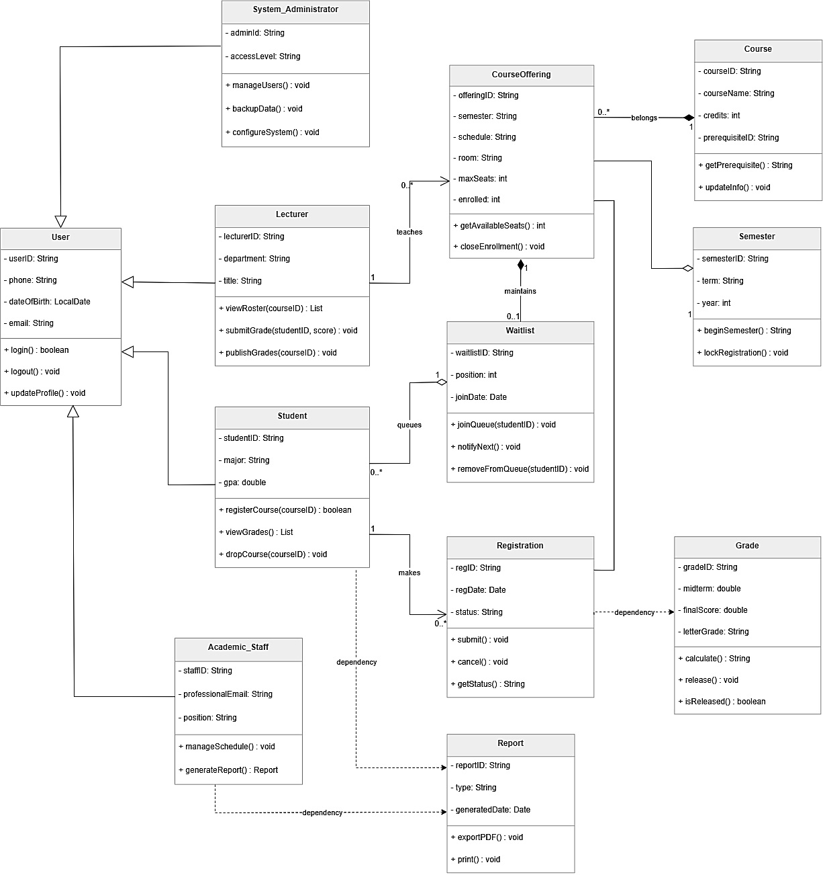

Question 6: AI in Coding (1.0 points)
This question assesses your ability to use AI coding assistants (e.g., GitHub Copilot, ChatGPT, Claude) as a practical aid during software development. Two Java code snippets from the Course Registration System are provided below. For each scenario, you must craft an effective AI prompt and then answer the follow-up tasks based on what the Al would identify.
Important: A good AI prompt must include: (1) clear context about the system, (2) the specific goal (review / find bug / fix), (3) the code itself, and (4) the expected output format.

Scenario A- RegistrationService.java (0.5 points)
The following Java method is part of the RegistrationService class in a Spring Boot application. It is intended to enroll a student in a course by (1) verifying the prerequisite is satisfied, (2) confirming a seat is available, and (3) persisting the new registration record. The code compiles without errors but contains THREE logical or semantic bugs.
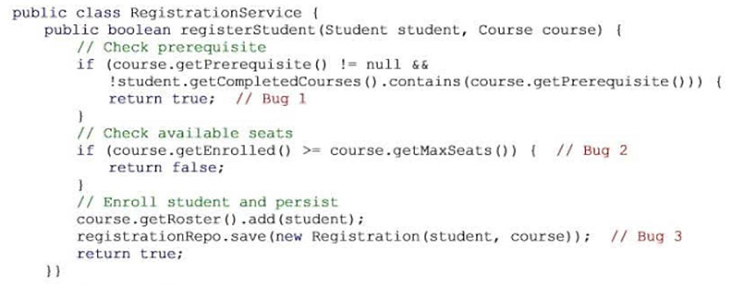
Your tasks for Scenario A:
- Write an AI Prompt for Code Review: Write a clear and complete prompt you would submit to an AI assistant to review the registerStudent() method. Your prompt must specify: the system context (CRS, Java, Spring Boot), what you want the AI to do (review for correctness, logic errors, and coding best practices), and the expected output format (e.g., a numbered list of issues with explanations and suggested fixes). (0.2 points)
- Identify the Bugs: Based on the AI review, identify all THREE bugs. For each bug state: the line or code fragment, the bug type (e.g., wrong return value, off-by-one, missing state update), and why it causes incorrect behaviour. (0.2 points)
- Write an AI Prompt to Fix the Bugs: Write a follow-up prompt asking the AI to provide the corrected Java method. Present the corrected code with an inline comment on each fix. (0.1 point)
Scenario B - GradeService.java (0.5 points)
The following Java method belongs to the GradeService class. It should publish final grades only when (1) the grading period is officially closed and (2) every enrolled student has a grade on record. The code contains TWO logical bugs and ONE critical security vulnerability.
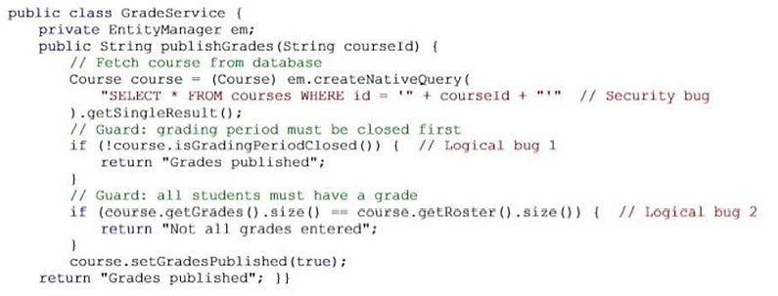
Your tasks for Scenario B:
- Write an AI Prompt for Security and Logic Review: Write a prompt asking an AI assistant to review publishGrades() for both logical correctness and security vulnerabilities. Specify the language and framework (Java / JPA), describe the method's intended behaviour, and request that each issue be explained with a risk level (Low / Medium / High / Critical). (0.2 points)
- Identify All Issues: Based on the AI review, explain all three issues: the two logical bugs (which condition is wrong and what the correct logic should be) and the security vulnerability (name the vulnerability type, describe how an attacker could exploit it in the CRS, and assign a risk level). (0.2 points)
- Write an AI Prompt to Fix the Issues: Write a follow-up prompt instructing the AI to provide the fully corrected Java method, replacing the native query with a JPA named query (parameterised). Present the corrected code with inline comments for each fix. (0.1 point).

Giải thích:
Dấu hiệu:
Scenario A (Lỗi logic đăng ký):
- Bug 1: Ở dòng kiểm tra môn tiên quyết (prerequisite), nếu sinh viên chưa học (!contains), code lại trả về true (thành công). Đúng ra phải trả về false hoặc báo lỗi.
- Bug 2: Theo đề bài (Case Study), nếu hết chỗ (full booked), sinh viên có thể vào danh sách chờ (waitlist). Code hiện tại chỉ trả về false là thiếu nghiệp vụ.
- Bug 3: Code có thêm sinh viên vào danh sách (roster) và lưu bản ghi đăng ký, nhưng không tăng số lượng enrolledCount của khóa học, dẫn đến việc kiểm tra chỗ trống ở các lần sau bị sai.
Scenario B (Lỗi bảo mật & logic điểm):
- Security Bug: Sử dụng nối chuỗi trực tiếp + courseId + trong câu lệnh SQL. Đây là lỗi SQL Injection cực kỳ nguy hiểm.
- Logical Bug 1: Nếu thời gian nhập điểm chưa đóng (!isGradingPeriodClosed), hệ thống lại trả về "Grades published". Đúng ra phải ngăn chặn việc xuất bản điểm.
- Logical Bug 2: Điều kiện so sánh ==. Khi số lượng điểm bằng số lượng sinh viên (tức là đã đủ), hệ thống lại báo "Chưa nhập đủ điểm".

Trả lời:
Scenario A - RegistrationService.java
Prompt 1 (Review):
"Act as a Java expert. Review this registerStudent method for a Course Registration System (Spring Boot). Find 3 logical bugs related to prerequisites, seat capacity, and student count. List issues with explanations."
Identify the Bugs:
- Line 6 (Prerequisite): Returns true even if the student lacks the prerequisite. (Type: Wrong logic).
- Line 11 (Waitlist): Returns false when full. It should add the student to the Waitlist as per requirements. (Type: Missing feature).
- Line 15 (Update): Does not increment the enrolledCount for the course. (Type: Missing state update).
Prompt 2 (Fix):
"Rewrite the registerStudent method. Fix the 3 bugs: return false for missing prerequisites, add to waitlist if full, and update the enrolled count. Add inline comments."
Scenario B - GradeService.java
Prompt 1 (Review):
"Review this Java publishGrades method for logical bugs and security risks. The method should only publish if the period is closed and all grades are entered. Provide issues with risk levels."
Identify All Issues:
- Security (SQL Injection): Using string concatenation in createNativeQuery. (Risk: Critical).
- Logic Bug 1 (Period): Returns "Grades published" when the grading period is still open.
- Logic Bug 2 (Grade count): Returns an error when all grades are actually complete (count matches).
Prompt 2 (Fix):
"Rewrite the method. Use a parameterized JPA query to fix SQL Injection. Correct the logical checks for grading period and grade counts. Add inline comments."

Question 7: Testing Stage and Type (1.5 points)
1. Map the four standard testing stages to the CRS development process. For each stage, state what is tested, who is responsible, and which testing types are most applicable: (0.5 points)
2. Write THREE test cases for the 'Register for Course' use case, covering the scenarios listed below. Present each test case in a table with the columns: Test Case ID | Test Case Name | Precondition | Test Steps | Expected Result | Testing Type. (1.0 points)
- Happy-path scenario - a student successfully registers for an available course
- Boundary / edge-case scenario - a student registers for the last available seat (quota = 1 remaining)
- Negative / error scenario - a student attempts to register without meeting the course prerequisite
Giải thích:
Bốn giai đoạn kiểm thử: Unit (Đơn vị - Dev làm), Integration (Tích hợp - Kết nối các module), System (Hệ thống - Kiểm tra toàn bộ tính năng), Acceptance (Nghiệm thu - Người dùng cuối kiểm tra).
Test Cases:
- Happy-path: Đăng ký thành công khi mọi thứ đều ổn.
- Boundary: Đăng ký vào chỗ trống cuối cùng (kiểm tra giới hạn số lượng).
- Negative: Đăng ký khi thiếu môn tiên quyết (kiểm tra báo lỗi).

Trả lời:
7.1. Testing Stage and Responsibility
Unit Testing:
- What is tested: Individual methods like checkPrerequisite() or calculateGPA().
- Responsible: Software Developers.
- Testing Types: White-box testing.
Integration Testing:
- What is tested: Interaction between modules (e.g., between the Web UI and the Student Database).
- Responsible: Developers and Testers.
- Testing Types: Interface testing and Functional testing.
System Testing:
- What is tested: The entire CRS system including Performance and Security (RBAC).
- Responsible: Independent Testers (QA Team).
- Testing Types: Black-box testing, Load testing, and Security testing.
Acceptance Testing (UAT):
- What is tested: If the system meets the actual needs of Students and Academic Staff.
- Responsible: End-users (Students, Lecturers, Staff).
- Testing Types: Alpha testing and Beta testing.
7.2. Test Cases
TCID | Test Case Name | Precondition | Test steps | Expected result | Test type
TC1 | Register Success | Student logged in. Course has seats. Prerequisite is done. | 1. Select course.  2. Click Register.  3. System checks prerequisite.  4. System checks seats.  5. System saves registration. | System shows "Registration successful". Seat count decreases by 1. | Functional
TC2 | Last Seat Check | Student logged in.  Course has 1 seat remaining. | 1. Select course.  2. Click Register.  3. System checks seats  4. System saves registration. | Registration is successful. Seat count becomes 0. Course is now full. | Boundary
TC3 | Missing Prereq | Student logged in.  Student did not finish prerequisite course. | 1. Select course.  2. Click Register.  3. System checks prerequisite.  4. Prerequisite not found. | System shows "Missing Prerequisite" error. Registration is blocked. | Negative

