Main Controller
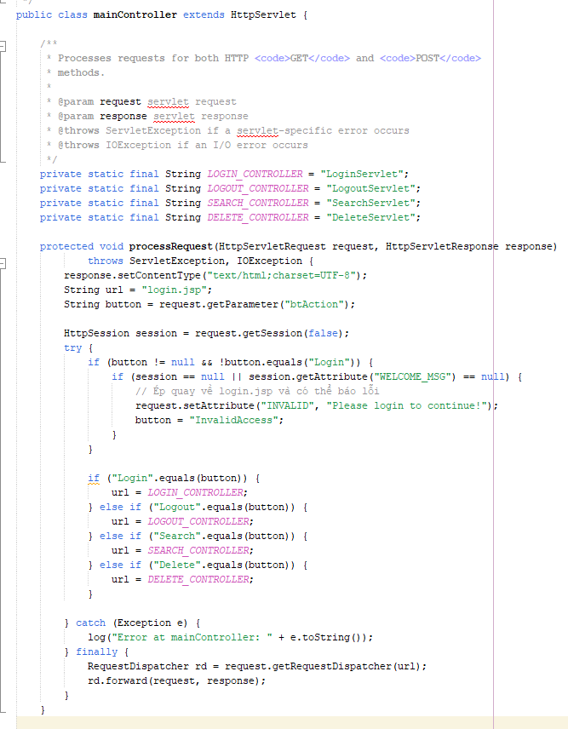

Function: Login
LoginServlet:
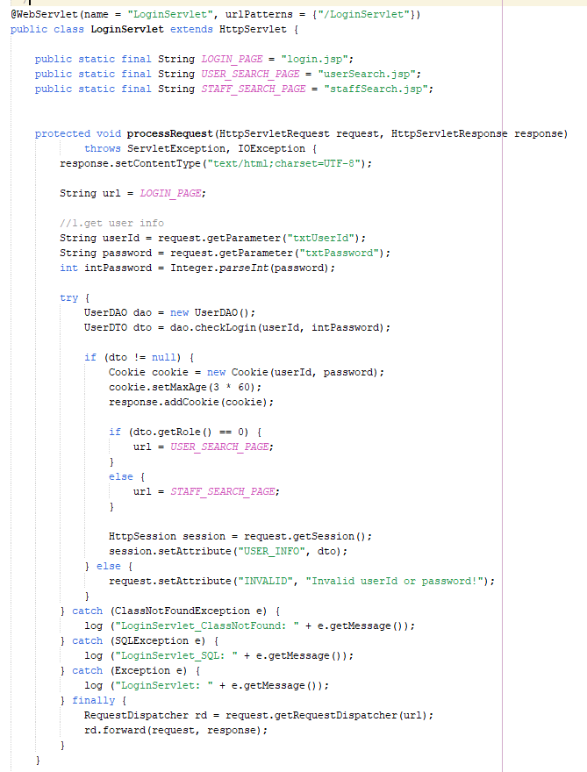

Login.jsp:
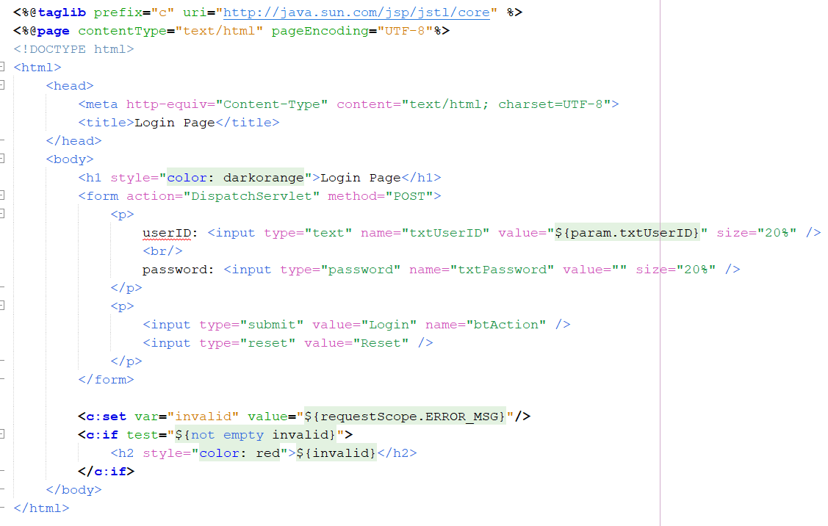

UsersDAO:
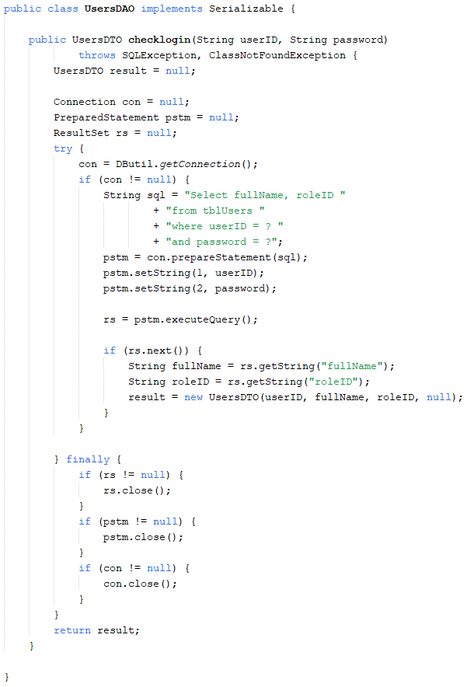

UserDTO:
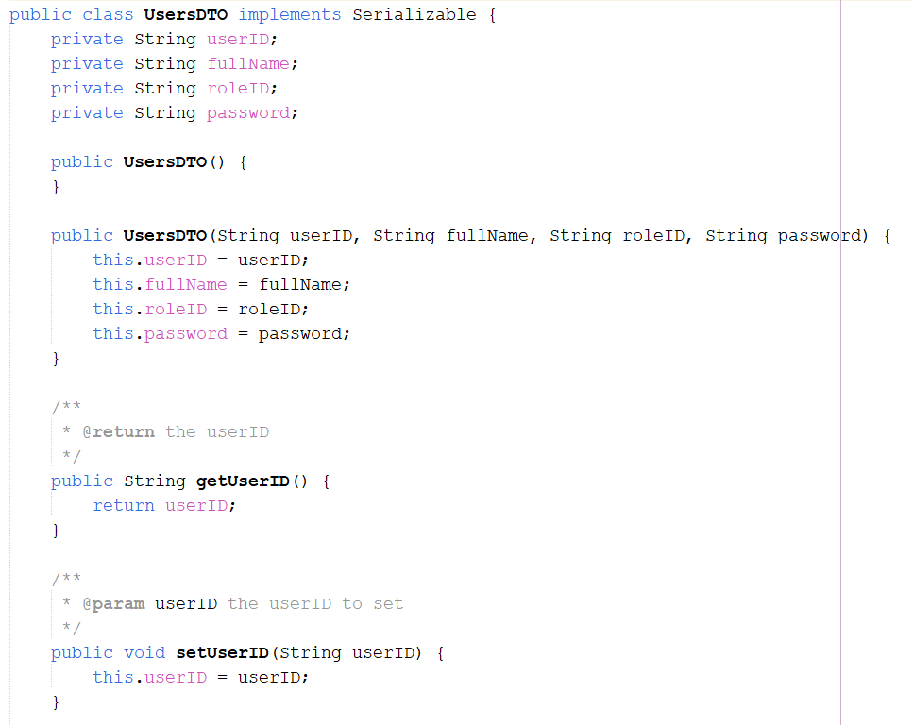
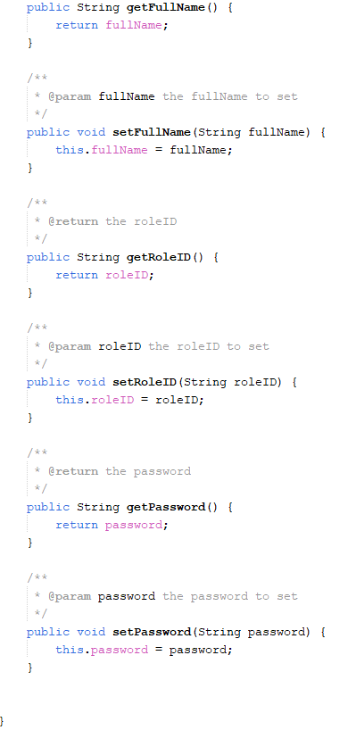
On login.jsp page, user enters userID and password.
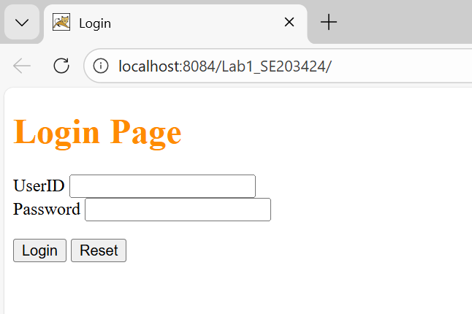
If the userID and password is correct, then grant the access permission and go to homestay.jsp page.
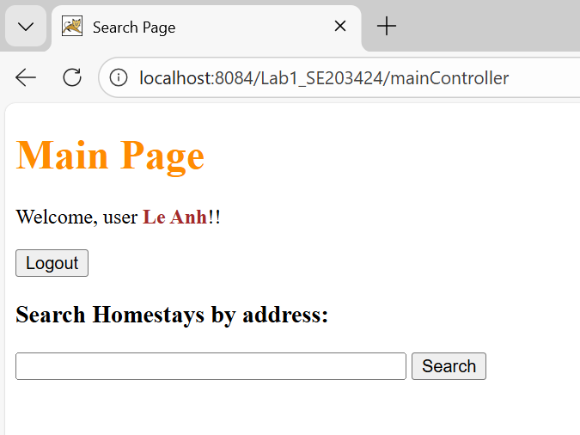
If not correct, the system will show the message” Incorrect UserID or Password” on login.jsp page.
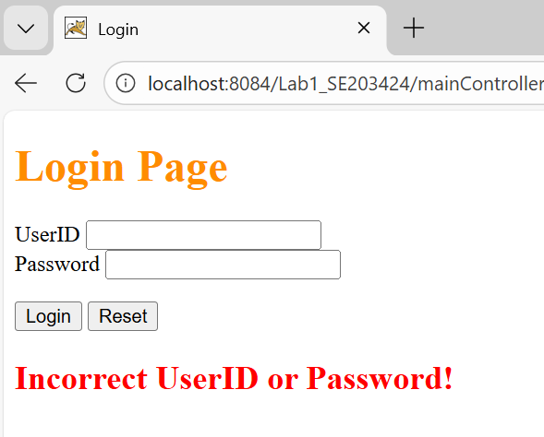

Function: Welcome
On homestay.jsp page need show welcome the fullName of login user.

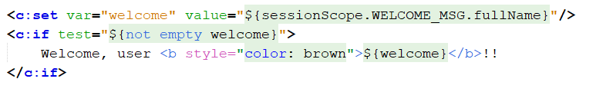

Function: Logout
LogoutServlet:
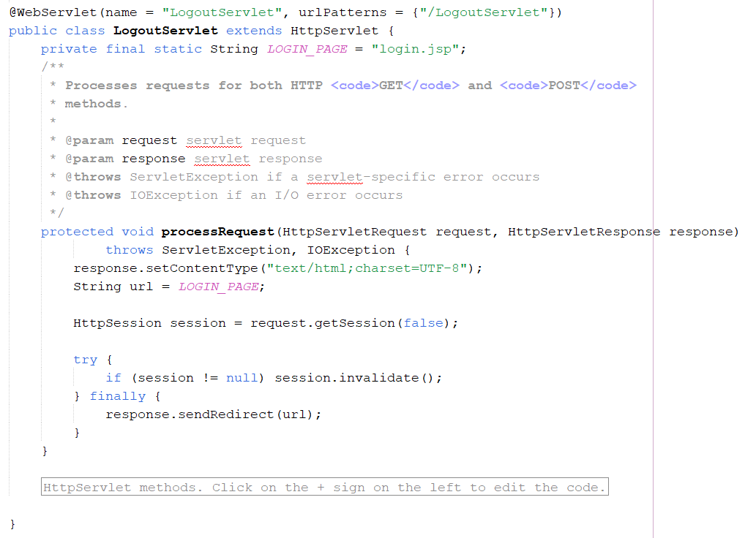
Homestay.jsp:
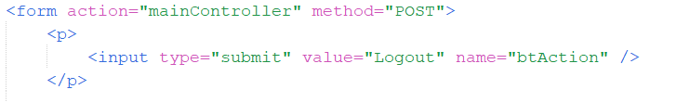

When the user clicks on the Logout button, the web application will remove the user's login information and display the login.jsp page again.
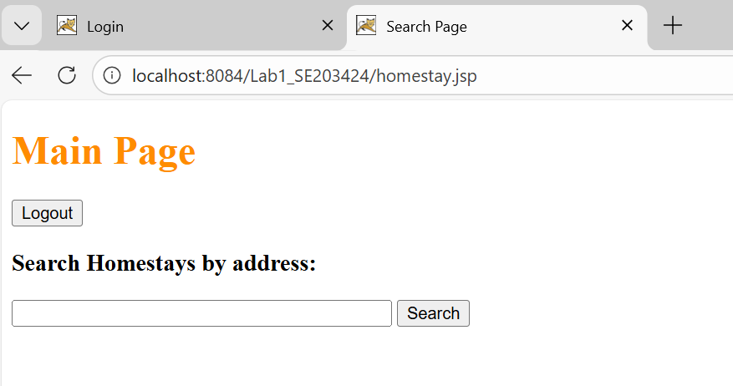

If try to search when clicked Logout button, immediately return login.jsp and require to login
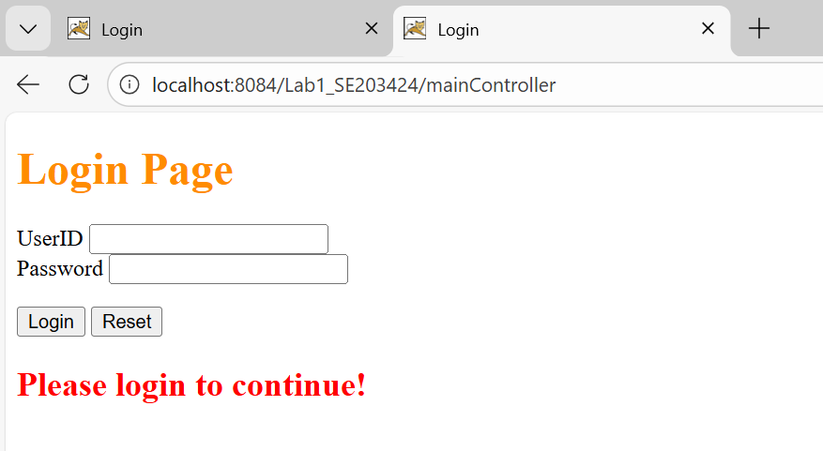

Function: Search
SearchServlet:
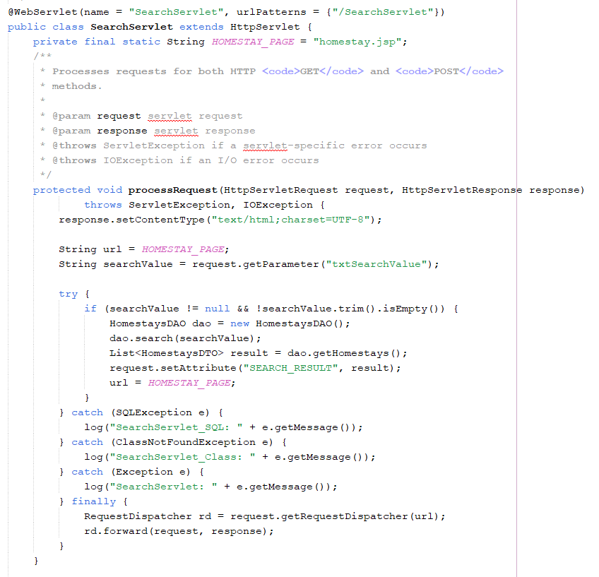

homestaysDAO:
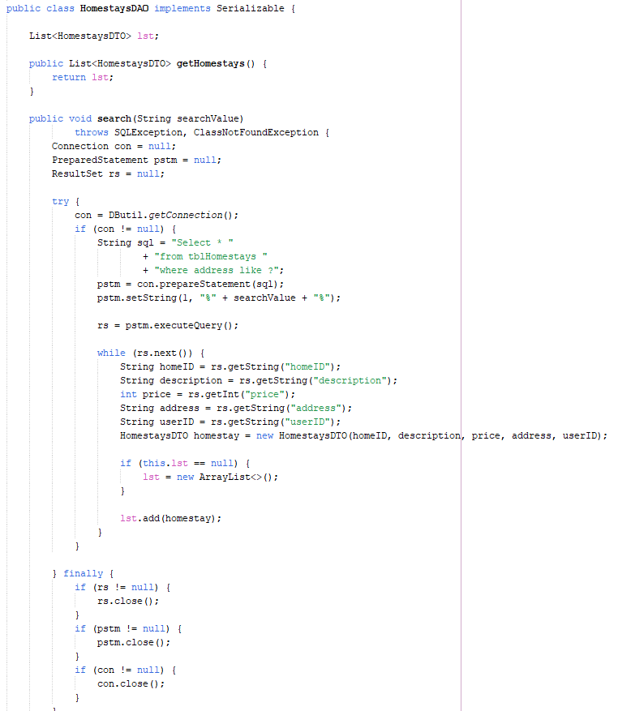

homestayDTO:
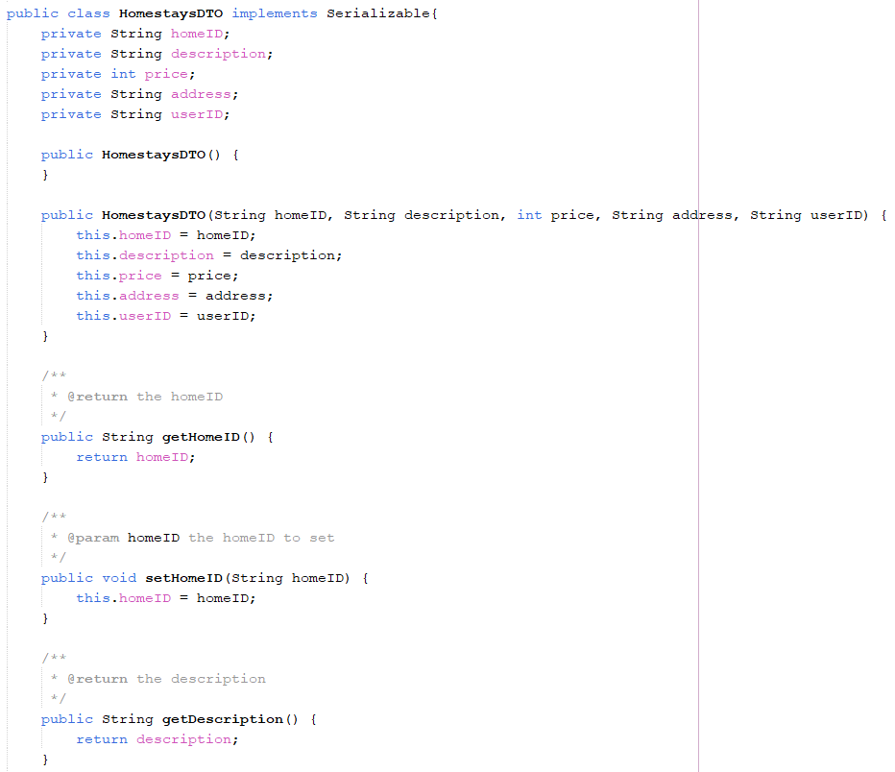
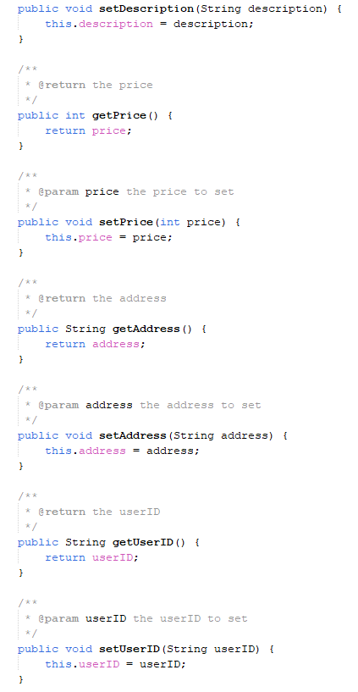
homestay.jsp:
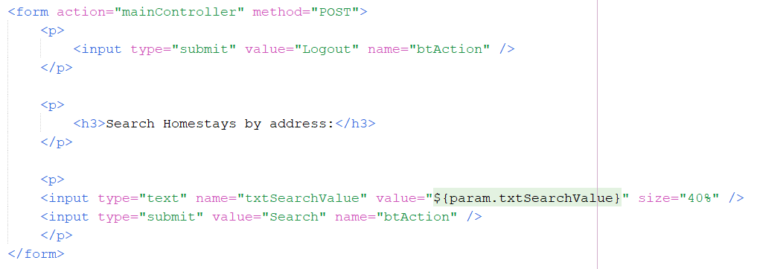
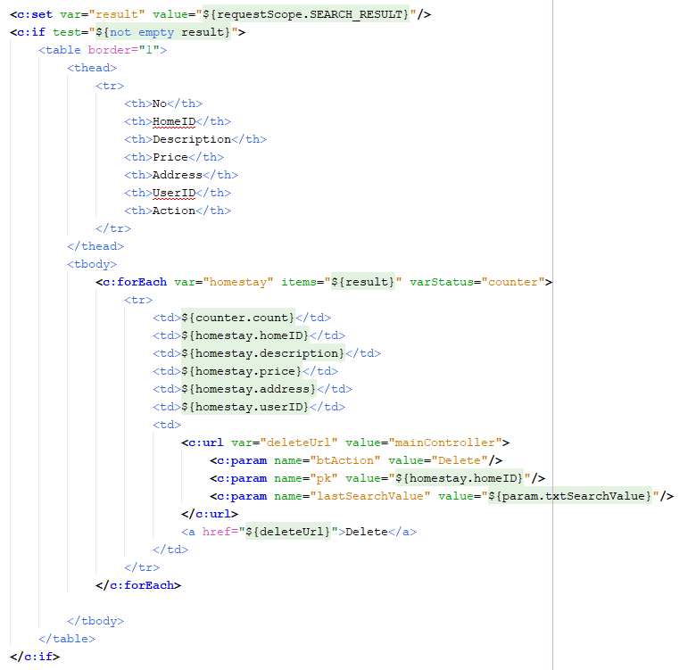

The data grid of homestays is shown with No, HomeID, Description, Price, Address, UserID, Action.
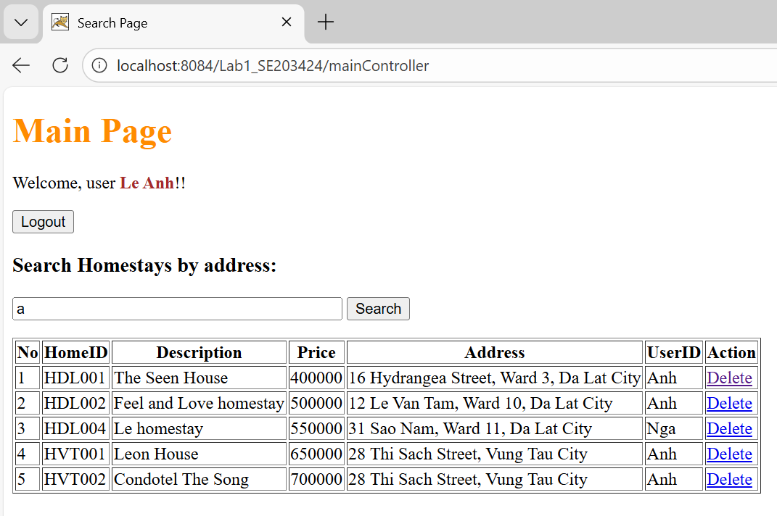

Function: Delete
DeleteServlet:
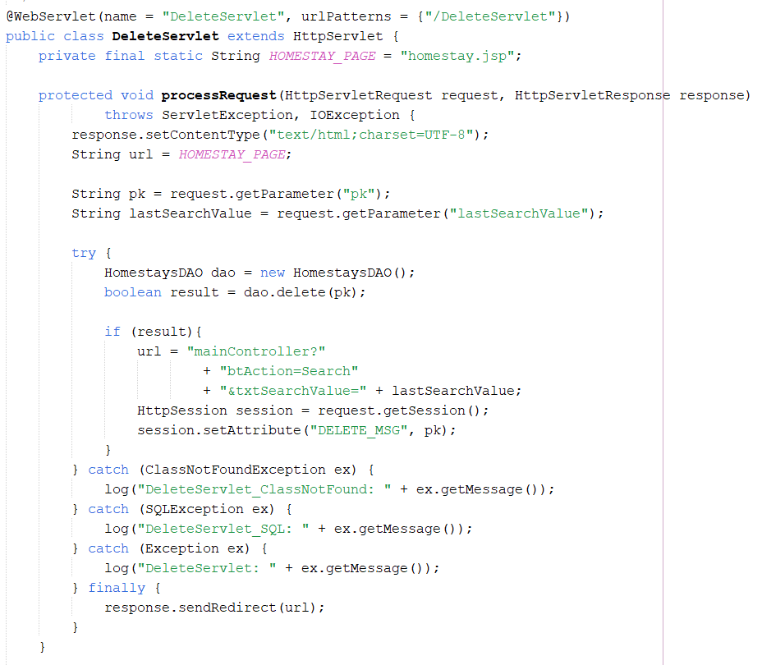
homestaysDAO:
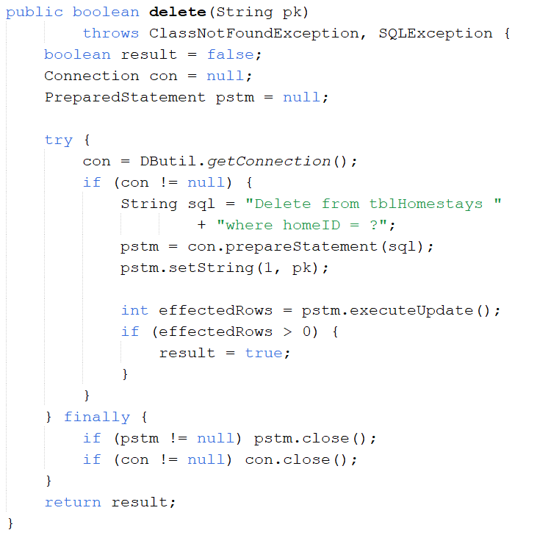
homestay.jsp:
