Lab 5
Banking System - Project Report
Course: DBI202 | Instructor: Ms. Nguyễn Thị Thu Thảo
Group Members:
Student ID | Full Name | Group | Group Mark | Contribution  (%) | Mark | Note
SE203334 | Hà Nguyễn Tiến Đạt | 7 |  | 100
SE190596 | Trần Hữu Việt | 7 |  | 100
SE193659 | Mai Thành Được | 7 |  | 100
SS190849 | Lê Nguyên Ngọc | 7 |  | 100

1. Objective
The lab's goal is to practice SQL programming on the "Banking System" database from Lab 4. This involves writing a variety of SQL queries (from basic to advanced), implementing functions, stored procedures, and triggers to automate tasks and enforce business rules. Students will also create views to simplify data access and indexes to improve performance.
2. SQL Queries
This section presents the SQL commands executed on the "Banking System" database, ranging from basic to advanced.
2.1. Basic Queries
2.1.1. Select all records
- Description: Retrieve all customers in the system.
SELECT * FROM CUSTOMER;
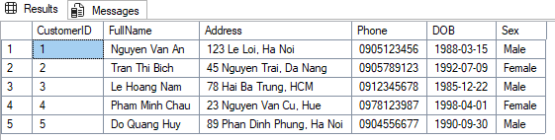
2.1.2. Filter rows (WHERE)
- Description: Find all 'Female' customers. (CUSTOMER)
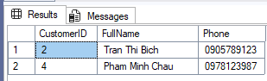
SELECT CustomerID, FullName, Phone FROM CUSTOMER
WHERE Sex = 'Female';
- Description: Find all accounts with a 'Closed' status. (ACCOUNT)
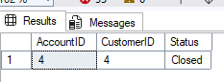
SELECT AccountID, CustomerID, Status FROM ACCOUNT
WHERE Status = 'Closed';
- Description: Find all loans with an amount greater than 400,000,000. (LOAN)
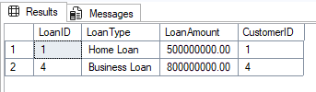
SELECT LoanID, LoanType, LoanAmount, CustomerID FROM LOAN
WHERE LoanAmount > 400000000;

- Description: Find all employees in Branch 1 with a salary over 17,000,000. (EMPLOYEE)
SELECT Employee_ID, Full_Name, Salary, BranchID FROM EMPLOYEE
WHERE BranchID = 1 AND Salary > 17000000;
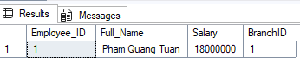
- Description: Find all withdrawal transactions (Amount < 0). (TRANSACTIONS)
SELECT TransactionID, Amount, TransactionDate FROM TRANSACTIONS
WHERE Amount < 0;
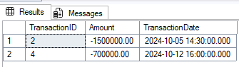
2.1.3. Sort results (ORDER BY)
- Description: List all customers sorted alphabetically by FullName. (CUSTOMER)
SELECT * FROM CUSTOMER ORDER BY FullName ASC;
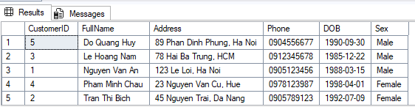

- Description: List all accounts, sorted from highest Balance to lowest. (ACCOUNT)
SELECT AccountID, Balance, Status FROM ACCOUNT
ORDER BY Balance DESC;
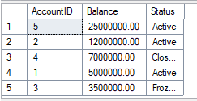
- Description: List all 'Approved' loans, sorted by StartDate (newest first). (LOAN)
SELECT LoanID, LoanType, StartDate, Status FROM LOAN
WHERE Status = 'Approved'
ORDER BY StartDate DESC;
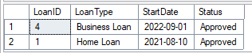
- Description: List employees, sorted by BranchID and then by Salary (highest first). (EMPLOYEE)
SELECT Employee_ID, Full_Name, BranchID, Salary FROM EMPLOYEE
ORDER BY BranchID, Salary DESC;
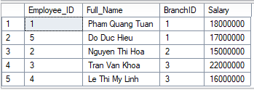

- Description: List transactions from October 1st to October 15th, 2024, sorted by date. (TRANSACTIONS)
SELECT * FROM TRANSACTIONS
WHERE TransactionDate >= '2024-10-01' AND TransactionDate < '2024-10-16'
ORDER BY TransactionDate ASC;
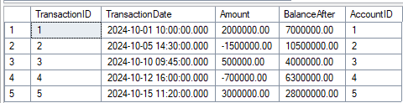
2.1.4. Aggregation (COUNT, AVG, AVG, MAX, MIN)
- Description: Count the total number of customers.
SELECT COUNT(CustomerID) AS TotalCustomers FROM CUSTOMER;
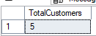
- Description: Calculate the total LoanAmount for all 'Approved' loans.
SELECT SUM(LoanAmount) AS TotalApprovedLoanValue FROM LOAN
WHERE Status = 'Approved';
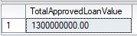
- Description: Find the highest Salary among all employees.
SELECT MAX(Salary) AS HighestSalary FROM EMPLOYEE;
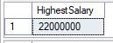

- Description: Find the lowest Balance of any 'Active' account.
SELECT MIN(Balance) AS LowestActiveBalance FROM ACCOUNT
WHERE Status = 'Active';
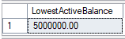
- Description: Calculate the average balance (AVG) for 'Checking' accounts.
SELECT AVG(Balance) AS AverageCheckingBalance FROM ACCOUNT
WHERE AccountType = N'Checking';
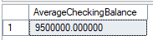
2.2. Intermediate Queries
2.2.1. Join multiple tables
- Description (INNER JOIN 1): Retrieve the customer's FullName and the Balance of all accounts they own.
SELECT c.FullName, a.AccountID, a.Balance
FROM CUSTOMER c
INNER JOIN ACCOUNT a ON c.CustomerID = a.CustomerID;
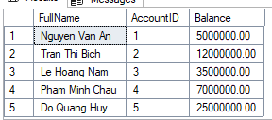

- Description (INNER JOIN 2): Get the Full_Name of employees and the BranchName they work at.
SELECT e.Full_Name, b.BranchName
FROM EMPLOYEE e
JOIN BRANCH b ON e.BranchID = b.BranchID;
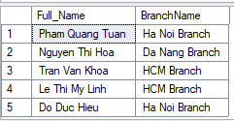
- Description (INNER JOIN 3): List all transactions with the FullName of the customer who owns the account.
SELECT t.TransactionID, t.Amount, t.TransactionDate, c.FullName
FROM TRANSACTIONS t
JOIN ACCOUNT a ON t.AccountID = a.AccountID
JOIN CUSTOMER c ON a.CustomerID = c.CustomerID;
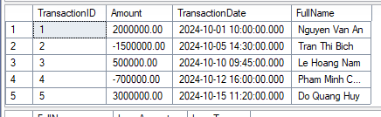
- Description (LEFT JOIN 1): List all customers and, if they have one, their LoanAmount. Customers without loans will still be listed with NULL.
SELECT c.FullName, l.LoanAmount, l.LoanType
FROM CUSTOMER c
LEFT JOIN LOAN l ON c.CustomerID = l.CustomerID;
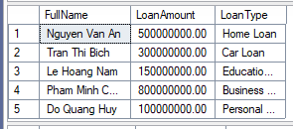
- Description (LEFT JOIN 2): Show all branches and the count of employees in each (even if a branch has zero employees).
SELECT b.BranchName, COUNT(e.Employee_ID) AS EmployeeCount
FROM BRANCH b
LEFT JOIN EMPLOYEE e ON b.BranchID = e.BranchID
GROUP BY b.BranchName;
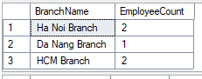
- Description (RIGHT JOIN): List all accounts and their customer details. This ensures all accounts are listed, even if they (hypothetically) had no matching customer.
SELECT c.FullName, a.AccountID, a.Balance
FROM CUSTOMER c
RIGHT JOIN ACCOUNT a ON c.CustomerID = a.CustomerID;
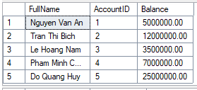
- Description (3-Table JOIN 1): Find the FullName of customers, their AccountType, and the BranchName where their account is held.
SELECT c.FullName, a.AccountType, b.BranchName
FROM CUSTOMER c
JOIN ACCOUNT a ON c.CustomerID = a.CustomerID
JOIN BRANCH b ON a.BranchID = b.BranchID;
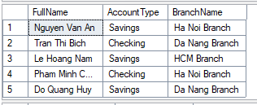
- Description (3-Table JOIN 2): List employees, their branch ManagerName, and the branch Address.
SELECT e.Full_Name, b.ManagerName, b.Address AS BranchAddress
FROM EMPLOYEE e
JOIN BRANCH b ON e.BranchID = b.BranchID;
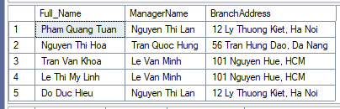
- Description (4-Table JOIN): Get transaction details (Amount, Date) for customers who have a 'Home Loan'.
SELECT t.TransactionID, t.Amount, c.FullName
FROM TRANSACTIONS t
JOIN ACCOUNT a ON t.AccountID = a.AccountID
JOIN CUSTOMER c ON a.CustomerID = c.CustomerID
JOIN LOAN l ON c.CustomerID = l.CustomerID
WHERE l.LoanType = 'Home Loan';
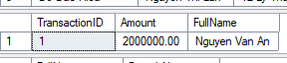

- Description (CROSS JOIN): Create all possible pairings of CUSTOMER and BRANCH (e.g., for a marketing mail merge).
SELECT c.FullName, b.BranchName
FROM CUSTOMER c
CROSS JOIN BRANCH b;
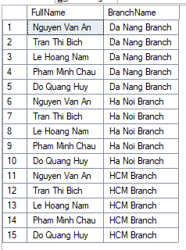
2.2.2. Group results (GROUP BY) and (HAVING)
- Description (GROUP BY 1): Count the number of accounts each CustomerID owns.
SELECT CustomerID, COUNT(AccountID) AS NumberOfAccounts
FROM ACCOUNT
GROUP BY CustomerID;
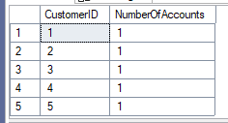

- Description (GROUP BY 2): Calculate the total Balance for each AccountType.
SELECT AccountType, SUM(Balance) AS TotalBalance
FROM ACCOUNT
GROUP BY AccountType;
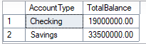
- Description (GROUP BY 3): Find the average Salary for each BranchID.
SELECT BranchID, AVG(Salary) AS AverageSalary
FROM EMPLOYEE
GROUP BY BranchID;
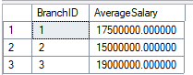
- Description (GROUP BY 4): Count the number of loans per BranchID.
SELECT BranchID, COUNT(LoanID) AS LoanCount
FROM LOAN
GROUP BY BranchID;
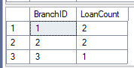
- Description (GROUP BY 5): Find the total LoanAmount grouped by LoanType.
SELECT LoanType, SUM(LoanAmount) AS TotalAmount
FROM LOAN
GROUP BY LoanType;
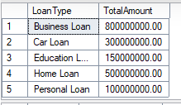
- Description (GROUP BY / HAVING 1): Calculate the total LoanAmount at each BranchID, but only show branches with a total loan sum greater than 700,000,000.
SELECT BranchID, SUM(LoanAmount) AS TotalLoanAmount
FROM LOAN
GROUP BY BranchID
HAVING SUM(LoanAmount) > 700000000;
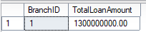
- Description (GROUP BY / HAVING 2): Show CustomerIDs who have equal or more than one account.
SELECT CustomerID, COUNT(AccountID) AS AccountCount
FROM ACCOUNT
GROUP BY CustomerID
HAVING COUNT(AccountID) >= 1;
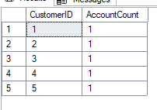
- Description (GROUP BY / HAVING 3): Show AccountTypes where the average balance is greater than 10,000,000.
SELECT AccountType, AVG(Balance) AS AvgBalance
FROM ACCOUNT
GROUP BY AccountType
HAVING AVG(Balance) > 10000000;
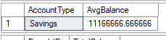
- Description (GROUP BY / HAVING 4): List branches where the total employee salary budget exceeds 30,000,000.
SELECT BranchID, SUM(Salary) AS TotalSalary
FROM EMPLOYEE
GROUP BY BranchID
HAVING SUM(Salary) > 30000000;
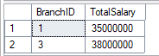
- Description (GROUP BY / HAVING 5): Show customers who have a total loan amount greater than 400,000,000.
SELECT CustomerID, SUM(LoanAmount) AS TotalLoans
FROM LOAN
GROUP BY CustomerID
HAVING SUM(LoanAmount) > 400000000;
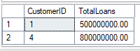
2.2.3. Subqueries (in WHERE or FROM)
- Description (Subquery in WHERE 1): Find the FullName of all customers who have at least one account with a balance over 10,000,000.
SELECT FullName, CustomerID FROM CUSTOMER
WHERE CustomerID IN (
SELECT CustomerID FROM ACCOUNT WHERE Balance > 10000000
);
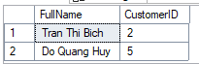
- Description (Subquery in WHERE 2): List all employees who work at the 'Ha Noi Branch'.
SELECT Full_Name, Salary FROM EMPLOYEE
WHERE BranchID = (
SELECT BranchID FROM BRANCH WHERE BranchName = 'Ha Noi Branch'
);
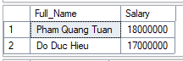
- Description (Subquery in WHERE 3): Find customers who have a 'Home Loan'.
SELECT FullName FROM CUSTOMER
WHERE CustomerID IN (
SELECT CustomerID FROM LOAN WHERE LoanType = 'Home Loan'
);
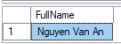
- Description (Subquery in WHERE 4): Find accounts that have had transactions greater than 1,000,000.
SELECT AccountID, Balance FROM ACCOUNT
WHERE AccountID IN (
SELECT AccountID FROM TRANSACTIONS WHERE Amount > 1000000
);
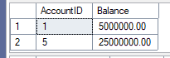
- Description (Subquery in WHERE 5): Find employees who earn more than the average salary of employees in 'HCM Branch'.
SELECT Full_Name, Salary FROM EMPLOYEE
WHERE Salary > (
SELECT AVG(Salary) FROM EMPLOYEE
WHERE BranchID = (SELECT BranchID FROM BRANCH WHERE BranchName = 'HCM Branch')
);
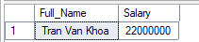
- Description (Subquery in FROM 1): Select the average balance from the derived table of 'Active' accounts.
SELECT AVG(ActiveAccounts.Balance) AS AvgActiveBalance
FROM (
SELECT Balance FROM ACCOUNT WHERE Status = 'Active'
) AS ActiveAccounts;
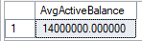
- Description (Subquery in FROM 2): Get the details of customers who own 'Savings' accounts, using a subquery in the JOIN clause.
SELECT c.FullName, c.Phone
FROM CUSTOMER c
JOIN (
SELECT CustomerID FROM ACCOUNT WHERE AccountType = 'Savings'
) AS sa ON c.CustomerID = sa.CustomerID;
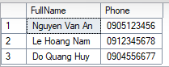

- Description (Correlated Subquery in SELECT): Show each customer's FullName and their total balance calculated with a subquery.
SELECT c.FullName, (
SELECT SUM(a.Balance)
FROM ACCOUNT a
WHERE a.CustomerID = c.CustomerID
) AS TotalBalance
FROM CUSTOMER c;
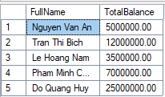
- Description (Subquery in WHERE with NOT IN): Find customers who have no 'Active' accounts.
SELECT FullName FROM CUSTOMER
WHERE CustomerID NOT IN (
SELECT CustomerID FROM ACCOUNT WHERE Status = 'Active'
);
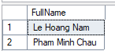
- Description (Subquery in WHERE): Find branches that have at least one 'Approved' loan.
SELECT BranchName FROM BRANCH
WHERE BranchID IN (
SELECT BranchID FROM LOAN WHERE Status = 'Approved'
);
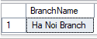

2.3. Advanced Queries
2.3.1.
Nested subqueries
- Description (Nested): Find the names of customers who have an 'Active' account and have made a transaction (deposit) over 1,000,000.
SELECT FullName FROM CUSTOMER
WHERE CustomerID IN (
SELECT CustomerID FROM ACCOUNT
WHERE Status = 'Active' AND AccountID IN (
SELECT AccountID FROM TRANSACTIONS WHERE Amount > 1000000
)
);
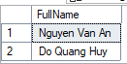
- Description (Nested): Find employees who work in a branch that manages a 'Business Loan'.
SELECT Full_Name FROM EMPLOYEE
WHERE BranchID IN (
SELECT BranchID FROM BRANCH
WHERE BranchID IN (
SELECT BranchID FROM LOAN WHERE LoanType = 'Business Loan'
)
);
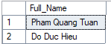

- Description (Nested): Find the FullName of customers who have a balance higher than the average balance of all 'Savings' accounts.
SELECT FullName FROM CUSTOMER
WHERE CustomerID IN (
SELECT CustomerID FROM ACCOUNT
WHERE Balance > (
SELECT AVG(Balance) FROM ACCOUNT WHERE AccountType = 'Savings'
)
);
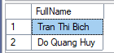
- Description (Nested): List all transactions for accounts held at the 'Da Nang Branch'.
SELECT * FROM TRANSACTIONS
WHERE AccountID IN (
SELECT AccountID FROM ACCOUNT
WHERE BranchID = (
SELECT BranchID FROM BRANCH WHERE BranchName = 'Da Nang Branch'
)
);
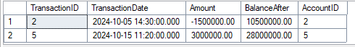
- Description (Nested): Find the 'Default' loans for customers who have an 'Active' or an 'Checking' account.
SELECT LoanID, LoanAmount FROM LOAN
WHERE Status = 'Default'
AND CustomerID IN (
SELECT CustomerID FROM ACCOUNT
WHERE AccountType = 'Checking' OR Status = 'Active'
);
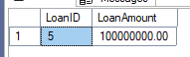
2.3.2.
Use of EXISTS, IN, and ANY/ALL
- Description (EXISTS 1): Retrieve the BranchName of all branches that manage at least one LOAN.
SELECT b.BranchName
FROM BRANCH b
WHERE EXISTS (
SELECT 1 FROM LOAN l WHERE l.BranchID = b.BranchID
);
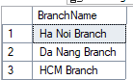
- Description (EXISTS 2): Find all customers who have at least one 'Active' account.
SELECT c.FullName
FROM CUSTOMER c
WHERE EXISTS (
SELECT 1 FROM ACCOUNT a WHERE a.CustomerID = c.CustomerID AND a.Status = 'Active'
);
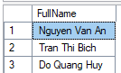
- Description (IN): Find customers who live in 'Ha Noi' or 'Da Nang'. (Note: IN was also used in 2.2.3).
SELECT FullName, Address FROM CUSTOMER
WHERE Address LIKE '%Ha Noi' OR Address LIKE '%Da Nang';
-- A better example if we had a City column:
-- WHERE City IN ('Ha Noi', 'Da Nang');
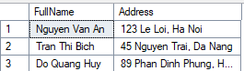
- Description (ANY): Find customers whose CustomerID matches any CustomerID in the LOAN table (equivalent to IN).
SELECT FullName FROM CUSTOMER
WHERE CustomerID = ANY (
SELECT CustomerID FROM LOAN
);
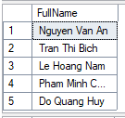
- Description (ALL): Find the employee(s) with the highest salary.
SELECT Full_Name, Salary FROM EMPLOYEE
WHERE Salary >= ALL (
SELECT Salary FROM EMPLOYEE
);
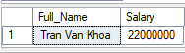
2.3.3.
Set Operations (UNION, INTERSECT, EXCEPT)
- Description (INTERSECT): Get a list (CustomerID, FullName) of customers who have both an ACCOUNT and a LOAN with the bank.
SELECT CustomerID, FullName FROM CUSTOMER
WHERE CustomerID IN (SELECT CustomerID FROM ACCOUNT)
INTERSECT
SELECT CustomerID, FullName FROM CUSTOMER
WHERE CustomerID IN (SELECT CustomerID FROM LOAN);
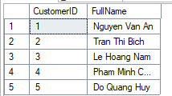
- Description (UNION): Get a combined list of all Phone numbers from CUSTOMER and EMPLOYEE tables (duplicates removed).
SELECT Phone FROM CUSTOMER
UNION
SELECT Phone_Number FROM EMPLOYEE;
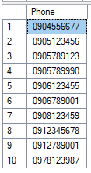
- Description (UNION ALL): Get a combined list of all Phone numbers from CUSTOMER and EMPLOYEE tables (including duplicates).
SELECT Phone FROM CUSTOMER
UNION ALL
SELECT Phone_Number FROM EMPLOYEE;
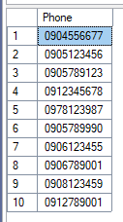
- Description (EXCEPT 1): Find customers who have an ACCOUNT but do not have a LOAN.
SELECT CustomerID FROM ACCOUNT
EXCEPT
SELECT CustomerID FROM LOAN;
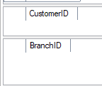
- Description (EXCEPT 2): Find branches that have EMPLOYEEs but no LOANs.
SELECT BranchID FROM EMPLOYEE
EXCEPT
SELECT BranchID FROM LOAN;
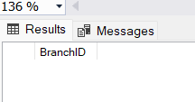
3. Functions
Per the requirement, here are four user-defined functions (UDFs) relevant to the banking domain.
3.1. Function 1: fn_CalculateCustomerAge (Scalar)
- Description: Calculates a customer's current age based on their Date of Birth (DOB).
CREATE FUNCTION fn_CalculateCustomerAge (@DOB DATE)
RETURNS INT
AS
BEGIN
RETURN DATEDIFF(YEAR, @DOB, GETDATE()) -
CASE
WHEN (MONTH(@DOB) > MONTH(GETDATE())) OR
(MONTH(@DOB) = MONTH(GETDATE()) AND DAY(@DOB) > DAY(GETDATE()))
THEN 1
ELSE 0
END;
END;
- Execution:
SELECT CustomerID, FullName, dbo.fn_CalculateCustomerAge(DOB) AS Age
FROM CUSTOMER;
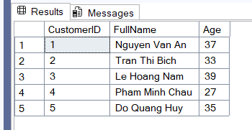
3.2. Function 2: fn_GetCustomerTotalBalance (Scalar)
- Description: Calculates the total balance of a specific customer (CustomerID) by summing the balances of all their accounts.
CREATE FUNCTION fn_GetCustomerTotalBalance (@CustomerID INT)
RETURNS DECIMAL(18, 2)
AS
BEGIN
DECLARE @TotalBalance DECIMAL(18, 2);
SELECT @TotalBalance = SUM(Balance)
FROM ACCOUNT
WHERE CustomerID = @CustomerID;
RETURN ISNULL(@TotalBalance, 0);
END;
- Execution:
SELECT DISTINCT dbo.fn_GetCustomerTotalBalance(CustomerID)
AS Customer1TotalBalance
FROM ACCOUNT
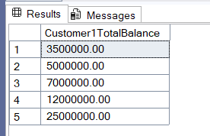
3.3. Function 3: fn_GetAccountsByCustomer (Table-Valued)
- Description: Returns a table containing all accounts (AccountID, AccountType, Balance, Status) for a specific CustomerID.
CREATE FUNCTION fn_GetAccountsByCustomer (@CustomerID INT)
RETURNS TABLE
AS
RETURN (
SELECT AccountID, AccountType, Balance, Status
FROM ACCOUNT
WHERE CustomerID = @CustomerID
);
- Execution:
SELECT * FROM dbo.fn_GetAccountsByCustomer(1);
SELECT * FROM dbo.fn_GetAccountsByCustomer(2);
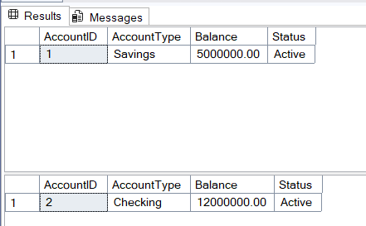
3.4. Function 4: fn_CalculateSimpleInterest (Scalar)
- Description: A helper function to calculate the simple interest on a loan, demonstrating a calculation function.
CREATE FUNCTION fn_CalculateSimpleInterest
(
@LoanAmount DECIMAL(18, 2),
@AnnualRate FLOAT,
@Years INT
)
RETURNS DECIMAL(18, 2)
AS
BEGIN
RETURN @LoanAmount * @AnnualRate * @Years;
END;
- Execution:
SELECT LoanID, LoanAmount, dbo.fn_CalculateSimpleInterest(LoanAmount, 0.05, 1) AS EstimatedInterest FROM LOAN;
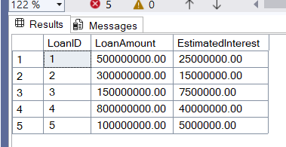
4. Stored Procedures
Here are four stored procedures that perform multi-step operations.
4.1. Procedure 1: sp_AddNewCustomer
- Description: Inserts a new customer record into the CUSTOMER table.
CREATE PROCEDURE sp_AddNewCustomer
@CustomerID INT,
@FullName NVARCHAR(100),
@DOB DATE,
@Address NVARCHAR(255),
@Phone VARCHAR(20),
@Sex VARCHAR(10)
AS
BEGIN
INSERT INTO CUSTOMER (CustomerID, FullName, DOB, Address, Phone, Sex)
VALUES (@CustomerID, @FullName, @DOB, @Address, @Phone, @Sex);
END;
- Execution:
EXEC sp_AddNewCustomer 7, N'Ngo Huy Long', '1990-01-01', N'321 ABC Street, Da Lat', '0992645378', 'Male';
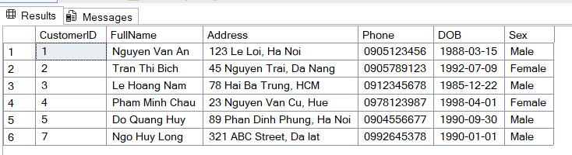
4.2. Procedure 2: sp_PerformTransaction
- Description: Performs a multi-step operation: updates an account balance and inserts a record into the TRANSACTIONS table, all within a single database transaction.

CREATE PROCEDURE sp_PerformTransaction
@AccountID INT,
@Amount DECIMAL(12,2)
AS
BEGIN
DECLARE @CurrentBalance DECIMAL(12,2);
DECLARE @NextTransactionID INT;

SELECT @CurrentBalance = Balance
FROM ACCOUNT
WHERE AccountID = @AccountID;

IF @CurrentBalance IS NULL
PRINT 'Account not found.';
ELSE IF (@CurrentBalance + @Amount) < 0
PRINT 'Insufficient funds to complete transaction.';
ELSE
BEGIN
UPDATE ACCOUNT
SET Balance = Balance + @Amount
WHERE AccountID = @AccountID;

SELECT @NextTransactionID = ISNULL(MAX(TransactionID), 0) + 1
FROM TRANSACTIONS;

INSERT INTO TRANSACTIONS (TransactionID, TransactionDate, Amount, BalanceAfter, AccountID)
VALUES (
@NextTransactionID,
GETDATE(),
@Amount,
(SELECT Balance FROM ACCOUNT WHERE AccountID = @AccountID),
@AccountID
);

PRINT 'Transaction successful.';
END
END;
- Execution (Deposit 25000):
EXEC sp_PerformTransaction 1, 25000.00
- Execution (Withdraw 20000):
EXEC sp_PerformTransaction 1, -20000.00
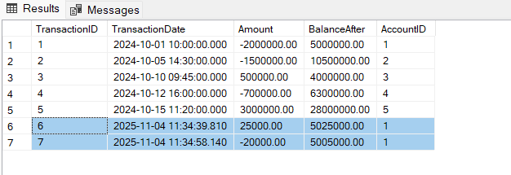
4.3. Procedure 3: sp_GetCustomerBankingSummary
- Description: Generates a summary report for a specific customer, returning their personal details, account list, and loan list.
CREATE PROCEDURE sp_GetCustomerBankingSummary @CustomerID INT
AS
BEGIN
-- 1. Customer Details
SELECT * FROM CUSTOMER WHERE CustomerID = @CustomerID;

-- 2. Account List
SELECT AccountID, AccountType, Balance, Status, OpenDate
FROM ACCOUNT WHERE CustomerID = @CustomerID;

-- 3. Loan List
SELECT LoanID, LoanType, LoanAmount, StartDate, Status
FROM LOAN WHERE CustomerID = @CustomerID;
END;
- Execution:
EXEC sp_GetCustomerBankingSummary 1;
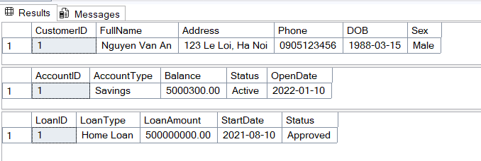
4.4. Procedure 4: sp_UpdateLoanStatus
- Description: A procedure to update related data, specifically changing the Status of a loan (e.g., 'Active', 'PaidOff', 'Default').
CREATE PROCEDURE sp_UpdateLoanStatus
@LoanID INT,
@NewStatus NVARCHAR(20)
AS
BEGIN
UPDATE LOAN
SET Status = @NewStatus
WHERE LoanID = @LoanID;
END;
- Execution:
EXEC sp_UpdateLoanStatus 1, N'Paid Off';
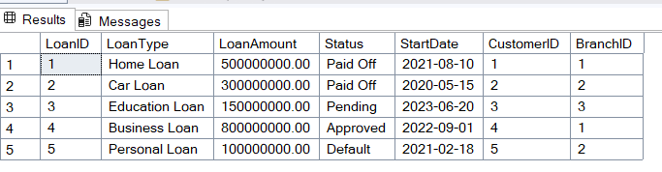

5. Triggers
Here are four triggers to enforce business rules and maintain consistency.
5.1. Trigger 1: trg_PreventBranchDeletion
- Description: This trigger prevents the deletion of a BRANCH record (parent record) if there are still associated child records (employees, accounts, or loans) linked to it. This helps ensure referential integrity.
CREATE TRIGGER trg_PreventBranchDeletion
ON BRANCH
INSTEAD OF DELETE
AS
BEGIN
DECLARE @BranchID INT;
SELECT @BranchID = d.BranchID FROM deleted AS d;

IF EXISTS (SELECT 1 FROM EMPLOYEE WHERE BranchID = @BranchID) OR
EXISTS (SELECT 1 FROM ACCOUNT WHERE BranchID = @BranchID) OR
EXISTS (SELECT 1 FROM LOAN WHERE BranchID = @BranchID)
BEGIN
RAISERROR('Cannot delete branch. Active employees, accounts, or loans are still associated.', 16, 1);
ROLLBACK TRANSACTION;
END
ELSE
BEGIN
DELETE FROM BRANCH WHERE BranchID = @BranchID;
END
END;
- Execution: The command fails and returns the error: Cannot delete branch...
DELETE FROM BRANCH WHERE BranchID = 1;
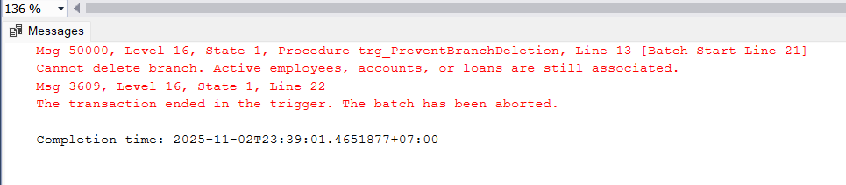

5.2. Trigger 2: trg_LogCustomerPhoneChange
- Description: Automatically logs changes to an audit table (Audit_CustomerChanges) whenever a customer's Phone number is updated.
CREATE TABLE Audit_CustomerChanges (
LogID INT IDENTITY PRIMARY KEY,
CustomerID INT,
OldPhone VARCHAR(20),
NewPhone VARCHAR(20),
ChangeDate DATETIME
);

CREATE TRIGGER trg_LogCustomerPhoneChange
ON CUSTOMER
AFTER UPDATE
AS
BEGIN
IF UPDATE(Phone)
BEGIN
INSERT INTO Audit_CustomerChanges (CustomerID, OldPhone, NewPhone, ChangeDate)
SELECT
i.CustomerID,
d.Phone,
i.Phone,
GETDATE()
FROM
inserted AS i
INNER JOIN
deleted AS d ON i.CustomerID = d.CustomerID
WHERE
i.Phone <> d.Phone;
END
END;
- Execution:
UPDATE CUSTOMER SET Phone = '0905111222' WHERE CustomerID = 1;
SELECT * FROM Audit_CustomerChanges; -- check
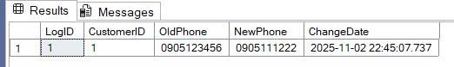
5.3. Trigger 3: trg_EnforceLoanLimit
- Description: Enforces a business rule. Prevents a new LOAN insertion if the customer's total loan amount would exceed 5 times their total deposit balance.
CREATE TRIGGER trg_EnforceLoanLimit
ON LOAN
INSTEAD OF INSERT
AS
BEGIN
DECLARE @CustomerID INT, @NewLoanAmount DECIMAL(18, 2);
DECLARE @TotalBalance DECIMAL(18, 2), @TotalLoans DECIMAL(18, 2);
SELECT @CustomerID = i.CustomerID, @NewLoanAmount = i.LoanAmount FROM inserted i;
SELECT @TotalBalance = ISNULL(SUM(Balance), 0) FROM ACCOUNT WHERE CustomerID = @CustomerID;
SELECT @TotalLoans = ISNULL(SUM(LoanAmount), 0) FROM LOAN WHERE CustomerID = @CustomerID;
IF (@TotalLoans + @NewLoanAmount) > (@TotalBalance * 5)
BEGIN
RAISERROR('Customer exceeds credit limit (5x total deposits). New loan denied.', 16, 1);
ROLLBACK TRANSACTION;
END
ELSE
BEGIN
INSERT INTO LOAN (LoanID, LoanType, LoanAmount, Status, StartDate, CustomerID, BranchID)
SELECT LoanID, LoanType, LoanAmount, Status, StartDate, CustomerID, BranchID FROM inserted;
END
END;
- Execution: Fails with error: Customer exceeds credit limit...
INSERT INTO LOAN (LoanID, LoanType, LoanAmount, Status, StartDate, CustomerID, BranchID)
VALUES (6, 'Personal Loan', 10000000, 'Pending', GETDATE(), 1, 1);
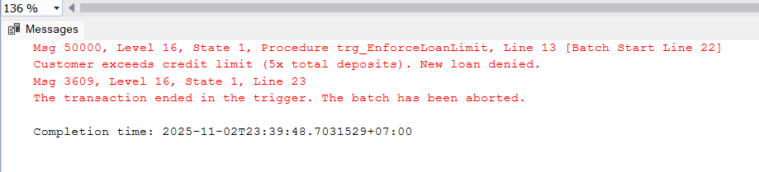
- Execution: The INSERT succeeds and the new loan (LoanID = 7) is added.
INSERT INTO LOAN (LoanID, LoanType, LoanAmount, Status, StartDate, CustomerID, BranchID)
VALUES (7, 'Car Loan', 10000000, 'Pending', GETDATE(), 5, 2);
SELECT * FROM LOAN WHERE LoanID = 7;
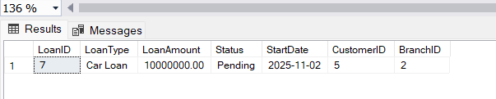
5.4. Trigger 4: trg_PreventClosingNonZeroBalanceAccount
- Description: This is the fourth required trigger. It enforces a business rule that prevents an account's Status from being changed to 'Closed' if its Balance is not 0.
CREATE TRIGGER trg_PreventClosingNonZeroBalanceAccount
ON ACCOUNT
AFTER UPDATE
AS
BEGIN
-- Check if an update tried to set Status to 'Closed' on an account with money
IF EXISTS (
SELECT 1
FROM inserted i
JOIN deleted d ON i.AccountID = d.AccountID
WHERE i.Status = 'Closed' AND d.Status <> 'Closed' AND i.Balance <> 0
)
BEGIN
RAISERROR('Cannot close an account with a non-zero balance. Please withdraw all funds first.', 16, 1);
ROLLBACK TRANSACTION;
END
END;
- Execution: The command fails and returns the error: Cannot close an account with a non-zero balance...
-- AccountID = 1 has a balance of 5,000,000.
UPDATE ACCOUNT SET Status = 'Closed' WHERE AccountID = 1;
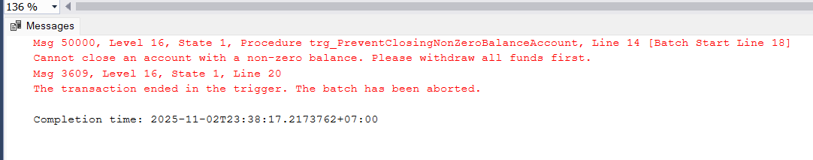
6. View and Index
6.1. Views
6.1.1. View 1: vw_CustomerAccountDetails
- Description: Defines a view to simplify complex queries. This view provides a straightforward way to see customer account details without needing to write the JOINs manually.
CREATE VIEW vw_CustomerAccountDetails AS
SELECT
C.CustomerID, C.FullName, C.Phone,
A.AccountID, A.AccountType, A.Balance, A.Status AS AccountStatus,
B.BranchName
FROM CUSTOMER AS C
JOIN ACCOUNT AS A ON C.CustomerID = A.CustomerID
JOIN BRANCH AS B ON A.BranchID = B.BranchID;
- Execution:
SELECT * FROM vw_CustomerAccountDetails WHERE FullName LIKE N'Nguyen Van A%';
6.1.2. View 2: vw_BranchLoanSummary
- Description: This view summarizes the total loan amount and the count of loans for each branch. It is useful for management reports to assess the performance of each branch.

CREATE VIEW vw_BranchLoanSummary AS
SELECT B.BranchName,
COUNT(L.LoanID) AS NumberOfLoans,
SUM(L.LoanAmount) AS TotalLoanAmount
FROM BRANCH AS B
LEFT JOIN LOAN AS L ON B.BranchID = L.BranchID
GROUP BY B.BranchName;
- Execution:
SELECT * FROM vw_BranchLoanSummary;
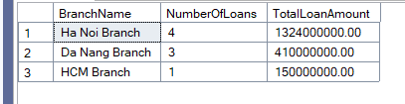
6.2. Views
6.2.1. Index 1: idx_Customer_Phone (Single Column)
- Description: Creates a UNIQUE, non-clustered, single-column index on the Phone column of the CUSTOMER table. Since a phone number is unique and often used for customer lookups, this index will significantly improve the performance of queries that filter by phone number.
CREATE UNIQUE INDEX idx_Customer_Phone
ON CUSTOMER(Phone);
- Execution:
SELECT * FROM CUSTOMER WHERE Phone = '0905123456';
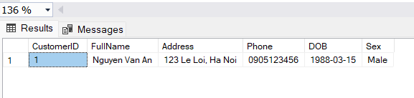
6.2.2. Index 2: idx_Account_CustomerBranch (Composite)
- Description: Creates a composite index on the CustomerID and BranchID columns in the ACCOUNT table. This index is designed to improve the performance of queries that frequently filter or join on both the customer and their branch.
CREATE INDEX idx_Account_CustomerBranch
ON ACCOUNT(CustomerID, BranchID);
- Execution:
SELECT AccountID, Balance FROM ACCOUNT
WHERE CustomerID = 1 AND BranchID = 1;

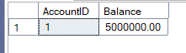
7. AI Utilization
During the development of Lab 5: Banking System, our group used AI tools to improve code quality, accuracy, and efficiency through Good Prompts, Debugging, and Refinement.
Good Prompts: AI suggested optimized SQL syntax for functions like fn_CalculateCustomerAge and helped structure multi-step logic in sp_PerformTransaction, ensuring clarity and efficiency.
Debugging: When testing sp_PerformTransaction, AI helped locate and fix a logic error in the balance validation condition IF (@CurrentBalance + @Amount) < 0, improving transaction accuracy.
Refinement: AI improved trigger efficiency, such as recommending IF UPDATE(Phone) with i.Phone <> d.Phone in trg_LogCustomerPhoneChange, so it runs only when the phone number changes.
AI served as a support tool, not a generator. All outputs were reviewed, tested, and aligned with our database’s business logic.
8. Conclusion and Reflection
Conclusion: Lab 5 enabled our group to apply advanced SQL concepts to the Banking System project. We completed:
- SQL queries (Basic → Intermediate → Advanced)
- 4 functions, 4 procedures, 4 triggers
- 2 views and 2 indexes
These elements simplify data handling, automate operations, and enforce data integrity.
Reflection (Computational Thinking & AI Use):
- Decomposition: We broke down complex tasks (e.g., deposit handling) into smaller parts in sp_PerformTransaction.
- Abstraction: Views (vw_CustomerAccountDetails) and functions (fn_GetCustomerTotalBalance) simplified complex joins for end users.
- Pattern Recognition: We reused logic patterns such as preventing parent deletion (trg_PreventBranchDeletion) and indexing frequent searches (Customer.Phone).
- Algorithmic Thinking: Procedures and triggers followed structured steps—validate, update, handle errors—ensuring reliable logic.
- AI Assistance: AI supported debugging and optimization. All suggestions were verified to maintain accuracy and originality.
Final Reflection: This lab enhanced our SQL design and teamwork skills. Combining computational thinking with AI refinement helped us build a more effective and reliable database system.

