  
  
  
  
  
  
  
  
  
  
  
  
  
**football news website  
Software Requirement Specification**  
  
  
  
  
  
  
  
  
  
  
  
  
  
  
  
  
  
  
  
  
  
  
  
– Hanoi, June 25, 2022 –

I[. Overview](https://docs.google.com/document/d/1GsRBEY69EMq3obhsgGH32WX2794Lkn3v/edit?fbclid=IwAR3F_r4i1CE8Oz91RARKwiCEKqacGFp10msQq1g9_K8PmKSNWDFjW4CxeRw#heading=h.tyjcwt)   
 1[. Introduction](https://docs.google.com/document/d/1GsRBEY69EMq3obhsgGH32WX2794Lkn3v/edit?fbclid=IwAR3F_r4i1CE8Oz91RARKwiCEKqacGFp10msQq1g9_K8PmKSNWDFjW4CxeRw#heading=h.26in1rg)

2[. System Function  
  
II.](https://docs.google.com/document/d/1GsRBEY69EMq3obhsgGH32WX2794Lkn3v/edit?fbclid=IwAR3F_r4i1CE8Oz91RARKwiCEKqacGFp10msQq1g9_K8PmKSNWDFjW4CxeRw#heading=h.26in1rg)[Functional Requirements](https://docs.google.com/document/d/1GsRBEY69EMq3obhsgGH32WX2794Lkn3v/edit?fbclid=IwAR3F_r4i1CE8Oz91RARKwiCEKqacGFp10msQq1g9_K8PmKSNWDFjW4CxeRw#heading=h.tyjcwt)  
  
 1[. Feature Common](https://docs.google.com/document/d/1GsRBEY69EMq3obhsgGH32WX2794Lkn3v/edit?fbclid=IwAR3F_r4i1CE8Oz91RARKwiCEKqacGFp10msQq1g9_K8PmKSNWDFjW4CxeRw#heading=h.26in1rg)

[a. Login](https://docs.google.com/document/d/1GsRBEY69EMq3obhsgGH32WX2794Lkn3v/edit?fbclid=IwAR3F_r4i1CE8Oz91RARKwiCEKqacGFp10msQq1g9_K8PmKSNWDFjW4CxeRw#heading=h.lnxbz9)

[b. Register  
c. Forgot Password](https://docs.google.com/document/d/1GsRBEY69EMq3obhsgGH32WX2794Lkn3v/edit?fbclid=IwAR3F_r4i1CE8Oz91RARKwiCEKqacGFp10msQq1g9_K8PmKSNWDFjW4CxeRw#heading=h.35nkun2)

d[. User Profile  
e. Change Password](https://docs.google.com/document/d/1GsRBEY69EMq3obhsgGH32WX2794Lkn3v/edit?fbclid=IwAR3F_r4i1CE8Oz91RARKwiCEKqacGFp10msQq1g9_K8PmKSNWDFjW4CxeRw#heading=h.35nkun2)

2[. Feature Public](https://docs.google.com/document/d/1GsRBEY69EMq3obhsgGH32WX2794Lkn3v/edit?fbclid=IwAR3F_r4i1CE8Oz91RARKwiCEKqacGFp10msQq1g9_K8PmKSNWDFjW4CxeRw#heading=h.26in1rg)

a[.](https://docs.google.com/document/d/1GsRBEY69EMq3obhsgGH32WX2794Lkn3v/edit?fbclid=IwAR3F_r4i1CE8Oz91RARKwiCEKqacGFp10msQq1g9_K8PmKSNWDFjW4CxeRw#heading=h.35nkun2) [Home](https://docs.google.com/document/d/1QE98nRebuO_29eRAOJ6XhIBVfDYjzzeu/edit#heading=h.35nkun2)

b[. News List](https://docs.google.com/document/d/1GsRBEY69EMq3obhsgGH32WX2794Lkn3v/edit?fbclid=IwAR3F_r4i1CE8Oz91RARKwiCEKqacGFp10msQq1g9_K8PmKSNWDFjW4CxeRw#heading=h.35nkun2)

c[.](https://docs.google.com/document/d/1GsRBEY69EMq3obhsgGH32WX2794Lkn3v/edit?fbclid=IwAR3F_r4i1CE8Oz91RARKwiCEKqacGFp10msQq1g9_K8PmKSNWDFjW4CxeRw#heading=h.35nkun2) News Details

3[. Feature Reader](https://docs.google.com/document/d/1GsRBEY69EMq3obhsgGH32WX2794Lkn3v/edit?fbclid=IwAR3F_r4i1CE8Oz91RARKwiCEKqacGFp10msQq1g9_K8PmKSNWDFjW4CxeRw#heading=h.26in1rg)  
 a. Comment

4[. Feature](https://docs.google.com/document/d/1GsRBEY69EMq3obhsgGH32WX2794Lkn3v/edit?fbclid=IwAR3F_r4i1CE8Oz91RARKwiCEKqacGFp10msQq1g9_K8PmKSNWDFjW4CxeRw#heading=h.26in1rg) Journalist

a[. Management News](https://docs.google.com/document/d/1GsRBEY69EMq3obhsgGH32WX2794Lkn3v/edit?fbclid=IwAR3F_r4i1CE8Oz91RARKwiCEKqacGFp10msQq1g9_K8PmKSNWDFjW4CxeRw#heading=h.35nkun2)

5[. Feature](https://docs.google.com/document/d/1GsRBEY69EMq3obhsgGH32WX2794Lkn3v/edit?fbclid=IwAR3F_r4i1CE8Oz91RARKwiCEKqacGFp10msQq1g9_K8PmKSNWDFjW4CxeRw#heading=h.26in1rg) Admin

a[. Management News](https://docs.google.com/document/d/1GsRBEY69EMq3obhsgGH32WX2794Lkn3v/edit?fbclid=IwAR3F_r4i1CE8Oz91RARKwiCEKqacGFp10msQq1g9_K8PmKSNWDFjW4CxeRw#heading=h.35nkun2)

b[.](https://docs.google.com/document/d/1GsRBEY69EMq3obhsgGH32WX2794Lkn3v/edit?fbclid=IwAR3F_r4i1CE8Oz91RARKwiCEKqacGFp10msQq1g9_K8PmKSNWDFjW4CxeRw#heading=h.35nkun2) Management User  
  
  
  
  
  
**I. Overview**

**1. Introduction** The aim of this project is to create a website to read and view the latest football news such as transfers, results, and outside information about players, coaches, and clubs. The news on the website will belong to various leagues worldwide.  
  
  
**2. System Functions  
  
*a. ERD Diagram  
  
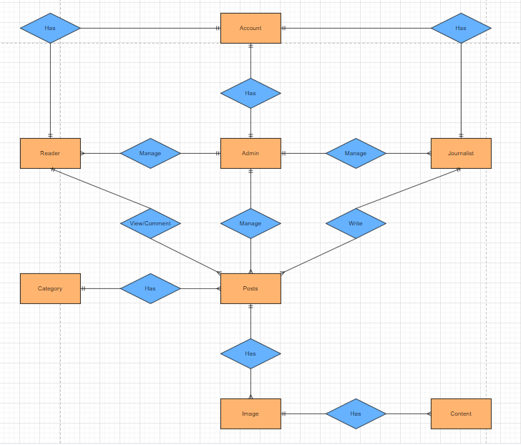  
  
b. Screen Details***

|  |  |  |  |
| --- | --- | --- | --- |
| **#** | **Function/Screen** | **Feature** | **Function/Screen Details** |
| 1 | User Login | Common | This is the screen when the user pops up allowing the user to enter an email and password to log in, on the page, there are also options for the user to register a new account, reset the password in case of forgetting. |
| 2 | User Register | Common | This screen allows the user to sign up for an account by entering the following information: username, email, password, confirm password. After that, the user needs to verify by entering the code that the system sent via email to confirm. |
| 3 | Reset Password | Common | The user of this screen enters his email to receive a random code, then goes to the page to check the code entered, if check successfully to the page to change the password, and then will enter a new password. |
| 4 | User Profile | Common | This is a pop-up screen that allows the user to edit their profile information, including information: avatar, username. Note she/he is not allowed to change the email. |
| 5 | Change Password | Common | This is a pop-up screen that allows the user to edit their password by enter old password, new password and confirm passowrd. Note she/he is not allowed to change the email. |
| 6 | Home | Public | The header shows the list of category and the search bar, the body shows the last 5 posts, the article frame shows the title, title image, creation date and short description |
| 7 | News [List](https://docs.google.com/document/d/1GsRBEY69EMq3obhsgGH32WX2794Lkn3v/edit?fbclid=IwAR3F_r4i1CE8Oz91RARKwiCEKqacGFp10msQq1g9_K8PmKSNWDFjW4CxeRw#heading=h.35nkun2) | Public | Displays a list of articles paginated by category, users clicking on the image of the article will go to their Newss Details screen. |
| 8 | News Details | Public | Display detailed information about the posts that the user just clicked. |
| 9 | Comment | Reader | This function allow user comment to news that they view details |
| 10 | Management News | Journalist | Show all news that this Journalist written, allow Journalist add, edit, update their news |
| 11 | Management News | Admin | Show all news in the system, allow admin add, edit, update news |
| 12 | Management User | Admin | Display a list of all users, allow admin add, edit, update user |

***c. Use-Case Diagram  
  
