HE186351-LAB 4

B1

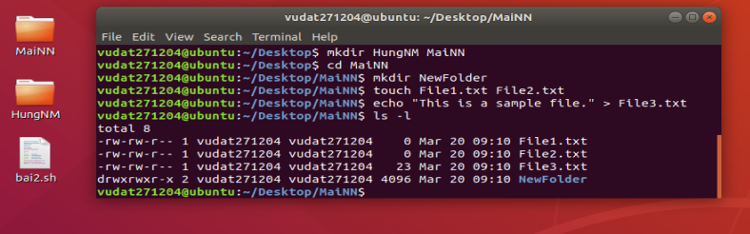

B2

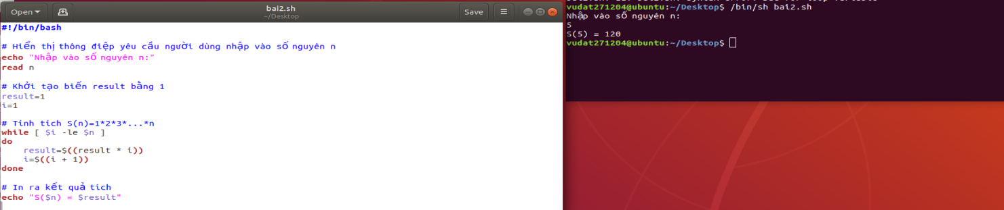

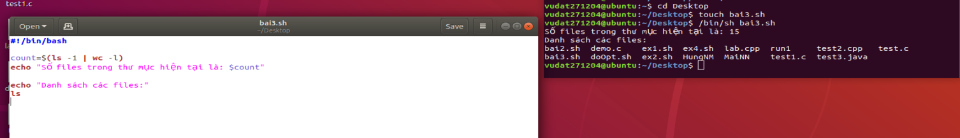

B3

