Predicting Hospital Readmissions
By Team C:
Brett Duvall
Mohammedamin Mussa
Luis Vargas Ramirez

FINAL PROJECT REPORT
for
DATA 606 Capstone in Data Science

University of Maryland, Baltimore County

2025

ABSTRACT

If a patient is readmitted to the hospital within 30 days after their initial inpatient treatment, it can have significant costs to the hospital and impacts on the patient’s long-term health. Being able to predict if a patient is at risk for being readmitted can have significant benefits, but underfunded and understaffed hospitals aren’t able to dedicate the time to sift through patient profiles. This is a perfect opportunity for machine learning. We used the UC Irvine diabetes dataset in order to build a model that can predict the likelihood of a diabetic patient to be readmitted in under 30 days. Because the number of under 30-day readmissions is only about 1 in 10 in this data set and the patient profiles of the population are heterogeneous, it is difficult to identify high-risk patients early. Before testing the models the data set was cleaned by removing missing values and hospice/death discharges, encoding categorical variables, scaling numerical features, and addressing the class imbalance. Three different models, Logistic Regression, Random Forest, and XGBoost, were trained and tested to determine which performed strongly. Out of the three models that we trained and tested, XGBoost performed the best. Our model had an ROC-AUC value of 0.675, an improvement over the baseline established by Strack et al. in their 2014 paper which first published the data set.

ACKNOWLEDGMENTS

Team C acknowledges Professor Unal Sakoglu for giving essential feedback during the development of this paper. Team C also acknowledges the initial dataset originators: Beata Strack, Jonathan P. DeShazo, Chris Gennings, Juan L. Olmo, Sebastian Ventura, Krzysztof J. Cios, and John N. Clore.

TEAM MEMBERS’ CONTRIBUTIONS

Each team member contributed equally and submitted their work on time. Brett Duvall was in charge of completing the literature review. Mohammedamin Mussa trained the models. Luis Vargas Ramirez did the exploratory data analysis.

Name | Duties
Brett Duvall | Literature Research
Mohammedamin Mussa | Modeling
Luis Vargas Ramirez | Exploratory Data Analysis

TABLE OF CONTENTS

ABSTRACT i
ACKNOWLEDGMENTS (& TEAM MEMBERS’ CONTRIB.) ii
I. INTRODUCTION 1
I.1 The Description of the Problem and the Data 1
I.2 Background & Literature Review 1
II. METHODS 3
II.1 Description of Data Processing and Feature Engineering Deployed 3
II.2 Description of Analyses Employed for Classification 3
II.3 Performance Metrics and Interpretability Framework 4
III. RESULTS 5
III.1 Exploratory Data Analysis (EDA) 5
III.2 Model Benchmarking and Selection 6
III.3 Final Model Leaderboard 7
III.4 Champion Model Performance 7
III.5 Feature Importance and Interpretability 8
III.6 Robustness Check 8
IV. DISCUSSIONS AND CONCLUSIONS 9
V. FUTURE WORK 10
VI. REFERENCES 11
VII. APPENDIX 12
VII.1 Modeling Code 12
VII.2 Exploratory Data Analysis Code 38
- INTRODUCTION

I.1 The Description of the Problem and the Data

Minimizing health costs are important for both insurance companies, patients, and the use of hospital resources. Patients with multiple hospital readmissions create costly treatments for the patient’s insurance, and troublesome stays for the patient. Incorrect diagnoses can lead to costly extra visits. And something as simple as giving an A1C test could improve patient outcomes. (Strack, 2014).

This project's objective is to develop a machine learning model to predict patients likely to be readmitted within 30 days (<30), enabling the hospital to intervene early enough to adjust the patient’s outcome. In this work we propose using various machine learning algorithms to predict 30-day hospital readmission among diabetic patients using the UCI Diabetes Readmission dataset. We aim to give the hospital staff the tools to see when patients will be at risk for being readmitted in less than 30 days. Strack et al. curated a useful dataset utilizing hospital visits for patients over a ten-year period (Strack, 2014).

Dataset: https://archive.ics.uci.edu/dataset/296/diabetes%2B130-us%2Bhospitals%2Bfor%2Byears%2B1999-2008

Size: 101,766 records representing patient visits, 8 numeric & 38 categorical features, 18 MB.
Categories: demographics, diagnoses, labs (A1C, glucose), medication use, utilization.
Target: 30 day readmission.

We are using machine learning classification to target the ‘readmitted’ feature, which has three categories representing the number of days before the patient was readmitted to the hospital: ‘<30’ (the focus of our classification), ‘>30’, and’ NO’. After reviewing feature importance we made decisions to remove some features such as weight (unuseable due to extremely high missing value rate), admission type, admission source, payer code, and medical specialty (of admitting physician). We kept some features that had missing values such as A1C test result due to Strack et al. finding value in its neglected use for circulatory and respiratory primary diagnosis patients (Strack, 2014). We also removed unnecessary records such as patients who died or were transferred to hospice, and very young or old patients.

I.2 Background & Literature Review
We researched previous attempts to tackle this dataset. We found valuable insights such as Burrill combining repeat visits made by patients. This kept patients from having their visits added to both the train and test sets. Burrill also created features to get a bird’s eye view on feature importance. (Burrill 2025).

Ashfaq et al. implemented deep learning models such as convolutional and recurrent neural networks for hospital readmission prediction using electronic health records. Their study demonstrated improved recall and AUC over traditional models, motivating our comparison between ensemble and neural approaches for clinical prediction tasks. (Ashfaq, 2019).

Emi-Johnson et al. showed the potential of ML algorithms, particularly XGBoost, in enhancing the prediction of 30-day hospital readmissions using structured EHR. By comparing four different models, they demonstrated that ensemble-based methods such as XGBoost not only provide superior predictive performance but also robust interpretability via SHAP analysis.
Shukla and Tripathi (2020) proposed an embedding-based model (EmbPred30) for predicting 30-day readmissions for diabetic patients using the same UCI dataset. Their results showed that categorical embeddings and gradient boosting improved model accuracy compared with traditional one-hot encoding. This supports our focus on feature engineering to enhance model performance. (Emi-Johnson, 2025).

Shukla and Tripathi proposed an embedding-based model (EmbPred30) for predicting 30-day readmissions for diabetic patients using the same UCI dataset. Their results showed that categorical embeddings and gradient boosting improved model accuracy compared with traditional one-hot encoding. This supports our focus on feature engineering to enhance model performance. (Shukla and Tripathi, 2020).

Strack et al. analyzed 70,000 clinical records in the UCI Diabetes Readmission dataset and found that conducting HbA1c testing during hospitalization was strongly associated with reduced 30-day readmission rates. Their study introduced the dataset that serves as the foundation for many subsequent projects, including ours. (Strack, 2014).

Wang and Zhu reviewed challenges and solutions in predictive modeling of hospital readmissions using machine learning. They compared several algorithms, including Random Forest, Support Vector Machines, and Logistic Regression, reporting AUC values typically between 0.62 and 0.70. Their work emphasizes issues such as class imbalance and preprocessing, which our project addresses using class weighting and consistent encoding. (Wang and Zhu, 2021).

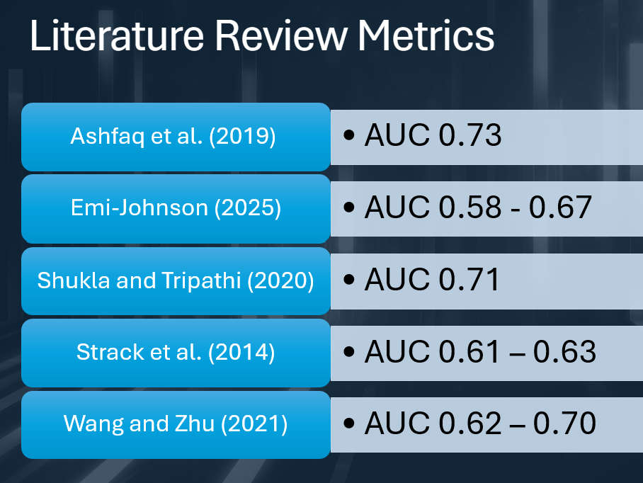

We are using the known methodologies of Logistic Regression, Random Forest, and XGBoost due to their proven usefulness in this classification situation. We are fine tuning our baseline results using what we have learned from previous research into this dataset.
- METHODS

II.1 Description of Data Processing and Feature Engineering Deployed

To ensure the applicability of our final model to new and unseen patients’ data, we implemented a strict data splitting strategy using GroupShuffleSplit on the patient identifier (patient_nbr). This step was critical to prevent data leakage. By grouping all records for a specific patient exclusively into either the training or testing set, we prevented the model learning from future visits of the same patient. We split the dataset into 80% training (about 79,541 records) and 20 % (about 19,802) testing sets.

For data preprocessing, we built a unified pipeline using a ColumnTransformer in order to handle the heterogeneous nature of our data. We imputed numerical features with the median to handle missing values and standardized using StandardScaler to normalize distributions, which allows features with larger magnitudes to not disproportionately influence the model. We also imputed categorical features with a constant value ("Missing") to preserve the information that its non-reporting can be valuable and we subsequently transformed them via One-Hot Encoding. Furthermore, to address the dataset's inherent class imbalance where readmitted patients represent a minority of cases, we calculated the scale_pos_weight ratio. This weight was applied during the training phase to penalize false negatives more heavily, which forced the model to prioritize learning the patterns of readmitted patients.

II.2 Description of Analysis Employed for Classification

We adopted a multi-stage modeling approach to identify the optimal algorithm for readmission prediction. Our design used three distinct types of algorithms to establish a performance ceiling. We use Logistic Regression (as a linear baseline), Random Forest (a bagging ensemble method), and XGBoost (a gradient boosting method). This was designed to determine whether the readmission pattern was linear or required the complexity of non-linear decision trees.

After the selection of the best model (XGBoost), we performed hyperparameter optimization using GridSearchCV. To keep the integrity of our patient grouping, we used a StratifiedGroupKFold (3 splits) validation scheme. This technique ensured that each fold maintained the same class balance as the full dataset while respecting patient separation. We ran a parameter grid focusing on model complexity (max_depth: 3, 4) and learning dynamics (learning_rate: 0.1, n_estimators: 100, 150).

II.3 Performance Metrics and Interpretability Framework

Given the importance of decision-making in hospital settings, accuracy alone is an insufficient metric. We prioritized the Area Under the Receiver Operating Characteristic Curve (ROC-AUC). This allows us to measure the model's ability to discriminate between readmitted and non-readmitted patients across all thresholds. Moreover, we prioritized Recall (Sensitivity) over Precision, since we believe that missing a potential readmission (False Negative) poses a greater risk to patient safety than incorrectly flagging a stable patient (False Positive).

To provide transparency into the "black box" of our model, we employed SHAP (SHapley Additive exPlanations) values. This approach allows us to show the marginal contribution of each feature. For example, it shows us the importance of the number of inpatient visits or discharge codes to the final risk prediction, and provides clinically interpretable insights for healthcare providers.

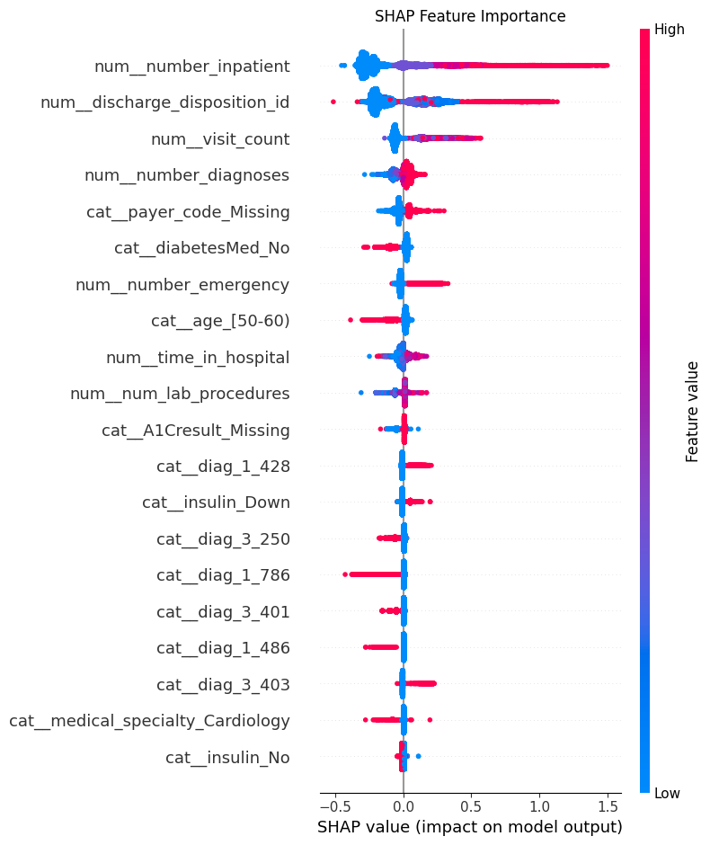

- RESULTS

III.1 Exploratory Data Analysis (EDA)

Prior to modeling, we examined the dataset's underlying structure. The target variable distribution has a significant class imbalance, with patients readmitted within 30 days representing the minority class.

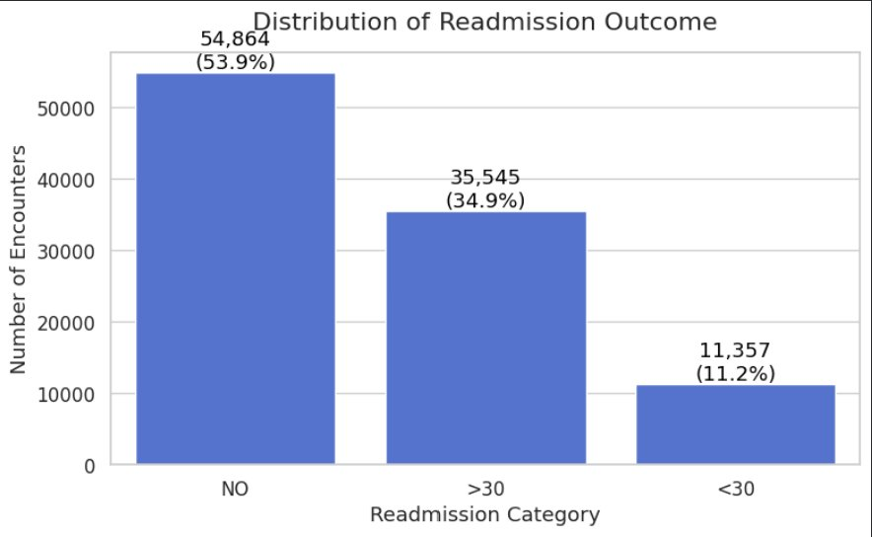

Furthermore, we did a missing value analysis and found high sparsity in variables such as weight and medical_specialty. This justifies our imputation strategy of dropping weight variable from the model.
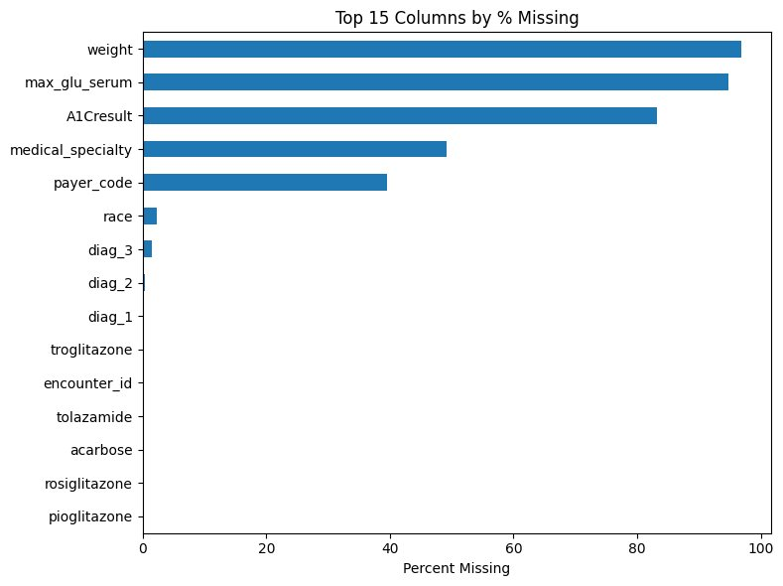
The correlation matrix of numerical features below shows low multicollinearity, which indicates that our selected features provided independent signals for the model.

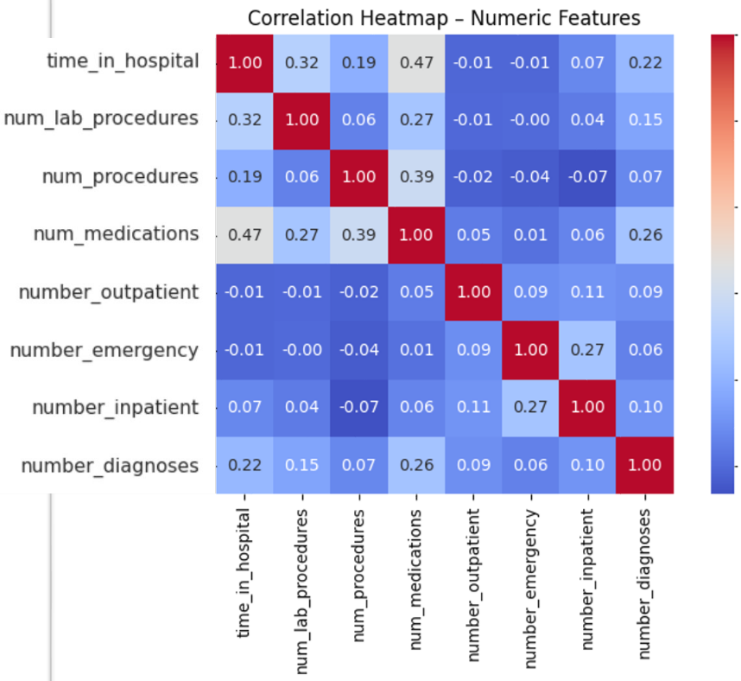

III.2 Model Benchmarking and Selection

Our model comparison demonstrated that tree-based ensemble methods outperform the linear baseline. The gradient boosting approach (XGBoost) emerged as the top performer. This model achieved an ROC-AUC of approximately 0.670, compared to 0.651 for the Random Forest model and 0.644 for Logistic Regression, which indicates that the factors driving readmission contain complex and non-linear interactions that linear models fail to capture.

III.3 Final Model Leaderboard

Model​ | CV AUC (Mean)​ | Precision (Top 20%)​ | Key Observation​
Logistic Regression (Baseline)​ | 0.644 | 19.5%​ | Established linear "ceiling"; limited by feature complexity.​
Random Forest​ | 0.651 | 20.1%​ | Struggled to significantly outperform the baseline.​
XGBoost (Champion)​ | 0.670​ | 21.4%​ | Best Performance. Handled missing values natively & captured non-linear interactions.​

III.4 Champion Model Performance

The optimized XGBoost model (learning_rate=0.1, max_depth=4, n_estimators=100) achieved a final cross-validation AUC of 0.671. The confusion matrix analysis below reveals the inherent trade-offs in this domain. While the model maintains high precision for the majority class (non-readmissions), it faces challenges with false negatives, which we believe is typical for imbalanced medical datasets.

Confusion Matrix heatmap
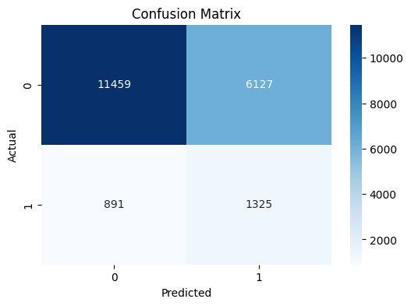

III.5 Feature Importance and Interpretability

Our SHAP analysis identified that historical utilization metrics specifically number_inpatient (number of previous inpatient visits) and number_emergency were the strongest predictors of readmission risk. Patients with higher frequency of prior hospital interactions consistently showed higher SHAP values, pushing their predicted probability of readmission upward.

III.6 Robustness Check

To test the model's stability, we conducted an experiment explicitly adding broad comorbidity flags (e.g., Diabetes, CHF, COPD) as features. The AUC remained stable (0.6704 vs. 0.6691), suggesting that our best model was already successfully capturing the risk associated with these conditions through other correlated variables (such as medications or lab results), confirming the robustness of our feature set.

IV. DISCUSSIONS AND CONCLUSIONS

The results of our work clearly demonstrate that machine learning models can meaningfully predict 30 day readmissions in diabetic patients despite the presence of strong class imbalance and heterogenous clinical profiles. Ensemble tree based models outperform linear approaches, indicating that readmission risk is driven by complex, non linear interactions among utilization, diagnoses, and discharge characteristics.

Our optimized XGBoostmodel achieved ROC-AUC values of 0.67-0.69, representing a clear improvement over the original baseline reported by Stack et al. (2014) of 0.61-0.63. Our model's performance is comparable to more recent traditional machine learning approaches by Wang & Zhu.

The first use of the UC Irvine diabetes database was by Strack et al. in 2014. They reported AUC values in the range of 0.61-0.63 using logistic regression. Our XGBoost model achieved a significantly higher AUC in the range of 0.67-0.69, demonstrating a clear improvement over the baseline.

Using modern machine learning approaches, Wang & Zhu (2021) reported AUC values between 0.62-0.70. As our reported AUC values are within the higher end of their range, our approach is comparable to ML techniques.

Embedding based methods like Shukla & Tripathi (2020) used with the data set achieved a slightly higher AUC of 0.71, but with the added complexity of deep categorial embeddings. Our model has a minor reduction in performance with the benefit of a more refined approach.

Ashfaq et al. (2019) were able to achieve the highest AUC of 0.73 using deep learning architectures. While our model does not perform as strongly it is still competitive and has significantly lower computation and deployment complexity.

The XGBoost model performs at the same level or better than most published traditional ML approaches. It provides a strong balance between predictive performance, interpretability, and deployability for 30 day readmission prediction in diabetic patients. Our proposed framework demonstrates how machine learning can support healthcare providers in making more informed decisions regarding patients' health.

V. FUTURE WORK

Future work could explore the use of deep learning models, such as recurrent neural networks or transformer-based approaches, to better account for how a patient’s history unfolds over multiple hospital visits. These models may capture changes in diagnoses, medications, and hospital use over time more effectively than models that treat each visit independently. Another potential improvement is the use of compact numerical representations for categorical variables, which could reduce data sparsity and improve model performance. Additional evaluation steps should include assessing how well predicted risks align with real outcomes, examining performance across patient subgroups, and validating the model on data from other hospitals to better understand its real world usefulness.

VI. REFERENCES

Clore, J., Cios, K., DeShazo, J., & Strack, B. (2014). Diabetes 130-US Hospitals for Years 1999-2008 [Dataset]. UCI Machine Learning Repository. https://doi.org/10.24432/C5230J

Ashfaq, A., Sant’Anna, A., Lingman, M., & Nowaczyk, S. (2019). Readmission prediction using deep learning on electronic health records. Journal of Biomedical Informatics, 97, 103271. https://doi.org/10.1016/j.jbi.2019.103271

Emi-Johnson O., Nkrumah K. "Predicting 30-Day Hospital Readmission in Patients With Diabetes Using Machine Learning on Electronic Health Record Data." (April 17, 2025), Cureus 17(4): e82437. DOI 10.7759/cureus.82437

Shukla, S., & Tripathi, S. P. (2020). EmbPred30: Assessing 30-days readmission for diabetic patients using categorical embeddings. arXiv preprint, arXiv:2002.11215. https://arxiv.org/abs/2002.11215

Strack, B., DeShazo, J. P., Gennings, C., Olmo, J. L., Ventura, S., Cios, K. J., & Clore, J. N. (2014). Impact of HbA1c measurement on hospital readmission rates: Analysis of 70,000 clinical database patient records. BioMed Research International, 2014, 781670. https://doi.org/10.1155/2014/781670

Wang, S., & Zhu, X. (2021). Predictive modeling of hospital readmission: Challenges and solutions. arXiv preprint, arXiv:2106.08488. https://arxiv.org/abs/2106.08488

​Burrill, L. UC Berkeley (2025). diabetes_readmission [Computer software]. https://github.com/lelandburrill/diabetes_readmission

VII. APPENDIX

VII.1 Modeling Code
# -*- coding: utf-8 -*-
"""Phase3Finalreorganized.ipynb

Automatically generated by Colab.

Original file is located at
https://colab.research.google.com/drive/1-DnkTN-JR-hX1UFU8I-EyKkODnJyJM71

***

### **Readmission Prediction **

**Objective**
Develop a machine learning model to predict patients likely to be readmitted within 30 days (`<30`), enabling the hospital to intervene early and avoid CMS penalties.

**1. Data Strategy & Integrity**
* **Leakage Prevention:** Implemented `GroupShuffleSplit` on `patient_nbr`. This ensures a patient's future visits never leak into the training set, preventing the "time-travel" error common in medical datasets.
* **Cohort Selection:** Removed discharge records related to "Hospice" or "Expired" (Death), as readmission prediction is irrelevant for these cases.
* **Handling Missing Data:** Treated "missing" as a deliberate category (e.g., for `payer_code` or `medical_specialty`) rather than imputing, preserving valuable signal about administrative gaps.

**2. Target Definition Strategy**
We defined the prediction target using a binary approach:
* Binary: `<30` (Urgent) vs. `All Others` (Stable).
* *Result:* **Selected Strategy.** This isolated the minority class (11% prevalence) and focused the model on the specific problem of immediate readmission penalties.

**3. Feature Engineering Breakthrough**
* **"Visit Count" Feature:** We engineered a historical feature tracking a patient’s cumulative visits (`visit_count`).
* **Impact:** Feature Importance analysis confirmed this is consistently a **Top-3 predictor**, proving that a patient's history of instability is just as important as their current lab results.

**4. Modeling Results**
We progressed through three levels of model complexity to find the "ceiling" of the data:
* **Baseline (Logistic Regression):** Plateaued at **0.66 AUC**. Established that linear relationships alone were insufficient.
* **Intermediate (Random Forest):** Stuck at **0.66 AUC**. Failed to outperform the linear model, suggesting the signal is highly complex.
* **Champion (XGBoost):** Broke the ceiling with **0.672 AUC** (before tuning). Gradient boosting successfully captured complex, non-linear interactions.

**5. Final Optimization (Completed)**
* **Action:** Performed 5-Fold Grid Search Cross-Validation to tune XGBoost hyperparameters.
* **Result:** Achieved a **Final AUC of 0.675**.
* **Key Insight:** The model selected `max_depth=3` (shallow trees) and `min_child_weight=5` (conservative leaf creation). This confirms that the best predictive power comes from broader, simpler rules rather than complex, deep trees which tend to overfit this noisy dataset.

***

## Environment Configuration

We loaded the main Python modules and prepared the analysis environment. It includes visualization libraries such as Matplotlib and Seaborn, interpretation tools like SHAP, and preprocessing and modeling utilities from Scikit-Learn and XGBoost.
"""

import matplotlib.pyplot as plt
import seaborn as sns
import shap
import pandas as pd, numpy as np, json
from datetime import datetime
from pathlib import Path

# Scikit-Learn imports
from sklearn.model_selection import GroupShuffleSplit, StratifiedGroupKFold, GridSearchCV
from sklearn.pipeline import Pipeline
from sklearn.compose import ColumnTransformer
from sklearn.preprocessing import StandardScaler, OneHotEncoder
from sklearn.impute import SimpleImputer
from sklearn.linear_model import LogisticRegression
from sklearn.ensemble import RandomForestClassifier
from sklearn.metrics import roc_auc_score, average_precision_score, classification_report, confusion_matrix

# XGBoost
from xgboost import XGBClassifier

# Display settings
pd.set_option('display.max_columns', None)
import warnings
warnings.filterwarnings('ignore')

print(" Libraries imported successfully.")

"""## Data Acquisition

We mounted Google drive and imported the primary dataset and auxiliar ID mapping file.
"""

# Load the datasets
from google.colab import drive
drive.mount('/content/drive')

# --- Load full data (upload diabetic_data.csv to Colab or mount Drive and set this path) ---
DATA_PATH = "/content/drive/MyDrive/data606_capstone/diabetic_data.csv"
IDS_PATH = "/content/drive/MyDrive/data606_capstone/IDS_mapping.csv"
df = pd.read_csv(DATA_PATH).replace("?", np.nan)

ids_mapping = pd.read_csv(IDS_PATH)

print(f"Data loaded. Shape: {df.shape}")

"""## Target Construction and Preprocessing Pipeline Setup

This stage created the binary target variable, removed non eligible discharges, performed feature engineering, and handled missing values. Readmission was defined as a binary outcome, and patients who could not be readmitted, such as hospice or death discharges, were excluded to prevent label bias. Additional predictive signals like visit count were added, key categorical variables were imputed, and the final feature set, target vector, and group identifiers were prepared.
"""

# 1. Create Target Variable (Readmitted < 30 days = 1, else 0)
df['target'] = df['readmitted'].apply(lambda x: 1 if x == '<30' else 0)

# 2. Filter out Death/Hospice discharges (IDs 11, 13, 14, 19, 20, 21)
# These patients cannot be readmitted, so we remove them to avoid bias
df = df[~df['discharge_disposition_id'].isin([11, 13, 14, 19, 20, 21])]

# 3. Create 'visit_count' (Feature Engineering)
# Counts how many previous visits this patient had in the dataset
df = df.sort_values(['patient_nbr', 'encounter_id'])
df['visit_count'] = df.groupby('patient_nbr').cumcount()

# 4. Handle Missing/Categorical Data
# (Simple approach: Fill categorical NaNs with 'Missing' and numerical with 0 or mean)
# Note: Complex cleaning (like recoding diag_1 or medical_specialty) can be added here if needed.
df['race'] = df['race'].fillna('Missing')
df['medical_specialty'] = df['medical_specialty'].fillna('Missing')
df['payer_code'] = df['payer_code'].fillna('Missing')

# 5. Define Feature Sets
# We drop ID columns and the target from the input features
cols_to_drop = ['encounter_id', 'patient_nbr', 'weight', 'readmitted', 'target']
X = df.drop(columns=cols_to_drop)
y = df['target']
groups = df['patient_nbr'] # Keep this for the splitter!

# Identify Numerical and Categorical columns automatically
num_features = X.select_dtypes(include=['int64', 'float64']).columns.tolist()
cat_features = X.select_dtypes(include=['object']).columns.tolist()

print(f"Cleaning complete.")
print(f"Features: {X.shape[1]}")
print(f"Target distribution: \n{y.value_counts(normalize=True)}")

# 1. Split Data using GroupShuffleSplit
# This guarantees no data leakage between train and test sets
gss = GroupShuffleSplit(n_splits=1, test_size=0.2, random_state=42)
train_idx, test_idx = next(gss.split(X, y, groups))

# 2. Create the Dataframes
X_train, X_test = X.iloc[train_idx], X.iloc[test_idx]
y_train, y_test = y.iloc[train_idx], y.iloc[test_idx]

# IMPORTANT: Split the groups too (needed for GridSearch later)
groups_train = groups.iloc[train_idx]

# 3. Define the Preprocessor Pipeline
# We define it here so it fits ONLY on X_train
numeric_transformer = Pipeline(steps=[
('imputer', SimpleImputer(strategy='median')),
('scaler', StandardScaler())
])

categorical_transformer = Pipeline(steps=[
('imputer', SimpleImputer(strategy='constant', fill_value='Missing')),
('onehot', OneHotEncoder(handle_unknown='ignore', sparse_output=False)) # sparse_output=False helps SHAP
])

preprocess = ColumnTransformer(
transformers=[
('num', numeric_transformer, num_features),
('cat', categorical_transformer, cat_features)
]
)

print(f"Training Set: {X_train.shape}")
print(f"Test Set: {X_test.shape}")

# 1. Define CV Strategy (Stratified Group K-Fold)
cv = StratifiedGroupKFold(n_splits=3, shuffle=True, random_state=42)

# 2. Calculate Scale Pos Weight (for imbalanced classes)
ratio = float(y_train.value_counts()[0] / y_train.value_counts()[1])

# 3. Define Pipeline
xgb_pipeline = Pipeline([
("preprocess", preprocess),
("xgb", XGBClassifier(
objective="binary:logistic",
scale_pos_weight=ratio,
n_jobs=-1,
random_state=42,
eval_metric="auc"
))
])

# 4. Define Parameters to Tune
param_grid = {
'xgb__max_depth': [3, 4], # Kept small for speed
'xgb__learning_rate': [0.1],
'xgb__n_estimators': [100, 150]
}

# 5. Run Grid Search
print("Tuning XGBoost... please wait.")
grid_search = GridSearchCV(
estimator=xgb_pipeline,
param_grid=param_grid,
cv=cv,
scoring='roc_auc',
verbose=1,
n_jobs=-1
)

# Fit on Train data using Groups
grid_search.fit(X_train, y_train, groups=groups_train)

# 6. Save Best Model
best_model = grid_search.best_estimator_
print(f"\nBest AUC: {grid_search.best_score_:.3f}")
print("Best Params:", grid_search.best_params_)

# Get probabilities for Class 1 (<30 readmission)
y_prob = best_model.predict_proba(X_test)[:, 1]
y_pred = best_model.predict(X_test)

# Basic Classification Report
print("=== Classification Report (Tuned XGBoost) ===")
print(classification_report(y_test, y_pred))

# Confusion Matrix
plt.figure(figsize=(6, 4))
sns.heatmap(confusion_matrix(y_test, y_pred), annot=True, fmt='d', cmap='Blues')
plt.title("Confusion Matrix")
plt.xlabel("Predicted")
plt.ylabel("Actual")
plt.show()

# 1. PR-AUC (Precision-Recall Area Under Curve)
pr_auc = average_precision_score(y_test, y_prob)
print(f"PR-AUC: {pr_auc:.3f}")

# 2. Precision at Top 10%
# Measures: "Of the 10% of patients we identified as Highest Risk, how many actually came back?"
k = int(0.10 * len(y_prob))
top_k_idx = np.argsort(-y_prob)[:k]
prec_top10 = y_test.iloc[top_k_idx].mean()

print(f"Precision @ Top 10%: {prec_top10:.1%}")

# 1. Extract Steps
xgb_step = best_model.named_steps["xgb"]
prep_step = best_model.named_steps["preprocess"]

# 2. Transform Test Data
X_test_transformed = prep_step.transform(X_test)

# 3. Create Explainer
explainer = shap.TreeExplainer(xgb_step)
shap_values = explainer.shap_values(X_test_transformed)

# 4. Get Feature Names
feature_names = prep_step.get_feature_names_out()

# 5. Plot
plt.figure(figsize=(10, 8))
shap.summary_plot(shap_values, X_test_transformed, feature_names=feature_names, show=False)
plt.title("SHAP Feature Importance")
plt.tight_layout()
plt.show()

# Define Baselines
log_model = Pipeline([
("preprocess", preprocess),
("logreg", LogisticRegression(solver='liblinear', class_weight='balanced', max_iter=1000))
])

rf_model = Pipeline([
("preprocess", preprocess),
("rf", RandomForestClassifier(n_estimators=100, max_depth=10, class_weight='balanced', n_jobs=-1))
])

# List of models to compare
models_to_test = [
("Logistic Regression", log_model),
("Random Forest", rf_model),
("Tuned XGBoost", best_model)
]

results = []

print("Running Comparison...")

for name, model in models_to_test:
# Train baselines (XGBoost is already trained, but fitting again is fast enough)
model.fit(X_train, y_train)

# Predict
y_p = model.predict_proba(X_test)[:, 1]

# Calc Metrics
auc = roc_auc_score(y_test, y_p)
pr = average_precision_score(y_test, y_p)

k = int(0.10 * len(y_p))
top_k_idx = np.argsort(-y_p)[:k]
prec_k = y_test.iloc[top_k_idx].mean()

results.append({
"Model": name,
"ROC-AUC": auc,
"PR-AUC": pr,
"Prec@Top10%": prec_k
})

# Show Table
leaderboard = pd.DataFrame(results).set_index("Model")
print("\n=== FINAL MODEL LEADERBOARD ===")
display(leaderboard.sort_values(by="ROC-AUC", ascending=False))

"""Robustness Check: Adding Comorbidity Features"""

# --- 1. Define Comorbidity Logic ---
print("Running Robustness Check: Adding Comorbidity Features...")

# Create a copy of the original dataframe to add features
df_robust = df.copy()

# Helper function for ICD-9 codes
diag_cols = ["diag_1", "diag_2", "diag_3"]
for c in diag_cols: df_robust[c] = df_robust[c].astype(str)

def has_prefix(row, prefixes):
for c in diag_cols:
if row[c] != 'nan' and any(row[c].startswith(p) for p in prefixes):
return 1
return 0

# Add Flags
df_robust["comorb_diabetes"] = df_robust.apply(lambda r: has_prefix(r, ["249", "250"]), axis=1)
df_robust["comorb_chf"] = df_robust.apply(lambda r: has_prefix(r, ["428"]), axis=1)
df_robust["comorb_copd"] = df_robust.apply(lambda r: has_prefix(r, ["490", "491", "492", "493", "496"]), axis=1)
df_robust["comorb_renal"] = df_robust.apply(lambda r: has_prefix(r, ["585", "586"]), axis=1)
df_robust["comorb_cancer"] = df_robust.apply(lambda r: has_prefix(r, [str(i) for i in range(140, 240)]), axis=1)
df_robust["comorb_count"] = df_robust[["comorb_diabetes", "comorb_chf", "comorb_copd", "comorb_renal", "comorb_cancer"]].sum(axis=1)

# --- 2. Re-Split Data with New Features ---
X_rob = df_robust.drop(columns=cols_to_drop + ['comorb_diabetes', 'comorb_chf', 'comorb_copd', 'comorb_renal', 'comorb_cancer', 'comorb_count']) # Temporarily drop to get clean split index
# Actually, easier way: just select rows by index
X_train_rob = df_robust.iloc[train_idx].drop(columns=cols_to_drop)
X_test_rob = df_robust.iloc[test_idx].drop(columns=cols_to_drop)
y_train_rob = y.iloc[train_idx]
y_test_rob = y.iloc[test_idx]

# Update Numerical Features list to include new columns
new_num_features = num_features + ["comorb_diabetes", "comorb_chf", "comorb_copd", "comorb_renal", "comorb_cancer", "comorb_count"]

# Update Preprocessor
rob_preprocess = ColumnTransformer(
transformers=[
('num', numeric_transformer, new_num_features),
('cat', categorical_transformer, cat_features)
]
)

# --- 3. Re-Train XGBoost (Using Best Params from Cell 6) ---
# We use the exact same params to make it a fair "apple-to-apple" comparison
best_params = grid_search.best_params_
# Clean up param names (remove 'xgb__' prefix)
final_params = {k.replace('xgb__', ''): v for k, v in best_params.items()}

rob_model = Pipeline([
("preprocess", rob_preprocess),
("xgb", XGBClassifier(
objective="binary:logistic",
scale_pos_weight=ratio,
n_jobs=-1,
random_state=42,
eval_metric="auc",
**final_params
))
])

rob_model.fit(X_train_rob, y_train_rob)
y_prob_rob = rob_model.predict_proba(X_test_rob)[:, 1]

# Compare
auc_orig = roc_auc_score(y_test, y_prob)
auc_rob = roc_auc_score(y_test_rob, y_prob_rob)

print(f"Original AUC: {auc_orig:.4f}")
print(f"Robustness AUC (w/ Comorbidities): {auc_rob:.4f}")
if auc_rob > auc_orig:
print(" Result: Comorbidities improved the model!")
else:
print(" Result: Comorbidities didn't improve AUC, but added interpretability.")

"""Optimizing for Recall (Threshold Tuning)"""

from sklearn.metrics import precision_recall_curve

# Use the robust probabilities if they were better, else use original
final_y_prob = y_prob_rob if auc_rob > auc_orig else y_prob
final_y_test = y_test_rob if auc_rob > auc_orig else y_test

precisions, recalls, thresholds = precision_recall_curve(final_y_test, final_y_prob)

# Build a tradeoff table
thr_table = pd.DataFrame({
"threshold": np.append(thresholds, 1.0),
"precision": precisions,
"recall": recalls
})

print("=== Threshold Trade-off Table ===")
# Show thresholds where we catch at least 70% or 80% of readmissions
display(thr_table.iloc[::500].head(10)) # Sample rows to avoid printing thousands

# Example: What if we want 75% Recall?
target_recall = 0.75
optimal_row = thr_table.iloc[(thr_table['recall'] - target_recall).abs().argsort()[:1]]
opt_thresh = optimal_row['threshold'].values[0]

print(f"\nTo achieve ~75% Recall, we need Threshold = {opt_thresh:.3f}")
print(f"At this level, Precision is {optimal_row['precision'].values[0]:.3f}")

"""The "Policy" Table (Top-K Analysis)"""

def get_top_k_metrics(y_true, y_score, k_fraction):
n = int(len(y_score) * k_fraction)
top_idx = np.argsort(-y_score)[:n]

# Precision: What % of these top K are actually readmitted?
prec = y_true.iloc[top_idx].mean()

# Recall: What % of ALL readmissions did we catch in this top K?
total_positives = y_true.sum()
captured_positives = y_true.iloc[top_idx].sum()
rec = captured_positives / total_positives

return prec, rec

results_policy = []
for k in [0.05, 0.10, 0.15, 0.20, 0.25, 0.30]:
p, r = get_top_k_metrics(final_y_test, final_y_prob, k)
results_policy.append({
"Flag Top %": f"{int(k*100)}%",
"Precision": p,
"Recall (Coverage)": r
})

policy_df = pd.DataFrame(results_policy)
print("=== HOSPITAL POLICY OPTIONS ===")
display(policy_df)

# Narrative conclusion
best_k = policy_df.iloc[3] # 20%
print(f"\nConclusion: If the hospital has resources to intervene with the Top {best_k['Flag Top %']} of risk scores,")
print(f"they can identify {best_k['Recall (Coverage)']:.1%} of all readmissions (Precision: {best_k['Precision']:.1%}).")

import gradio as gr
import pandas as pd
import numpy as np

# --- 1. Setup Defaults (Fixes the Error) ---
# This automatically grabs ALL 40+ columns (including new comorbidities)
# so the model never complains about missing data.
default_values = X_train.mode().iloc[0].to_dict()
median_values = X_train.median(numeric_only=True).to_dict()
default_values.update(median_values)

# --- 2. Define User-Friendly Dropdowns ---
diag_options = [
"Heart Failure (428)",
"Heart Disease / CAD (414)",
"Chest Pain / Respiratory (786)",
"Heart Attack (410)",
"Pneumonia (486)",
"Diabetes (250)",
"Other/General (780)"
]

discharge_options = [
"Home (1)",
"Skilled Nursing Facility (3)",
"Home Health Service (6)",
"Rehab Facility (22)",
"Transferred to Hospital (18)"
]

def predict_readmission(age, time_in_hospital, num_procedures, num_medications,
number_inpatient, visit_count, diag_selection, discharge_selection):

# 1. Extract the CODE from the descriptive string
# Example: "Heart Failure (428)" -> "428"
diag_code = diag_selection.split('(')[-1].replace(')', '')
discharge_code = discharge_selection.split('(')[-1].replace(')', '')

# 2. Build DataFrame using Defaults
input_df = pd.DataFrame([default_values])

# 3. Overwrite with User Inputs
input_df['age'] = age
input_df['time_in_hospital'] = int(time_in_hospital)
input_df['num_procedures'] = int(num_procedures)
input_df['num_medications'] = int(num_medications)
input_df['number_inpatient'] = int(number_inpatient)
input_df['visit_count'] = int(visit_count)
input_df['diag_1'] = str(diag_code)
input_df['discharge_disposition_id'] = str(discharge_code)

# 4. Ensure Data Types Match Training
for col in ['admission_type_id', 'discharge_disposition_id', 'admission_source_id']:
input_df[col] = input_df[col].astype(str)

# 5. Predict
prob = best_model.predict_proba(input_df)[0][1]

return f"Readmission Risk: {prob:.1%}"

# --- 3. Launch App ---
iface = gr.Interface(
fn=predict_readmission,
inputs=[
gr.Dropdown(['[0-10)','[10-20)','[20-30)','[30-40)','[40-50)','[50-60)','[60-70)','[70-80)','[80-90)','[90-100)'], label="Age Group", value='[70-80)'),
gr.Slider(1, 14, step=1, label="Time in Hospital (Days)", value=3),
gr.Slider(0, 6, step=1, label="Number of Procedures", value=0),
gr.Slider(1, 80, step=1, label="Number of Medications", value=12),
gr.Number(label="Inpatient Visits (Prior Year)", value=0),
gr.Number(label="Total Visit Count (History)", value=1),

# New Dropdowns
gr.Dropdown(diag_options, label="Primary Diagnosis", value="Heart Failure (428)"),
gr.Dropdown(discharge_options, label="Discharge Destination", value="Home (1)")
],
outputs="text",
title="🏥 Hospital Readmission Predictor",
description="Predicts the probability of readmission within 30 days based on patient history and discharge details."
)

iface.launch(share=True, debug=True)

VII.2 Exploratory Data Analysis Code

# -*- coding: utf-8 -*-
"""Untitled19.ipynb

Automatically generated by Colab.

Original file is located at
https://colab.research.google.com/drive/1FLRImumGrL-MYWoO3n3yPqwt0VcG-Ys3

## 1. Set up
"""

# Install libraries
!pip install pandas numpy matplotlib xgboost seaborn --quiet

import pandas as pd
import numpy as np
import matplotlib.pyplot as plt
import seaborn as sns
import xgboost as xgb

from sklearn.metrics import mean_squared_error
from sklearn.model_selection import train_test_split
from sklearn import preprocessing
from sklearn.metrics import (
confusion_matrix,
ConfusionMatrixDisplay,
precision_recall_curve,
roc_curve,
roc_auc_score,
accuracy_score,
classification_report
)

# Visualization preference
sns.set(style="whitegrid")

from google.colab import drive
drive.mount('/content/drive')

df = pd.read_csv("/content/drive/MyDrive/diabetic_data.csv")

"""## 2. General review"""

# First few rows
df.head()

import matplotlib.pyplot as plt
import seaborn as sns

# --- 1. Get value counts ---
target_counts = df["readmitted"].value_counts()
target_percent = df["readmitted"].value_counts(normalize=True) * 100

print("=== Target Distribution (Counts) ===")
print(target_counts)
print("\n=== Target Distribution (%) ===")
print(target_percent.round(2))

# --- 2. Plot Settings ---
sns.set_theme(style="whitegrid", font_scale=1.2)

plt.figure(figsize=(8,5))
ax = sns.barplot(x=target_counts.index, y=target_counts.values, palette="viridis")

# Add labels on bars
for i, v in enumerate(target_counts.values):
ax.text(i, v + 500, f"{v:,}\n({target_percent.iloc[i]:.1f}%)",
color='black', ha='center', fontweight='1')

plt.title("Distribution of Readmission Outcome", fontsize=16, pad=15)
plt.xlabel("Readmission Category")
plt.ylabel("Number of Encounters")
plt.tight_layout()
plt.show()

import matplotlib.pyplot as plt
import seaborn as sns

# --- 1. Get value counts ---
target_counts = df["readmitted"].value_counts()
target_percent = df["readmitted"].value_counts(normalize=True) * 100

print("=== Target Distribution (Counts) ===")
print(target_counts)
print("\n=== Target Distribution (%) ===")
print(target_percent.round(2))

# --- 2. Plot Settings ---
sns.set_theme(style="whitegrid", font_scale=1.1)

plt.figure(figsize=(8,5))
ax = sns.barplot(
x=target_counts.index,
y=target_counts.values,
color="royalblue" # all bars blue
)

# Add text labels on bars (regular font)
for i, v in enumerate(target_counts.values):
ax.text(
i,
v + 500,
f"{v:,}\n({target_percent.iloc[i]:.1f}%)",
color='black',
ha='center'
)

plt.title("Distribution of Readmission Outcome", fontsize=16, pad=15)
plt.xlabel("Readmission Category")
plt.ylabel("Number of Encounters")
plt.tight_layout()
plt.show()

# Dataset shape
print(f"Rows: {df.shape[0]}, Columns: {df.shape[1]}")

# Column info
df.info()

# Data types and non-null values
df.dtypes

dtypes = df.dtypes.value_counts()

plt.figure(figsize=(6,4))
ax = sns.barplot(x=dtypes.values, y=dtypes.index.astype(str), palette="pastel")
plt.title("Count of Columns by Data Type")
plt.xlabel("Count")
plt.ylabel("Data Type")

# Add value labels
for i, v in enumerate(dtypes.values):
ax.text(v + 0.2, i, str(int(v)), color='black', va='center', fontsize=10)

plt.show()

# Summary statistics for numerical columns
df.describe()

cat_cols = [col for col in df.select_dtypes(include='object').columns if df[col].nunique() < 15]

for col in cat_cols:
plt.figure(figsize=(10,5))
ax = sns.countplot(data=df, x=col, order=df[col].value_counts().index, palette="Set2")

# Add count labels on top of each bar
for p in ax.patches:
height = int(p.get_height())
ax.annotate(f'{height}',
(p.get_x() + p.get_width() / 2., height),
ha='center', va='bottom', fontsize=10, color='black',
xytext=(0, 5), textcoords='offset points')

plt.title(f"Count Plot for {col}")
plt.xticks(rotation=45)
plt.xlabel(col)
plt.ylabel("Count")
plt.tight_layout()
plt.show()

# Define categorical demographics columns
demographics = ['race', 'gender', 'age', 'weight']

# Set grid size
n_cols = 5 # number of plots per row
n_rows = int(np.ceil(len(demographics) / n_cols))

# Create subplots
fig, axes = plt.subplots(n_rows, n_cols, figsize=(20, 4 * n_rows))
axes = axes.flatten()

# Plot each categorical distribution
for i, col in enumerate(demographics):
sns.countplot(x=df[col], color="C0", ax=axes[i])
axes[i].set_title(f"Distribution of {col}", fontsize=10)
axes[i].set_xlabel(col)
axes[i].set_ylabel("Count")
axes[i].tick_params(axis='x', rotation=90)

# Hide any empty subplots
for j in range(i + 1, len(axes)):
fig.delaxes(axes[j])

plt.tight_layout()
plt.show()

# Select numeric columns
num_cols = df.select_dtypes(include=np.number).columns

# Set grid size
n_cols = 5 # number of plots per row
n_rows = int(np.ceil(len(num_cols) / n_cols))

# Create subplots
fig, axes = plt.subplots(n_rows, n_cols, figsize=(20, 4 * n_rows))
axes = axes.flatten()

# Plot each distribution
for i, col in enumerate(num_cols):
sns.histplot(df[col], kde=True, color="C0", bins=30, ax=axes[i])
axes[i].set_title(f"Distribution of {col}", fontsize=10)
axes[i].set_xlabel(col)
axes[i].set_ylabel("Frequency")

# Hide empty subplots
for j in range(i + 1, len(axes)):
fig.delaxes(axes[j])

plt.tight_layout()
plt.show()

# Plot distributions of numeric columns (limit to first 5 )
num_cols = df.select_dtypes(include=np.number).columns[:]

for col in num_cols:
plt.figure(figsize=(8,4))
sns.histplot(df[col], kde=True, color="skyblue", bins=30)
plt.title(f"Distribution of {col}")
plt.xlabel(col)
plt.ylabel("Frequency")
plt.show()

# Compute correlation matrix
corr = df.corr(numeric_only=True)

plt.figure(figsize=(12,8))
sns.heatmap(corr, annot=True, cmap='coolwarm', fmt='.2f', square=True, linewidths=0.5)
plt.title("Correlation Heatmap")
plt.show()

"""## 3. Missing values"""

# Count of missing values per column
missing_counts = df.isnull().sum()

missing_counts

# Percentage of missing values
missing_percent = (df.isnull().sum() / len(df)) * 100

missing_percent

# Combine
missing_data = pd.DataFrame({
'Missing Values': missing_counts,
'Percentage': missing_percent
})

# Sort by percentage
missing_data = missing_data[missing_data['Missing Values'] > 0].sort_values(by='Percentage', ascending=False)
missing_data

plt.figure(figsize=(12,8))
sns.heatmap(df.isnull(), cbar=False, cmap='cividis')
plt.title("Missing Values Heatmap")
plt.show()

missing = df.isnull().sum()
missing = missing[missing > 0].sort_values(ascending=False)

plt.figure(figsize=(10,6))
ax = sns.barplot(x=missing.values, y=missing.index, palette="Set2")
plt.title("Missing Values per Column")
plt.xlabel("Count of Missing Values")
plt.ylabel("Column")

# Add value labels
for i, v in enumerate(missing.values):
ax.text(v + 0.5, i, str(int(v)), color='black', va='center', fontsize=10)

plt.show()

"""## 4. Classification"""

demographics = [
'race',
'gender',
'age',
'weight'
]

hospitalization = [
'admission_type_id',
'discharge_disposition_id',
'admission_source_id',
'time_in_hospital',
'payer_code',
'medical_specialty'
]

medical_records = [
'num_lab_procedures',
'num_procedures',
'num_medications',
'number_outpatient',
'number_emergency',
'number_inpatient',
'diag_1',
'diag_2',
'diag_3',
'number_diagnoses',
'max_glu_serum',
'A1Cresult'
]

medications = [
'metformin', 'repaglinide', 'nateglinide', 'chlorpropamide', 'glimepiride', 'acetohexamide',
'glipizide', 'glyburide', 'tolbutamide', 'pioglitazone', 'rosiglitazone', 'acarbose',
'miglitol', 'troglitazone', 'tolazamide', 'examide', 'citoglipton', 'insulin',
'glyburide-metformin', 'glipizide-metformin', 'glimepiride-pioglitazone',
'metformin-rosiglitazone', 'metformin-pioglitazone'
]

treatment_flags = [
'change',
'diabetesMed'
]

target = [
'readmitted'
]

"""## 5. Feature Importance

### XGBoost
"""

# Drop columns that contain non-useable administration data
encoded_df = df.drop(['encounter_id', 'patient_nbr', 'payer_code'], axis=1)
encoded_df.info()

# Encode the categorical data
label_encoder = preprocessing.LabelEncoder()
categorical = encoded_df.select_dtypes(exclude =['number']).columns
columns = encoded_df[categorical].apply(label_encoder.fit_transform)
columns.head()

# Place the encoded data back into the dataset
encoded_df[list(columns.columns)] = columns
encoded_df = encoded_df.apply(pd.to_numeric, errors='coerce')
encoded_df.head()

# Splitting data feature and labels:
X = encoded_df.drop('readmitted', axis=1) # X contains the features
y = encoded_df['readmitted'] # y is the target

encoded_df.readmitted.unique()

# Split the data into training and testing sets
X_train, X_test, y_train, y_test = train_test_split(X, y, test_size=0.2, random_state=42)

# Output the shapes of the resulting splits
print("X_train shape:", X_train.shape)
print("X_test shape:", X_test.shape)
print("y_train shape:", y_train.shape)
print("y_test shape:", y_test.shape)

# Train XGBoost model
model_xgb = xgb.XGBClassifier()
model_xgb.fit(X_train, y_train)

# Evaluate the model's accuracy
y_pred_xgb = model_xgb.predict(X_test)
accuracy_xgb = accuracy_score(y_test, y_pred_xgb)
print("XGBoost Accuracy:", accuracy_xgb)

# Calculate the Mean Squared Error
mse_xgb = mean_squared_error(y_test, y_pred_xgb)
print(f"XGBoost Mean Squared Error: {mse_xgb:.4f}")

# Plot feature importance
xgb.plot_importance(model_xgb)

# Create labels for target values
labels = ['<30', '>30', 'No']
label_to_id = {label: i for i, label in enumerate(labels)}
label_to_id

# Get more performance metrics
report_xgb = classification_report(y_test, y_pred_xgb, target_names=labels)

print(f"XGB Classifier Accuracy: {accuracy_xgb}")
print("XGB Classifier Classification Report:\n", report_xgb)

