Welcome to SnowFlow

Contents

Legal 1

Goal: 1

Setup 1

Step 1 – Create Stored Procedures in Snowflake - Optional 2

Step 2 – Privileges Required 2

Step 3 – Install Excel Addin 2

Using SnowFlow 5

Connection Parameters 5

Executing a query 5

Writing Data to Snowflake 6

Known Issues 8

SnowFlow was design out of the need for organizations to manipulate and write-back data into Snowflake from Excel. There are many uses for this tool but some of drivers include financial budgeting write-back, Look-up table maintenance, pricing analysis and many more.

# Legal

SnowFlow is not a supported product by Snowflake or any company. SnowFlow will write data to the Snowflake database and should be used with great care. Use at your own risk.

Goal: Give Organizations the ability to flow data in and out of Snowflake using Excel.

# Setup

All the components needed to run SnowFlow are located in GitHub.

* [SnowFlow - Snowflake Excel Integration GitHub](https://github.com/SnowFlowSolutions/Excelerator.git)

Clone the repository which contains the following files:

* SnowFlow_Stored_Procedures.sql
* SnowFlow_Create_Role.sql
* SnowflakeAddin.xlam. (excel plugin)

## Step 1 – Create Stored Procedures in Snowflake - Optional

Creating the Stored Procedures is an optional step. It is only needed to enable the ‘Data Type Auto-generation’ feature, when adding a new table or column. Without the stored procedures, the user will have to define the data types for each new column.

If you have access to the Snowflake web interface and a role with elevated privileges such as ACCOUNTADMIN, you can run the “SnowFlow_Stored_Procedures.sql”. If not, then contact your Snowflake DBA and have them run the script for you. This script will need to be run in the same database that you login into with the Excel Addin, see below.

## Step 2 – Privileges Required

Below are the privileges required for each capability.

Query

Database: USAGE

Schema: USAGE, CREATE STAGE - Unless a Stage is provided in the login, then the user will need USAGE to that Stage

Table: SELECT

Upload (everything in Query plus)

Schema: CREATE TABLE

Table: INSERT, UPDATE, TRUNCATE

Rollback (Schema level privileges above plus)

Table: Ownership

For advanced feature: Auto-generate Data Types

usage on all procedures

usage on future procedures

usage on all functions

usage on future functions

One approach to handle these privileges is to create a new role with the above Schema and Database privileges and assigned that role existing role with the Table level privileges.

A script is provided to create this role and assigns the role to a parent role.

Script name: SnowFlow_Create_Role.sql

You will have to update the script before executing it with the information specific to your environment. In the script, you will be providing the parent role. You will use the parent role when logging in.

## Step 3 – Install Excel Addin

* Install the SnowFlow Addin
* Make sure you have access to the developer menu item within Excel. If it is not there you can add by right clicking on the toolbar and selecting “customize the ribbon” the following screen will show up where you can check the developer option

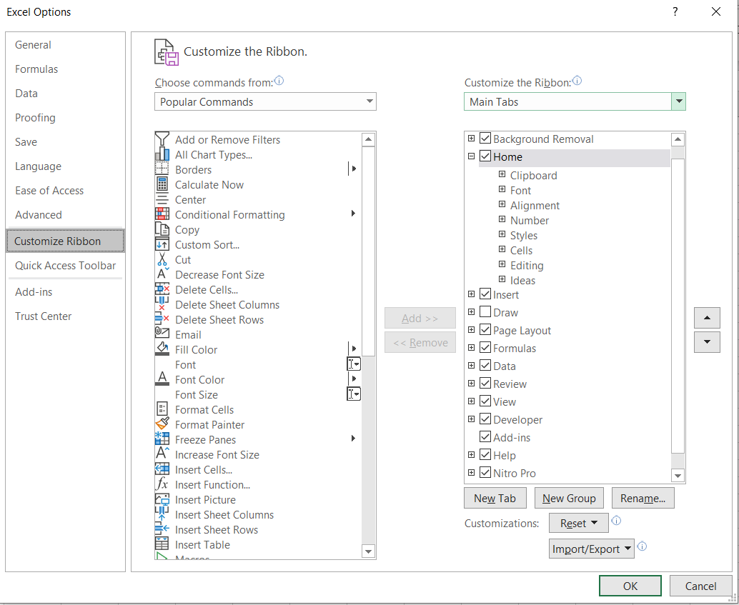

* Once you have access to “Developer” in the excel menu then add the Excel SnowFlow Addin by selecting Excel Add-ins

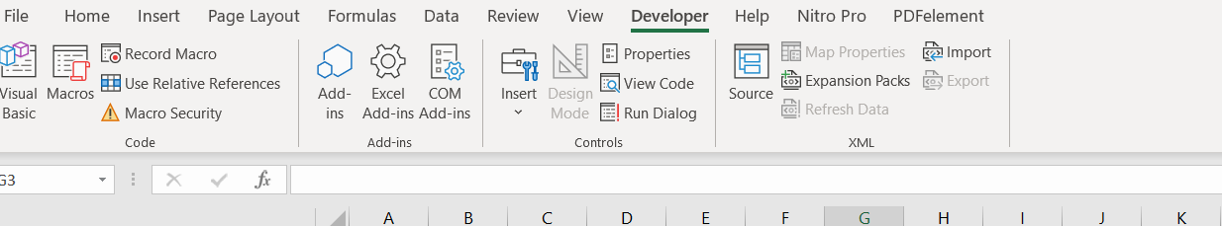

* Select browse and find the directory the SnowflakeAddin.xlam was saved to. Make sure to check the plugin before selecting OK

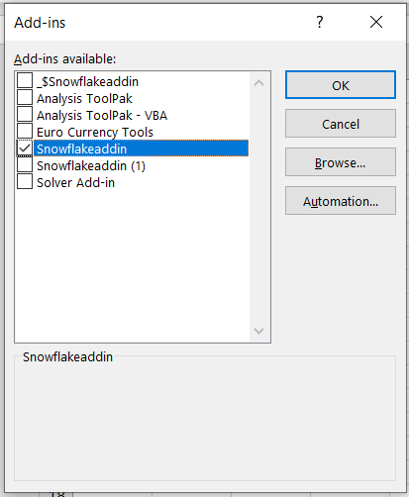

# Using SnowFlow

## Connection Parameters

Open Excel and enter the connection information. After enabling the Addin you should see a new Snowflake menu section within the Home tab

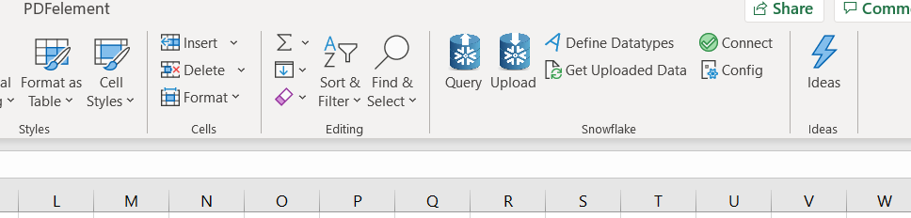

Select the connect button and enter the Snowflake connection information. There are two security types standard (login & password) and SSO. We recommend using SSO for a more secure authentication.

In the Role field, add the role that you entered into the script in Step 3.

IMPORTANT!! The login database and schema specified in the connection must be the same database and schema the Stored Procs were run under

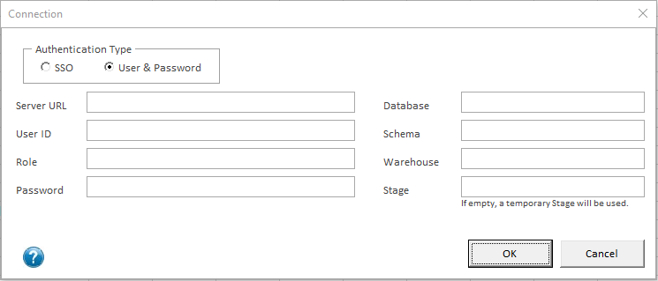

## Executing a query

Now you are ready to start using the plugin. We will walk through how to use each section and what they do Users can work with data that they sourced from other data sources files etc. within Excel or they can pull data from Snowflake into Excel. They may manipulate the data using VBA scripts and vlookups but then want to write that final data set back to Snowflake. SnowFlow handles both reading and writing scenarios

* Users pulls data into excel by select the “Query button” you can then enter a query

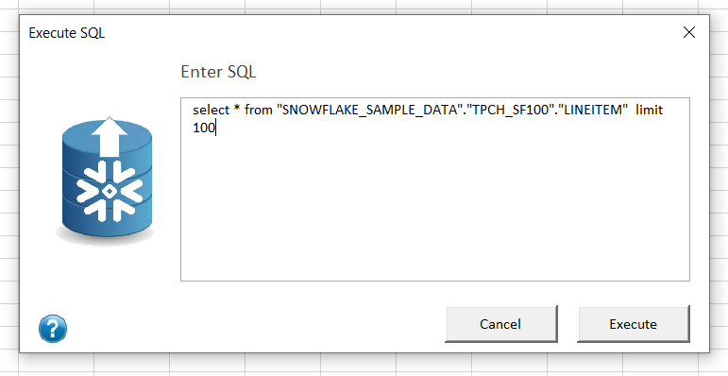

Results

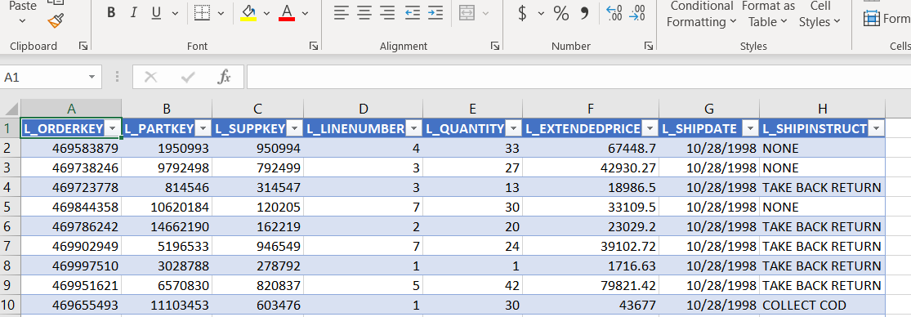

## Writing Data to Snowflake

Once the data is returned the user can update a row, insert a new row or even add a new column within Excel.

* To propagate those changes to Snowflake the user should press the “Upload” button. Here they can enter the worksheet the data is being sourced from and also define the table it’s being written to. Another important option is defining the columns that will represent the keys in order to do the update logic needed if the user updates or adds a new column in the Excel sheet. This can be done by entering the column position ex. A,B,C. So the first 3 columns in the excel sheet and target table will be the key

There are also advanced features that allow you to truncate all data before uploading or recreating the table and then upload the data. These might be used if you decide the current structure is not correct and just want to recreate and load

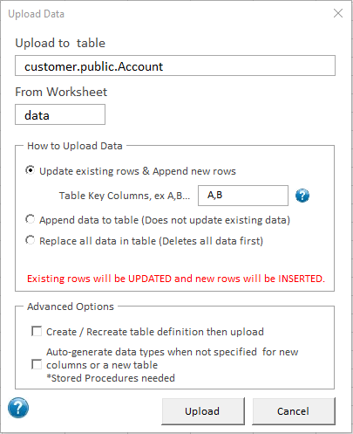

* When you add a new table or column to the sheet, the last check box starting with ‘Auto-generate’ will allow the system to automatically create the column data types.

However, there may be times where you want to explicitly define the data types within the Excel sheet before uploading the data. The plug-in supports that as well. Press the “Define data type” button in the Excel Ribbon and a data type selector will appear above the column header.

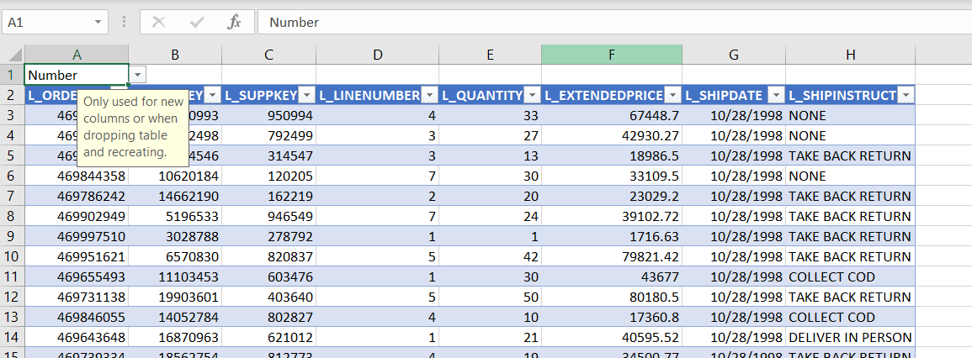

# Known Issues

* Timestamps don’t handle anything less than seconds. To workaround this, the time will have to be manually cast to a varchar in the SQL.