**Requirement:**

Need to identify the Contributing Factors to target the potential buyers by analyzing the history of campaign data.

**To Whom:** Marketing Team/Executive.

Market Executives will refer this data and select the customer for their target.

**What:** Use the history of customer data during campaign

**How:**

By sharing the history of successful rate of purchase through phone conversation and give them the final report showing who are all will be the potential buyers.

Data analysis:

Total Number of people from history are 41188 out of which 4640 ie 11.27% of people had purchased.

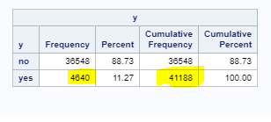

Analysis of each attribute:

Age: Inference: People between 25 to 40 are active customers.

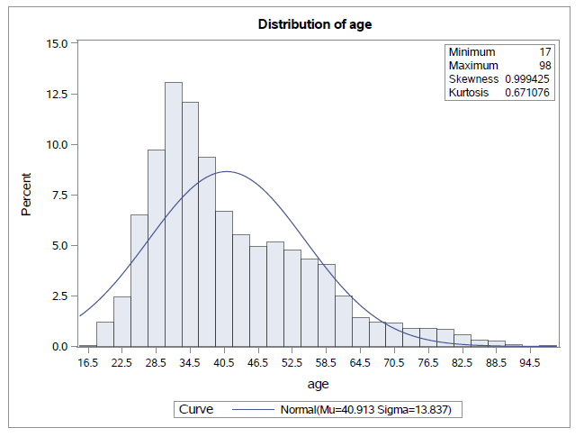

Campaign:

Campaign: number of contacts performed during this campaign and for this client (numeric, includes last contact)

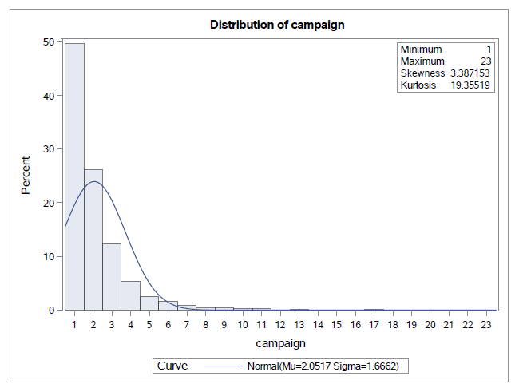

**Defaulter**: 90% of People who are Non defaulter buying.

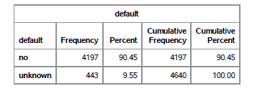

**pdays:** number of days that passed by after the client was last contacted from a previous campaign

999 means client was not previously contacted

79% -it is evident that people who are newly contacted or contacted within 1st week are purchasing.

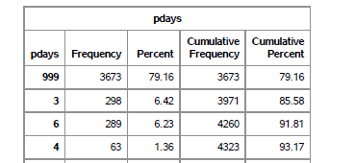

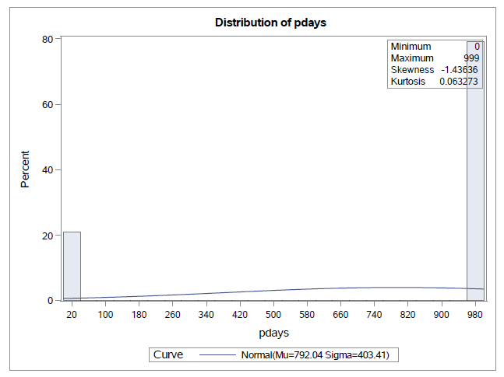

**contact**: contact communication type

83% responded people are contacted via cellphone

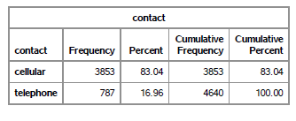

**loan**: has personal loan?

82% of people who are not having personal loans are buying

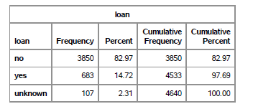

**housing**: has housing loan?

Not a major diff between the People having/not housing loan.

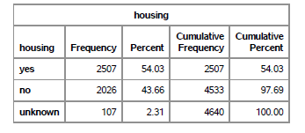

**Month**: it is observed that Dec month is having less than 2% percentage of purchase and no records for Jan and Feb. So, it is better to avoid during year end and jan&feb.

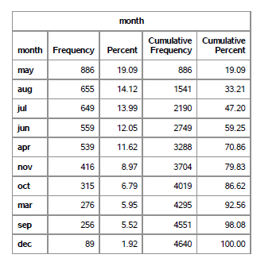

**marital** : marital status- 50% of married people are purchasing.

