**Data Engineering Evaluation.**

This evaluation has the objective of measuring the knowledge in the management of certain skills necessary for the data engineer role.

Skills to be evaluated:

* Cloud Architect (**AWS**)
* Cloud ETL (**AWS**)
  + Python
* Relational Database (**AWS – My SQL**)
* Data Warehousing (Concepts and Technics)
* Git (Concepts)

**The time to build the solution of the evaluation is 4 days once the case is assigned through the Git classroom.**

**Case:**

Design maps and charts tracking cases, deaths, and trends of COVID-19 in the United States.

Solution should help to the Government improve performance, reduces cost, and eliminates data preparation bottlenecks for the pipeline.

The Components of the Architecture (A data architecture is a framework of software components built to ingest and process voluminous raw data from multiple sources.)

**Components to be considerer:**

1. To collect data and redistribute it using Python code
   * Amazon S3 (Json Format)
   * Amazon RDS – Staging Area (MYSQL Version)

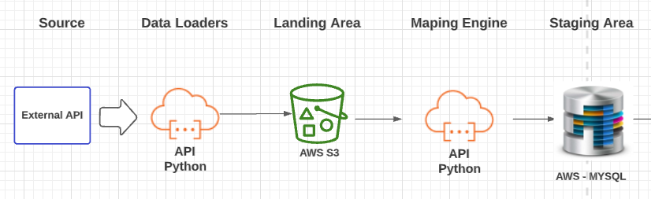

**Sources:**

* <https://api.covidtracking.com/v2/states/>
* [https://api.covidtracking.com/v2/states.json](https://protect-us.mimecast.com/s/Z0tbCBB28zC2yYLh6ZHvY?domain=api.covidtracking.com)

**Staging Tables**:

* + Stg_covid_states
  + Stg_covid_transactions
  + Stg_calendar

1. Data transformation (ETL – Store Procedures), to ready data for querying.

Dimension should be designed according to the slowly changing dimension technic – history table.

* Create Dimension(s)
  + Dim Calendar
  + Dim_States
* Create Fact table(s)
  + Fact_Covid_Transactions
* Create View(s)
  + Objects to be used in the Report Tool

1. Design Dashboards to show trends.

* Using the views created in the point before ways to analyze trends.
  + At least 4 trends should be built.

**Bonus Exercise:**

1.- Generate a forecast of what would happen 5 year later according to the historical behavior of the data.

* Create a table whit the data
* Create dashboard to explain the forecast