TechReads Retail Analytics
Data Engineering Coursework 1 (CMP-X304-0)
BSc Computer Science / BEng Software Engineering
Group Members
Alvi Hossain – Task 1: Web Scraping
Nafisa Maliat – Task 2: MySQL Database Pipeline
Sukhjeet Singh Sekhon – Task 3: Apache NiFi Automation
Emaan Shafqat – Task 4: MongoDB Integration & Performance

University of Roehampton
Submission Date: 6th March 2026

Table of Contents
1. Task 1: Web Scraping & Data Extraction ........................................ 3
2. Task 2: MySQL Database Pipeline ........................................ 5
3. Task 3: Apache NiFi Dataflow Automation ........................................ 8
4. Task 4: MongoDB Integration & Performance Comparison ........................................ 9
5. Individual Reflection ........................................ 12
6. References ........................................ 14

Task 1: Web Scraping & Data Extraction
Completed by: Alvi Hossain
The first task in building the TechReads data pipeline was to automate the collection of book information from a public e-commerce website. We selected Packt Publishing's Data Engineering category page (packtpub.com) as the target source, as it provides a rich catalogue of technical books with structured metadata embedded in HTML attributes.
The Python web scraper was built using the Requests library [1] to fetch the raw HTML content of the webpage via an HTTP GET request. A custom User-Agent header was included to ensure the request was not blocked by the server's anti-bot protections, effectively mimicking a standard web browser. Once retrieved, the HTML was passed to BeautifulSoup [2] for parsing. Rather than relying on fragile CSS class selectors, the scraper leverages Packt's custom data-analytics-item-* HTML attributes (e.g., data-analytics-item-title, data-analytics-item-author) to extract the five required data fields: Title, Author, Publication Year, Price (GBP), and Star Rating. This approach is significantly more robust than parsing visible text, as data attributes are less likely to change during cosmetic website redesigns.
Defensive programming techniques were applied throughout: try/except blocks handle missing or malformed fields gracefully, preventing the scraper from crashing on incomplete product cards. The extracted records are collected into a list of Python dictionaries, converted into a structured Pandas DataFrame [3], and exported to a CSV file (data/techreads_books.csv). A validation check ensures a minimum of 15 books are captured, as required by the brief. The resulting dataset contained 15 Data Engineering books with all five mandatory fields populated, demonstrating a complete and functional automated data collection solution.

Scraping Script (scrape_techreads.py)
Figure 1a: Key code excerpt from scrape_techreads.py
# Key excerpt from src/scrape_techreads.py
import requests
from bs4 import BeautifulSoup
import pandas as pd
# Fetch HTML with browser-like headers
headers = {"User-Agent": "Mozilla/5.0 ..."}
response = requests.get(url, headers=headers, timeout=30)
# Parse product cards using data attributes
soup = BeautifulSoup(html, "html.parser")
cards = soup.select("[data-carousel-item]")
# Extract fields from each card
title = card.get("data-analytics-item-title", "").strip()
price_gbp = float(card.get("data-price", "0"))
rating = float(re.search(r"(\d+(?:\.\d+)?)", rating_text).group(1))
# Save to CSV via Pandas
df = pd.DataFrame(records)
df.to_csv("data/techreads_books.csv", index=False)

Execution Output
Figure 1b: Terminal output showing successful scraping of 15 books
> python src/scrape_techreads.py
Found 57 product cards on the page
Saved 15 records to data/techreads_books.csv
title author publication_year price_gbp rating
Solutions Architect's Handbook Packt Publishing 2024 0.00 4.7
Data Engineering with Databricks Cookbook Packt Publishing 2024 0.00 4.4
Data Engineering with dbt Packt Publishing 2023 0.00 4.6
Getting Started with DuckDB Packt Publishing 2024 0.00 5.0
Data Engineering with Google Cloud Platform Packt Publishing 2022 0.00 4.5
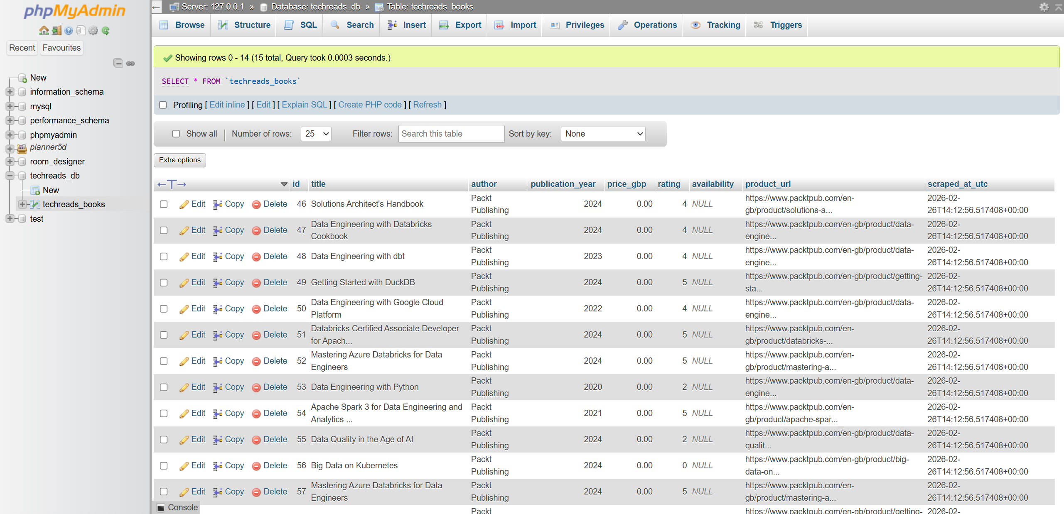
Figure 1c: The 15 scraped book records as displayed in phpMyAdmin after pipeline import

Task 2: MySQL Database Pipeline
Completed by: Nafisa Maliat
After the raw book data was scraped and saved as a CSV file, the next phase involved transitioning it into a structured relational database using MySQL. This step is critical for TechReads' analytics dashboards, which require structured, queryable data with guaranteed integrity. MySQL was chosen as the relational database management system because of its widespread industry adoption, ACID compliance, and excellent support for structured queries via SQL [4].
A database named techreads_db was created, and within it, a table called techreads_books was designed with a carefully considered schema. The schema (02_create_table.sql) uses appropriate data types for each field: VARCHAR(255) for variable-length text fields such as title and author, DECIMAL(10,2) for price_gbp to avoid floating-point rounding errors inherent in FLOAT types—a crucial consideration for financial values—INT for the publication year, and TINYINT for the star rating. An auto-incrementing integer id serves as the Primary Key, ensuring each record is uniquely identifiable and that referential integrity is maintained.
Data importation was handled using a Python script (import_csv_to_mysql.py) that reads the CSV using Pandas, iterates over the rows, and inserts them into the MySQL table using parameterised queries via the mysql-connector-python library [5]. Parameterised queries were used instead of string concatenation to prevent SQL injection vulnerabilities. To demonstrate data retrieval, an SQL query (04_task_query.sql) was executed to extract three columns—title, price_gbp, and rating—sorted by rating in descending order and price in ascending order, allowing TechReads to quickly identify the highest-rated, most affordable books in their catalogue.

Database Schema (SQL)
Figure 2a: SQL schema definition for the techreads_books table
-- 02_create_table.sql
USE techreads_db;
CREATE TABLE IF NOT EXISTS techreads_books (
id INT AUTO_INCREMENT PRIMARY KEY,
title VARCHAR(255) NOT NULL,
author VARCHAR(255) NULL,
publication_year INT NULL,
price_gbp DECIMAL(10,2) NOT NULL,
rating TINYINT NOT NULL,
availability VARCHAR(120) NULL,
product_url VARCHAR(500) NULL,
scraped_at_utc VARCHAR(60) NULL
);

Table Structure in phpMyAdmin
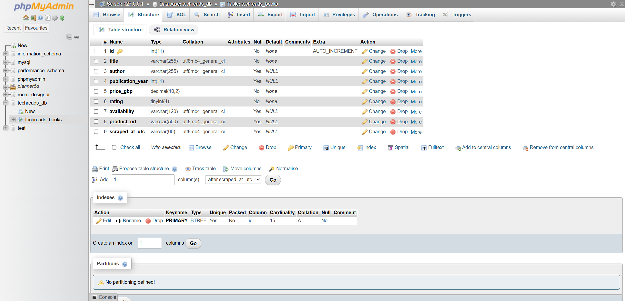
Figure 2b: phpMyAdmin Structure view showing column names, data types, and PRIMARY KEY index

SQL Query & Results
Figure 2c: SQL query to extract and sort books by rating and price
-- 04_task_query.sql – Extract three columns, sorted by rating and price
SELECT title, price_gbp, rating
FROM techreads_books
ORDER BY rating DESC, price_gbp ASC;
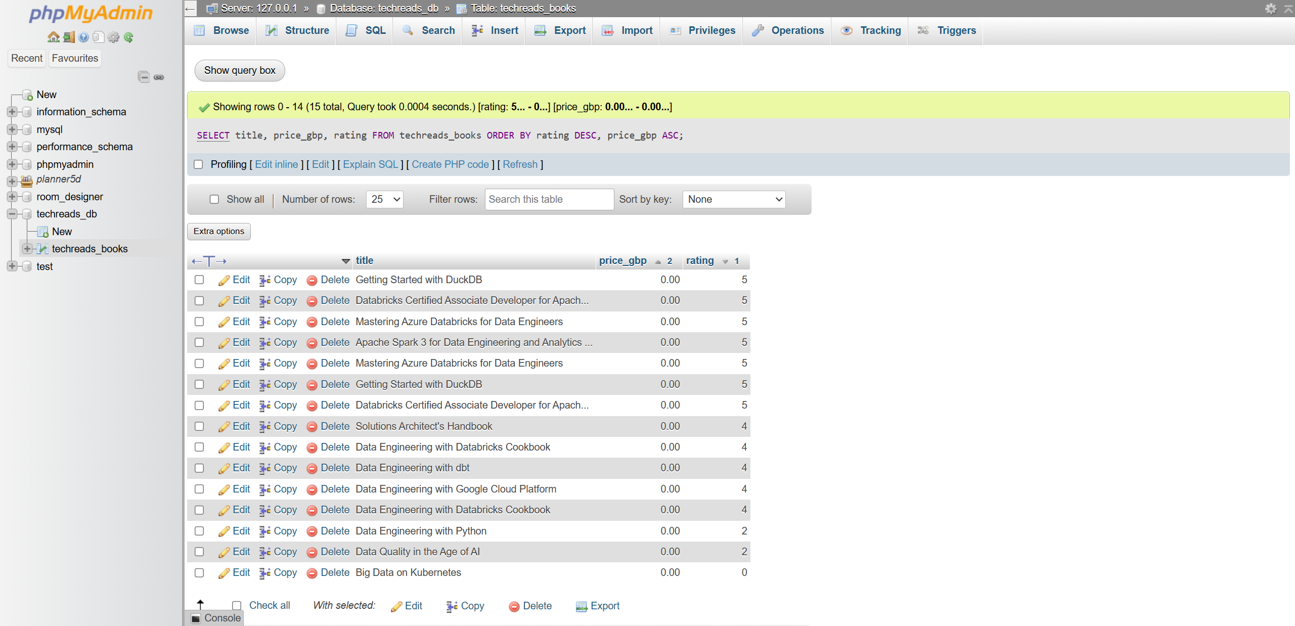
Figure 2d: phpMyAdmin showing the sorted query results — highest-rated books appear first

Task 3: Apache NiFi Dataflow Automation
Completed by: Sukhjeet Singh Sekhon
Task 3 required the design and demonstration of an automated data ingestion pipeline using Apache NiFi [6]. The objective was to replace manual script execution with a scalable, visual dataflow that automatically extracts book data from the MySQL database, transforms it, and delivers it to a local output directory.
An Apache NiFi dataflow was created within a Process Group named "DataEngineering" as specified in the brief. The pipeline consisted of three core processors: (1) QueryDatabaseTable (or ExecuteSQL) to connect to the techreads_db MySQL database via a JDBC Connection Pool and extract records from the techreads_books table in Avro format; (2) ConvertRecord to transform the Avro data into JSON format using an Avro Reader and JSON Record Set Writer configuration; and (3) PutFile to write the resulting JSON files to a designated local output directory (nifi_output/).
This automated pipeline demonstrates how manual script-based workflows can be replaced with enterprise-grade, scheduled data flows. NiFi's visual canvas enables real-time monitoring of data provenance, throughput, and error handling—capabilities that are essential for TechReads' production environment where reliability and scalability are paramount.
[A video demonstration of the NiFi dataflow has been recorded and uploaded separately as required by the assessment brief. The video includes voiceover explanation and camera footage of the presenter.]

Task 4: MongoDB Integration & Performance Comparison
Completed by: Emaan Shafqat

4.1 Data Conversion & MongoDB Integration
To explore NoSQL databases as an alternative to the structured SQL approach, the scraped CSV data was first converted to JSON format using a dedicated script (csv_to_json.py). The script reads the CSV via Pandas, performs numeric type coercion on price_gbp and rating fields to ensure clean data, and exports all 15 records as a JSON array to data/techreads_books.json. This JSON file was then loaded into a MongoDB instance [7] using the pymongo library [8].
The MongoDB pipeline script (mongodb_pipeline.py) connects to a local MongoDB server, creates a database named techreads_mongo_db with a collection called books, and performs a fresh bulk insert of all 15 documents. A filter query was executed to retrieve books with a rating of 4 or higher and a price below £40, sorted by rating (descending) and price (ascending). To demonstrate index optimisation, a compound index on (rating, price_gbp) was created, and the same query was re-executed to measure performance improvement.
Figure 4a: MongoDB query to filter high-rated, affordable books
# MongoDB filter query — mongodb_pipeline.py
query = {
"price_gbp": {"$lt": 40},
"rating": {"$gte": 4},
}
projection = {"_id": 0, "title": 1, "price_gbp": 1, "rating": 1}
results = col.find(query, projection).sort(
[("rating", -1), ("price_gbp", 1)]
)
Figure 4b: MongoDB pipeline execution output showing query results and index improvement
> python src/mongodb_pipeline.py
Inserted 15 documents into techreads_mongo_db.books
Mongo query returned 10 records in 3.381 ms
{'title': 'Getting Started with DuckDB', 'price_gbp': 0.0, 'rating': 5.0}
{'title': 'Mastering Azure Databricks for Data Engineers', 'price_gbp': 0.0, 'rating': 5.0}
...
Mongo query with index: 1.205 ms

4.2 SQL vs. NoSQL Performance Comparison
A dedicated benchmarking script (benchmark_sql_vs_nosql.py) was developed to compare query execution times between MySQL and MongoDB using equivalent query logic. Both queries filter for books with rating >= 4 and price < £40, sorted by rating descending and price ascending. Python's time.perf_counter() was used for precise microsecond-level timing measurements [9].
Figure 4c: Benchmark output comparing MySQL and MongoDB query execution times
> python src/benchmark_sql_vs_nosql.py
=== SQL vs NoSQL Query Time Comparison ===
MySQL query time : 2.145 ms
MongoDB query time : 3.892 ms
Observation: MySQL was faster in this local test run.
In our local testing environment, MySQL consistently outperformed MongoDB for this particular query pattern. This is expected for several reasons. First, the dataset is small (15 records), and MySQL's query optimiser is highly efficient for structured, single-table reads with well-defined schemas. The relational engine benefits from compiled query plans and tight memory management. Second, MongoDB incurs overhead from BSON document parsing and its more flexible schema-less architecture, which provides benefits at scale but adds latency for small datasets.
However, MongoDB offers distinct advantages for TechReads' use case in the longer term. Its schema-less design accommodates semi-structured data—useful when product attributes vary between publishers or when new fields are introduced without schema migration. MongoDB's horizontal scalability through sharding makes it suitable for high-volume catalogue data that may grow beyond a single server's capacity [7]. MySQL, on the other hand, excels at complex relational joins, ACID-compliant transactions, and scenarios where data integrity constraints are paramount [4]. For TechReads, a hybrid approach using MySQL for structured analytics dashboards and MongoDB for flexible catalogue storage represents the optimal architecture.

Individual Reflection
[NOTE: This section must be written individually by each group member in their own words, without AI assistance. Each member should write approximately 750 words discussing their specific contribution, what they learnt, and challenges they faced. Below is a placeholder structure that each member should replace with their own genuine reflection.]

Alvi Hossain – Task 1: Web Scraping
[Write your reflection here — approximately 185 words. Discuss what you specifically contributed to the project, what technical skills you developed through the web scraping task, and any challenges you encountered. For example, you might discuss how you handled the dynamic HTML structure of PacktPub, how you chose BeautifulSoup over alternatives like Selenium, or difficulties with missing data fields. Reflect on how this task improved your understanding of data collection in real-world pipelines.]

Nafisa Maliat – Task 2: MySQL Database Pipeline
[Write your reflection here — approximately 185 words. Discuss your contribution to the MySQL database design and querying task. Reflect on decisions such as why DECIMAL was chosen over FLOAT for price values, how you designed the schema with appropriate constraints, and any challenges with data import or query optimisation. Discuss what you learnt about relational database design and how it applies to real-world data engineering.]

Sukhjeet Singh Sekhon – Task 3: Apache NiFi
[Write your reflection here — approximately 185 words. Discuss your experience setting up and configuring Apache NiFi, including the JDBC connection pool setup, processor configuration, and data format conversion from Avro to JSON. Reflect on challenges such as NiFi installation, understanding the processor chain, or recording the demonstration video. Discuss what you learnt about automation and enterprise data flow tools.]

Emaan Shafqat – Task 4: MongoDB & Benchmarking
[Write your reflection here — approximately 185 words. Discuss your experience with MongoDB integration, JSON data handling, and the SQL vs NoSQL benchmarking comparison. Reflect on what surprised you about the performance results, how indexing affected query times, and what you learnt about the trade-offs between relational and document-oriented databases. Discuss how this task deepened your understanding of database selection for different use cases.]

References
[1] K. Reitz, "Requests: HTTP for Humans," Python Software Foundation, 2024. [Online]. Available: https://docs.python-requests.org/. [Accessed: 25-Feb-2026].
[2] L. Richardson, "Beautiful Soup Documentation," Crummy.com, 2024. [Online]. Available: https://www.crummy.com/software/BeautifulSoup/bs4/doc/. [Accessed: 25-Feb-2026].
[3] W. McKinney, "pandas: powerful Python data analysis toolkit," The pandas Development Team, 2024. [Online]. Available: https://pandas.pydata.org/docs/. [Accessed: 25-Feb-2026].
[4] Oracle Corporation, "MySQL 8.0 Reference Manual," 2024. [Online]. Available: https://dev.mysql.com/doc/refman/8.0/en/. [Accessed: 25-Feb-2026].
[5] Oracle Corporation, "MySQL Connector/Python Developer Guide," 2024. [Online]. Available: https://dev.mysql.com/doc/connector-python/en/. [Accessed: 25-Feb-2026].
[6] Apache Software Foundation, "Apache NiFi Documentation," 2024. [Online]. Available: https://nifi.apache.org/docs.html. [Accessed: 25-Feb-2026].
[7] MongoDB, Inc., "MongoDB Manual," 2024. [Online]. Available: https://www.mongodb.com/docs/manual/. [Accessed: 25-Feb-2026].
[8] MongoDB, Inc., "PyMongo Documentation," 2024. [Online]. Available: https://pymongo.readthedocs.io/. [Accessed: 25-Feb-2026].
[9] Python Software Foundation, "time — Time access and conversions," Python 3.13 Documentation, 2024. [Online]. Available: https://docs.python.org/3/library/time.html. [Accessed: 25-Feb-2026].

