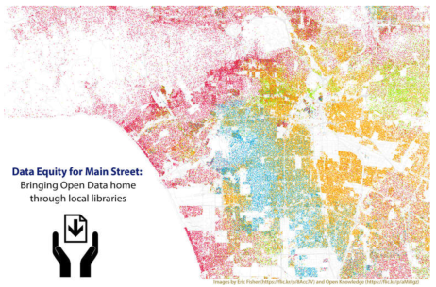

*Handout 1*

Open Data: What is it?

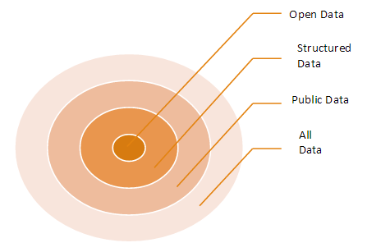

**Definition:**

“Open data and content can be freely used, modified, and shared by anyone for any purpose” – <http://opendefinition.org>

**Resources:**

What Can Open Data do for you? – Open Data Institute

<https://youtu.be/Q_I7B7rtPQQ> (video - 2:44)

**How do people use open data?**

*News Stories*

Vaccination Rates for Every Kindergarten in California

*More than a quarter of schools in California have measles-immunization rates for kindergarteners that are below the standard the C.D.C. says is needed to maintain so-called herd immunity. (Feb 6, 2015)*

<https://www.nytimes.com/interactive/2015/02/06/us/california-measles-vaccines-map.html?_r=1>

Source: <https://data.chhs.ca.gov/dataset/school-immunizations-in-kindergarten-by-academic-year>

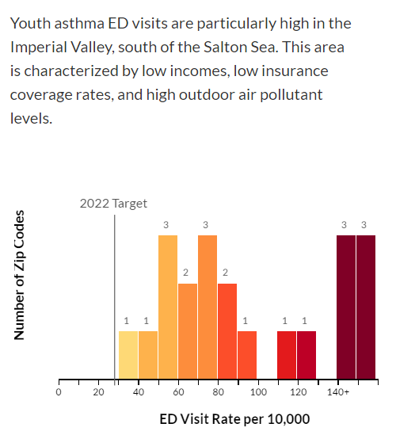

*Raise Awareness*

<http://asthmastoryca.org> tells the story of youth asthma using

data from the California Health and Human Services Agency’s

open data portal.

*Answer Questions*

[foreignassistance.gov](http://foreignassistance.gov) explains how much 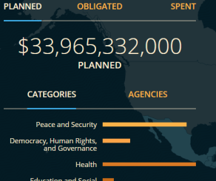

foreign assistance the U.S. provides.

*Make Life Easier*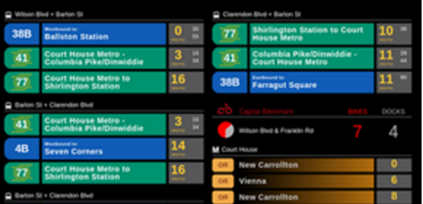

A company uses open data to create real-time transit screens

that show commuters when the next bus is coming.

<https://transitscreen.com/>