**Data Equity for Main Street Handout 5: How to a Make a Map and a Chart**

*(Note: Datasets for this exercise may be found in the* ***Datasets*** *folder.)*

First, sign in to Google and click on the Google apps icon. Select the Drive App. (You can also go directly to drive.google.com).

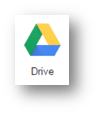

Instructions for making a Chart

* 1. Click on New > Google Sheets

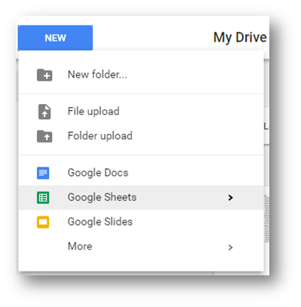

* 1. In the new spreadsheet window that opens, choose File > Import

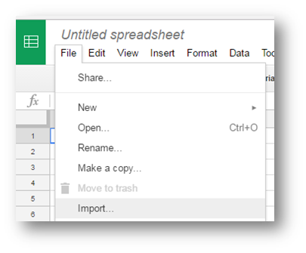

* 1. Select “Upload” and use the “Select a file from your computer” option to locate and upload “2015 California Wildfires.csv.”

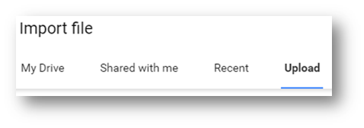

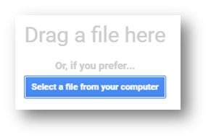

* 1. Leave the import options at their default setting and click ‘import data.’
  2. Give the new spreadsheet the title “2015 California Wildfires.”

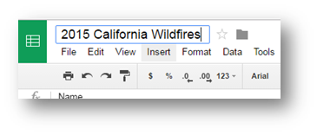

* 1. With any cell selected, choose Insert > Chart.

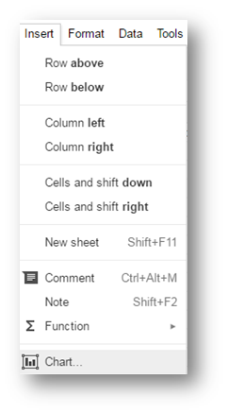

* 1. Take a few minutes to explore the options available to you, including Recommendations, Chart types, and Customization options.
  2. Create a bar chart that shows the number of acres burned in each wildfire (hint: try putting the fire names on the Y axis and the acreage on the X axis).

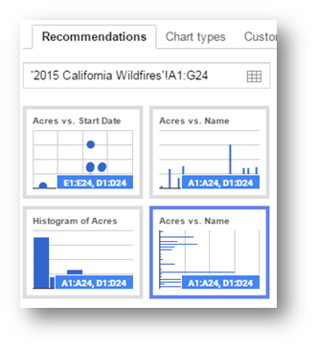

* 1. Take note of anything that you find particularly challenging about the exercise, or anything that you find really useful or easy to do, and prepare to share your thoughts with the rest of the class.

Make a Map Instructions

* 1. Return to you Drive account by navigating to drive.google.com
  2. Click on New > More > Google My Maps

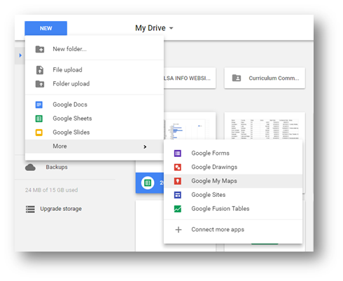

* 1. A map will open in a new window. Click on the “Import” link in the map editor window.

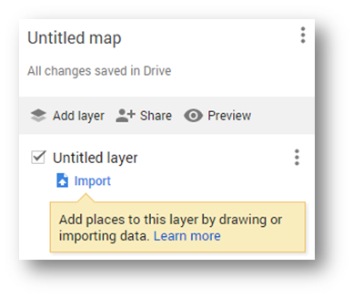

* 1. Use the “Select a file from your computer” option to load “2015 California Wildfires.csv.”

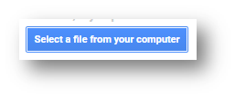

* 1. Google Maps will ask you which data columns should be used to geolocate the place marks. Choose “County” and “State” and “Continue”.

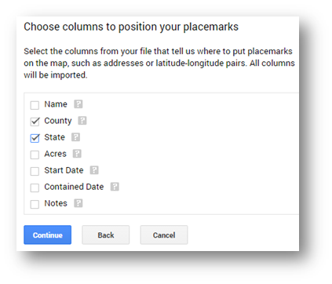

* 1. Google Maps will then ask which column to use for the title of each marker. Choose “Name” and Finish.

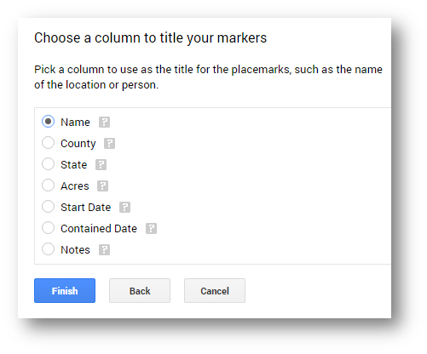

* 1. Drag and zoom in on the map to get a better view of the geography and place makers.
  2. Click on the markers to see how the CSV file data is displayed.

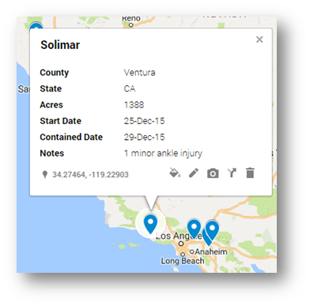

* 1. Experiment with the “Base map” options to find the most suitable visualization.

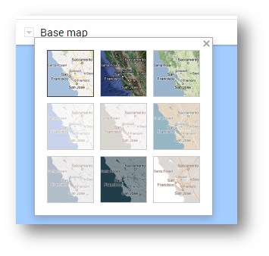

* 1. Change the map’s title to “2015 California Wildfires” and add a description.

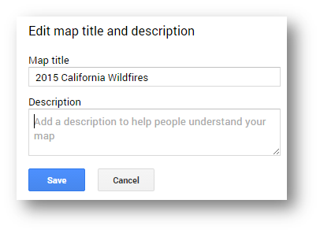

* 1. Use the ‘share’ icon to investigate how you could publish the map to the Web and share with others. Make note of the different privacy settings.



* 1. Bonus points: change the markers so that they go from light to dark according to the number of acres burned.
* Click on the paint roller icon and use the drop-down menu to change the “Group places by” option to “Acres” under “Style by data column.”

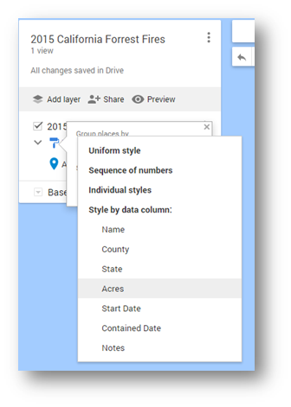

* Select the “Ranges” radio button and then select the number of color gradations to use.

