**Software installation tasks to be carried out prior to the first training session**

1. Install R for Windows from WOAH’s Company portal
2. Install Rstudio from WOAH’s Company portal
3. Launch Rstudio from your computer App menu

Check no error or warning message is displayed.

You should simply get something along the line of (don’t mind the version number):

|  |
| --- |
| R version 4.4.0 (2024-04-24 ucrt) -- "Puppy Cup"  Copyright (C) 2024 The R Foundation for Statistical Computing  Platform: x86_64-w64-mingw32/x64  R is free software and comes with ABSOLUTELY NO WARRANTY.  You are welcome to redistribute it under certain conditions.  Type 'license()' or 'licence()' for distribution details.  R is a collaborative project with many contributors.  Type 'contributors()' for more information and  'citation()' on how to cite R or R packages in publications.  Type 'demo()' for some demos, 'help()' for on-line help, or  'help.start()' for an HTML browser interface to help.  Type 'q()' to quit R.  [Workspace loaded from ~/.RData] |
|  |
| |  | | --- | | > | |

1. Go to the [Data Science Sharepoint](https://oieoffice365.sharepoint.com/sites/DataVisualisationTeam/Documents%20partages/Forms/AllItems.aspx) and “Add a Shortcut to OneDrive”, cf below (to facilitate future interactions)

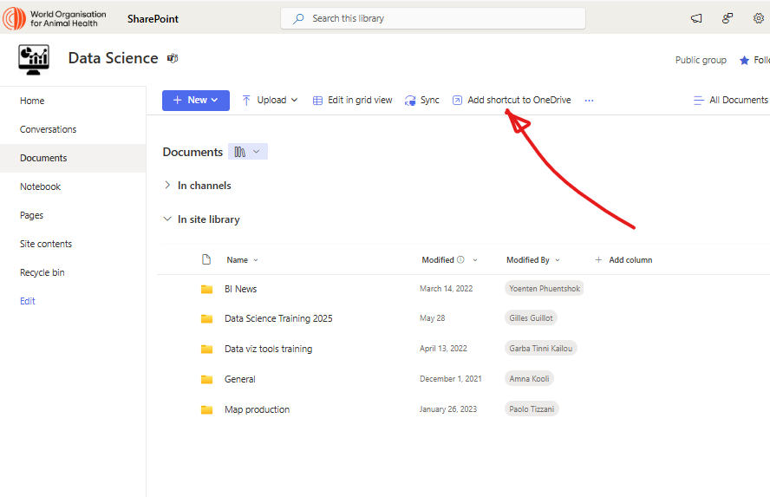

1. Finally, launch Rstudio (optional step, can be done during first session)
   1. Open the file **R_package_installation.R** located in the same folder as the present file
   2. Click on 