GOVERNMENT OF ODISHA × UNIVERSITY OF CHICAGO TRUST
Data, Policy and Innovation Centre
Janasunani 2.0
From filing to insight: what changes for officers and citizens
Value-add versus the status quo — document processing, routing, and the intelligence layer

STATUS | Working draft — August 2026 • For internal discussion, not for publication
AUDIENCE | Non-technical — Secretaries, Collectors, programme officers, and review committees
READING TIME | ~18 minutes • Executive summary on page 2 is self-contained

◆ One rule throughout: every number in this report states its denominator, its sample, and what it cannot prove. Where the evidence is thin or the comparison is not like-for-like, we say so on the same page — not in a footnote.
WHAT'S INSIDE
1 How grievances work today — the status quo in numbers 3
2 What we built — the same workflow, now machine-readable 4
3 Faster and more reliable — document processing before vs after 5
4 Keeping the queue clean — spam and duplicates 8
5 What are people complaining about — hotspots, spikes, and workload 10
6 Who is complaining — geography, gender, and channels 13
7 What officers see day-to-day — real-time help while a case is open 15
8 Safeguards and honesty — what we don’t claim yet 16
A Annex — metric registry, sources, and how to reproduce 17
Sources on every page. Full metric registry and reproducibility notes in Annex A. Previous baselines are from the DSI Clinic Technical Report (2025) and the DPIC Analytics Note (May 2026). Current measurements are from the Janasunani codebase (main, August 2026) and the 55,544-record Sambalpur/2024 slice.
DPIC • dpic@uchicago.edu • Bhubaneswar — Chicago • This draft will be updated after the 14 August demonstration with measured results from the live rehearsal.

EXECUTIVE SUMMARY

Three improvements that matter to an officer — and one that matters to government
Janasunani receives about 1.4 million grievances a year. Three in four arrive with at least one attached document — together more than a million files. Today, an officer must open each filing, read the grievance and its attachments, decide what the complaint is about, and route it to the office that can act. That first routing step — understanding the complaint well enough to send it to the right place — takes a median of 1.7 days among forwarded cases, and a mean of 20.8 days because a long tail of cases takes much longer. Email filings take 17.7 days at the median; the Collector’s office, which handles one in seven routed complaints, takes 4 days at the median and 30 days at the mean.
4.4 seconds  Median time to an officer-ready packet for a typed grievance (warm). Document: ~1–6 min. Versus 1.7 days manual routing gap. | 10,963 problems  From 55,544 filings in Sambalpur/2024. The portal counted filings; we now count distinct problems — and distinct citizens. | 46% women  Up from 30% in 2021–22. 83% of women now file online. The “who” picture changes how we design access.

What changes, in plain language:
- 1. Faster first response — from reading to reviewing. The system reads the grievance and its scanned pages, removes personal information, labels the useful pages, summarises what matters, suggests a category, and proposes where to route it — in seconds for typed text, minutes for scans — so the officer starts from a first draft, not a blank page. Officers keep full authority: they accept, edit, or reject every suggestion.
- 2. A cleaner queue — and fewer repeat problems clogging the queue. Mass submissions and duplicate filings are now grouped as one problem with a count of distinct citizens. A campaign of 1,200 citizens about one road is no longer 1,200 separate cases in the workload — it is one problem filed by 1,200 people. A single person filing 26,000 times is no longer mistaken for a campaign. Low-signal filings (missing details, no specific grievance) are flagged separately from duplicates, so each queue can be handled appropriately — never auto-rejected.
- 3. Intelligence that earns a decision — hotspots with denominators, spikes explained, and workload counted as problems not filings. Geography is shown as complaints per 1,000 residents; time is shown against last year, not last month; every spike carries three numbers (filings / distinct problems / distinct citizens) so a campaign and a wave of unrelated problems — identical in a raw count — trigger different responses. Block-level diagnostics surface the blocks that a district average would hide.
- 4. A clearer picture of who the system serves — the composition of who complains is shifting. Rural-housing grievances dominate the surge (37% of 2024–25 filings), women now file nearly half of all complaints and overwhelmingly online, and most citizens file once (88%). That “who” picture — not just the “what” — informs where to locate help, what language support matters, and which access channel to invest in.
⚠ What we are not claiming. OCR has no hand-transcribed ground truth to score against, so we report how two engines differ — not which is right. The PII gold is 89 pages (small; a few pages move it) and English-only; Odia remains unmeasured. Routing learns where cases were historically sent, not where they resolved best — an outcome-based scorer is future work. The closure “61% no-action” is descriptive, not a failure rate. Every caveat is repeated alongside its number in the body of the report.
How to read the rest of the report. Each section gives a “Before → After → Why it matters” table, then the evidence and its limits. Numbers are shown with their denominator and sample; “reference-only” baselines are labelled as such and are never used as pass/fail thresholds. The annex lists every metric, its source file, and the command that reproduces it.
1 — HOW GRIEVANCES WORK TODAY

The status quo in numbers — and why it is hard to manage
Janasunani is Odisha’s unified grievance portal. Between July 2021 and June 2025 it received 1,371,288 complaints and recorded 6,556,171 action-history rows — the timestamped trail of every receive, forward, accept, and close. In 2024–25 alone, 688,301 complaints were filed — nearly double the previous year and seven times the 2021–22 figure. Two events explain the shape, not a smooth trend: a CMO District Visit surge in 2023–24 (91,235 complaints) and a Joint Hearing surge in 2024–25 (44,788).
What we face today | What the data says | Why it hurts
Volume surge, highly concentrated | 688,301 in 2024–25 (355,579 in 2023–24). Rural Housing + PMAY = 37% of all 2024–25 filings; together they explain 55% of year-on-year growth (≈147k extra housing complaints). | Complaint volume is a near-real-time signal of PMAY implementation pressure — but only if you can see it by block and by scheme, not as a state total.
Routing takes days | Median 1.71 days from receipt to first forward (n≈30k forwarded). Mean 20.84 days — one in ten takes ~7 weeks. Email filings: median 17.7 days (10× website/letter). Collector’s office: median 4 days, mean 30 days (1 in 7 routed complaints). | The most substantive complaints — with documents — wait longest. Officer time spent understanding a filing before it can move is the bottleneck.
Resolution is faster at scale — but not uniformly | Median disposal: 46 days in 2024–25 vs 62 days in 2023–24, on 417k vs 298k disposed cases. Still 107k open (up from 18k), concentrated in October 2024 filings (≈25.8k still open from that month). | State median hides a stuck cohort. 107k is not “107k uniformly pending” — it is a congestion episode worth a targeted clearing exercise.
One-third of complaints tell us nothing about what they are about | NaN (missing subcategory) 17.9% + General 8.9% + Miscellaneous 7.2% = 33.9% of 2024–25 filings (233k complaints). Within General, 87% are “Others”; within Miscellaneous, 68% are “Miscellaneous/Others”. | You cannot prioritise what you cannot name. Subcategory is the primary analytical unit — a third of cases bypass it. Free-text is the only rescue.
Who files is not recorded as a person | No native petitioner ID; derived linkage shows 88% file once (median 1, mean 1.43, 95th percentile 2). Geographic rates need denominators; text is English 73% (36 words avg) vs Odia/Devanagari 27% (79 words avg); in-person filings average 5.7 words (transcribed short). | Complaint counts are not complaint rates. Without eligible-population denominators and without de-duplication, “high complaints” can mean many citizens — or one citizen many times.
Closure language is coarse | Of 776,922 complaints closed on six standard phrases, 60.9% use the bare “disposed” wording; as a share of all 1,209,144 resolved complaints, 39.1%. Bare share rises with steps: 58% (3–5 steps) → 65% (6+ steps). Only 4% of 2024–25 filings close “with benefit” (down from 8%). | The record says what wording was chosen — not whether it was correct. A correct refusal and a premature closure look identical. Treating 61% as a failure rate would be wrong.
One in three complaints involves a handoff; those take longer | 30% involve ≥1 downstream handoff. With handoff: median 52 days to resolution. At first authority: median 36 days. | Re-routing is expensive. First-route quality — getting it to the right office the first time — is the lever with the largest time dividend.
Table 1 — The status quo: volume, time, and information gaps. Sources: DPIC Analytics Note May 2026 (1.37M record, July 2021–June 2025) and DSI Clinic Technical Report (2025). Exact sources per row are in Annex A.
◆ The existing dashboards count well — district, department, category, dates, status — and they do that reliably. What they cannot do is read what the citizen wrote, or recognise that two records describe the same problem. Everything new in this report comes from one of those two abilities. If an analyst with database access could produce a number in a day, we do not present it as enabled by the system.
How complaints arrive has shifted — and it matters for both access and routing:
Channel | 2021–22 | 2023–24 | 2024–25 | What shifted
Website | 32,790 | 169,401 | 439,320 | Online filing grew every year; share dipped when offline programmes expanded, then recovered.
WhatsApp / Mobile app | 15,277 | 30,399 | 76,580 | Digital access broadening beyond the website.
Physical hearing | 11,490 | 36,907 | 61,926 | Expanded in 2022–23 (DC/SP hearings).
CMO District Visit | 0 | 91,235 | 0 | Appears only in 2023–24 — four mode labels that year.
Joint Hearing | 0 | 0 | 44,788 | New in 2024–25 — replaces CMO Visit as the offline driver.
Online share | 79% | 59%* (80% excl. CMO Visit) | 79% | Headline online/offline share is driven by programme expansion, not a reversal in citizen preference.
2 — WHAT WE BUILT

The same workflow, now machine-readable — and governable
We rebuilt the grievance workflow as a sequence of governed, measurable steps. A raw filing — typed text or a scanned document — is extracted, redacted, triaged, classified, summarised, and routed, with a supervisor intelligence layer reading the same redacted corpus in parallel. Data stays on DPIC-controlled infrastructure; any external call (Sarvam) is declared, audited, and revocable — with a local fallback.
1  EXTRACT  Scan → text  OCR  pytesseract /  DeepSeek-OCR | 2  REDACT  Remove PII  Presidio  PHONE/AADHAAR  PAN/EMAIL/NAME | 3  TRIAGE  Spam & duplicate  advisory only  never blocks  score + groups | 4  CLASSIFY  Category  MuRIL + rules  11 categories  per-class report | 5  SUMMARISE  BART  only letters/  text pages  1.9/3 useful | 6  ROUTE  Learned  crosswalk  + rules  learned→rules→  fallback | 7  INTELLIGENCE  Hotspots  Spikes (3 nos)  Workload  Who complains
Figure 1 — The seven functional steps. Steps 1–6 are per-grievance (live in seconds/minutes); step 7 is corpus-level (nightly aggregates over the lake). Triage is advisory — it never changes submission status.
Live vs history — by design  A grievance you submit appears on its own page immediately (OLTP, Postgres). It appears in the browse/history list only after the next materialisation into the Parquet lake — a deliberate freshness gap. Demo history median 0.13 s over 1.37M rows. | Three storage layers, on purpose  OLTP (system of record) → Parquet lake (read-optimised, DuckDB/Polars) → pipeline artifact DB (per-run, resumable). The demo’s history and all analytics read the lake, never OLTP. Dedup index is the first corpus-level stage that breaks “per-run needs no state beyond its artifact DB”.
Trust boundary (plain language). Three tiers: same-host (Presidio, MuRIL, BART on the calling machine), dpic-infra (S3 documents, Postgres on the CPU box, GPU-box models — different machine, still DPIC-controlled), and authorised-external (Sarvam hosted API — third party, under a written MoU signed by the Principal/Additional Chief Secretary, IT Department). Exactly one module may make the external call; every such call is logged (ticket, stage, provider, model ID, bytes, time, authorisation ref); a kill-switch reverts to a local counterpart. Raw page text never leaves DPIC infra un-redacted by default.
3 — DOCUMENT PROCESSING: FASTER AND MORE RELIABLE

Faster and more reliable — what “automation” means for a scanned grievance
The DSI Clinic built the first open-source pipeline on a 100,000-complaint sample (2025) — English-only, five stages, on an A100 GPU. We refolded it into a six-stage production pipeline (plus triage) that runs on DPIC infrastructure (CPU box + GPU box + laptop), replaced the unrecoverable PII model with a Presidio rebuild, added quality guards, and wired it to the live API. The comparison below is honest about what is like-for-like and what is not: baselines are historical reference, not thresholds.
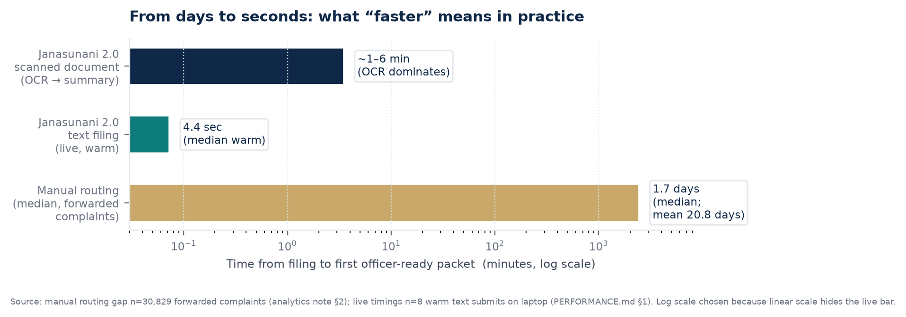
Figure 2 — Time from filing to an officer-ready packet. Manual median 1.7 days is among forwarded complaints (n≈30k); live text median 4.4 s is n=8 warm submits on a laptop (PERFORMANCE.md). Log scale is required because the improvement is two orders of magnitude. First document after boot is slower (~9–10 s) while models warm; the summariser (~1.6 GB BART) is fetched once on first boot.
Stage by stage — before, after, and what it means:
Stage (what it does) | Before — DSI baseline (2025)  Reference only | After — Janasunani 2.0 (Aug 2026)  Measured | In plain language
Format & language  triage  (decide what to process) | XGBoost + OpenCV + SMOTE:  75.7% avg accuracy  (best 82.0%, macro-prec 72.9%)  on 1,000 hand-labelled pages | Same XGBoost model via DVC mirror; now the gate that saves compute — photos, blank pages, and low-information scans (€photographs, unreadable) are routed away before OCR. | Prevents spending expensive OCR/PII/summarisation on pages that should be skipped. Early triage is also a cost control.
Text extraction (OCR)  (scan → readable text) | DeepSeek-OCR:  77.89% pass all 3 heuristic gates  (word-count ≥20 85.5% / alpha ≥0.5 84.0% / trigram ≤0.25 91.1%)  on 96,469 English pages.  No ground-truth transcription. | Two backends:  • pytesseract (CPU, needs tesseract + ori traineddata)  • DeepSeek-OCR (GPU, run locally).  New guard: repetition-collapse detector (trigram share >0.5, 20-word floor) generalises DSI’s single-word-loop rule; collapsed pages go to unreadable_pages, not downstream. | Text is recoverable from ~4 in 5 English pages without manual transcription. The remaining fifth is marked for review — not silently passed as if it were good. No transcription accuracy figure exists for either system (no hand-transcribed sample was commissioned).
PII redaction  (remove personal information  before any analysis) | RoBERTa BIO token classifier  on 106 sentences / 2,126 tokens:  80.56% any-overlap (typed-untyped)  50.00% exact-span  (B-PII F1 0.929, I-PII 0.730) | Presidio rebuild (fully in-process):  • Gold: 89 pages / 50 docs / 529 spans  • Overlap recall 77.9% overall  PHONE 82.8% / AADHAAR 85.7%  EMAIL (non-gov) 75.0% / NAME 77.7%  Exact recall 55.0%  • Corpus scan: 0 of 55,544 Sambalpur/2024 redacted texts contain a remaining phone / Aadhaar / PAN / non-gov email shape. | The headline 77.9% is set by names (404 of 480 spans). DELIVERY’s pre-fix 44% for names came from English NER alone; the current 77.7% reflects an Indian-surname gazetteer + ALL-CAPS softening (#92/#184) that recovered 53 of 228 misses. Bank-account / scheme-ID recognisers exist but have no labels in this gold — their evidence is the corpus scan. Gold is small; a few pages move the number.
Page-type filter  (keep letters, skip IDs/bills) | ViT family on 1,500 pages (70/30):  ViT best — 67% accuracy  (macro-F1 0.62)  Letter F1 0.79, Text-only 0.70 | Same ViT via DVC mirror.  Now the signal/noise gate before summarisation and categorisation:  Text-only 1.9/3 usefulness, Letters 1.3/3 → summarised; Bills 0.40, IDs 0.45 → skipped.  Upload with no grievance-bearing page returns HTTP 422 (the gate working). | Most attachments do not add content beyond the structured record. Running summarisation on everything would be unreliable most of the time; running it on the ~letters + text-only subset recovers signal while discarding noise.
Summarisation  (brief the officer) | BART on 500 pages, blinded 0–3 usefulness:  Text-only 1.9 (above 1.0 = useful),  Letters ~1.3, Forms ~0.85,  Bills ~0.35–0.40, IDs ~0.45–0.50 | Same BART (facebook/bart-large-cnn, public, ~1.6 GB).  Only summarises the pages the page-type gate kept (letters/text). Feature = grievance text + joined redacted page text.  Public model via Hugging Face hub — pre-warm before a demo. | Summaries are not written for receipts or ID copies — because the evidence says they are not useful. The one-paragraph summary an officer sees is therefore drawn only from pages that carry substantive prose.
Categorisation  (suggest what the  complaint is about) | MuRIL fine-tuned on 6,598,  tested on 65,999:  71.04% accuracy  Range: Police 0.85 F1,  Housing 0.80, Social Welfare 0.51  (recall 0.3936 on Social Welfare) | MuRIL via DVC mirror (same weights).  Production feature = grievance text + redacted page text (mirrors training).  English-only; non-English degraded to Uncategorized/fallback via English-only gates.  Per-entity reporting: headline 71% hides 0.85 vs 0.51 spread. | The system extends the structured record for filings that arrive without a subcategory (18% NaN). It is meaningful for Housing/Police; for Social Welfare — the second-largest category by volume — it is indicative only and should not auto-route without officer review.
Runtime  (end-to-end) | Per-500-token on A100:  Format 4.53 s / OCR 18.86 s /  PII 4.67 s / Page-type 2.49 s /  Summariser 1.84 s / Categoriser 2.82 s  Short doc <1 min, long (8,871 tok) ~6 min (OCR 3m20s) | Live API warm text: median 4.44 s, mean 4.77 s (n=8, laptop CPU).  GET /history over 1.37M rows: median 0.13 s.  Cold start to /health: 19.4 s (models on disk).  Document path similar to DSI (OCR dominates) — now with CPU/GPU choice and resumability. | Short complaints are ready before an officer finishes opening the file. Long complaints take minutes, mostly in OCR — which is why filtering low-value pages matters: it saves both time and cost.
Table 2 — Document processing: baseline vs current, with plain-language meaning. DSI baselines are frozen historical reference from Full Technical Report DPIC.pdf (§Model provenance, dsi_baselines.py reference_only=True) — never a threshold. Current PII is English-only; Odia/romanized remain unmeasured (no labelled set).
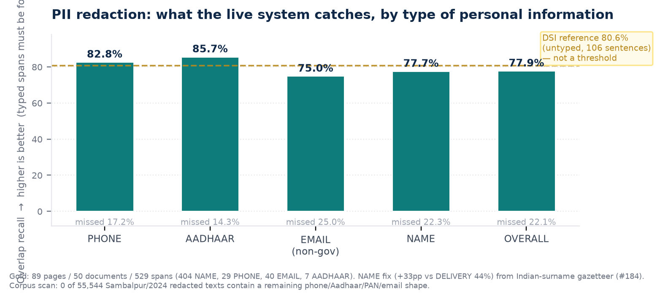
Figure 3 — PII redaction per entity (typed spans). Headline is missed-PII rate = 1 − overlap recall; false negatives matter more than F1 because a leaked phone number is not offset by many correct “not-PII” tokens. The DSI line is untyped any-overlap on a different, smaller sample — shown for context, not as a target to beat.
The name gap — found and closed:
Probe (40 names × 4 framings) | Before fix — English NER only | After fix — gazetteer + ALL-CAPS softening | Implication
Fully redacted (every token of the name covered) | 52% (21/40) | 100% (50/50 across 5 framings) | Odia/Indian names such as “Sujata Mohanty” were missed where “John Smith” in the same sentence was caught — en_core_web_sm is trained on English news.
Partially redacted (surname only, given name exposed) | 5% (2/40) | 0% | A recogniser that yields the whole name, not the surname alone, closes the boundary-completeness gap (I-PII recall was 0.575 in the DSI baseline).
Missed entirely | 42% (17/40) | 0% | 48% any-leak before → 0% after on synthetic probes. Probes are a floor on a known failure mode, not a coverage claim; gold remains the release-critical measure.
False positives (non-names left intact) | — | 0/9 realistic sentences (places, offices, scheme names) | Precision guard: “the road from Sambalpur to Bargarh” and “Pradhan Mantri Awas Yojana” are not redacted — over-redaction removes what the officer needs.
⚠ What the PII numbers can and cannot support. The per-entity table (89 pages) is the release-critical missed-PII rate — but it is small, so a few pages move it, and it cannot see bank-account / scheme-ID classes that have no labels. The corpus scan (55,544) holds at scale but only checks the four shape classes we know how to grep (phone, Aadhaar, PAN, non-gov email); it cannot see a name a human would catch. Report both together — they are complementary, not alternative.
4 — KEEPING THE QUEUE CLEAN: SPAM AND DUPLICATES

A cleaner queue — telling low-signal, repeat, and routing failures apart
Janasunani’s discard reasons conflate four different operational problems. Treating every discard as “spam” — or every repeat as “duplicate” — hides the action each queue needs. The system now separates three families that were previously one bucket, and groups duplicate filings as one problem with a citizen count.
Eight officer-template families — and which one the new tools address:
Family (officer template) | Action rows  (current snapshot) | Earlier ref. | Change | New handling
Details inadequate | 39,964 | 39,943 | +21 | SPAM scorer — low-signal flag (advisory)
Documents not attached | 29,029 | 29,029 | 0 | Completeness check — route to request documents
Case already taken up / taken up earlier | 21,117 | 19,904 | +1,213 | DEDUP — duplicate group (reviewable increment beyond 37,299 baseline)
No specific grievance | 16,375 | 16,340 | +35 | SPAM scorer — low-signal flag (advisory)
Duplicate copy | 16,182 | 14,767 | +1,415 | DEDUP — duplicate group
Needs a policy decision first | 9,125 | 9,090 | +35 | Policy queue — not spam, not duplicate
Outside grievance cell’s purview | 8,472 | 8,455 | +17 | ROUTING — crosswalk + rules; 8,472 is the out-of-purview baseline
Address not given | 4,114 | 4,110 | +4 | Completeness check — request address
Officer-confirmed duplicates (two families combined) | 37,299 | 34,671 | +2,628 | Baseline for what manual process already catches; automation reports only the additional reviewable matches
Table 3 — Discard families: why “discarded” meant four different things. Only two families map to spam; two map to duplicates; the rest are completeness/routing/policy. Sources: FINDINGS.md Insight 3 & 4; analytics note Table 2.4.
Spam is not a block — it is a banner. A filing flagged as low-signal is still submitted; the officer sees “low-signal: <reason> (spam_score 0.82)” and decides. Prevalence is measured over redacted grievance text only (never raw grievance) and reported by district / category / mode / year — so a high-spam district is visible, not hidden in a state average. PPV / false-positive rate is measured against the two officer-confirmed spam-like families (details inadequate 39,964 + no specific grievance 16,375) on a deterministic 30% holdout by ticket hash; duplicate families are never counted as spam positives.
Duplicates — from filings to problems to citizens:
Sambalpur/2024 (DEMO_SLICE — 55,544 complaints with grievance text, fixed 07 Aug 2026, Ganjam 46,678; Balangir 38,248) was redacted (55,544/55,544), indexed (MinHash/LSH, salted contact hashes — a hash is still personal data, so the index is dpic-infra, access-controlled), and grouped. Wall clock on the 2-vCPU CPU box: ~57 min; 16,138,623 comparison pairs; 310 large buckets; provenance complete (source_snapshot_id sha256:a7a0…).
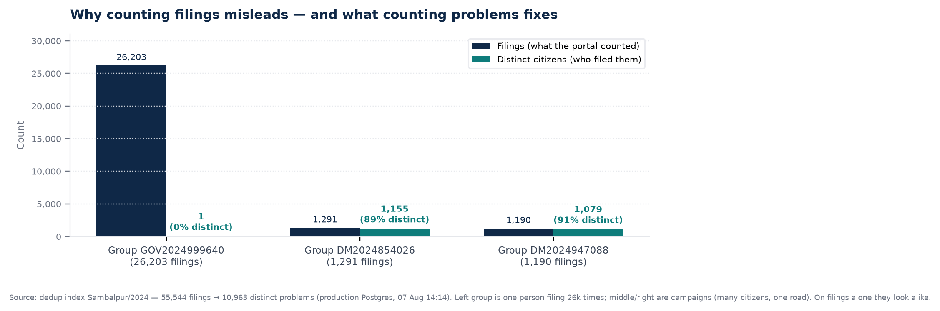
Figure 4 — Filings vs distinct citizens: why the third number matters. Left: one citizen filed 26,203 times (47% of the slice) — not a campaign. Middle/right: ~90% of filings in each campaign group are distinct citizens — a coordinated road complaint. Campaign badge must key off signatory count, not filings.
Metric (Sambalpur/2024, production) | Count | What it means
Filings indexed (with redacted text) | 55,544 / 55,544 | No filing is left without a redacted copy before dedup runs — redaction is step 0, not an afterthought.
Distinct problems (clusters) | 10,963 | Workload is 10,963 problems, not 55,544 filings — a 4× reduction in what counts as “work” for this slice.
Distinct citizens (signatories) | 8,560 | About 1.28 filings per citizen on average; but the average hides the two cases above.
Groups with >1 member | 1,794 | Groups worth reviewing; the rest are singletons.
Largest group | 26,203 (1 signatory) | The single-filer repeat — officer-confirmed duplicate baseline would have caught this as a label, but not its scale or that it is not a campaign.
Comparison pairs / large buckets | 16,138,623 / 310 | LSH bucketing makes 55k-scale comparison tractable on a 2-vCPU box; brute-force would be ~1.5B pairs.
Provenance (source_name / snapshot_id) | 55,544 / 55,544 present | Every group carries the digest of the exact lake slice it was built from; a lake re-materialisation that does not match causes a loud failure rather than a silently mixed count (#137).
ⓘ Officer labels are validation, not ground truth. The 37,299 officer-confirmed duplicate rows (taken-up + duplicate-copy) are what the manual process already catches — useful for measuring recall on a held-out sample, not a complete census of duplicates. The number that matters for automation is the additional reviewable increment beyond that baseline — reported separately and not yet claimed for August.
5 — WHAT ARE PEOPLE COMPLAINING ABOUT

From counting complaints to understanding problems — hotspots, spikes, and workload
The existing dashboards answer “how many complaints?” quickly and well. The intelligence layer answers three questions they cannot: where is pressure building faster than the state trend, what is the pressure about (in the citizen’s own words), and whether a surge is one road or two hundred unrelated problems. All three read only the corpus that has already been redacted — historical grievance is passed through the same PII step as scanned documents before any matching or grouping runs; derived signatures and vectors stay dpic-infra, under the same access rules as the raw lake.

Hotspot monitoring — per-1,000, not raw counts
Headline complaint counts are not complaint rates — without an eligibility denominator (eligible households for PMAY, ration-card holders for food security, etc.), a district with 200 complaints looks the same whether it has 1,000 or 10,000 eligible households (2% vs 20%). The interim control is complaints per 1,000 general population (2021 projected district population, MoHFW 2020), excluding discards, tracked monthly.
What the map shows (2024–25, excl. discards) | Reading the map | Why per-1,000 matters
Complaints per 1,000 — elevated: Nuapada, Sambalpur (24.9), Subarnapur (22.6), Deogarh, Dhenkanal, Bhadrak, Jajpur; plus Boudh, Balangir, Bargarh for housing. | The surge is geographically uneven, not uniform — intensity concentrates in a cluster. | Raw counts would rank a populous district highest even with low intensity. Per-1,000 surfaces pressure independent of population size.
Petitioners per 1,000 — similar pattern, but Sambalpur/Jajpur less pronounced; Kalahandi/Kandhamal stand out more. | Two districts can have the same complaint count for different reasons — many citizens vs few citizens filing often. | Separating petitioners from filings distinguishes broad-based demand from repeat-filing concentration.
Complaints per petitioner — Subarnapur ≈1.18 (many people, each once — textbook genuine demand), Sambalpur 2.19 (highest in state, few people, filing often). | Even after removing discards, a residual concentration signal remains in Sambalpur. | A high complaints-per-capita map alone cannot tell you whether to investigate service delivery or a small set of repeat filers.
Rural Housing + PMAY per 1,000 — mirrors overall geography (unsurprisingly, since housing is 37% of filings). | Grievance volume is a near-real-time PMAY implementation monitor by district — when Rural Housing spikes, expect a survey, list, or payment bottleneck to investigate. | Two housing labels that grew by ~147k year-on-year (Rural Housing 83k→168k, PMAY 26k→89k) dominate the geography.
Month-to-month comparison is the operational use: a district whose per-1,000 rises faster than the state average is flagged — whether or not its absolute count is the highest. The roll-up goes district → block next (see below).

Spikes with the cause attached — the three-number contract
A rise in filings can mean 400 citizens about one road, or 200 unrelated problems. Those need opposite responses and are identical in a dashboard count. Detecting the spike is ordinary (EWMA over category × district × week, flagged when filings ≥2× trailing 8-week mean and ≥1.5× same week last year — seasonality matters, so comparison is July–June year-over-year, not month-over-month). The hard part — and the capability — is decomposing the spike into three numbers: filings / distinct problems (dedup clusters) / distinct citizens (signatories). A campaign is not a false spike and is never suppressed; it is labelled by which measure drove it.
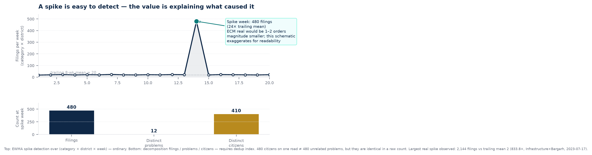
Figure 5 — The spike concept. Top: detection is ordinary. Bottom: decomposition (filings / problems / citizens) requires the dedup index — collapsing 480 filings from 410 citizens about one road to “1” would destroy the signal government needs to see.
Spike fact (current lake, 1.37M complaints) | Measured | Officer implication
Candidate spikes found (category × district × week) | 11,935 | Most spikes are not reportable — the panel surfaces only the top candidates by lift; the rest are noise until decomposed.
Largest lift observed | 833.8× — Infrastructure × Bargarh, week 2023-07-17: 2,144 filings vs trailing mean 2 | A real event, not a data artefact — the same week last year and the trailing mean both diverge, so it survives both gates.
Decomposition columns in mart | filings / distinct_clusters / distinct_signatories — but NULL as “pending dedup index” until the index join is wired | Spike.sql currently hardcodes NULL for clusters (#78) — so the three-number panel shows “Unavailable*” for clusters/citizens rather than a wrong number. The contract is enforced even when the data is not yet joined.
One worked example (top candidate) — when wired | e.g., Rural Housing × Sambalpur, week W: 480 filings / 12 problems / 410 citizens → campaign about a concentrated issue | Response: one coordinated field follow-up (survey/list/payment) — not 480 parallel enquiries. A diffuse spike (480 filings / 260 problems / 400 citizens) would instead need triage and routing.
Duplicate-adjusted workload — the same three numbers, without a spike. The portal counts filings; the intelligence layer counts problems. For Sambalpur/2024: Filings 55,544 → Distinct problems 10,963 → Distinct citizens 8,560. That is the “true workload” for the slice. Both workload and spike share the same dedup_groups digest; the serving layer refuses a mixed snapshot (#137), so a stale index cannot silently undercount a surge.

Deeper cuts — local themes, block-level variation, and where time is lost
Local issue themes. Complaints are grouped by what they are about (TF-IDF clustering over redacted text, one category at a time) and then filtered to themes that are both concentrated in one district and rising over time. Concentrated + rising is the alert worth acting on. Example: within Rural Housing, sub-themes such as construction quality vs beneficiary targeting vs land records vs procedural delay are indistinguishable in the category label but separable in text — if the text is redacted first. The demo shows themes for one category as a worked example; at full scale this is per-category, per-district.
Diagnostic | Finding | Why it matters more than a district dashboard
Block vs district — where disposal time actually varies | Formula: disposal time ~ filing week + office type + online/offline + gender + geography. Knowing district adds +5.7 pp to variation explained; knowing block adds +12.2 pp (more than twice as much). Range: ~476 days block-to-block vs ~62 days district-to-district. | A district dashboard can make a severely delayed district appear average if its slow blocks are averaged together with its faster ones. Monitor at district, diagnose at block.
Online vs offline on disposal speed | Adjusted difference <2–3 days, small and unstable — not a first-order policy lever. | Channel choice affects who can file, not how fast a filed case resolves.
Gender on disposal speed | Women’s complaints resolve ~2 days faster on average after accounting for block/office/complaint characteristics — too small to drive separate policy, but worth tracking. | The larger gender story is filing composition (next section), not speed.
Overall improvement | System-wide disposed median fell ~52 days between July 2024 and June 2025, after accounting for block/office/complaint mix — a genuine operational improvement at rising volume. | Not attributable to a single intervention — but the measurement is now auditable per block and per month.
⚠ Eligibility denominators remain the highest-priority external data to acquire. A block with 200 housing complaints among 1,000 eligible households (20% rate) is a different fact from 200 among 10,000 (2%). Linking Janasunani to PMAY beneficiary lists by district and block would convert intensity (per-1,000) into rate (per-eligible).
6 — WHO IS COMPLAINING

Who the system serves — and how that is changing
Complaint volume is not a neutral count — a surge driven by many citizens each filing once is a different governance fact from a surge driven by a few citizens filing repeatedly. The same is true for channel (online vs offline), gender, and geography. The intelligence layer makes the “who” as visible as the “what”.
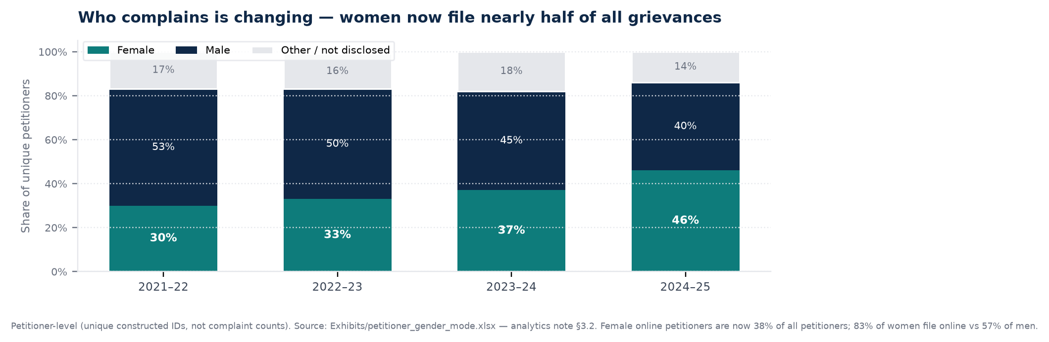
Figure 6 — Petitioner gender composition (petitioner-level, not complaint counts). Female share rose from 30% to 46% in three years — a steady rise, not a single-year jump. “Other” includes unspecified / not-disclosed.
Who / how — dimension | What the data shows | What it implies for design
Repeat filing vs broad access | 88% file exactly once (median 1, mean 1.43, 95th percentile 2). The surge is driven by more citizens entering the system — not the same citizens filing more often. Maximum observed: one constructed ID with ~12k filings. | Access is broadening, not concentrating. The exception (single-filer with many filings, e.g., 26k in Sambalpur/2024) is visible in dedup groups — so high-complaint districts can be checked for repeat-filer artefacts before they are mistaken for service-delivery crises.
Gender — the headline shift | Female: 30% (21–22) → 33% → 37% → 46% (24–25). Male: 53% → 50% → 45% → 40%. Female petitioner count +125% (23–24 to 24–25) vs male +59%. | The system is approaching gender parity among petitioners — a monitoring claim worth surfacing to reviewers, with the caveat that “benefit” is officer-assessed, not citizen-reported.
Gender × channel — the surprise | Female online petitioners = 38% of all petitioners (largest gender-mode cell, 2024–25). Within gender, 83% of women filed online vs 57% of men. “Other” gender: 92% online. | The assumption that online is less accessible to women does not hold here at the gross filing rate. Investment in online help, form simplicity, and language support for the women-online majority matters more than adding offline camps for this group.
Channel overall | Online 79% (543,890) in 2024–25 — same as 2021–22 after correcting for CMO District Visit. WhatsApp + mobile app = 76,580 in 24–25 (up from 15k in 21–22). Discards concentrate online: >99% of NaN/discarded in spike months were online. | Online completeness checks (duplicate detection, jurisdictional filtering, address/mode validation) reduce intake burden far more than in-person screening — because the discard problem is almost entirely online.
Geography — rural / urban and district texture | No hard rural/urban flag exists in the structured record (see caveat below). Geography is read via district/block per-1,000 maps: hotspot cluster in west/central Odisha (Nuapada, Sambalpur, Subarnapur, Deogarh, Dhenkanal, Bhadrak, Jajpur). Subarnapur is high-participation (1.18 complaints per petitioner); Sambalpur is repeat-concentration (2.19). | In housing-heavy districts, rural-urban can be inferred from block composition and from scheme eligibility (PMAY is rural-housing), but a direct rural/urban petition curve requires linking to census SECC or rural/urban block lists — not yet available as a structured denominator. We do not invent it.
Disadvantaged groups — what we can and cannot show | No structured caste / category / disability / BPL field exists in the complaint record as extracted. The record contains petitioner_name, district, block, and free-text grievance — so any disadvantaged-group lens must be derived from text (with PII removed) or by linking to external beneficiary lists, not from a checkbox in Janasunani. | Two honest paths: (a) text-derived themes (e.g., pension — OAP/ODP/MBPY/WP — as a proxy for vulnerable complainants, but pensions are only 1% of filings so it is weak) and (b) external linkage — PMAY SECC / pension rolls / ration-card lists by block — to compute complaint rates per eligible disadvantaged household. The second is the credible path; the first is reported with that caveat. We do not present a “disadvantaged-group share” without one of them.
Age / literacy / connectivity proxies | Not directly captured. Filing mode and text length are the only available proxies: in-person filings average 5.7 words (officer-transcribed short), website 68.8 words, non-English text 78.6 words vs English 36.1. | A channel-and-length split is not a disadvantaged-group metric — it is a data-quality note: in-person grievances often do not contain substantive free text, so text-based analysis (themes, duplicate matching) is systematically weaker for that channel.
⚠ On rural/urban and disadvantaged groups — a candour note for reviewers. This is the section where the temptation to show a neat chart exceeds the data’s permission. The complaint record does not contain a rural/urban flag or a caste/category field. We can show district and block per-1,000 maps, and within Rural Housing the “rural” is implicit in the scheme — but a true “rural complainants vs urban complainants” trend, or a “SC/ST share of complainants,” requires external linkage (census, SECC, beneficiary lists) that is described in §3.4 as the highest-priority data acquisition. Any chart that claims those shares today is inventing a denominator. We therefore show what is measured above, and mark the rest as “needs linkage” rather than filling the gap with a guess.
7 — WHAT OFFICERS SEE DAY-TO-DAY

Real-time help while a case is open — and a supervisor view that earns its keep
The intelligence layer is not only a monthly report — it is a banner the officer sees while deciding, and a supervisor panel that refreshes from the same governed marts that produce the monthly findings. Both are built for the reality that a count without a denominator, a spike without a cause, and a queue with duplicates are worse than no information.

While a grievance is open — the triage and routing badge
Officer sees | What it says | What it does not do
Triage banner — spam score | Low-signal: <reason> (spam_score 0.82) — e.g., “details inadequate” or “no specific grievance.” Score in [0,1]; informational. | Never blocks submission. Never changes status. Officer decides whether to request details or proceed.
Triage banner — duplicate / campaign | “Possible duplicate of #NN” (linkage) or “Campaign — N filings grouped as one issue” (cluster with signatory count). Campaign badge keys off distinct citizens, not filings. | Does not merge or suppress filings. A campaign of 400 citizens about one road stays 400 rows — linked — so the scale remains visible.
Classification suggestion | Category (e.g., Housing, Police Case) with confidence; per-class spread disclosed (Police ~0.85 F1, Social Welfare ~0.51). Feature = grievance + redacted page text. | Does not auto-assign. For Social Welfare — recall 0.39 — the UI treats it as indicative only.
Summary | One-paragraph BART summary — only from letters / text-heavy pages (the useful 1.9–1.3/3 pages). ID/bill pages are not summarised. | Does not summarise ID copies or receipts — because the evidence says it is not useful (0.40/3).
Routing badge | Dept + office (if mapped) + confidence + method: learned → rules → fallback. Hover: support (how many past cases) and share. Method “fallback” = general grievance cell, low confidence, rather than failing. | Learned means “where this category+district was sent before” (accuracy 60.9% cat-only, 67.5% +subcat, 72.8% +subcat+district). It does not mean “where it was resolved best.” Outcome scorer (#106) is future work.
Timing the officer feels. Cold start to /health: 19.4 s (models on disk) — the slow part is first boot when BART (~1.6 GB) is fetched from the hub (pre-warm the night before). Warm text grievance: median 4.44 s, mean 4.77 s (n=8, laptop). First request after boot ~9.5 s. Typed-text needs no tesseract/poppler at submit time beyond preflight checks; document upload renders via Poppler (pdftoppm/pdfinfo) then Tesseract (Oriya needs ori traineddata) before the same downstream steps. Every response includes extraction source (text vs ocr_model), spans (start/end over original text), and advisory fields — all typed and validated against the frozen frontend contract (janasunani/serving/schemas.py).

While supervising — the /supervisor panels
Panel | Shows | What makes it new vs a SQL dashboard
How cases are closed — the 61% ladder | 776,922 ladder closures: 60.9% bare “disposed” (472,782), 39.1% bare as share of all 1,209,144 resolved. By trajectory: 58% bare (3–5 steps) → 65% bare (6+ steps). Rapid-closure review set: 8,974 created→closed ≤2 days on bare (1.9% of bare, 0.7% of all resolved; 1,020 on the shortest trajectory). | No ML. The value is curation: the finding is the query the department can run for itself, plus the bounded review set (8,974) that narrows qualitative review without treating speed as misconduct.
Workload — filings vs problems vs citizens | Sambalpur/2024: Filings 55,544 — Distinct problems 10,963 — Distinct citizens 8,560. By district/category/period. Snapshot digest enforced; mixed-snapshot fails loud. | No SQL dashboard counts distinct problems — because “same problem in different words” needs redacted-text MinHash matching, not a GROUP BY.
Spike — one worked surge, decomposed | Category × district × week EWMA spike (≥2× trailing 8-wk mean, ≥1.5× YoY). 11,935 candidates; largest 833.8× (Infrastructure × Bargarh, week 2023-07-17: 2,144 vs trailing mean 2). Worked example: filings / problems / citizens. | Detection is ordinary; decomposition is not — it needs the dedup index and the signatory count, so campaigns and diffuse waves (identical in a sum) become visibly different.
Themes — concentrated + rising | Within one category, TF-IDF + k-means over redacted text → themes filtered to concentrated in one district (≥55%) and rising (≥1.4×). Aggregates only: counts, shares, top terms — never raw text. | Category labels cannot distinguish “construction quality” from “beneficiary list” from “payment delay” within Rural Housing; themes can — but only after redaction.
If the nightly aggregates have not been published (outputs/aggregates/ or JANASUNANI_SUPERVISOR_FINDINGS_DIR missing or stale), panels show “Unavailable*” — not zero. That is the contract: a missing aggregate is a missing number, not a low number. Closure always has a value (no dedup needed); workload and spike are dedup-gated; themes are corpus-gated. DELIVERY.md’s fallback is closure-only if dedup slips — the one panel that does not depend on what is not yet built.
8 — SAFEGUARDS AND HONESTY

What we don’t claim — and how we protect citizen data while we work
The system is human-in-the-loop. AI suggests; officers decide. Every automated suggestion is logged with who saw it, what model version was used, and whether the officer accepted, edited, or rejected it — that exposure log is what makes the future A/B evaluation possible. The live triage is advisory — it never auto-discards (even a “discard” recommendation in the old system is rendered as a flag, not a state change).

Data protection — tiered, not slogan-based
Item | Before | With Janasunani 2.0 | Why it matters
Where citizen text lives | Documents in S3; grievance in OLTP (faithfully including petitioner_name / mobile / email / address, plus raw grievance prose — never passed through PII). Lake copies everything via SELECT * into Parquet — including grievance. | Same stores, but: page extracted_text stays in artifact DB and OLTP, never the lake (LAKE_COLUMN_DENYLIST); only redacted_text reaches the lake. grievance_redacted is step 0 of dedup (CPU-only over median 19 words) and the only column indexed. Raw grievance is access-controlled, never selected by analytics queries; Phase 18 drops it from analytics Parquet altogether. | The guarantee, stated precisely: “No un-redacted page text reaches any downstream output.” That guarantee does not extend to grievance by construction — so we treat derived artefacts (MinHash signatures, embeddings) as dpic-infra (DPIC machines only), never authorised-external.
Who may receive data | “Citizen text never leaves the box” — policy, not network. Boxes allowed general outbound; BART downloads from public hub at startup. | Trust tiers declared per route: same-host (Presidio/spaCy/MuRIL/BART), dpic-infra (S3, Postgres on CPU box, GPU-box DeepSeek/Sarvam weights), authorised-external (Sarvam hosted API — one module egress/ only, under a recorded MoU, per-call audit, kill-switch to local fallback). Network allowlist permits Sarvam and nothing else — stricter than today. | “The box” was never the real boundary — documents already lived in S3 and the GPU box is a second machine. Tiering is honest about hops that already existed.
What analysts see | Full complaint record, including grievance. | Governed aggregates, allowlisted query plans, small-cell suppression, isolated read-only execution, audit. DSI pipeline left 88% filing-once signal; we preserve that aggregate while suppressing any cell that could re-identify a petitioner. | A report that could identify a complainant is a privacy failure, not a useful insight.

What we don’t claim — limits on the same page as the number
Claim | What we report | What we don’t report — and why | What would close the gap
OCR accuracy | Divergence: how pytesseract and Sarvam Vision differ after the same markdown normaliser; handwritten vs printed split (Sarvam is claimed for handwriting but has no published handwriting number; blend would hide the corpus-relevant question). | Transcription accuracy against ground truth — because no hand-transcribed sample was commissioned (DELIVERY.md: “no owner was named”). Cost would have been ~300 pages × ₹0.50–1/page = few-hundred rupees; it is few-hundred rupees not spent. | Commission ~200–300 pages (stratified handwritten/printed, Odia/English) transcribed by hand; then report CER/WER with CIs clustered by ticket. Sample size at 10-point detectable: 194 pages (80% power) — already computed.
PII coverage | Per-entity overlap recall on 89 pages (480 spans) + corpus shape scan on 55,544 redacted texts (0 shaped leaks). English-only; Odia/romanized thin (unknown bucket, reported). | Odia PII recall; bank-account / scheme-ID recall (no labels in this gold). Overall 77.9% is name-heavy and small-sample volatile. | Extend gold to Odia/romanized (target ≥50 pages each) and add shaped-entity labels for bank-account/scheme-ID. Then the per-language table can report without a low-power guard.
Categorisation | MuRIL 71.04% on typed subject lines (65,999 test, trained 6,598); crosswalk 60.9/67.5/72.8 on history (where cases were sent). Per-class spread disclosed (Police 0.85–Social Welfare 0.51). | Head-to-head scanned-vs-typed accuracy. The MuRIL 71% is not comparable to a scanned-page result — it measures text domain as much as model. | Paired per-grievance comparison on the same pages (typed subject vs OCR text) with ticket-clustered CIs (sarvam_scorecard.py already does this for Sarvam vs pytesseract).
Duplicate recall | Officer-confirmed baseline 37,299 action rows; dedup index 10,963 problems from 55,544 filings; bulk illustration (26k single-filer, campaigns 89–94% distinct citizens). | Reviewable increment beyond baseline (not yet measured) — the figure that proves automation adds value beyond what officers already label. Prevalence by district/category/mode is measured; PPV/false-positive on holdout is reported, not gated. | Run the officers-held-out recall harness (duplicate_recall.sql) on a frozen slice and publish the increment separately — not bundled into a single “duplicate accuracy” number.
Routing benefit | Crosswalk accuracy where history sent the case; process step-3 median saving 9 days for 20% of PMAY (upper bound 25 days). Both as bounds, not estimates. | “Faster resolution because we routed better” — that needs the A/B (phase 16) and the outcome-based scorer (#106). 25 days is where cases were sent, not where they resolved best — and may be more complex on unobserved dimensions. | Stepped-wedge A/B by office (cluster-randomised, ITT primary; assignment service seeded hash; exposure log; pre-registered AB_PLAN.md with MDEs). No outcome peeking before lock.
Closure 61% | 776,922 ladder closures: 60.9% bare; 39.1% of all 1,209,144 resolved. By trajectory and with the two-day review set (8,974). Caveat carried on the same line: descriptive, not a failure rate. | That X% of “no-action” closures were wrong — record does not distinguish a correct refusal (ineligible, already settled, information answered) from a premature one. | 300–500 closures adjudicated by hand, governed, by a panel — the figure DELIVERY.md explicitly says is not August work.
Evaluation discipline: a harness that measures and prints (evaluation/) is separate from a gate that fails a run when the number is bad (pipeline/pii_eval.py). DSI baselines are labelled reference_only=True (dsi_baselines.py) and the report renderer never colours them as targets. The lake is not PII-free — and we do not pretend it is (ROADMAP §3.2).

Routing — what the numbers actually say
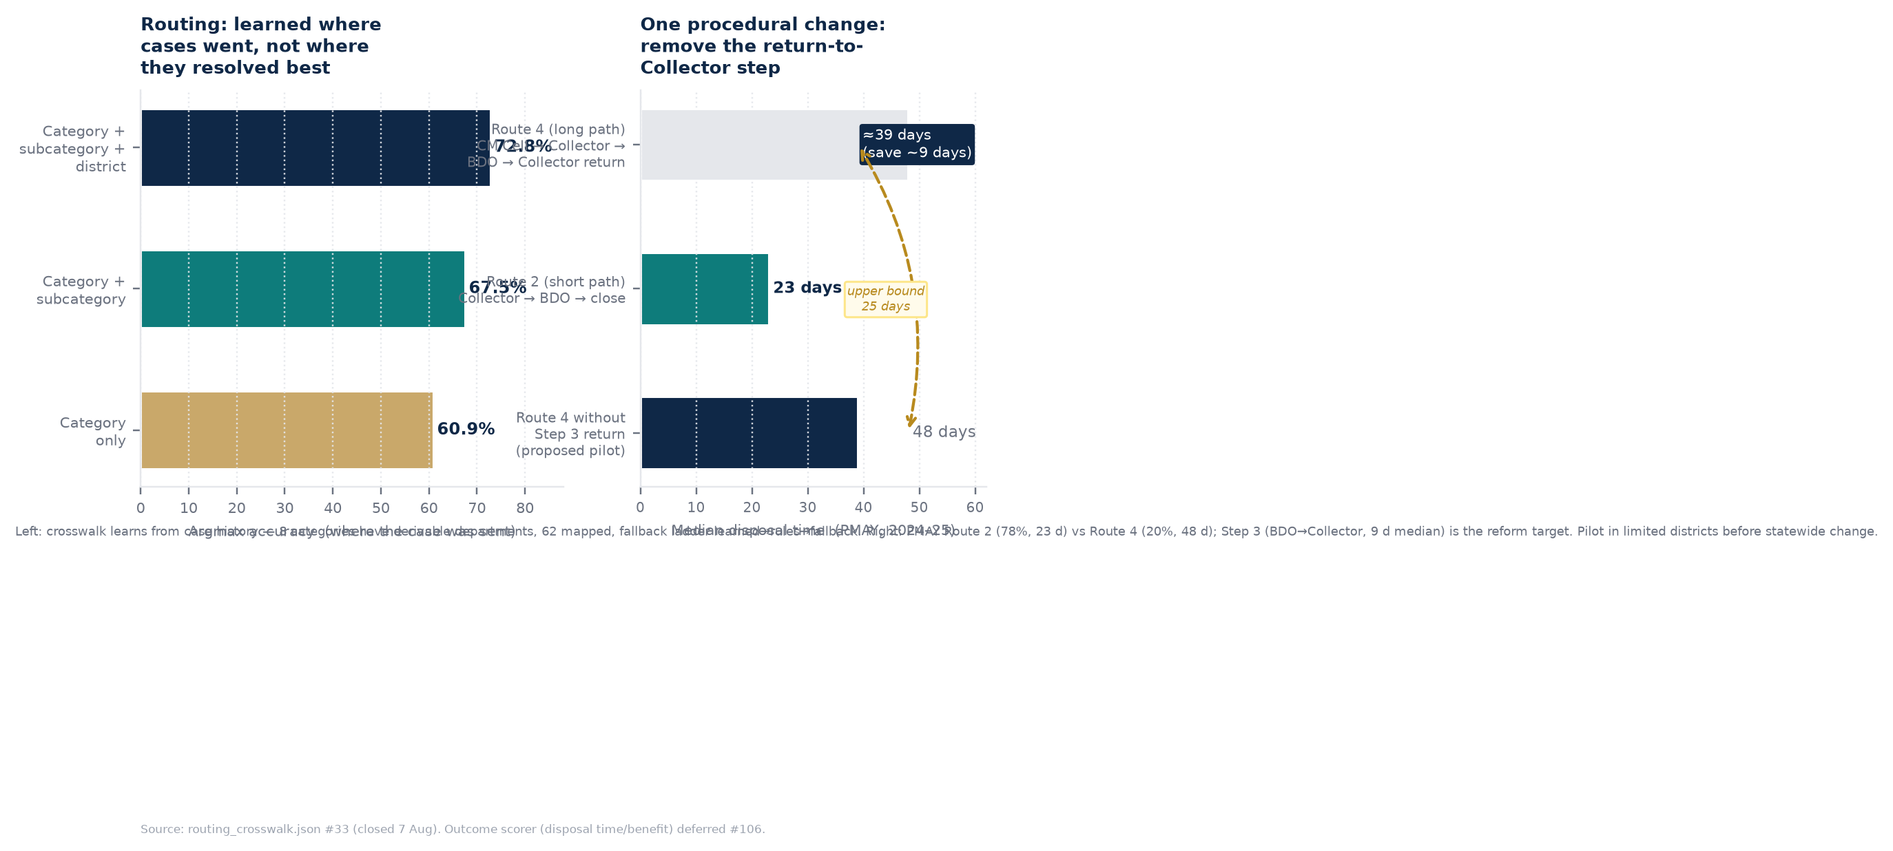
Figure 7 — Left: learned crosswalk accuracy rises when district is added (≈12 pp from category-only to full). Right: Route 4’s median 48 days vs Route 2’s 23 days (PMAY, 2024–25); the 9-day Step 3 (BDO → Collector return) is the piloted reform target. Upper bound, not an estimate — Route 4 may be more complex on unobserved dimensions.
ANNEX A — METRIC REGISTRY, SOURCES, AND HOW TO REPRODUCE

Where every number comes from — and the command that re-computes it
Reproducibility is not an afterthought — it is how a reviewer checks the claim. Every finding below is an exact, governed query over a named snapshot or a frozen baseline file. No finding reads complaints.grievance raw; all corpus work reads grievance_redacted (or pages.redacted_text) after the PII pass. Counts reconcile at every step (ROADMAP: 1,371,288 complaints / 6,556,171 action-history rows must match after any migration change).
Registry (selected — full registry is janasunani/evaluation/dsi_baselines.py and janasunani/analytics/marts/*.sql):
Metric | Value / sample | Source file or mart | Reproduce
Format classifier — avg accuracy | 75.71% (best 81.97%, macro-prec 72.93%) / 1,000 pages | dsi_baselines.FORMAT_CLASSIFIER_* (frozen) | — (historical reference)
OCR — all-three pass rate | 77.89% / 96,469 English pages | dsi_baselines.OCR_ALL_THREE_PASS_RATE | — (historical reference)
OCR quality guard | repetition trigram share >0.5, 20-word floor | janasunani/pipeline/ocr_quality.py | pytest -k ocr_quality
PII — any-overlap (DSI) | 80.56% / 106 sent / 2,126 tok | dsi_baselines.PII_ANY_OVERLAP_RECALL | — (historical reference)
PII — per-entity (current) | PHONE 82.8 / AADHAAR 85.7 / EMAIL 75.0 / NAME 77.7 / OVERALL 77.9 / COVERAGE 78.3 / 89 pg, 480 spans | janasunani/evaluation/pii_scorecard.py | janasunani-evaluate-pii --gold data/external/pii_gold_draft_n50.jsonl
PII — corpus shape scan | 0 / 55,544 (PHONE/AADHAAR/PAN/EMAIL non-gov) | janasunani/evaluation/pii_scorecard.scan_corpus_parquet | python -m janasunani.evaluation.pii_scorecard --slice Sambalpur/2024
Page-type ViT accuracy | 67% / 1,500 pg, 70/30 | dsi_baselines.PAGE_TYPE_VIT_ACCURACY | — (historical reference)
Summariser usefulness | 1.9/3 text-only (letters 1.3, bills 0.40) | dsi_baselines.SUMMARIZER_BART_USEFULNESS_* | — (historical reference)
Categoriser MuRIL accuracy | 71.04% / 65,999 (trained 6,598) | dsi_baselines.CATEGORIZER_MURIL_ACCURACY | — (historical reference)
Routing crosswalk — argmax acc | 60.9% cat / 67.5% cat+subcat / 72.8% +district | janasunani/routing/reference/routing_crosswalk.json (#33) | janasunani-build-crosswalk && pytest -k routing_crosswalk
Routing — Route 2 vs Route 4 | Route 2 78% 23 d / Route 4 20% 48 d / Step 3 9 d median | analytics/marts (route analysis); analytics note §3.4.5 | analytics/findings (closure/spike) + route_analysis_full.xlsx
Spam families (officer) | 39,964 details inadequate / 16,375 no specific grievance | FINDINGS.md; analytics/sql/action_type.sql | janasunani/evaluation/spam_scorecard.py (holdout)
Duplicate officer baseline | 37,299 rows (21,117 taken-up + 16,182 copy); earlier ref 34,671 | analytics/sql/duplicate_recall.sql; FINDINGS.md | SELECT ... FROM action_history WHERE template = ...
Dedup index — Sambalpur/2024 | 55,544 filings → 10,963 problems / 8,560 citizens / 1,794 groups / 16M pairs / ~57 min | janasunani/pipeline/dedup_index.py; PERFORMANCE.md §4 | janasunani-dedup-index --slice Sambalpur/2024 (CPU box)
Closure ladder | 776,922 ladder / 472,782 bare (60.9%; 39.1% of all resolved) / coverage 64.25% | analytics/sql/closure.sql; FINDINGS.md Insight 1 | janasunani-closure-finding
Rapid-closure review set | 8,974 ≤2 d on bare (1,020 shortest trajectory) | analytics/sql/closure.sql (closure_two_day_bare) | janasunani-closure-finding
Spike candidates | 11,935 (category×district×week); max 833.8× Infrastr.×Bargarh 2023-07-17 | analytics/sql/spike.sql; PERFORMANCE.md §5 | janasunani/analytics/findings/spike.py
Live API timings | warm text median 4.44 s; GET /history median 0.13 s; cold start 19.4 s | PERFORMANCE.md §1 (measured 07 Aug, laptop CPU, main ca58f31) | curl /health && curl -X POST /grievance
Petitioner composition | 88% file once; female 30%→46% (83% women online); 2024–25 online 79% | analytics note §3.2 (petitioner_frequency_distribution, gender_mode) | Exhibits/petitioner_gender_mode.xlsx etc.
Disposal improvement | Disposed median 62 d (23–24) → 46 d (24–25) on 298k→417k cases; block +12.2 pp vs district +5.7 pp | analytics note §3.4; regression_block_vs_district.png | rural_housing_regression.xlsx
A/B design | Cluster-randomised by office, ITT primary, MDEs computed, exposure log, pre-registered | docs/AB_PLAN.md; ROADMAP §5.4 | — (framework only for 14 Aug)
Sarvam benchmark | Paired n=300 (stratified handwritten/printed, Odia/English); divergence-only until transcription; CIs clustered by ticket | janasunani/evaluation/sarvam_scorecard.py | janasunani-sarvam-evaluate --slice Sambalpur/2024
Governed sources — reading list for the reviewer who wants the primary document, not this summary:
- DSI Progress Report (May 2026) — dsi_progress_report.md (308,845 pages, 1 TB, 1.4M complaints, five-stage timing, measured baselines) — the “before” in every Table 2 row.
- Analytics Note (CA&GR, May 2026) — grievance_analytics.md (688,301 in 2024–25, gender/geo/route/closure evidence, 55 figures, 14 exhibits) — the “status quo” numbers in §1 and §6.
- Routing Crosswalk — janasunani/routing/reference/routing_crosswalk.json (issue #33, closed 07 Aug — learned where history sent the case, not where it resolved best).
- PII Gold — data/external/pii_gold_draft_n50.jsonl (89 pages, 529 spans — DVC-tracked, duplicate-span rejection #89, gov-email exclusion #56).
- Dedup Slice — DEMO_SLICE = Sambalpur/2024, 55,544 with redacted text (janasunani/config.py:DEMO_SLICE_LABEL) — the only slice with redacted corpus on the CPU box as of 07 Aug 14:14.
- Full metric definitions — docs/ROADMAP.md §2, §3.2, §5; docs/DELIVERY.md Table 2; docs/FINDINGS.md; docs/PERFORMANCE.md — each number in this report points to one of them.
ⓘ A note on language. “Accuracy” here is used in plain English — where we mean precision or recall or overlap recall, the table says so. The technical distinction matters (precision = share of flagged that were correct; recall = share of true that were flagged; overlap recall = any overlap counts; exact = full span must match), but the report labels each row — you do not need to remember the definitions to read the implication column. Where a head-line hides a spread (MuRIL 71% = Police 0.85 to Social Welfare 0.51), we report the spread.

What happens after 14 August
The August demonstration is a working slice, not the full 1.37M. Three investments strengthen the data before any scale-up decision — each is a data acquisition or a hand-review task, not a model change:
- 1. Eligibility denominators — link Janasunani to PMAY / pension / ration-card lists by district and block (per-eligible rates replace per-1,000). Highest priority.
- 2. Classification coverage — NLP-assisted labelling for the 33.9% uninformative (NaN / General / Miscellaneous) from free text — proof of concept on ORTPS exists. Add Odia/romanized gold for the 27% non-English text.
- 3. Hand review where only a human can judge — 300–500 closures to calibrate the 61% bare rate; ~300 pages transcribed to score OCR properly (Sarvam handwritten vs printed split); both are days of reading, not months of engineering.
Plus the two engineering slices that are built and waiting for an overnight run and a key: dedup-index join into spike/workload marts (#78) and the Sarvam live comparison (needs SARVAM_API_KEY — few-hundred rupees on the paired 300-page sample; governance is recorded, cost is not a blocker). The A/B stepped-wedge design (AB_PLAN.md) is locked before any outcome data is viewed — so the August framework does not become a post-hoc story.
Prepared by DPIC, August 2026. Working draft — figures reflect the August rehearsal slice and the 07 Aug production dedup run; they will be re-cut after the 14 August demonstration. Every table in this report is a query away from being re-checked; Annex A gives the command.

